EXPENSES DASHBOARD | FY 2025
Project Documentation & Dashboard Analysis
Prepared by: Manish Singh
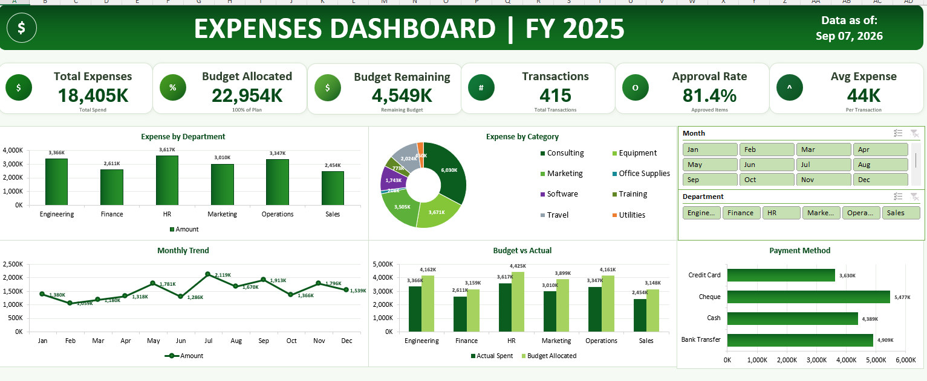

1. Project Overview
The Expenses Dashboard | FY 2025 is an Excel-based business intelligence and financial analytics project developed to provide a consolidated view of organizational spending. The dashboard converts transaction-level expense data into KPIs, charts, and interactive filters that make financial performance easier to understand and monitor.

2. Problem Statement
Organizations may have hundreds of expense transactions spread across departments, categories, vendors, payment methods, and months. Reviewing such records manually makes it difficult to identify spending patterns, compare actual expenses with budgets, and quickly detect high-cost areas. This project addresses the problem by presenting the data through an interactive and management-friendly dashboard.

3. Project Objectives
- Monitor total organizational expenses and transaction volume.
- Compare actual spending with allocated budgets.
- Track remaining budget for financial control.
- Identify high-spending departments and expense categories.
- Analyze monthly expense trends and peak spending periods.
- Measure the approval rate of expense transactions.
- Analyze spending by payment method.
- Provide interactive Month and Department filters for focused analysis.

4. Dataset Description
The source dataset contains 415 expense transactions and 13 fields. It includes transaction identifiers, dates, departments, categories, amounts, payment methods, approval status, budgets, vendors, invoices, and month information.
Field | Type | Purpose
Expense ID | Text | Unique transaction identifier
Date | Date | Transaction date
Department | Category | Department responsible for expense
Category | Category | Expense type
Description | Text | Transaction description
Amount (INR) | Numeric | Actual expense amount
Payment Method | Category | Payment channel
Approved | Category | Approval status
Budget Allocated | Numeric | Allocated budget
Budget Remaining | Numeric | Remaining budget
Vendor Name | Text | Vendor information
Invoice Number | Text | Invoice reference
Month | Category | Month used for trend analysis

5. Key Performance Indicators (KPIs)
KPI | Value
Total Expenses | ₹18,405,183
Budget Allocated | ₹22,953,950
Budget Remaining | ₹4,548,767
Transactions | 415
Approval Rate | 81.4%
Average Expense | ₹44,350

6. Dashboard Components
Expense by Department: Compares total spending across Engineering, Finance, HR, Marketing, Operations, and Sales.
Expense by Category: Shows the contribution of major categories such as Consulting, Equipment, Marketing, Software, Training, Travel, Utilities, and Office Supplies.
Monthly Trend: Displays month-wise spending from January to December to identify changes and peak periods.
Budget vs Actual: Compares actual spending with allocated budgets for each department.
Payment Method: Shows the value of expenses processed through Credit Card, Cheque, Cash, and Bank Transfer.
Interactive Filters: Month and Department slicers allow users to focus the dashboard on selected periods or departments.

7. Key Insights
- HR is the highest-spending department, with approximately ₹3,616,924 in expenses.
- Consulting is the largest expense category, with approximately ₹6,030,171.
- Cheque is the highest-value payment method, accounting for approximately ₹5,477,461.
- Jul records the highest monthly spending, at approximately ₹2,119,404.
- The overall approval rate is 81.4%, indicating the proportion of transactions marked as approved.

8. Methodology
- Data Collection: Imported transaction-level expense records from the Excel dataset.
- Data Validation: Reviewed dates, numeric values, categorical fields, and missing values.
- Data Aggregation: Summarized expenses by department, category, month, and payment method.
- KPI Development: Calculated total expenses, budget, remaining budget, transactions, approval rate, and average expense.
- Visualization: Built charts for departmental expenses, category distribution, monthly trends, budget comparison, and payment methods.
- Interactivity: Added Month and Department slicers to support dynamic analysis.

9. Business Recommendations
- Regularly monitor high-spending departments and categories against their budgets.
- Review major consulting and other high-value expense areas for cost optimization.
- Investigate unusually high monthly spending and compare it with operational requirements.
- Track unapproved transactions to identify approval bottlenecks.
- Use vendor and invoice details for detailed expense audits and reconciliation.
- Standardize payment processes where appropriate to improve financial control.

10. Business Impact
The dashboard provides a single, visual source for monitoring expense performance. It can reduce manual reporting effort, improve budget visibility, highlight cost drivers, and support faster data-driven financial decisions.

11. Tools & Technologies
- Microsoft Excel
- Pivot Tables and Pivot Charts
- Excel Slicers
- Data Cleaning & Transformation
- KPI Analysis
- Data Visualization
- Financial Analytics

12. Project Structure
- Expense_data.xlsx — Source transaction dataset
- Expense_Dashboard.png — Dashboard preview
- README.md — GitHub project overview
- DATA_DICTIONARY.md — Dataset field definitions
- PROJECT_DOCUMENTATION.md — Detailed project documentation

13. Author
Manish Singh
B.Tech CSE | Data Analytics & Business Intelligence Enthusiast
This project demonstrates practical skills in Excel-based data analysis, dashboard development, KPI reporting, financial analytics, and business intelligence.

