VRINDA STORE ANNUAL REPORT 2025
Dashboard Project Documentation & Business Analysis
Prepared by: Manish Singh
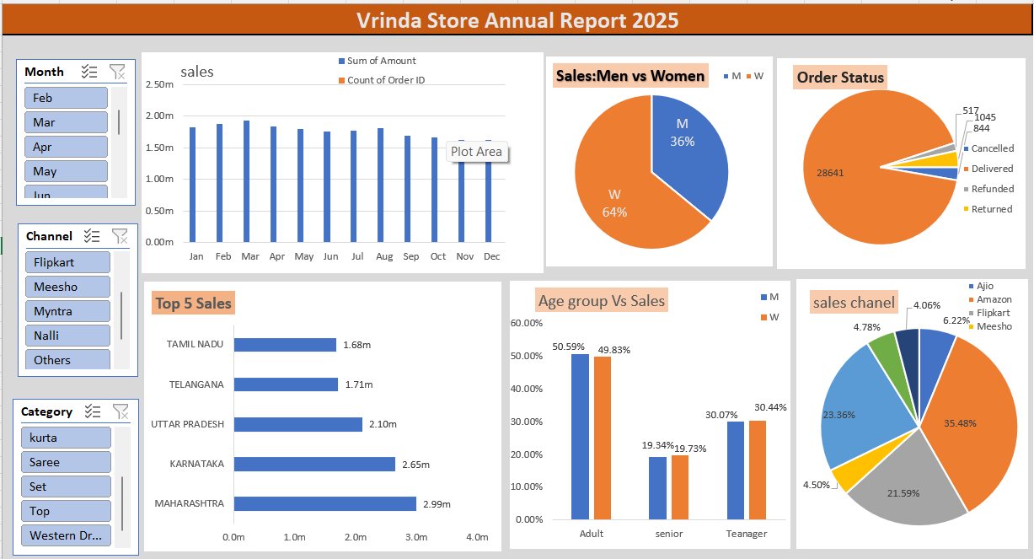

1. Project Overview
The Vrinda Store Annual Report 2025 is an Excel-based sales analytics dashboard designed to evaluate annual retail performance through interactive visualizations and key performance indicators. The dashboard provides management with a consolidated view of sales, orders, customer gender distribution, order status, top-performing states, age groups, sales channels, product categories, and monthly performance.

2. Problem Statement
Retail transaction data can become difficult to interpret when sales information is spread across thousands of orders, customers, products, locations, and sales channels. Manual analysis makes it difficult to identify high-performing regions, customer segments, profitable channels, and monthly sales patterns. The purpose of this dashboard is to transform raw transaction data into an easy-to-understand analytical report for faster business decision-making.

3. Project Objectives
- Analyze overall annual sales and order performance.
- Compare sales contribution between men and women customers.
- Monitor order status distribution, including delivered, cancelled, refunded, and returned orders.
- Identify the top five states based on sales value.
- Analyze sales performance across customer age groups.
- Compare sales contribution across major online sales channels.
- Evaluate category-wise sales performance.
- Analyze month-wise sales trends.
- Provide interactive filters for Month, Channel, and Category.

4. Dataset Description
The primary workbook sheet used for this documentation is 'Sheet1'. It contains 31,047 transaction records and 21 columns. The dataset supports customer, order, product, location, sales-channel, and transaction-level analysis.
Field | Type | Analytical Use
Order ID | Text | Order identification and order count
Gender | Categorical | Men vs women sales comparison
Month | Categorical | Monthly sales trend
Channel | Categorical | Sales channel performance
Category | Categorical | Product/category performance
Amount | Numeric | Sales value and revenue analysis

5. Key Performance Indicators
KPI | Value
Total Sales | ₹21,176,377
Total Orders | 28,471
Average Order Value | ₹744
Women Sales Share | 69.4%
Men Sales Share | 30.6%
Delivered Orders | 28,641

6. Dashboard Components
Monthly Sales: Displays month-wise sales performance and helps identify high and low sales periods.
Sales: Men vs Women: Compares sales contribution by gender and highlights the dominant customer segment.
Order Status: Shows the distribution of cancelled, delivered, refunded, and returned orders.
Top 5 Sales by State: Ranks the five highest-sales states and helps identify strong geographic markets.
Age Group vs Sales: Compares sales contribution across Adult, Senior, and Teenager customer groups.
Sales Channel: Shows sales contribution from channels such as Amazon, Flipkart, Myntra, Ajio, and Meesho.
Interactive Slicers: Month, Channel, and Category filters enable focused and dynamic analysis.

7. Key Insights
- MAHARASHTRA is the highest-selling state, with approximately ₹2,990,221 in sales.
- Amazon is the leading sales channel, contributing approximately ₹7,519,933.
- Set is the highest-sales category in the source data, with approximately ₹10,507,546.
- Women contribute approximately 69.4% of the gender-segmented sales, compared with 30.6% for men.
- Mar is the highest-sales month in the source data, with approximately ₹1,928,066.
- Delivered orders account for 28,641 transactions in the source dataset.

8. Methodology
- Data Collection: Loaded the retail transaction dataset into Excel.
- Data Preparation: Reviewed fields, categories, dates/months, order identifiers, and sales amounts.
- Aggregation: Summarized sales by month, gender, state, age group, category, channel, and order status.
- KPI Development: Calculated total sales, orders, average order value, and segment-level measures.
- Visualization: Used column charts, bar charts, and pie charts to communicate business performance.
- Interactivity: Added slicers for Month, Channel, and Category to allow dynamic filtering.

9. Business Recommendations
- Focus marketing and promotional activity on the highest-performing states while developing targeted campaigns for lower-performing regions.
- Strengthen the leading sales channels while comparing channel-level margins, returns, and customer acquisition costs.
- Use gender and age-group insights to create more targeted product recommendations and campaigns.
- Monitor cancelled, returned, and refunded orders to identify operational or product-related issues.
- Plan inventory and promotional campaigns around high-performing months and seasonal demand.
- Review category-level performance regularly to optimize product assortment and stock allocation.

10. Business Impact
The dashboard provides a centralized and visual view of retail performance. It can reduce manual reporting effort, improve sales visibility, support customer segmentation, highlight strong geographic and channel markets, and help management make data-driven decisions related to marketing, inventory, and sales strategy.

11. Tools & Technologies
- Microsoft Excel
- Pivot Tables
- Pivot Charts
- Excel Slicers
- Data Cleaning & Transformation
- KPI Analysis
- Data Visualization
- Retail Sales Analytics

12. Project Structure
- Store_data.xlsx — Source retail sales dataset
- Vrinda_Store_Dashboard.png — Dashboard preview
- README.md — GitHub project overview
- DATA_DICTIONARY.md — Dataset field definitions
- PROJECT_DOCUMENTATION.md — Detailed project documentation

13. Conclusion
The Vrinda Store Annual Report 2025 demonstrates how Excel-based data analytics can convert raw retail transactions into actionable business intelligence. By combining KPIs, trend analysis, customer segmentation, geographic analysis, channel performance, and interactive filters, the dashboard provides a practical framework for monitoring sales performance and supporting retail decisions.

14. Author
Manish Singh
B.Tech CSE | Data Analytics & Business Intelligence Enthusiast

