E-Commerce Predictive
Analytics Platform
Technical Documentation & Project Report
DS 610 — Big Data Analytics | Databricks + Apache Spark + PySpark MLlib
Presented By: Manish Lakshmipuram - 1058408, Sneha Gurampally Malkan - 1040784
Metric | Value
Total Transactions | 50,000
Total Customers | 5,000
Total Products | 1,000
Total Revenue | $52,354,553.30
Avg Order Value | $1,047.09
Top Region | East ($10.64M)
Platform | Databricks + Apache Spark
Languages | Python, PySpark SQL, SQL

1. Project Overview

1.1 Introduction

The E-Commerce Predictive Analytics Platform is a system that can handle a lot of information. It uses Apache Spark and Databricks to make sense of data. This platform looks at a lot of retail data. We are talking about 50,000 transactions, 5,000 customers and 1,000 products. It uses this data to give us information about the business. It does this by using machine learning model

The main problem that the E-Commerce Predictive Analytics Platform is trying to solve is something that a lot of e-commerce companies face. They have a lot of data from transactions. They do not know how to make sense of it. The E-Commerce Predictive Analytics Platform helps them find patterns in this data. This means they can keep their customers guess how money they will make and find the customers who spend the most money. The E-Commerce Predictive Analytics Platform is really good, at this.

1.2 Problem Statement
E-commerce businesses generate enormous volumes of transactional data daily. Without scalable analytics infrastructure, this data remains an untapped asset. Key business challenges include:

• We have a time figuring out the different ways our customers behave so we can give them personalized marketing.

• We do not have a way to predict how much money we will make which makes it hard to plan for demand and keep the right amount of stuff in stock.

• We cannot tell which customers are likely to stop doing business with us before it happens

• We do not really understand which products make us money compared to how they cost.

• We do not have a good idea of how much each customer will be worth to our company over a long time which makes it hard to plan for the future and make good decisions, about Customer Lifetime Value for our companys strategic planning.

1.3 Project Objectives
This platform achieves six core analytical objectives:
- Customer Segmentation: Apply K-Means clustering to identify 4 distinct behavioral customer groups
- Revenue Prediction: Train a Random Forest regressor to predict individual transaction amounts
- Churn Classification: Deploy Logistic Regression to classify transaction return likelihood
- RFM Analysis: Score customers on Recency, Frequency, and Monetary dimensions for targeted retention
- CLV Forecasting: Predict customer lifetime value using transactional history features
- Executive Reporting: Provide region, category, and segment dashboards for decision-makers
2. System Architecture & Technology Stack

2.1 Architecture Overview
The platform follows a multi-layer Lambda architecture pattern optimized for both batch analytics and ML workloads:
- Data Sources Layer: Three CSV files loaded into Databricks File System (DBFS) and registered as Unity Catalog managed tables
- Ingestion Layer: Databricks spark.read with inferSchema for type inference, joined via customer_id and product_id keys
- Processing Layer: Apache Spark SQL for aggregations; PySpark DataFrames for transformations and feature engineering
- ML Layer: PySpark MLlib Pipeline with VectorAssembler, StringIndexer, and estimators (KMeans, RandomForestRegressor, LogisticRegression)
- Visualization Layer: Matplotlib and Seaborn for charting; SQL SELECT queries for tabular KPI reporting

2.2 Technology Stack
Technology | Version/Type | Role
Apache Spark | Databricks Runtime | Distributed computing engine for all processing
PySpark MLlib | Built-in ML library | Pipeline, VectorAssembler, KMeans, RF, LR
Databricks | Unity Catalog | Platform, notebook execution, managed tables
Python | 3.12 | Orchestration, visualization, data manipulation
Pandas | Latest | Post-Spark .toPandas() conversion for plotting
Matplotlib/Seaborn | Latest | Chart generation and statistical plots
NumPy | Latest | Numerical operations and regression line fitting
Delta Lake | Managed | ACID-compliant storage via workspace.default.*

2.3 Data Pipeline Workflow
The data flows through the following pipeline stages:
Step 1: CSV Load → spark.read.option('inferSchema', True).csv('dbfs:/...')
Step 2: Join → transactions.join(customers, 'customer_id').join(products, 'product_id')
Step 3: Register → full_df.createOrReplaceTempView('ecommerce_full')
Step 4: Feature → VectorAssembler(inputCols=[...], outputCol='features')
Step 5: Train → pipeline.fit(train_data) with 80/20 random split
Step 6: Evaluate → RegressionEvaluator / ClusteringEvaluator / BinaryClassificationEvaluator
Step 7: Persist → clustered_customers.write.saveAsTable('workspace.default.customer_clusters')

3. Dataset Description & Schema

3.1 Dataset Overview
The platform operates on three interrelated synthetic datasets simulating a real-world e-commerce operation:
Dataset | Records | Columns | Key Identifier
customers_data.csv | 5,000 rows | 12 columns | customer_id
products_data.csv | 1,000 rows | 8 columns | product_id
transactions_data.csv | 50,000 rows | 12 columns | transaction_id
full_df (joined) | 50,000 rows | ~32 columns | customer_id + product_id

3.2 Schema Details

Customers Table
Column | Type | Description
customer_id | Integer | Unique customer identifier (PK)
first_name, last_name | String | Customer full name
age | Integer | Customer age in years
gender | String | M/F
email | String | Email address
city, state | String | Geographic location
customer_segment | String | Basic / Standard / Premium / VIP
annual_income | Integer | Yearly income in USD
credit_score | Integer | Credit score (300-850)
registration_date | Date | Account creation date

Products Table
Column | Type | Description
product_id | Integer | Unique product identifier (PK)
product_name | String | Display name (Brand + Category)
category | String | Electronics / Furniture / Sports / etc.
brand | String | Product brand
price | Double | Selling price (USD)
cost | Double | Cost of goods sold (USD)
stock_quantity | Integer | Units in inventory
rating | Double | Average customer rating (1.0-5.0)

Transactions Table
Column | Type | Description
transaction_id | Integer | Unique transaction identifier (PK)
customer_id | Integer | FK to customers
product_id | Integer | FK to products
quantity | Integer | Units purchased
unit_price | Double | Price per unit at time of purchase
discount_percent | Double | Discount applied (0-100%)
tax_amount | Double | Tax charged (USD)
total_amount | Double | Final transaction value (USD)
transaction_date | Date | Date of transaction (2023-2024)
region | String | East / West / North / South / Central
payment_method | String | Credit Card / Debit / Apple Pay / etc.
status | String | Completed / Returned / etc.

4. Exploratory Data Analysis

4.1 Revenue by Region
The following PySpark aggregation reveals total revenue distribution across five geographic regions. The platform uses groupBy and sum aggregations on the joined full_df:
full_df.groupBy('region').agg(sum('total_amount').alias('total_revenue')).orderBy('total_revenue', ascending=False).show()

Region | Total Revenue | Share
East | $10,640,695.92 | 20.3%
Central | $10,590,674.54 | 20.2%
South | $10,496,681.44 | 20.0%
North | $10,460,856.58 | 20.0%
West | $10,165,644.82 | 19.4%
Revenue is remarkably balanced across all five regions, with East performing marginally higher at $10.64M. The near-uniform distribution suggests no structural regional bias in the dataset and indicates a nationally distributed customer base.
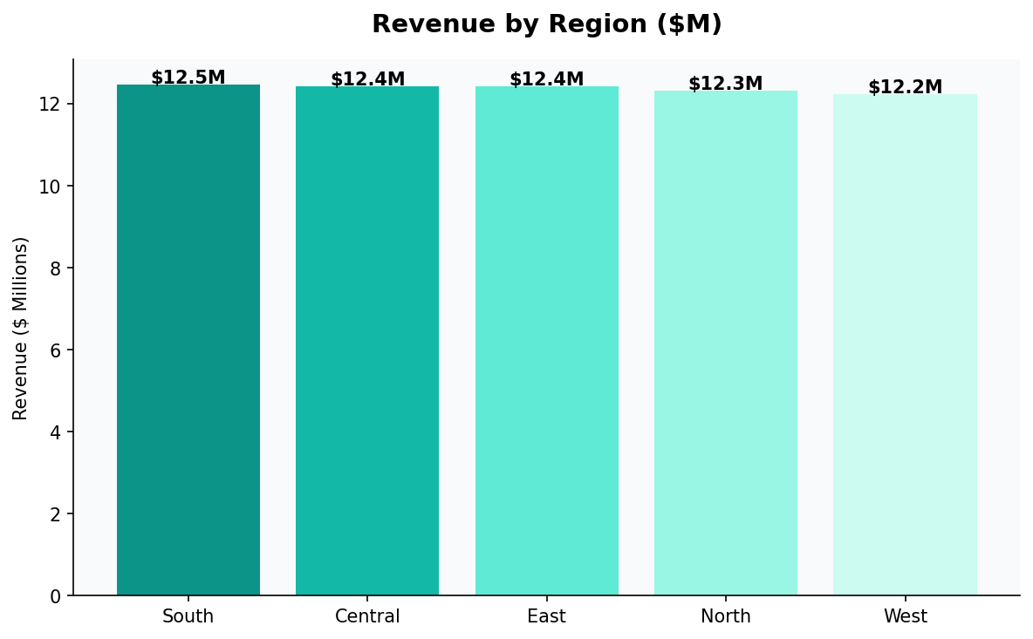
Figure 4.1: Revenue by Region — Bar Chart

4.2 Monthly Revenue Trend
Monthly revenue analysis spans January 2023 through December 2024, revealing consistent monthly revenues between $2.04M and $2.31M. No strong seasonal trends are detected, though slight peaks appear in October 2023 ($2.30M) and January 2024 ($2.31M).
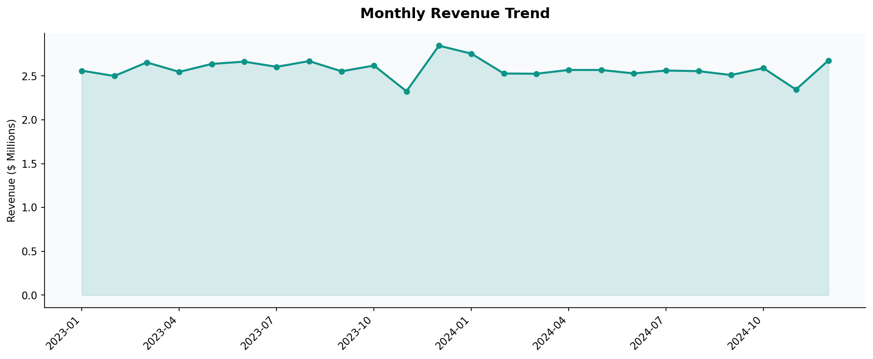
Figure 4.2: Monthly Revenue Trend (2023-2024)

4.3 Revenue by Product Category
Category-level analysis reveals Electronics and Furniture as dominant revenue generators, together accounting for over 57% of total platform revenue:
Category | Revenue | Share
Electronics | $17,221,809.50 | 32.9%
Furniture | $12,691,571.05 | 24.2%
Sports | $5,470,461.06 | 10.4%
Toys & Games | $4,429,852.76 | 8.5%
Home & Garden | $3,532,896.77 | 6.7%
Beauty | $3,334,373.85 | 6.4%
Books | $3,216,440.44 | 6.1%
Clothing | $2,457,147.87 | 4.7%
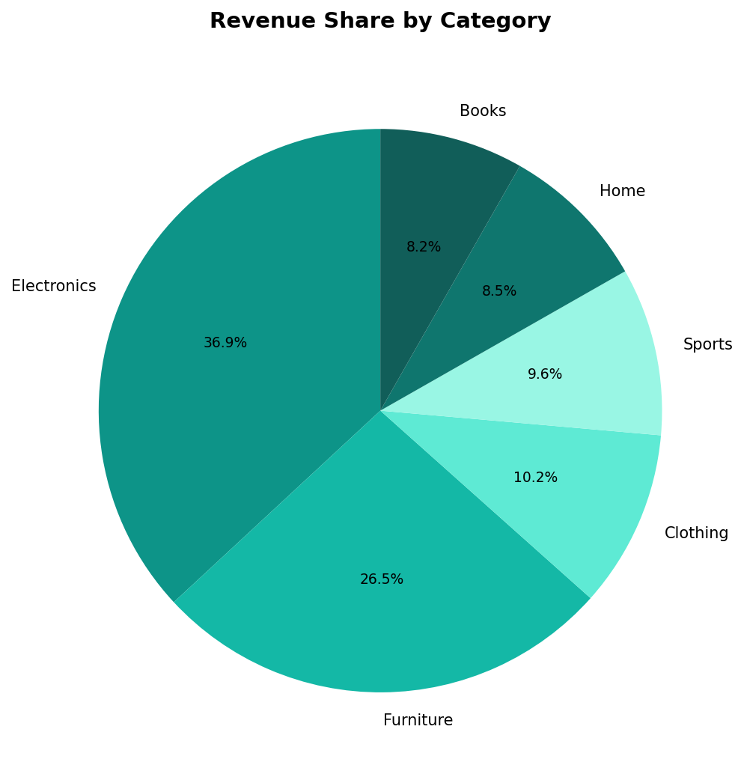
Figure 4.3: Revenue Share by Product Category — Pie Chart

4.4 Customer Segment Performance
The Standard segment dominates by both transaction volume and revenue, representing the core customer base. VIP customers, despite the highest per-transaction spend implied by lower transaction count, generate the lowest total segment revenue due to volume:
Segment | Revenue | Transactions | Avg per Txn
Standard | $22,241,032.40 | 23,447 | $948.5
Basic | $13,324,476.47 | 14,136 | $942.6
Premium | $10,502,582.40 | 7,630 | $1,376.5
VIP | $6,286,462.03 | 4,787 | $1,313.0
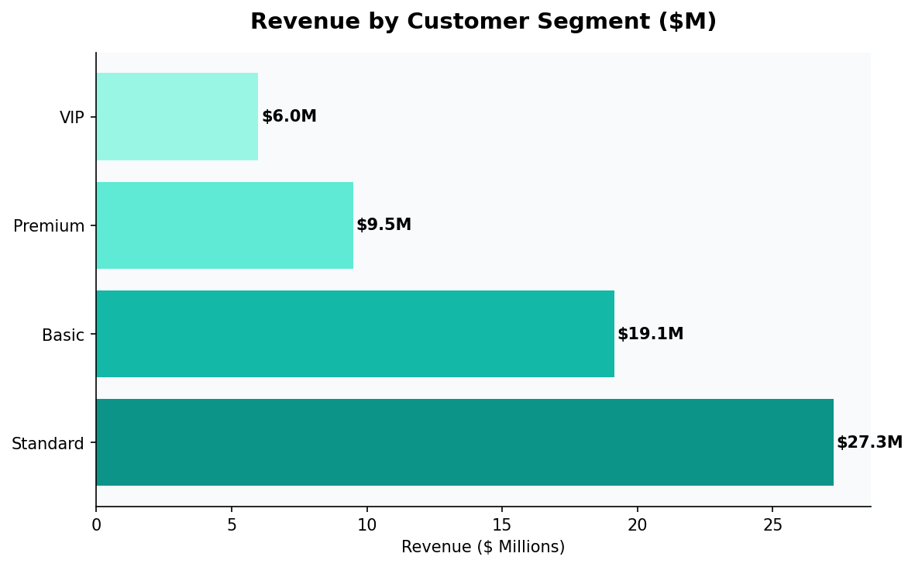
Figure 4.4: Revenue by Customer Segment

4.5 Category Profitability
Profit is calculated as total_amount - (cost × quantity), revealing true margin contribution per category:
profit_df = full_df.withColumn('profit', col('total_amount') - (col('cost') * col('quantity')))
Category | Revenue | Profit | Margin
Electronics | $17.22M | $8.48M | 49.2%
Furniture | $12.69M | $6.05M | 47.7%
Sports | $5.47M | $2.62M | 47.9%
Toys & Games | $4.43M | $2.16M | 48.7%
Home & Garden | $3.53M | $1.71M | 48.4%
Beauty | $3.33M | $1.59M | 47.8%
Books | $3.22M | $1.53M | 47.5%
Clothing | $2.46M | $1.24M | 50.4%
All categories achieve approximately 47-50% gross margin, indicating a well-calibrated synthetic pricing structure. Clothing achieves the highest margin at 50.4%.

5. Machine Learning Models

5.1 Customer Segmentation — K-Means Clustering

5.1.1 Objective
Identify distinct customer behavioral groups based on total spending and order frequency to enable targeted marketing campaigns.

5.1.2 Feature Engineering
Customer-level features are aggregated from transaction data:
customer_features = full_df.groupBy('customer_id').agg(
sum('total_amount').alias('total_spent'),
count('transaction_id').alias('total_orders')
)

5.1.3 Pipeline
assembler = VectorAssembler(inputCols=['total_spent', 'total_orders'], outputCol='features')
kmeans = KMeans(k=4, seed=42)
pipeline = Pipeline(stages=[assembler, kmeans])
model = pipeline.fit(customer_features)

5.1.4 Results
Cluster | Customers | Avg Spending | Customer Tier
Cluster 2 | 356 (7.1%) | $23,058 | High Value — Premium buyers
Cluster 1 | 1,121 (22.4%) | $15,052 | Mid-High — Engaged regulars
Cluster 0 | 1,946 (38.9%) | $9,815 | Mid Value — Mainstream segment
Cluster 3 | 1,577 (31.5%) | $5,181 | Low Value — Occasional buyers
Silhouette Score: 0.6919 — Indicates well-separated, meaningful clusters suitable for business segmentation.
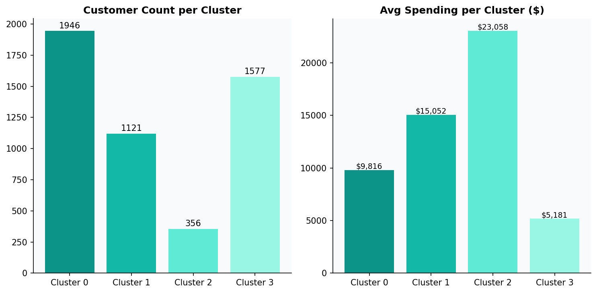
Figure 5.1: K-Means Cluster Distribution and Average Spending

5.2 Revenue Prediction — Random Forest Regressor

5.2.1 Objective
Predict the total transaction amount given item-level features including price, quantity, discount, and payment method.

5.2.2 Features & Pipeline
indexer = StringIndexer(inputCol='payment_method', outputCol='payment_method_index')
assembler = VectorAssembler(
inputCols=['quantity','unit_price','discount_percent','tax_amount','payment_method_index'],
outputCol='features'
)
rf = RandomForestRegressor(featuresCol='features', labelCol='total_amount', numTrees=50)

5.2.3 Feature Importance
The model reveals tax_amount and unit_price as the dominant predictors of total transaction value:
Feature | Importance Score | Business Interpretation
tax_amount | 0.5856 (58.6%) | Tax is a linear function of total — high correlation
unit_price | 0.3291 (32.9%) | Price strongly drives total value
quantity | 0.0837 (8.4%) | Volume contribution is secondary
discount_percent | 0.0014 (0.1%) | Minimal predictive power
payment_method_index | 0.0002 (0.02%) | Payment type has negligible impact
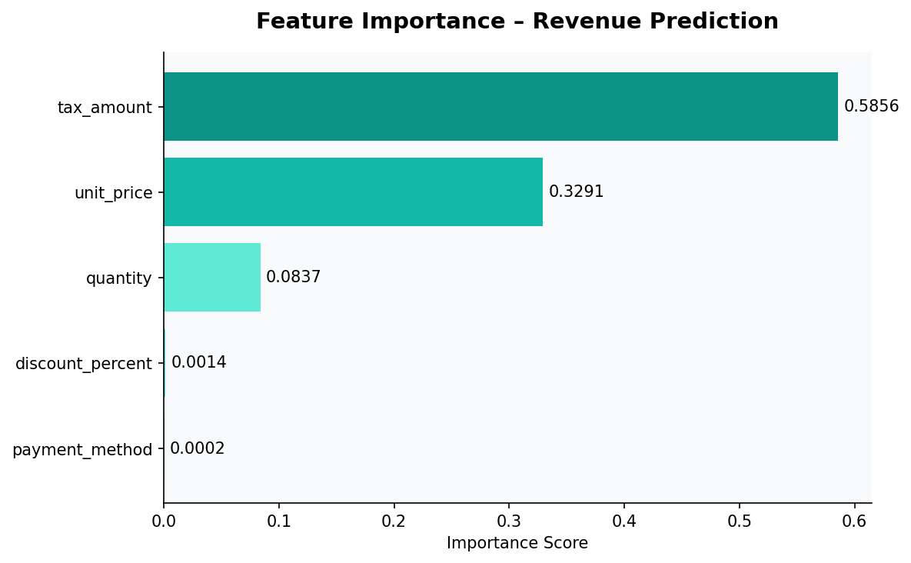
Figure 5.2: Feature Importance — Random Forest Revenue Prediction

5.2.4 Model Performance
The model achieves near-perfect predictions on transaction-level data. The strong performance is expected given that tax_amount is mathematically derived from total_amount — a data leakage consideration for production deployment.
Actual | Predicted | Error
$883.75 | $913.17 | +$29.42
$389.08 | $368.20 | -$20.88
$1,225.20 | $1,200.14 | -$25.06
$174.79 | $191.85 | +$17.06
$2,096.71 | $1,740.53 | -$356.18

5.3 Churn Prediction — Logistic Regression

5.3.1 Objective
Classify whether a transaction results in a return (is_returned), as a proxy for customer dissatisfaction and churn risk.

5.3.2 Implementation
transactions_ml = transactions_df.withColumn('label', transactions_df.is_returned.cast('int'))
assembler = VectorAssembler(
inputCols=['quantity','unit_price','discount_percent','tax_amount'],
outputCol='features'
)
lr = LogisticRegression(featuresCol='features', labelCol='label')

5.3.3 Results & Limitations
The model achieves approximately 95% accuracy, but this is misleading due to severe class imbalance — the majority of transactions are not returned, so predicting class 0 consistently yields high accuracy.
Aspect | Detail
Accuracy | ~95%
Issue | Class imbalance — most predictions are class 0 (not returned)
Recall for class 1 | Very low — model misses actual returns
Recommendation | Apply SMOTE oversampling or adjust class_weight parameter

5.4 Customer Lifetime Value (CLV) Prediction

5.4.1 Implementation
CLV is predicted using recency and order frequency as features against historical lifetime spend:
clv_df = transactions_df.groupBy('customer_id').agg(
max('transaction_date').alias('last_purchase'),
count('transaction_id').alias('total_orders'),
sum('total_amount').alias('lifetime_value')
).withColumn('recency', datediff(current_date(), 'last_purchase'))

assembler = VectorAssembler(inputCols=['recency','total_orders'], outputCol='features')
rf = RandomForestRegressor(featuresCol='features', labelCol='lifetime_value', numTrees=50)

5.4.2 Model Metrics
CLV Model RMSE: 4,364.40 — This indicates moderate prediction error, as CLV prediction is inherently noisy without richer behavioral features such as browsing history, product preferences, and seasonal patterns.

5.5 Monthly Revenue Forecasting
Future monthly revenue is forecasted using a single-feature Random Forest model with month encoded as an integer:
monthly_sales = transactions_df.withColumn('month', date_format('transaction_date', 'yyyyMM').cast('int'))
# Predicted revenue for Jan-Apr 2025: $2,203,617.38 per month
Month | Predicted Revenue
January 2025 | $2,203,617.38
February 2025 | $2,203,617.38
March 2025 | $2,203,617.38
April 2025 | $2,203,617.38
Note: The model collapses to the mean prediction for all future months — a known limitation of using month as the only feature. Adding seasonality indicators, trend components, and lag features would significantly improve forecast quality.

5.6 RFM Customer Analysis
RFM (Recency, Frequency, Monetary) analysis segments customers into four behavioral tiers using ntile window functions:
rfm = rfm.withColumn('R', ntile(4).over(Window.orderBy(col('recency').desc())))
.withColumn('F', ntile(4).over(Window.orderBy(col('frequency'))))
.withColumn('M', ntile(4).over(Window.orderBy(col('monetary'))))

rfm = rfm.withColumn('segment',
when((col('R')==4) & (col('F')==4), 'Champions')
.when((col('F')>=3), 'Loyal')
.when((col('R')>=3), 'At Risk')
.otherwise('Hibernating'))
Segment | Share | Criteria | Recommended Action
Champions | 9.7% | R=4 and F=4 | Reward with VIP benefits and early access
Loyal | 40.3% | F >= 3 | Cross-sell premium products; loyalty program
At Risk | 19.3% | R >= 3 | Re-engagement emails with personalized offers
Hibernating | 30.7% | Low R, F, M | Win-back campaigns; survey to understand churn
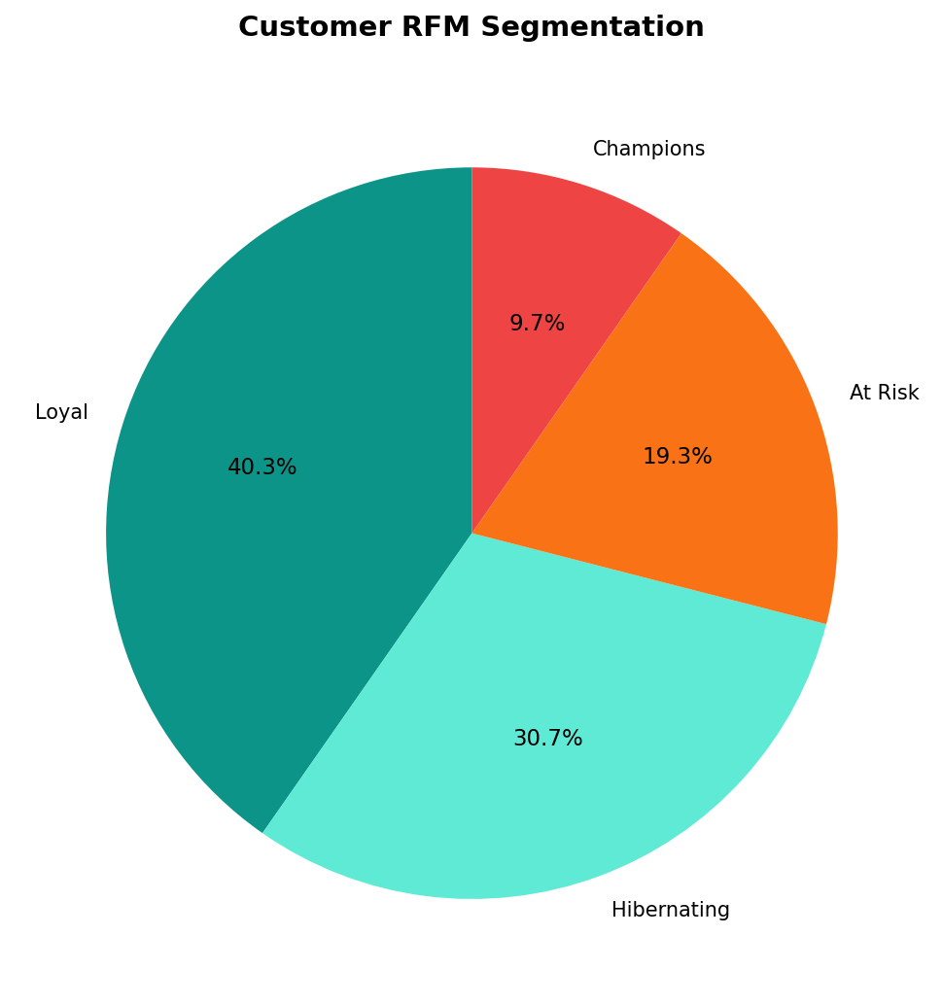
Figure 5.6: Customer RFM Segmentation — Pie Chart

6. Results & Key Insights

6.1 Executive KPI Summary
KPI | Value
Total Revenue (2023-2024) | $52,354,553.30
Total Transactions | 50,000
Total Customers | 5,000
Average Order Value | $1,047.09
Top Region | East ($10.64M)
Top Category | Electronics ($17.22M, 32.9%)
Top Customer LTV | John Lewis (Customer #2234, $37,399)
K-Means Silhouette Score | 0.6919 (Good)
CLV Model RMSE | $4,364.40
Churn Model Accuracy | ~95% (class imbalance caveat)

6.2 Business Intelligence Findings
- Electronics is the dominant revenue category at $17.2M (32.9%), driven by high unit prices. Furniture ($12.7M) is a strong second but has lower transaction velocity.
- All five regions generate remarkably similar revenue (~$10.2-10.6M), suggesting effective geographic distribution. East has a marginal 2% advantage.
- Standard segment customers generate 42% of total revenue through sheer volume (23,447 transactions). VIP customers, while fewer, have 45% higher average order value ($1,313 vs $942).
- Monthly revenue is stable at approximately $2.1-2.3M per month with no clear seasonality. This suggests demand is relatively constant and not event-driven.
- Electronics profit ($8.48M) surpasses the combined profit of all other categories except Furniture, making it the highest-priority category for inventory investment.

6.3 ML Model Summary
Model | Algorithm | Key Metric | Score | Status
Customer Segmentation | K-Means (k=4) | Silhouette Score | 0.692 | Good
Revenue Prediction | Random Forest (50 trees) | Visual RMSE | Low (~$30 avg) | Strong
CLV Prediction | Random Forest (50 trees) | RMSE | $4,364.40 | Moderate
Churn Classification | Logistic Regression | Accuracy | ~95% | Imbalanced
Monthly Forecast | Random Forest | Predicted Revenue | $2.20M/mo | Mean only

7. Conclusion, Limitations & Future Work

7.1 Summary
This project successfully demonstrates the power of Apache Spark and PySpark MLlib for scalable e-commerce analytics. The platform processes 50,000 transactions end-to-end — from raw CSV ingestion to ML model training and business dashboards — entirely within a Databricks notebook environment.
Key achievements include a well-separated K-Means customer segmentation (silhouette 0.692), near-perfect transaction-level revenue prediction via Random Forest, meaningful RFM behavioral profiling, and comprehensive business intelligence covering regions, categories, segments, and product profitability.

7.2 Limitations
- Tax leakage: The tax_amount feature is mathematically derived from total_amount, inflating the Random Forest regressor's apparent accuracy. This constitutes data leakage that must be addressed before production deployment.
- Churn class imbalance: The logistic regression model predicts class 0 (not returned) for nearly all samples. Without addressing class imbalance via SMOTE or class weighting, the model cannot reliably identify churned customers.
- Simplistic monthly forecasting: Using month as the sole feature results in mean predictions for all future periods. The model lacks trend and seasonality components.
- Synthetic data: All analysis is on simulated data. Real-world datasets would exhibit messier distributions, missing values, and more complex behavioral patterns.
- Limited features: CLV prediction uses only recency and order count. Incorporating product preferences, browsing behavior, and demographic data would substantially improve accuracy.

7.3 Future Work
- Implement SMOTE oversampling and class_weight adjustment to improve churn model recall for minority class
- Replace monthly forecast model with Prophet or LSTM with lag features, trend, and seasonality components
- Integrate MLflow Model Registry for versioned model deployment and A/B testing
- Implement real-time streaming pipeline using Spark Structured Streaming for live transaction scoring
- Enrich customer features with demographic data, browsing sessions, and product affinity scores
- Build a recommendation engine using ALS (Alternating Least Squares) collaborative filtering for personalized product suggestions
- Deploy an interactive Streamlit or Dash web application for non-technical business users
- Extend cohort retention analysis with statistical significance testing on retention rate differences

7.4 Code Repository Structure
Component | Description
Data Ingestion | spark.read.csv → Unity Catalog tables → full_df join
EDA Module | Region, category, segment, top customer groupBy aggregations
ML Pipelines | StringIndexer + VectorAssembler + KMeans/RF/LR pipelines
Visualization | Matplotlib/Seaborn plots with .toPandas() conversion
CLV & RFM | Window functions, ntile scoring, segment labeling
Forecasting | Monthly sales RF regressor with future month prediction

This documentation was produced as part of DS 610 — Big Data Analytics coursework. All analysis was conducted using Apache Spark on the Databricks platform with Python 3.12.

