Live Class Assistant
Technical architecture and deployment plan

Product: ClassCue (working name, to be confirmed)
Document version: 1.0
Date: 12 October 2026
Status: Desktop app built; licence module, installer and server deployment pending
Source code: github.com/Manish1307/ShortlistedPrepRepo

1. Summary 3
2. System overview 3
3. The server 4
3.1 Database tables (admin/data/admin.db) 4
3.2 Public API 4
3.3 Admin dashboard (private) 5
3.4 What the server does not store 5
4. Customer journey: purchase and activation 5
5. How the licence check works 6
5.1 Signed answers 6
5.2 Behaviour in the app 6
5.3 Security limits 7
6. During a live class 7
7. Hosting and deployment 7
7.1 Where each part is hosted 7
7.2 Go-live today 7
7.3 Not possible today 8
8. Build status 8
9. Security and backup checklist 8
10. Open decisions 9

1. Summary
The Live Class Assistant is a Windows desktop app for teachers running online classes on Teams, Meet or Zoom. A private window, hidden from screen sharing, listens to the class, reads questions shared on screen, and shows the teacher clear answers in real time.
It is sold as a licensed desktop product. Four parts work together: the desktop app on the teacher's PC, a small server you run (licences, customers, orders, updates), a static website, and a payment provider. The AI work happens on the teacher's PC with the teacher's own AI key, so your server never handles class content and stays small and cheap.
Key point: the hidden-from-screen-share window, system-audio capture and global shortcuts are only possible in an installed app. This product cannot be a web page.

2. System overview
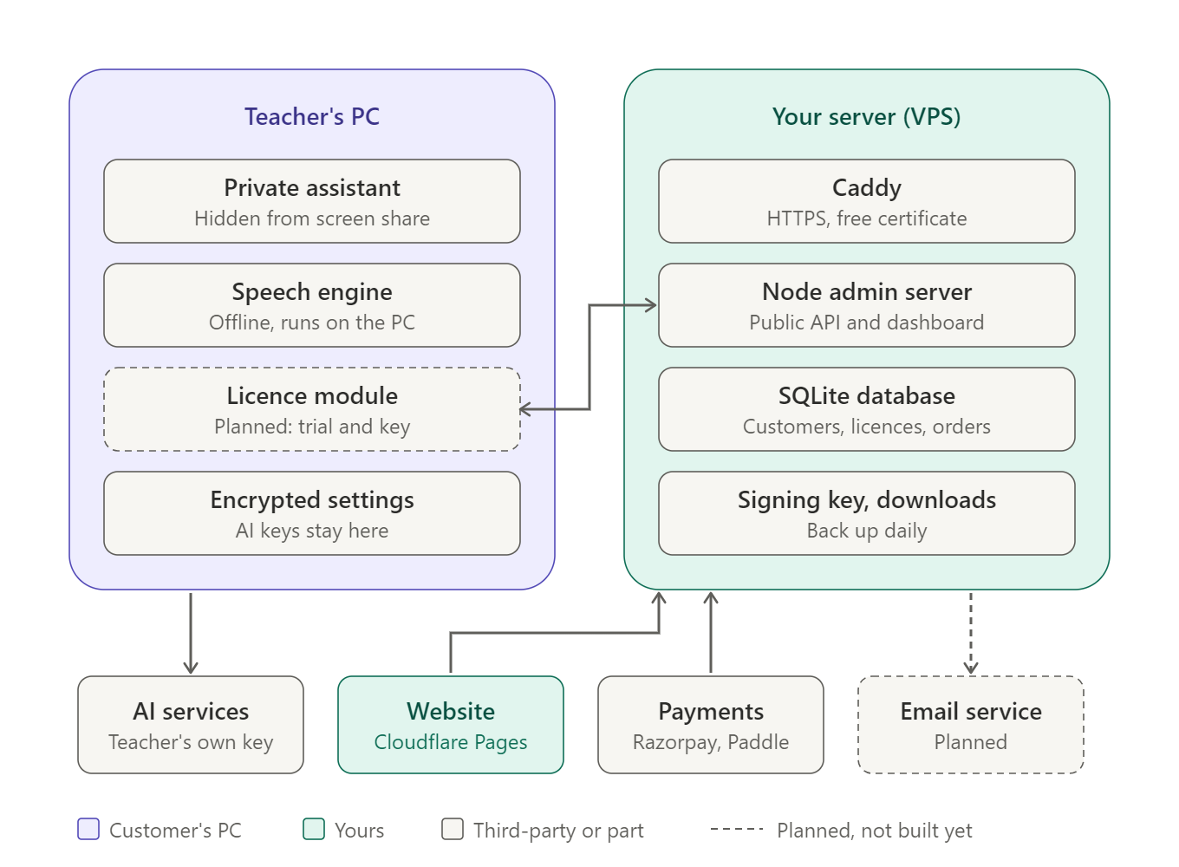
Figure 1. What runs where
Part | Where it runs | What it does
Private assistant | Teacher's PC | Hidden window: question list, answers, capture, Ask box, editable questions
Speech engine | Teacher's PC | whisper.cpp, offline speech-to-text (about 190 MB model)
Licence module (planned) | Teacher's PC | Trial, key entry, signed-answer check, offline grace period
Encrypted settings | Teacher's PC | Settings and AI keys, encrypted with Windows (DPAPI)
Caddy | Your VPS | HTTPS with a free certificate; forwards requests to the Node server
Node admin server | Your VPS | Public API (licences, releases, contact) and private dashboard
SQLite database | Your VPS | Customers, licences, PCs, orders, releases, messages, audit log
Signing key and downloads | Your VPS | Ed25519 private key that signs licence answers; installer files
AI services | Groq, Gemini, Claude | Answers and screen reading, paid by the teacher's own key
Website | Cloudflare Pages | Product pages, pricing, download, contact form
Payments | Razorpay or Paddle | Checkout; card and UPI details never reach your server
Email service (planned) | For example Resend or Amazon SES | Sends licence keys and receipts automatically

3. The server
One small Linux VPS (Ubuntu 24.04, about 1 GB RAM) runs everything. The server code is in the admin/ folder: Node 22 or newer, no extra packages, with the database in one SQLite file. It needs a VPS with a persistent disk; serverless hosts such as Vercel are not suitable.

3.1 Database tables (admin/data/admin.db)
Table | What it holds
customers | Name, email, organisation, country, notes, date joined
licences | Key, customer, plan, trial or paid, active or revoked, expiry date, PC limit (default 2), linked order
devices | PCs using each licence: PC id, PC name, app version, first and last seen
orders | Customer, plan, amount, currency, paid / refunded / failed, payment provider and reference
releases | Version, release notes, download link, oldest supported version
messages | Website contact form: name, email, topic, text, open or closed, notes
admins | You and your team: email, name, role (owner, admin, support), hashed password
sessions | Dashboard sign-ins, stored hashed, expire after 12 hours
audit | Who did what and when in the dashboard

3.2 Public API
Called by | Endpoint | Purpose
Desktop app | POST /api/licence/activate | First use of a key on a PC (counts toward the PC limit)
Desktop app | POST /api/licence/validate | Re-check at every start; never adds a PC
Desktop app | POST /api/licence/deactivate | Free a PC (for example, a new laptop)
Desktop app | POST /api/licence/trial (to add) | Start a free trial; one trial per PC
Desktop app | GET /api/releases/latest | Is there a newer version?
Desktop app | GET /api/public-key | Public key that verifies signed answers
Website | POST /api/contact | Contact form, saved to the Support inbox
Licence calls are limited to 60 a minute per address and the contact form to 5 an hour. A successful licence answer contains the plan, kind, expiry, a JSON payload and an Ed25519 signature of that payload.

3.3 Admin dashboard (private)
- Overview: revenue, customers, active and expiring licences, trial-to-paid rate
- Customers, licences (issue, extend, cancel, change PC limit, remove a PC), orders and refunds
- Releases, Support inbox, audit log, team roles (owner, admin, support)
- Security: scrypt password hashing, lock-out after 5 wrong attempts, HttpOnly SameSite cookies, strict content-security policy

3.4 What the server does not store
- Card or UPI details (the payment provider holds them; you store only the order reference)
- Teachers' AI keys (encrypted on the teacher's own PC)
- Class audio, screenshots, questions or answers (they go from the PC to the teacher's chosen AI service)

4. Customer journey: purchase and activation
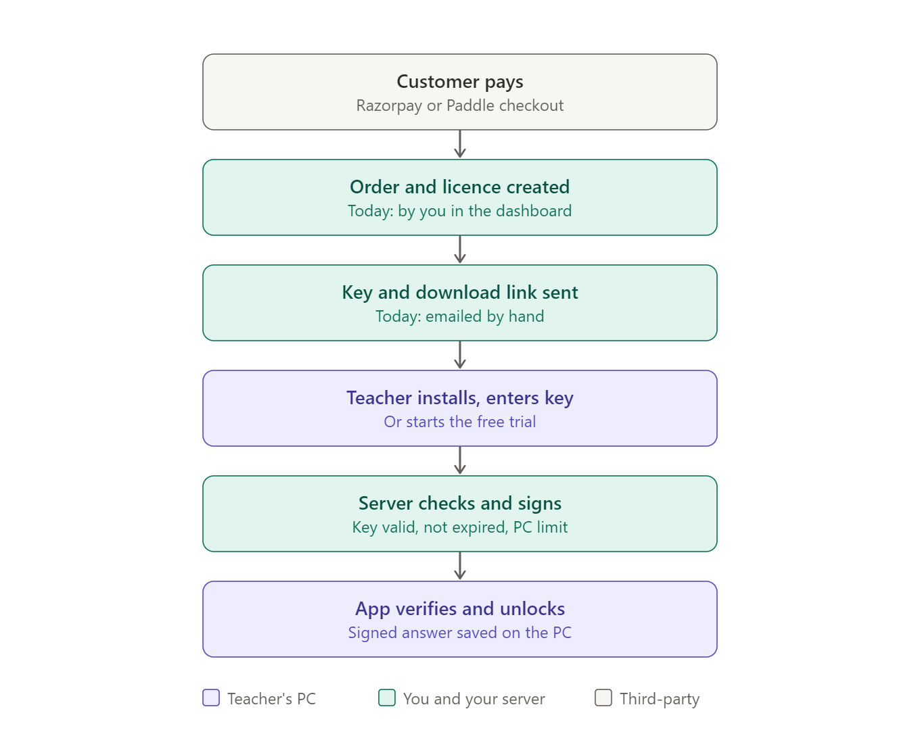
Figure 2. From payment to an unlocked app
- The customer pays through Razorpay (quick for India) or Paddle (handles sales tax worldwide).
- An order and a licence are created. Today you do this in the dashboard; later a payment webhook does it automatically.
- The key and download link are emailed. Today by hand; later automatically.
- The teacher installs the app and enters the key, or starts the free trial.
- The server checks the key (exists, not cancelled, not expired, PC limit) and signs its answer.
- The app verifies the signature with its built-in public key and unlocks.

5. How the licence check works

5.1 Signed answers
The server signs every licence answer with the private key (signing-key.pem), which never leaves the server. The app contains only the matching public key: it can check signatures but cannot create them. A faked "OK" answer fails the check, so the app stays locked. The app also checks that the answer is for its own PC id and that the expiry date has not passed.

5.2 Behaviour in the app
Situation | What happens
First start | Welcome screen: "Start free trial" or "I have a licence key"
Every start | Quick re-check with the server (validate)
Server or internet down | Works from the last signed answer for a grace period (for example 7 days)
Trial or plan ended | Assistant locked; Buy and Enter key buttons; settings and notes kept
Renewal | You extend the licence in the dashboard; the app unlocks at its next check
Refund | You cancel the licence; the app locks at its next check
New laptop | "Deactivate this PC" on the old one, or remove it in the dashboard

5.3 Security limits
The design stops key sharing (PC limit), fake answers (signatures), use after a refund (re-check) and repeat trials (recorded per PC on the server). It cannot fully stop a skilled person from modifying the app's code; no desktop app can. The aim is to make paying the easy choice.

6. During a live class
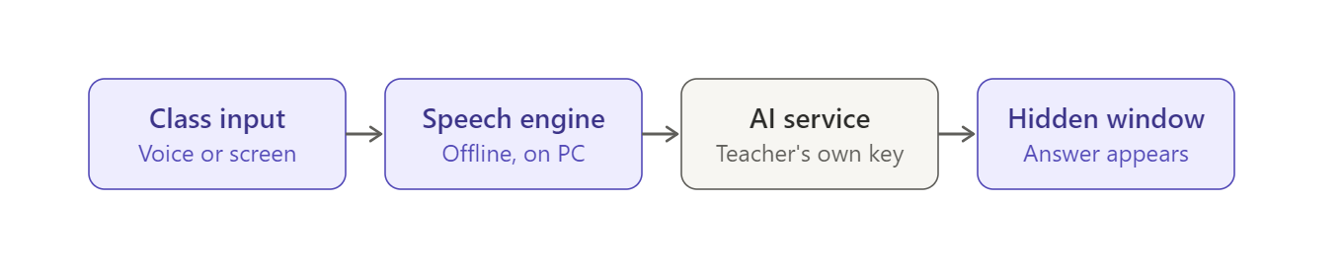
Figure 3. Live class flow; your server is not involved
- Inputs: meeting audio and microphone, screen capture of a shared question (Ctrl+Shift+Q), the Ask box, selected answer text, and edited questions
- The speech engine runs offline on the PC; only text and captured pictures go to the AI service
- Answers appear in the hidden window in a teacher's speaking style, with code kept in its own block
- Separate AI choices: one service for answers (for example Groq, fastest) and one for reading pictures (for example Gemini)

7. Hosting and deployment

7.1 Where each part is hosted
Part | Host | Address (example) | Cost
Admin server and API | VPS: Hetzner, DigitalOcean or AWS Lightsail | api.yourdomain.com, admin.yourdomain.com | A few dollars a month
Installer download | Same VPS (Caddy file server) | download.yourdomain.com | Included
Website | Cloudflare Pages, connected to GitHub | yourdomain.com | Free
Domain | Any registrar | yourdomain.com | Yearly fee
Payments | Razorpay or Paddle | Their checkout pages | A fee per sale

7.2 Go-live today
# | Step | Who | Time
1 | Licence check and free trial in the app | Developer (Claude) | 2 to 3 hours
2 | Windows installer (.exe) including the speech engine | Developer (Claude) | About 1 hour
3 | Server deployment files: service, HTTPS config, backup script, commands | Developer (Claude) | 30 minutes
4 | Buy the domain | Owner | 15 minutes
5 | Rent the VPS (Ubuntu 24.04) | Owner | 15 minutes
6 | Point DNS (api., admin., download.) and run the deployment commands | Owner, with step-by-step guide | 1 hour
7 | Publish the website on Cloudflare Pages | Owner, with guide | 30 minutes
8 | First sales by hand: payment link, issue key, email it | Owner | Per sale

7.3 Not possible today
- Code-signing certificate: needs identity or company checks (days to weeks). Until then Windows shows an "unknown publisher" warning.
- Paddle or Lemon Squeezy approval: they review the product first; positioning and acceptable-use terms must be clear. Razorpay is quicker in India.
- Automatic order, key and email: built once the payment provider account is approved.
- Legal review: Terms of Service, Privacy Policy and acceptable-use clause are drafts and need a lawyer.

8. Build status
Area | Built | To build
Desktop app | Hidden assistant, speech engine, screen capture, Ask box, Ask selected, editable questions, export | Licence module, installer, auto-update
Server | Database, licence and release API, dashboard, contact API, roles, audit log | Trial API, download hosting, backup script, deployment files
Payments | Orders recorded by hand | Webhook that creates orders and licences
Email | None | Automatic licence and receipt emails
Website | Pages and design | Live Class product pages, real prices, contact form wired to the API
Legal | Draft Terms and Privacy | Lawyer review, acceptable-use clause

9. Security and backup checklist
- Run the server only behind HTTPS (Caddy) and set SECURE_COOKIES=1
- Restrict the admin dashboard by IP or VPN; only /api/ needs to be public
- Back up admin/data/ (database and signing-key.pem) every day to a second location
- Never share or commit signing-key.pem; losing it locks out every installed app
- Add two-factor sign-in before giving staff dashboard access
- Keep the app positioned for teaching, with an acceptable-use clause forbidding exams, interviews and proctored tests

10. Open decisions
Decision | Options | Needed for
Product name | ClassCue or another (check trademark and domain) | Installer, app window, website
Trial length | 7 days suggested | Licence module
Domain | Existing or new | Server and website addresses
Payment provider | Razorpay (India, fast) or Paddle (global, tax handled) | Checkout and webhook
PC limit per licence | 2 suggested | Licence settings

