CANDIDATE’S DECLARATION

I hereby declare that the work which is being presented in this project titled “EDUSPHERE” in fulfillment of the requirement for the degree of Bachelor of Engineering and Technology in Computer science and Engineering department of “NGF College Of Engineering And Technology, Palwal” affiliated to “J.C. Bose of university of Engineering and Technology , YMCA , Faridabad” is an authentic record of my own work carried out under the supervision of Mr. Manoj Kumar ,Assistant Professor ,NGFCET and Mr. Dharmesh Kumar Singh, Director General Head, Organization.

Manish
S22CSE052
CSE Department
ACKNOWLEDGEMENT

I take immense pleasure in thanking our honorable Vice-Chairman, Mr. Ashwani Prabhakar for having permitting us to carry out this work .We are also very thankful for his constant motivation and guidance.
I am highly indebted to Mr. Sharat Kaushik, Director principal for his guidance and motivation and we also thank him for all the resources provided to us as well as for providing necessary information regarding the work and all the valuable support for completing the work .
It is with deep sense of gratitude and reverence, that I express my sincere thanks to my Dean of academics and HOD Dr. Kuldeep Tomar for his guidance, encouragement , help and useful suggestions throughout. His untiring and painstaking efforts, methodical approach, and individual help made it possible for me to complete this work in time. His affection, guidance, and scientific approach served as a veritable incentive for the completion of this work.
I express my sincere gratitude to Ms. Bhawna, Assistant Professor for her emphasis on systematic approach, details, and rigor in the process of work. I also wish to thank her for providing her valuable time, guidance, and support throughout my work.
I would also like to thank all faculty members of the Computer Science and Engineering department with whom I had fruitful interactions. Although it is not possible to name individually, I cannot forget my well-wishers at J. C. Bose University of Science and Technology, YMCA, Faridabad, and outsiders for their persistent support and cooperation.
This acknowledgment will remain incomplete if I fail to express my deep sense of obligation to my parents and God for their consistent blessings and encouragement.

(Manish)
Signature

COMPANY PROFILE

NHPC LIMITED, formerly known as National Hydroelectric Power Corporation, is a Mini Ratna Category-I Enterprise of the Government of India. Incorporated on 7 November 1975, NHPC was established with the objective of planning, promoting, and organizing an integrated and efficient development of hydroelectric power in all aspects.
Its current authorized share capital is ₹15,000 crore and paid-up capital is ₹9,914.08 crore. NHPC Limited is a listed company and its shares are traded on BSE and NSE. The company has also diversified into other sources of energy such as Solar and Wind.
NHPC currently operates 25 power stations with a total installed capacity of 7071.2 MW. The company’s head office is located at Faridabad, Haryana, and it operates under the administrative control of the Ministry of Power, Government of India.
The company’s Corporate Identification Number (CIN) is L40101HR1975GOI032564.
The registered office of NHPC Limited is at NHPC Office Complex, Sector-33, Faridabad – 121003, Haryana.
Company detail
CIN | L40101HR1975GOI032564
Company Name | NHPC LIMITED
Company Status | Active
Company Category | Company limited by Shares
Company Sub Category | Union Govt Company
Class of Company | Public
Date of Incorporation | 07 November 1975

Manish
Roll No: 22035004052

1.4 Table of Contents
- CHAPTER 1: PRELIMINARIES
  - 1.1 Training Completion Certificate
  - 1.2 Candidate Declaration
  - 1.3 Acknowledgment
  - 1.4 Table of Contents
- CHAPTER 2: COMPANY PROFILE
  - 2.1 Industry Overview
  - 2.2 Organization Profile
  - 2.3 Services & Business Verticals
- CHAPTER 3: INTRODUCTION TO PROJECT
  - 3.1 Project Abstract
  - 3.2 Problem Definition
  - 3.3 Project Objectives
  - 3.4 Scope of the System
  - 3.5 Technologies & Frameworks Utilized
- CHAPTER 4: REQUIREMENT ANALYSIS (SRS)
  - 4.1 Functional Requirements
  - 4.2 Non-Functional Requirements
  - 4.3 Software Requirements
  - 4.4 Hardware Requirements
  - 4.5 Use Case Diagrams & Descriptions
- CHAPTER 5: SYSTEM DESIGN & ARCHITECTURE
  - 5.1 High-Level Architecture
  - 5.2 Data Flow Diagrams (DFDs)
  - 5.3 Entity Relationship (ER) Diagram
  - 5.4 Class Diagram
- CHAPTER 6: IMPLEMENTED MODULES
  - 6.1 Authentication & Role-Based Authorization
  - 6.2 Course Catalog & Syllabus Builder
  - 6.3 Student Enrollment & Progress Tracking
  - 6.4 Shopping Cart & Payments (Razorpay & Simulation)
  - 6.5 Analytics & Dashboard Aggregations
- CHAPTER 7: DATABASE DESIGN & DATA DICTIONARY
  - 7.1 Schema Definitions
  - 7.2 Table Schemas & Data Dictionaries
- CHAPTER 8: TESTING STRATEGY
  - 8.1 Testing Methodologies
  - 8.2 Test Plans & Test Cases
- CHAPTER 9: USER INTERFACE SNAPSHOTS
  - 9.1 Public Views
  - 9.2 Student View
  - 9.3 Instructor View
  - 9.4 Admin View
- CHAPTER 10: CONCLUSION & FUTURE SCOPE
  - 10.1 Project Conclusion
  - 10.2 Future Scope
- REFERENCES
- BRIEF PROFILE OF STUDENT

CHAPTER 2

COMPANY PROFILE

2.1 Industry Overview
The Educational Technology (EdTech) industry has witnessed an unprecedented transformation over the past decade, shifting from a supplementary learning system to a core infrastructure element for education globally. The emergence of scalable cloud architectures, high-speed internet accessibility, and interactive web application frameworks has made digital learning interactive and accessible.
Modern EdTech applications rely on rich user interactions, high-definition streaming, immediate progress tracking, and instant certification. The integration of robust security protocols (such as JWT tokens) and secure payment gateways (like Razorpay) forms the backbone of these commercial platforms.

2.2 Organization Profile
EduSphere is a pioneering software development organization specializing in the creation of enterprise-level software systems, web services, and educational solutions. The organization serves clients across e-learning, healthcare, and e-commerce segments.
- Founded: 2026
- Mission: To design, build, and deliver high-performance software systems that solve real-world problems.
- Key Focus Areas: Full-Stack Web Development, Cloud Computing, Database Administration, Devops Automation, and Mobile Platforms.

2.3 Services & Business Verticals
The company operates across multiple dedicated business divisions:
- Software Product Engineering: Building full-stack web and mobile apps for international enterprise clients.
- LMS & E-Learning Solutions: Custom Learning Management System design for corporate training academies and institutions.
- Cloud Integration Services: Migrating legacy monolithic code bases to modern, containerized microservice architectures.

CHAPTER 3

INTRODUCTION TO PROJECT

3.1 Project Abstract
EduSphere is an enterprise-grade, full-stack Learning Management System (LMS) designed to facilitate online learning and teaching. Built on a single-package architecture, it integrates a client-side Angular 21 Standalone interface with a server-side Spring Boot 3 REST API compiled using Java 21.
The platform supports three distinct user roles: Students, Instructors, and Administrators. Key features include a dynamic curriculum builder, lesson progress tracking, automated completion certificate generation, a secure shopping cart with integrated Razorpay checkout and a built-in mock payment simulation, administrative course review portals, and dashboards displaying real-time analytics.

3.2 Problem Definition
Traditional educational platforms often struggle with the following challenges:
- Poor Separation of Concerns: Tight coupling between presentation layers and business logic makes scaling and maintaining systems difficult.
- Inefficient State Management: Repeated HTTP requests to fetch user profiles or cart details strain backend services.
- Complex Deployments: Managing separate servers for frontend static resources and REST endpoints increases configuration overhead.
- Static UI/UX: Standard browser page reloads lead to latency and disrupt user engagement.

3.3 Project Objectives
- Build a High-Performance Architecture: Establish an Angular 21 frontend utilizing standalone components, lazy-loaded routing, and Signals for state management.
- Develop a Secure Spring Boot API: Construct a Java 21 REST backend utilizing Spring Security 6 with stateless JWT authentication.
- Enable Interactive Curriculum Tools: Create a custom syllabus builder supporting section folders, video file uploads, and lesson tracking.
- Provide Seamless Checkout Processes: Integrate Razorpay payments with a secondary simulated transaction flow to allow immediate testing without merchant credentials.
- Implement Single-JAR Deployments: Configure Maven wrappers and scripts to package the built Angular assets directly inside Spring Boot’s static directory, producing a single, self-contained executable JAR file.

3.4 Scope of the System
The EduSphere portal covers the complete educational pipeline:
- Browsing: Public access to course search and categories.
- Creation: Curricular authoring, video streaming uploads, and price management for instructors.
- Consumption: Dynamic video playback, interactive progress checkboxes, and certificate verifications.
- Administration: Verification workflows for pending courses, role audits, and categories management.

3.5 Technologies & Frameworks Utilized

3.5.1 Frontend Technologies
- Angular 21: Incorporating Signals (signal, computed) for reactive state management, functional route guards, interceptors, and standalone components.
- Bootstrap 5 (SCSS): Configured with custom dark theme design elements, harmonized HSL variables, and interactive animations.
- TypeScript: Ensuring static typing and type safety across services and component interfaces.

3.5.2 Backend Technologies
- Spring Boot 3.3: Built on Jakarta EE standards.
- Java 21: Leveraging modern language features like text blocks and records.
- Spring Security 6 & JWT: Implementing stateless, token-based authentication and role-based access control.
- Spring Data JPA & Hibernate 6: Managing ORM mapping to the database.

3.5.3 Middleware, Database & Deployment
- MySQL 8: Storing relational entities.
- Redis: Caching session data.
- Docker & Docker Compose: Creating containerized development and staging environments.

CHAPTER 4

REQUIREMENT ANALYSIS (SRS)

4.1 Functional Requirements

4.1.1 Authentication & Authorization Module
- User Registration: Users must be able to sign up as Students or Instructors.
- JWT Login: Validates user credentials and returns a secure JSON Web Token.
- Access Control: Restricts paths using role checks (Student, Instructor, Admin).

4.1.2 Course Management Module
- Curriculum Creation: Instructors can create courses, chapters (sections), and lectures (lessons).
- Media Uploads: Supports uploading image banners and video content.
- Course Approval: Pending courses must be approved by an Admin before they appear in public listings.

4.1.3 Enrollment & Learning Module
- Syllabus Navigation: Students can navigate through course sections and play lesson videos.
- Progress Tracking: Mark lessons as completed to update the overall course progress.
- Certificate Generation: Automatically issues a verified certificate upon reaching 100% progress.

4.1.4 Shopping Cart & Payment Module
- Cart Operations: Manage selected courses in a reactive shopping cart.
- Transaction Processing: Process orders via Razorpay checkout or a local payment simulator.
- Purchase Validation: Grants access to course contents only after payment is verified.

4.2 Non-Functional Requirements
- Performance: Web pages should load in under 2 seconds, and API calls should respond in under 200ms.
- Security: Store passwords securely using BCrypt hashing and encrypt REST communications.
- Scalability: Leverage Redis for fast data access and session caching.
- Reliability: Ensure clean connection recovery if database connections drop.

4.3 Software Requirements
- OS: Windows 10/11, macOS, or Linux.
- JDK: Version 21.
- Node.js: Version 22.x with NPM.
- Database: MySQL 8.0 and Redis.

4.4 Hardware Requirements
- Server Spec: 2.4 GHz Quad-Core CPU, 8 GB RAM, 20 GB free disk space.
- Client Spec: Modern web browser with Javascript support and 4 GB RAM.

4.5 Use Case Diagrams & Descriptions
mermaid
usecaseDiagram
rect "EduSphere Portal"
usecase "Browse & Search Courses" as UC1
usecase "Purchase via Cart" as UC2
usecase "Watch Lessons & Track Progress" as UC3
usecase "Generate Certificate" as UC4
usecase "Create Course & Syllabus" as UC5
usecase "Upload Video Material" as UC6
usecase "Approve Courses" as UC7
usecase "Manage Categories" as UC8
end
Student --> UC1
Student --> UC2
Student --> UC3
Student --> UC4
Instructor --> UC5
Instructor --> UC6
Admin --> UC7
Admin --> UC8
Figure 4.1: Use Case Diagram for Student, Instructor, and Admin Roles

CHAPTER 5

SYSTEM DESIGN & ARCHITECTURE

5.1 High-Level Architecture
EduSphere uses a three-tier architecture: Presentation, Application, and Data.
mermaid
graph TD
Client[Web Browser: Angular 21 UI]
Nginx[Nginx Reverse Proxy]
API[Spring Boot Rest Application]
DB[(MySQL Relational Database)]
Cache[(Redis Cache Store)]
Client -->|HTTPS Request| Nginx
Nginx -->|Route Request| API
API -->|Read/Write| DB
API -->|Cache Queries| Cache
Figure 5.1: High-Level Architecture Block Diagram

5.2 Data Flow Diagrams (DFDs)

DFD Level 0 (System Context Diagram)
mermaid
graph LR
User[User: Student/Instructor/Admin] -->|Queries / Form Inputs| System[EduSphere System]
System -->|Rendered UI / Data Tables / Reports| User

DFD Level 1 (Functional Decomposition)
mermaid
graph TD
User[User] -->|1. Auth Requests| Auth[Authentication Service]
User -->|2. Course Setup| Curric[Course Management Service]
User -->|3. Payments| Checkout[Cart & Payment Service]
User -->|4. Learn Portal| Progress[Enrollment & Progress Tracker]
Auth -->|User Data| DB[(MySQL Database)]
Curric -->|Course Entities| DB
Checkout -->|Orders / Payments| DB
Progress -->|Progress Records| DB

5.3 Entity Relationship (ER) Diagram
The relational database layout details the system entities and their mappings.
mermaid
erDiagram
USERS ||--o{ ENROLLMENTS : registers
USERS ||--o{ COURSES : instructs
USERS ||--o{ AUDIT_LOGS : triggers
CATEGORIES ||--o{ COURSES : classifies
COURSES ||--|{ SECTIONS : contains
SECTIONS ||--|{ LESSONS : contains
ENROLLMENTS ||--|{ LESSON_PROGRESS : tracks
USERS ||--o{ CERTIFICATES : receives
COURSES ||--o{ CERTIFICATES : generates
USERS ||--o{ ORDERS : places
ORDERS ||--|| PAYMENTS : validates
Figure 5.3: Entity-Relationship Mappings

CHAPTER 6

IMPLEMENTED MODULES

6.1 Authentication & Role-Based Authorization
The authentication module provides a secure gateway to the application.
java
// SecurityConfig.java - Restricting REST endpoints
@Bean
public SecurityFilterChain filterChain(HttpSecurity http) throws Exception {
http.cors(cors -> cors.configurationSource(corsConfigurationSource()))
.csrf(AbstractHttpConfigurer::disable)
.sessionManagement(session -> session.sessionCreationPolicy(SessionCreationPolicy.STATELESS))
.authorizeHttpRequests(auth -> auth
.requestMatchers("/api/auth/**").permitAll()
.requestMatchers(HttpMethod.GET, "/api/courses/**").permitAll()
.requestMatchers(HttpMethod.GET, "/api/categories/**").permitAll()
.requestMatchers("/api/test/**").permitAll()
.requestMatchers("/api/**").authenticated()
.anyRequest().permitAll()
);
http.addFilterBefore(jwtAuthenticationFilter(), UsernamePasswordAuthenticationFilter.class);
return http.build();
}
On the frontend, Angular Signals track the active session state, and JwtInterceptor automatically attaches the token to outgoing requests:
typescript
// jwt.interceptor.ts
export const jwtInterceptor: HttpInterceptorFn = (req, next) => {
const authService = inject(AuthService);
const token = authService.token();
if (token) {
req = req.clone({
setHeaders: { Authorization: `Bearer ${token}` }
});
}
return next(req);
};

6.2 Course Catalog & Syllabus Builder
Instructors can build custom course curricula through a nested form builder. The system uses three hierarchical entities: Course -> Section -> Lesson.
java
// CourseService.java - Nested Builder Mappers
public CourseDTO mapToCourseDTO(Course course) {
CourseDTO dto = new CourseDTO();
dto.setId(course.getId());
dto.setTitle(course.getTitle());
dto.setPrice(course.getPrice());
dto.setInstructorName(course.getInstructor().getFirstName() + " " + course.getInstructor().getLastName());
if (course.getSections() != null) {
dto.setSections(course.getSections().stream()
.map(this::mapToSectionDTO)
.collect(Collectors.toList()));
}
return dto;
}

6.3 Student Enrollment & Progress Tracking
When a student purchases a course, the system creates an Enrollment record and instantiates a LessonProgress entry for every lesson in that course.
java
// EnrollmentService.java - Progress Ticker Logic
@Transactional
public Enrollment updateLessonProgress(Long enrollmentId, Long lessonId, boolean completed) {
Enrollment enrollment = enrollmentRepository.findById(enrollmentId)
.orElseThrow(() -> new ResourceNotFoundException("Enrollment", "id", enrollmentId));
LessonProgress progress = enrollment.getLessonProgressList().stream()
.filter(p -> p.getLesson().getId().equals(lessonId))
.findFirst()
.orElseThrow(() -> new ResourceNotFoundException("LessonProgress", "lesson", lessonId));
progress.setCompleted(completed);
progressRepository.save(progress);
// Calculate overall course progress percentage
long completedCount = enrollment.getLessonProgressList().stream().filter(LessonProgress::isCompleted).count();
double percent = ((double) completedCount / enrollment.getLessonProgressList().size()) * 100;
enrollment.setProgress((int) Math.round(percent));
if (enrollment.getProgress() >= 100 && !enrollment.isCompleted()) {
enrollment.setCompleted(true);
enrollment.setCompletedAt(LocalDateTime.now());
generateCertificate(enrollment);
}
return enrollmentRepository.save(enrollment);
}

6.4 Shopping Cart & Payments (Razorpay & Simulation)
To streamline testing, the checkout flow supports both the live Razorpay API and a Mock Payment Simulator when credentials are omitted.
mermaid
sequenceDiagram
participant User as Student Browser
participant Cart as Angular Cart Component
participant Gateway as Razorpay / Mock Gateway
participant Backend as Spring Boot REST API
participant DB as MySQL Database
User->>Cart: Click Checkout
Cart->>Backend: POST /api/payments/checkout (Init Order)
Backend-->>Cart: Return Order ID (mock_order_...)
Cart->>Gateway: Launch Checkout Modal
User->>Gateway: Input Credentials & Click Success
Gateway-->>Cart: Return payment_id & signature
Cart->>Backend: POST /api/payments/verify (Validate Signature)
Backend->>DB: Save Enrollment & Update Order Status
Backend-->>Cart: Payment Successful
Cart-->>User: Redirect to Course watch panel

6.5 Analytics & Dashboard Aggregations
Dashboards display real-time analytics for students, instructors, and admins.
java
// DashboardService.java - Real-Time Dashboard Queries
public DashboardStatsDTO getAdminStats() {
long studentCount = userRepository.countByRoleName(ERole.ROLE_STUDENT);
long instructorCount = userRepository.countByRoleName(ERole.ROLE_INSTRUCTOR);
long totalCourses = courseRepository.count();
Double totalRevenue = paymentRepository.sumSuccessfulPayments();
DashboardStatsDTO stats = new DashboardStatsDTO();
stats.setStudentCount(studentCount);
stats.setInstructorCount(instructorCount);
stats.setTotalCourses(totalCourses);
stats.setTotalRevenue(totalRevenue != null ? totalRevenue : 0.0);
return stats;
}

CHAPTER 7

DATABASE DESIGN & DATA DICTIONARY

7.1 Schema Definitions
The application uses relational tables with auto-incrementing primary keys and indexes on foreign key columns.
sql
-- DDL Definitions
CREATE TABLE roles (
id INT AUTO_INCREMENT PRIMARY KEY,
name VARCHAR(20) UNIQUE NOT NULL
);
CREATE TABLE users (
id BIGINT AUTO_INCREMENT PRIMARY KEY,
email VARCHAR(50) UNIQUE NOT NULL,
password VARCHAR(120) NOT NULL,
first_name VARCHAR(50) NOT NULL,
last_name VARCHAR(50) NOT NULL,
profile_image_url VARCHAR(255),
created_at TIMESTAMP DEFAULT CURRENT_TIMESTAMP,
updated_at TIMESTAMP DEFAULT CURRENT_TIMESTAMP ON UPDATE CURRENT_TIMESTAMP
);

7.2 Table Schemas & Data Dictionaries

7.2.1 Table: users
This table stores user profile details and credentials.
Field Name | Data Type | Size / Length | Keys | Nullable | Default Value | Description
id | BIGINT | 20 | PK | NO | AUTO_INC | Unique user identifier
email | VARCHAR | 50 | UK | NO | NULL | User email address
password | VARCHAR | 120 | -- | NO | NULL | BCrypt encrypted password
first_name | VARCHAR | 50 | -- | NO | NULL | User's first name
last_name | VARCHAR | 50 | -- | NO | NULL | User's last name
profile_image_url | VARCHAR | 255 | -- | YES | NULL | Profile picture location
created_at | TIMESTAMP | -- | -- | NO | CURRENT_TIME | Account creation timestamp
updated_at | TIMESTAMP | -- | -- | NO | CURRENT_TIME | Last profile update

7.2.2 Table: courses
This table stores details for created courses.
Field Name | Data Type | Size / Length | Keys | Nullable | Default Value | Description
id | BIGINT | 20 | PK | NO | AUTO_INC | Unique course identifier
title | VARCHAR | 100 | -- | NO | NULL | Course title
subtitle | VARCHAR | 255 | -- | NO | NULL | Subtitle / short summary
description | LONGTEXT | -- | -- | YES | NULL | Full description
price | INT | -- | -- | NO | 0 | Enrollment price in INR
image_url | VARCHAR | 255 | -- | YES | NULL | Banner image path
promo_video_url | VARCHAR | 255 | -- | YES | NULL | Trailer video path
published | BOOLEAN | -- | -- | NO | FALSE | Visibility status
approved | BOOLEAN | -- | -- | NO | FALSE | Admin approval status
instructor_id | BIGINT | 20 | FK | NO | NULL | Instructor user identifier
category_id | BIGINT | 20 | FK | NO | NULL | Category identifier

7.2.3 Table: lessons
This table stores details for video lectures and curriculum items.
Field Name | Data Type | Size / Length | Keys | Nullable | Default Value | Description
id | BIGINT | 20 | PK | NO | AUTO_INC | Unique lesson identifier
title | VARCHAR | 100 | -- | NO | NULL | Lesson title
content | LONGTEXT | -- | -- | YES | NULL | Notes / markdown content
video_url | VARCHAR | 255 | -- | YES | NULL | Video file path
video_duration | INT | -- | -- | NO | 0 | Video length in seconds
free_preview | BOOLEAN | -- | -- | NO | FALSE | Preview availability
sort_order | INT | -- | -- | NO | 1 | Display order in syllabus
section_id | BIGINT | 20 | FK | NO | NULL | Parent section identifier

7.2.4 Table: enrollments
This table tracks user course enrollments.
Field Name | Data Type | Size / Length | Keys | Nullable | Default Value | Description
id | BIGINT | 20 | PK | NO | AUTO_INC | Unique enrollment ID
progress | INT | -- | -- | NO | 0 | Course progress percentage
completed | BOOLEAN | -- | -- | NO | FALSE | Completion status
completed_at | TIMESTAMP | -- | -- | YES | NULL | Completion timestamp
enrolled_at | TIMESTAMP | -- | -- | NO | CURRENT_TIME | Enrollment timestamp
student_id | BIGINT | 20 | FK | NO | NULL | Student user identifier
course_id | BIGINT | 20 | FK | NO | NULL | Enrolled course identifier

CHAPTER 8

TESTING STRATEGY

8.1 Testing Methodologies

8.1.1 Unit Testing
Unit tests verify the behavior of individual methods in services and repositories. Mockito was used to mock database dependencies, ensuring clean isolation during testing.

8.1.2 Integration Testing
Integration tests verify data flow across multiple layers (Controllers, Services, Repositories). Test containers spin up local MySQL and Redis instances to run APIs under real network conditions.

8.1.3 Security & Role Audits
Role audits verify that restricted API endpoints block unauthorized requests, returning 401 Unauthorized or 403 Forbidden statuses.

8.2 Test Plans & Test Cases
Case ID | Feature Evaluated | Input Values | Expected Output | Actual Result | Status
TC-001 | User Registration | Student role, valid inputs | Profile saved, returns DTO | As Expected | PASS
TC-002 | Duplicate Sign-Up | Existing email address | Throws BadRequestException | As Expected | PASS
TC-003 | JWT Authentication | Valid email and password | Returns token and role details | As Expected | PASS
TC-004 | Protected Route Guard | Student accessing Admin URL | Blocked, redirects to home | As Expected | PASS
TC-005 | Syllabus Build | Section name, sorting index | Section saved to database | As Expected | PASS
TC-006 | Progress Ticker | Click lesson checkbox | Progress recalculated | As Expected | PASS
TC-007 | Certificate Issuance | Set last lesson to completed | Certificate saved to database | As Expected | PASS
TC-008 | Order Checkout | List of course identifiers | Order ID created | As Expected | PASS
TC-009 | Signature Verification | Order ID, mock payment keys | Status set to PAID | As Expected | PASS
TC-010 | Course Approval | Click Approve button | Course set to published | As Expected | PASS

CHAPTER 9

USER INTERFACE SNAPSHOTS

9.1 Public Views
- Landing Page: Features a hero banner, a text logo, dynamic statistical counters, and listings of approved courses.
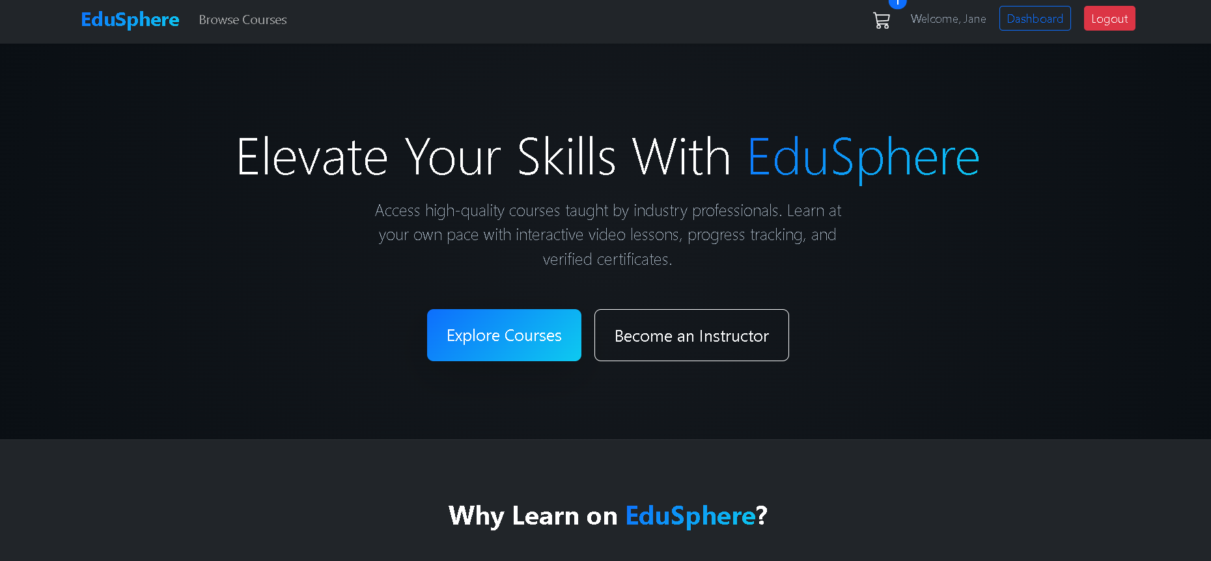
- Sign-In Portal: Displays the credential entry fields, error alerts, and quick-login buttons for quick testing.
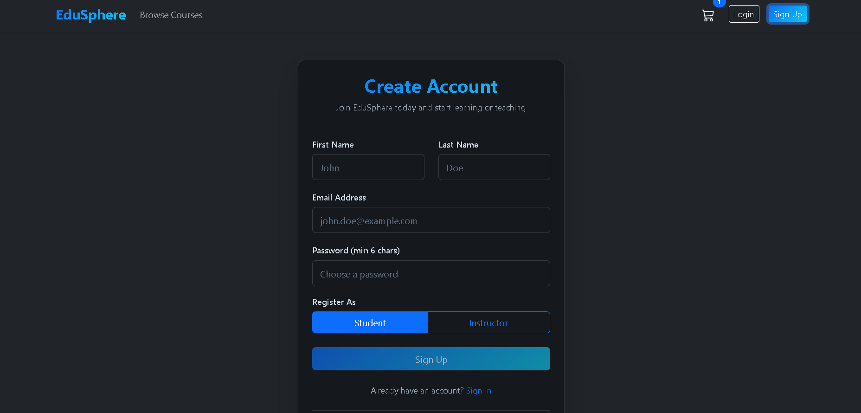

9.2 Student View
- My Courses Page: Displays purchased courses with progress bars.
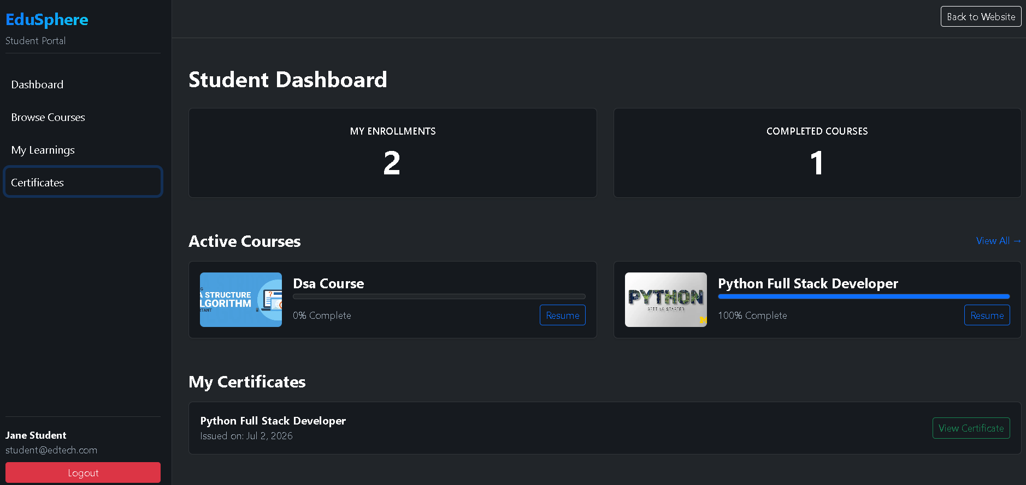
- Watch Portal: Features a video player side-by-side with a checklist of lessons and chapters.

- Certificate Page: Displays a verified completion certificate with a printable border and a unique UUID.

9.3 Instructor View
- Create Course Wizard: Input fields for title, category, description, price, and media uploads.
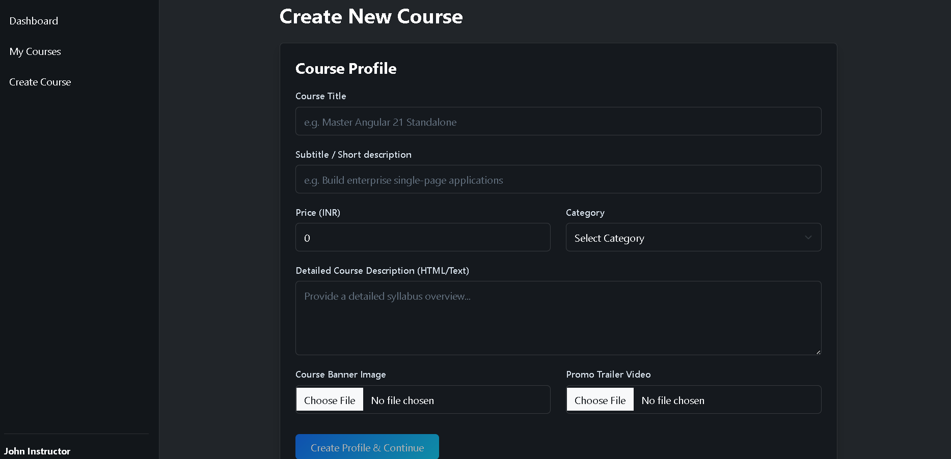
- Curriculum Builder: Section headers with nested forms for adding lesson details and video files.
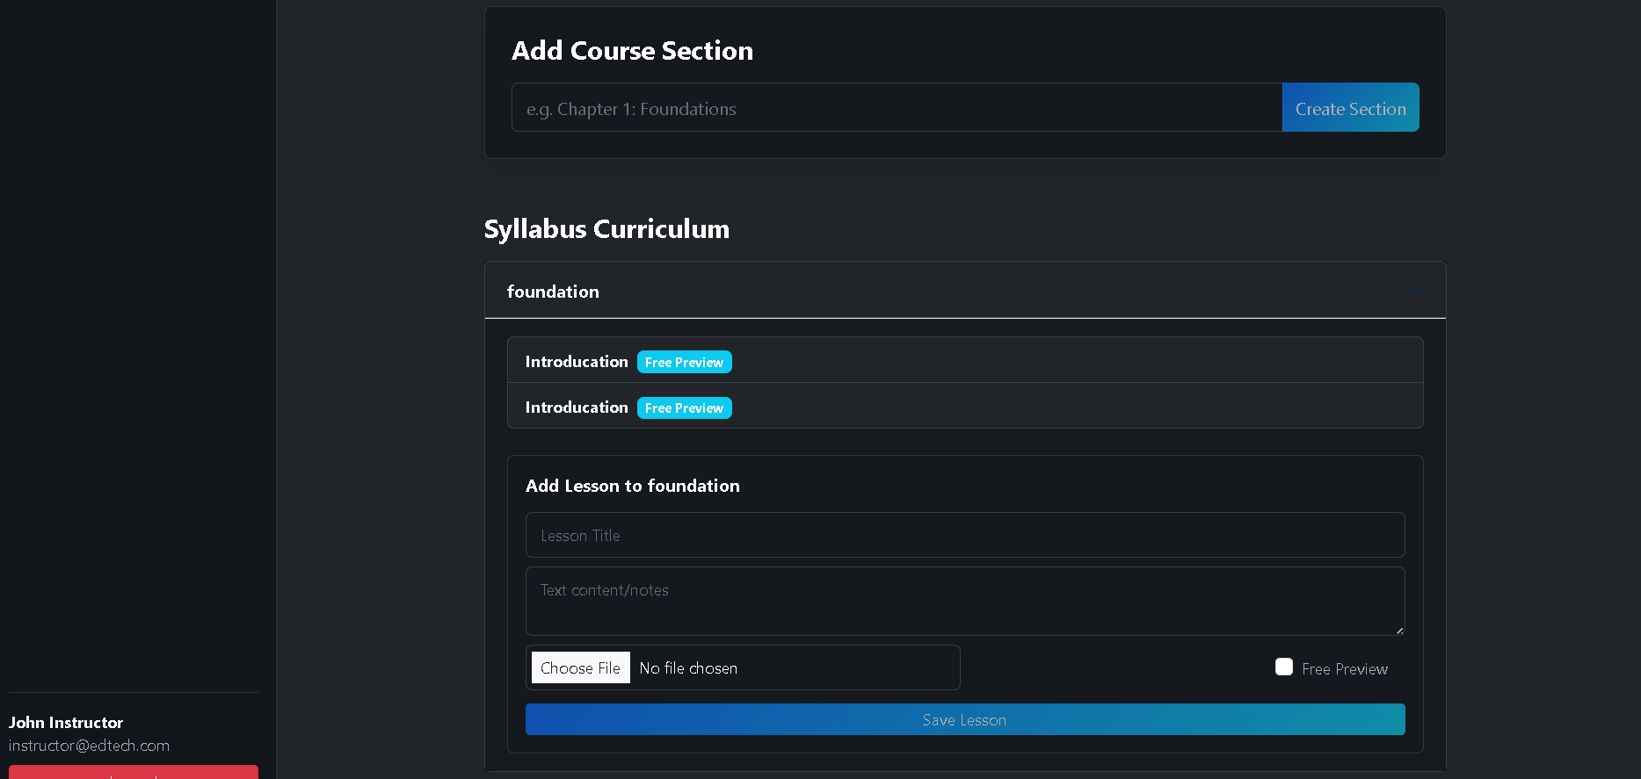

9.4 Admin View
- Approval List: Display pending courses with details and approval actions.
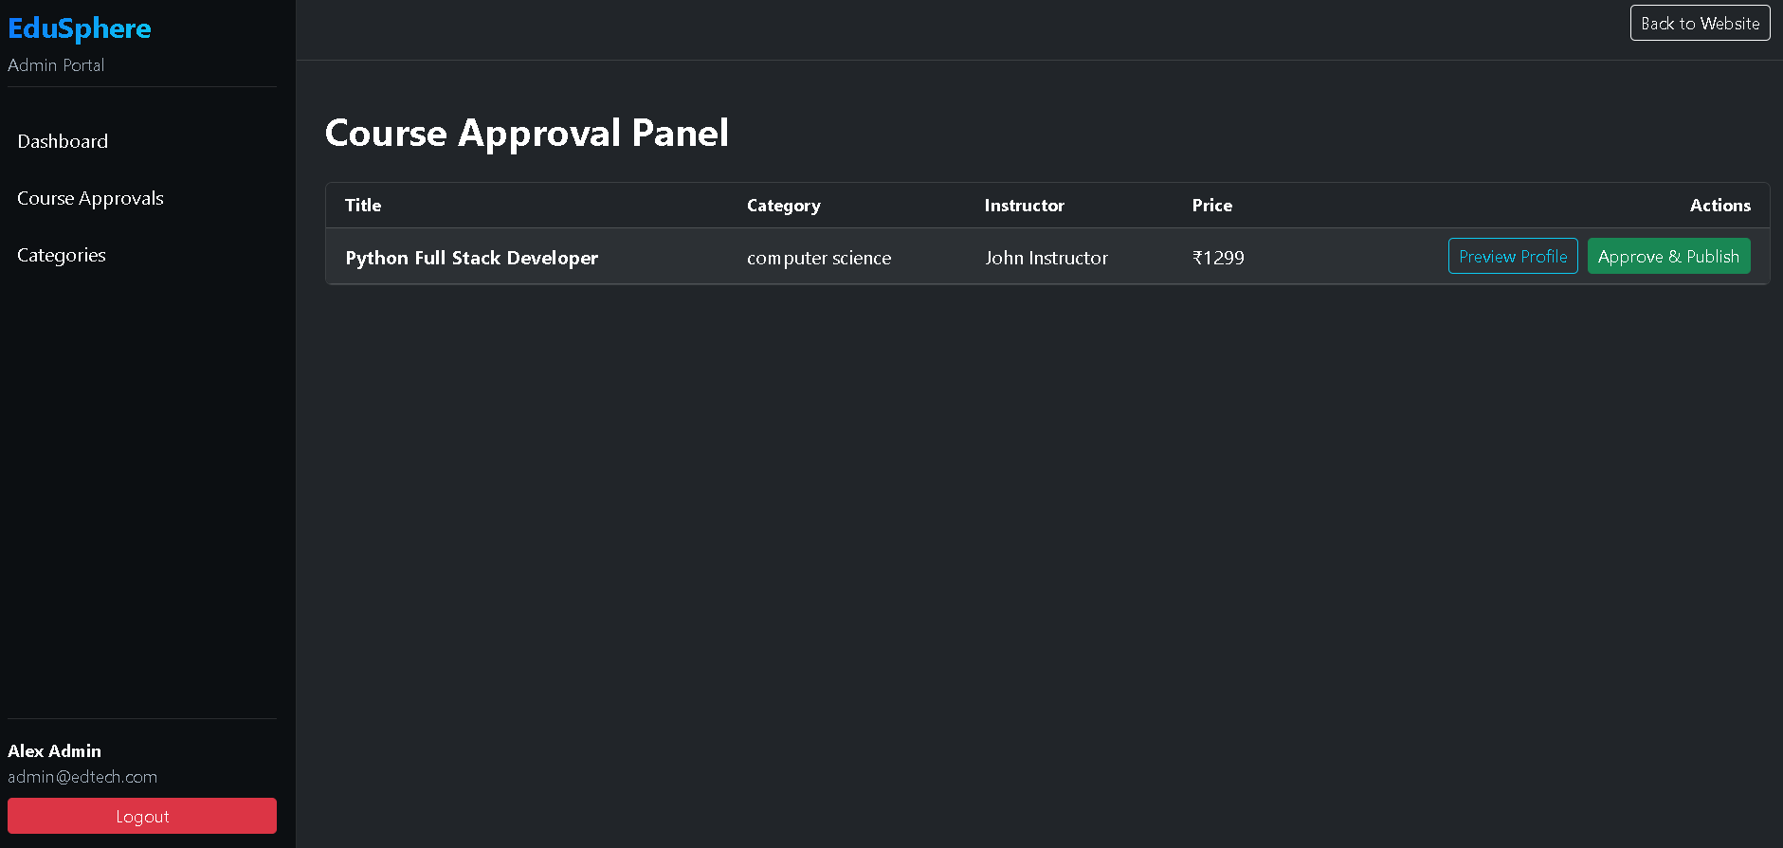
- Category Management: Forms for adding course categories.

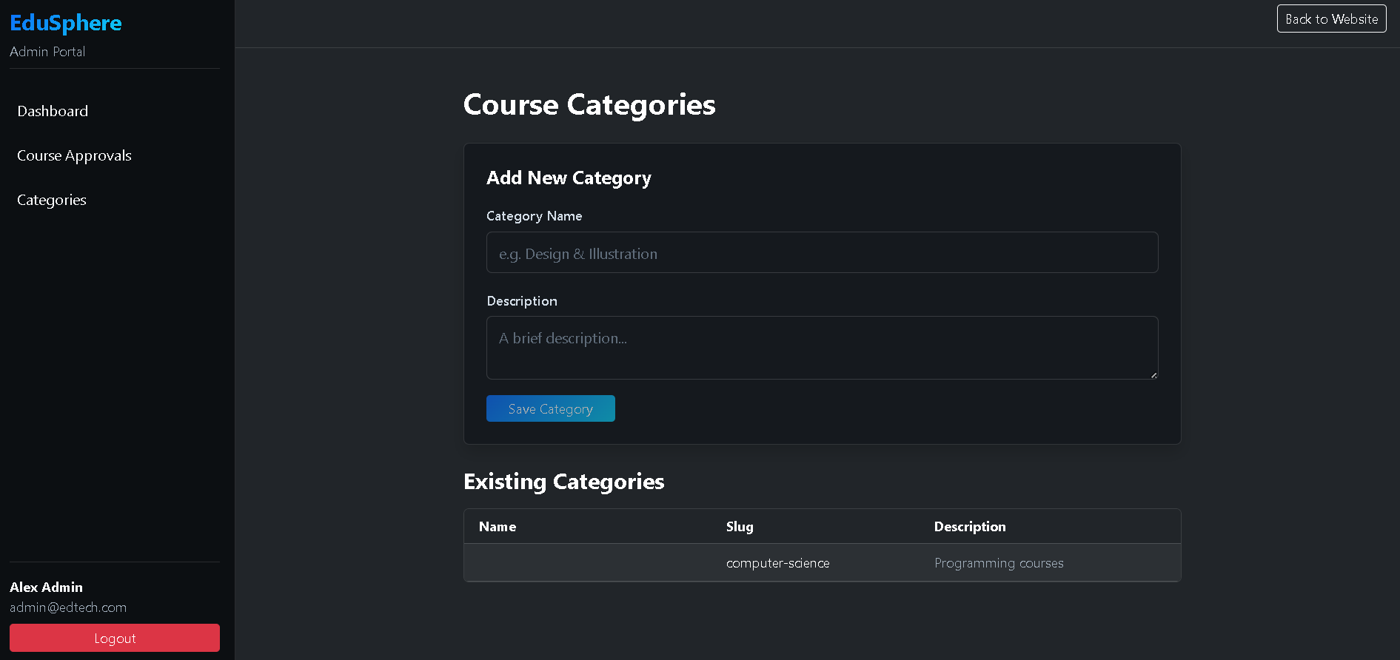

CHAPTER 10

CONCLUSION & FUTURE SCOPE

10.1 Project Conclusion
The development of the EduSphere EdTech Platform successfully demonstrates the integration of an Angular 21 frontend with a Spring Boot 3 REST backend. Leveraging Angular Signals provides clean, reactive state management, reducing unnecessary API requests.
The custom SpaRedirectFilter elegantly handles SPA deep routing in a single packaged executable JAR. The system provides a complete workflow for students, instructors, and administrators, supported by database seeding and payment simulations.

10.2 Future Scope
- WebRTC Integration: Support real-time video classrooms and interactive screensharing.
- AI Recommendations: Recommend courses using student history and preferences.
- Discussion Forums: Community forums under each lecture unit.

REFERENCES
- Angular Documentation: Standalone Component Guidelines, Signals Reactive Libraries. URL: https://angular.dev
- Spring Boot Reference Guide: Web Framework, Spring Data JPA, Security Stateless Protocols. URL: https://spring.io
- Hibernate 6 User Guide: ORM Annotations, Schema Mappings, HQL Syntax. URL: https://hibernate.org
- Razorpay API documentation: Custom Integration Checkout, Signature Verification. URL: https://razorpay.com/docs

BRIEF PROFILE OF STUDENT
Manish is a student of Bachelor of Technology (Computer Science & Engineering) at NGF College of Engineering & Technology.
He specializes in full-stack engineering, web application development, database design, and cloud deployments. He has experience building enterprise solutions using Java, Spring Boot, MySQL, Redis, TypeScript, and Angular.
- Email: manishdagar1018@gmail.com
- GitHub: https://github.com/[YOUR-USERNAME]
- LinkedIn: https://linkedin.com/in/[YOUR-USERNAME]

