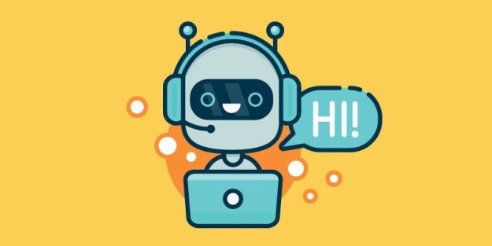

**CHATBOT**

A chatbot is a piece of software that simulates a conversation via auditory or textual methods in applications, on websites, in mobile apps, or through the telephone line. For businesses, chatbots open up a world of scaling customer service and help customers leave feedback, schedule appointments, or order products quicker.

**What exactly is a chatbot?**

A chatbot is an artificial intelligence (AI) software that can simulate a conversation (or a chat) with a user in natural language through messaging applications, websites, mobile apps or through the telephone.  
Why are chatbots important? A chatbot is often described as one of the most advanced and promising expressions of interaction between humans and machines.

There are two different tasks at the core of a chatbot:  
1) User request analysis  
2) Returning the response

**1)User request analysis**: this is the first task that a chatbot performs. It analyzes the user’s request to identify the user intent and to extract relevant entities.

The ability to identify the user’s intent and extract data and relevant entities contained in the user’s request is the first condition and the most relevant step at the core of a chatbot: If you are not able to correctly understand the user’s request, you won’t be able to provide the correct answer.

2) **Returning the response**: once the user’s intent has been identified, the chatbot must provide the most appropriate response for the user’s request.

**Why chatbots are important**

Chatbot applications streamline interactions between people and services, enhancing customer experience. At the same time, they offer companies new opportunities to improve the customers engagement process and operational efficiency by reducing the typical cost of customer service.

To be successful, a chatbot solution should be able to effectively perform both of these tasks. Human support plays a key role here: Regardless of the kind of approach and the platform, human intervention is crucial in configuring, training and optimizing the chatbot system.

**Index.html**

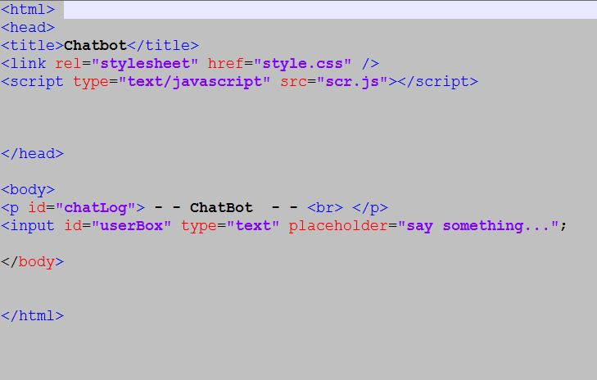

**Style.css**

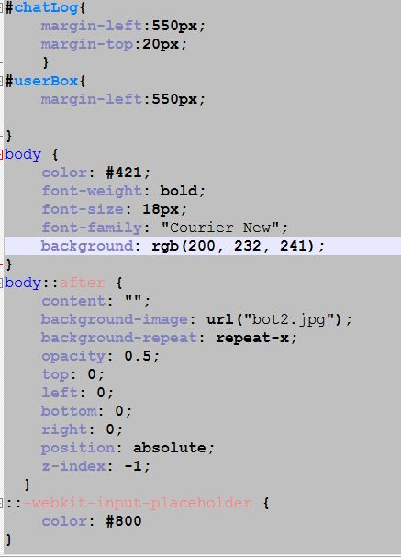

**Scr.js**

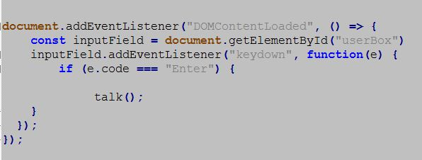

Adding an event listener to the document for the condition of DOMContentLoaded means your JS won't run until the HTML has loaded. This is almost always good practice. Then the EventListener for keypress enter button. Notice we must also select the #input for the form submission, or else our event listener would respond every time we pressed the enter key! These are all just ways of telling the event listener that we only care about the enter key - that's what makes the nice, dynamic effect of instant rendering when we type a message and press enter! No more tedious clicking of a 'submit' button while messaging our bot friend. setting .value = "" ensures our form is cleared after submission.

**Functions**

Now for the functions that actually make this bot.

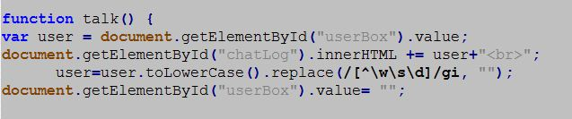

Before anything, I want to take whatever the user types in the input field, and make it a little more standard with some basic RegExp action. As noted in the comments, these methods make everything in the input lowercase, remove any rogue characters that would make matches difficult

**(user text) and (bot text)**

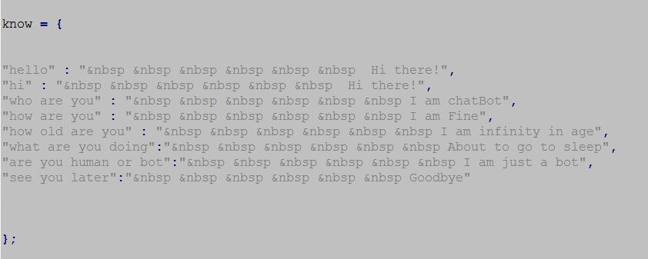

The final step is to update the DOM so our messages actually display

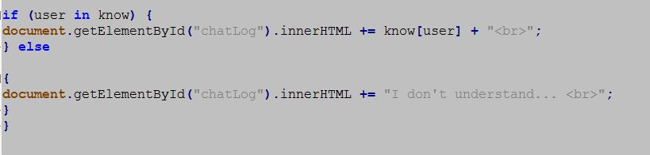

**Output**

