**Wireshark Packet Capture Lab Report**

**Objective**

* To capture live internet traffic and identify some basic network protocols like HTTP, DNS, and TCP.

**Tools Used**

* Wireshark (free packet capturing tool

**Steps Followed**

1. Installed and opened Wireshark on the computer.
2. Started capturing packets on the active network interface.
3. Opened a website and used the ping command to create some traffic.
4. Waited for about a minute, then stopped the capture.
5. Used filters like http, dns, and tcp to view specific packets.

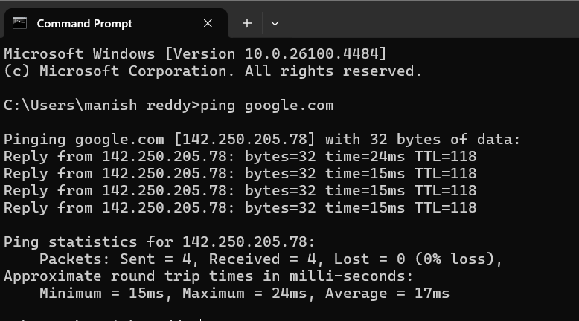

1. Noticed at least 3 different protocols: HTTP, DNS, and TCP.

1. Saved the capture as a .pcap file.
2. Wrote a short summary of what was seen during the capture.

**Outcome**

* Learned how to capture and analyze real network traffic.
* Understood how different protocols work during internet activity.
* Got basic hands-on experience using Wireshark.