**USE CASE STUDY REPORT: EFFECTIVE WAREHOUSE MANAGEMENT**

**Exclusive Summary:**

The primary objective of this study was to design and implement a sophisticated relational database that can be used by the warehouses that supply goods to distribution centers and to stores from there where the end user can buy online or offline. Sorting out all the data that one gets in this industry is humongous for which the old-fashioned invoicing cannot do the job of maintaining all the data under one roof. As this is a big industry that has a lot of scope for expansion, as the industry is this big, profit margins are smaller on single items but on whole it has good margins in profits, because of these low profits on items, the margin of error is very minimal. While looking at this huge industry people are still using old-fashioned invoicing outward and inward data, which is not as efficient as the relational database.

This database can be connected to a Python application platform. Get all the data from the database then work on the analysis part to get the insights from the data also the warehouse management can find out the trend of the consumers at what time of the year. As the preferences of people change concerning the seasons. And maintain the stock according to the trend along with a bit of buffer stock.

The database was modeled taking requirements of data fields that are required for the warehouse to the end user which includes distribution centers, stores, consumers, online orders also about goods. The UML and EER diagrams were designed keeping the business model and structure in mind followed by mapping the conceptual model to a relational model with the required primary and foreign keys. This database was then fully implemented fully MySQL with a well-structured 16 tables and several relationships were implemented between tables after that these tables were read in MongoDB with Studio3T GUI to study all the tables in a NoSQL environment

The created Database is a great hit, and by connecting it to Python, the analytics competencies are enormous, some of which have been shown in this study with the graphical representation of the intuitions. These queries can be very helpful in tracking inward, outward, distribution, percentages of distribution, and a lot more like these.

**Introduction:**

A warehouse is a place where raw materials or manufactured goods may be stored before their export or distribution to centers, from centers, the goods are then distributed to stores where they met the end user either online or offline. Maintaining such huge volumes of data in an old-fashioned way is not practical.

To extract maximum profits from warehouses they should be stocked up with the optimal number of goods, both overstocking and understocking can become a hole to the profits that they are making. Understock can ruin the chances of making profits and overstock can create more chaos if the goods expire, also the investment on overstocking becomes a dead investment and might also become a burden to maintain a lot of goods, especially food related. Keeping the details of food products which has less life span, keeping that in mind all the time and maintaining them requires a lot of ground men on work. Which is an additional burden on the warehouse organizer. To cut out all these extra expenses and make more profits relational database comes into play

The sales of goods like food, clothing, and electronics are very unstable, the inflow and outflow of such huge volumes and finding out the trends through invoicing method is not feasible, the trend of food, clothing, and electronics is very volatile because the preferences of the people change according to seasons which gives a huge advantage to make profits by creating a sophisticated database which can accommodate all the data that is required to find out the trend. To be precise about the trend we got to consider the goods sold in the stores by knowing from where one good is going to where in one system and the magnitude of that good. We can calculate the percentage of the goods that have been supplied to each state and district knowing this information, we can distribute the goods to the distribution center based on this information. Once the database is connected to python, numerous insights can be drawn and changes in the business cycle can be made to get profits.

**II. Conceptual Data Modeling**

***

*2) Unified Modeling Language*

**III. Mapping Conceptual Model to Relational Model**

Primary Key- Underlined Foreign Key- *Italicized*

Warehouse (warehouse_name, warehouse_phonenumber, warehouse_state, warehouse_city, warehouse_pincode)

Primary Key: warehouse_name

Foreign Key: NA

Distribution_center (center_name, center_phonenumber, center_address, *warehouse_name*)

Primary Key: center_name

Foreign Key: warehouse_name [NOT NULL]

Store (store_ID, store_name, store_location)

Primary Key: store_ID *SSN, warehouse_name*, *center_name*, *store_ID*

Foreign Key: NA

Online_order (order_ID, ordered_date, delivery_date, order_qty, *customer_ID*)

Primary Key: order_ID

Foreign Key: customer_ID [NOT NULL]

Customer (customer_ID, customer_name, customer_number, customer_address)

Primary Key: customer_ID

Foreign Key: NA

Goods (product_code, product_name, price, stock, manufactured_date, manufactured_name)

Primary Key: product_code

Foreign Key: NA

Food (*product_code*, weight, expiry_date, category, nutrition_facts, ingredients)

Primary Key: product_code

Foreign Key: product_code [NOT NULL]

Clothing (*product_code*, colour, size, fitting, material_type)

Primary Key: product_code

Foreign Key: product_code [NOT NULL]

Electronics (*product_code*, specifications, model_no, weight)

Primary Key: product_code

Foreign Key: product_code [NOT NULL]

Manager (manager_Id, SSN)

Primary Key: manager_Id

Employee (*SSN*, *manager_id*, emp_name, emp_address, emp_phonenumber)

Primary Key: SSN

Foreign Key: manager_id [NULL IS ALLOWED]

Employee_Email (SSN, emp_email)

Primary Key: SSN, emp_email

Foreign Key: SSN [NOT NULL]

Works_At (*SSN, warehouse_name*, *center_name*, *store_ID*)

Primary Key: SSN, warehouse_name, center_name, store_ID

Foreign Key: SSN, warehouse_name, center_name, store_ID

Supplies_To (*center_name*, *store_ID*)

Primary Key: center_name, store_ID

Foreign Key: center_name, store_ID [NOT NULL]

Sells (*store_ID*, *product_code*)

Primary Key: store_ID, product_code

Foreign Key: store_ID, product_code [NOT NULL]

Payment (payment_ID, payment_method, amount)

Primary Key: payment_ID

Foreign Key: NA

Receives (*order_ID*, *payment_ID*, *store_ID*, amount)

Foreign Key: order_ID, payment_ID, store_ID

**IV. Implementation of Relation Model via MySQL and NoSQL**

**SQL Implementation:** The Database was implemented in MySQL Workbench.

**Creating a schema named ‘Warehouse’ and creating all the tables in Relational Model.**

**The following Queries are executed after creating the database and loading the data.**

use warehouse;

**Query 1: Displaying the required tables**

**Query 2: Find the top 5 goods with highest stock available and show their price**

select product_name, sum(stock) as stock, round(avg(price)

from Goods

group by product_name

order by stock DESC

limit 5;

**Query 3: Total amount of money through credit and debit for online orders**

select payment_method, sum(amount)

from Payment

group by payment_method;

**Query 4: Find the warehouse name if the distribution center which supplies to more than 20 stores.**

select warehouse_name from Distribution_center

where center_name in

(

select center_name from Supplies_To

group by center_name

having count(*) > 20

);

**Query 5: Displaying the products that have max price higher than the products from manufacturer "Mia".**

select product_name from goods

group by product_name

having max(price) >=

all(

select price from goods

where manufacturer_name = "Mia"

);

**Query 6: Find the address of customers who ordered top 5 quantity in online order.**

select c.customer_name,c.customer_address, o.order_qty

from Online_order as o

INNER JOIN Customer as c

on o.customer_ID=c.customer_ID

order by o.order_qty DESC limit 5;

**Query 7: Select product names and codes from goods of a manufacturer named "Mason" with price <= 1000 using "EXISTS".**

select product_code, product_name

from goods as g

where exists (

select * from goods g1

where g.manufacturer_name = "Mason"

and g.price <= "1000"

) ;

**Query 8: Find the distribution center name, address which supplies to the highest revieved payment happened in a store.**

select s.supplies_to_center_name,d.center_address, r.amount

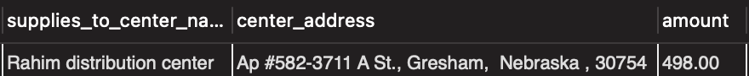from Receives as r

INNER JOIN Supplies_To as s

on r.receives_store_ID=s.supplies_to_store_ID

INNER JOIN Distribution_center as d

on s.supplies_to_center_name=d.center_name

order by r.amount desc limit 1;

**Query 9: Find the stock availability of all the cloths with respect to each type.**

select c.material_type,

SUM(g.stock) as Total_Stock

from Clothing as c

inner join Goods as g

on c.clothing_product_code=g.product_code

group by c.material_type;

**Query 10: Find the stock availability of all the food types with respect to each type.**

select f.category as Food_Category,

SUM(g.price*g.stock) as Total_Cost

from Food as f inner join Goods as g

on f.food_product_code=g.product_code

group by f.category;

**NoSQL Implementation:** MongoDB was used as a query language for NoSQL Database. Studio 3T was used as a GUI.

**Created a Database names “warehouse” and created all the collections in MongoDB**

**The following Queries are executed after creating the database and loading the data.**

use warehouse;

**Query 1: Displaying the required collections**

db.Customer.find();

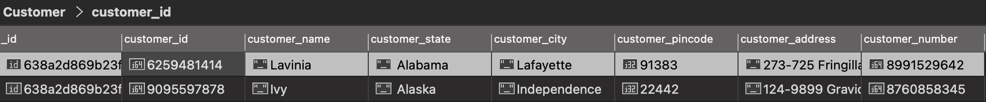

**Query 2: Joining Distribution table and warehouse table on warehouse_name** [Adding 2 screenshots because it’s a wide table].

db.Distribution_center.aggregate([

{

$lookup: {

from: "Warehouse",

localField: "warehouse_name",

foreignField: "warehouse_name",

as: "supplies_from_warehouse_name",

},

}

]) 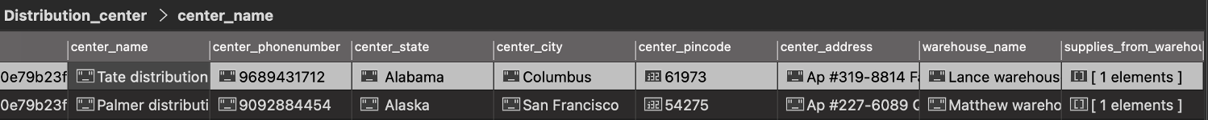

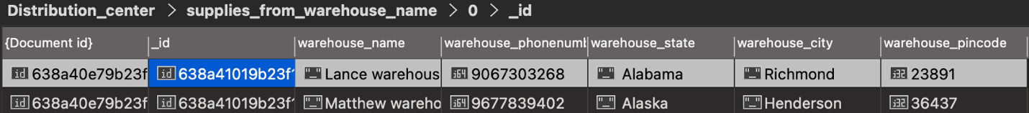

**V. Database Access via R or Python**

The ‘Warehouse’ data in MySQL is connected in Python using ‘mysql-connector’. For better data analysis all the tables are loaded as python dataframes. Few data visualizations are performed in the application. Such as,

**Graph 1: Percentage contribution of every state in total orders placed.**

**Graph 2: Top 10 customer who purchased more products**

**Graph 3: Food category Vs Stock Availability**

**VI. Summary and Recommendation**

Effective warehouse management is ready to use a database that can be used in the warehouse management in place of their invoicing methods which gives them an edge over others as they can keep track of where the good is being shipped and where is it reaching the end user that gives a better understanding to the warehouse manager about how much of the goods have to be stored in the warehouse, which helps them to not overbuy or under buy the goods that have to be distributed.

With a few modifications, UI part, and data security, this database will be industry ready database and an application can be created with the right set of UI designs and applying data science techniques we can assess the trends of the goods from manufacturing unit to end customer.