**LOGISTICS DASHBOARD DEPLOYMENT USING FLASK AND DOCKER**

**Table of Contents**

Introduction 3

Objective 3

System Features 3

Delivery Time Prediction 4

Route Optimization 4

Interactive Dashboard 4

Data Collection and Management 4

Data Sources 4

Data Storage 5

Data Engineering 6

Preprocessing 6

Challenges in Data Engineering 8

Predictive Modeling 8

Route Optimization 9

Workflow 11

System Deployment 11

Flask APIs 13

Docker Containerization 13

Testing and Debugging 14

Interactive Dashboard 14

Performance Metrics 16

Challenges and Solutions 16

Docker Connectivity Issues 16

Dependency Conflicts 16

Resource Management 16

Future Enhancements 17

Cloud Deployment 17

Real-Time Features 17

Enhanced Monitoring 17

CI/CD Integration 17

Conclusion 18

References 19

# Introduction

A detailed presentation exists within this report regarding the development along with containerization and deployment procedures for a logistics optimization and analytics system. The application includes machine learning prediction capabilities for delivery times while utilizing advanced optimization systems for route scheduling along with a web-based display for the user interface. The system focuses on solving major logistics hurdles which involve speedier deliveries and financial savings together with route optimization for multiple vehicle deployments. The application achieved platform-independent scalability through Docker containerization which delivered consistent performance together with portability features. The report vividly depicts the development method along with significant obstacles while showcasing prospective development opportunities.

# Objective

Virtual Teams worked to create an end-to-end logistics system that would scale for TransLogi's operations as it developed its delivery optimization program. The system was required to provide:

* **Predictive Analytics**: A predictive model will forecast delivery durations for upcoming orders by processing data from vehicle use rates and environmental factors including temperature and weather elements.
* **Route Optimization**: A system should develop the most efficient paths for multiple transport vehicles while taking into account road conditions alongside vehicle load capabilities and transport prerequisites.
* **Monitoring and Visualization**: The system delivers real-time operational data visualization through interactive mapped displays.
* **Ease of Deployment**: The system needs to be deployable across any platform via Docker container deployment.

# System Features

## Delivery Time Prediction

Through machine learning technology the system generates predictions for delivery times. Through its predictive capabilities logistics managers can achieve precise delivery allocation which leads to better resource management and satisfied customers (Malhotra *et al.,* 2024). The model received training from simulated data which contained variables including vehicle utilization statistics combined with weather information and climate data.

## Route Optimization

The application used Google OR tools to create efficient routes connecting multiple delivery vehicles during the Vehicle Routing Problem solution (Kumari *et al.,* 2024). This enhancement provides both faster deliveries and maximum resource optimization. The implemented framework included precise constraints that factored in delivery demands traffic conditions and vehicle capacities for obtaining practical solutions.

## Interactive Dashboard

User interaction with the system happened through an easy-to-use web-based dashboard. Through a dashboard interface user can input data that generates real-time predictions alongside visual route optimization presented via an interactive map (Malhotra *et al.,* 2024). Leaflet.js enabled dynamic interactive capability, delivering a superior interactive experience to map-based users.

# Data Collection and Management

## Data Sources

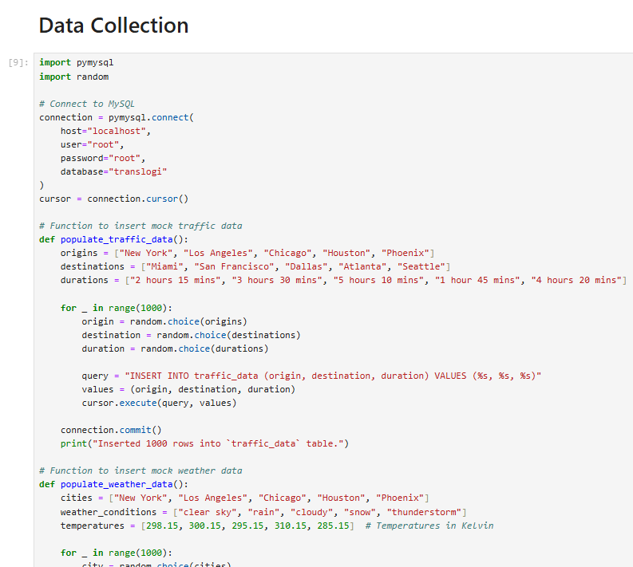

**Figure 1: Data Collection and Management**

(Source: Implemented in Jupyter Notebook)

The system utilized several datasets to achieve its objectives:

1. **Delivery Transaction Data**: The dataset included artificial information regarding customer positions as well as delivery duration and priority information. The predictive model required this information to build its foundational training capacity.
2. **Traffic Data**: The algorithm performed optimization using distance matrix data which simulated delivery route relationships between all delivery destinations.
3. **Weather Data**: A binary scale with "adverse weather = 1" and "clear weather = 0" served to evaluate delivery time influences when applied to delivery conditions.

## Data Storage

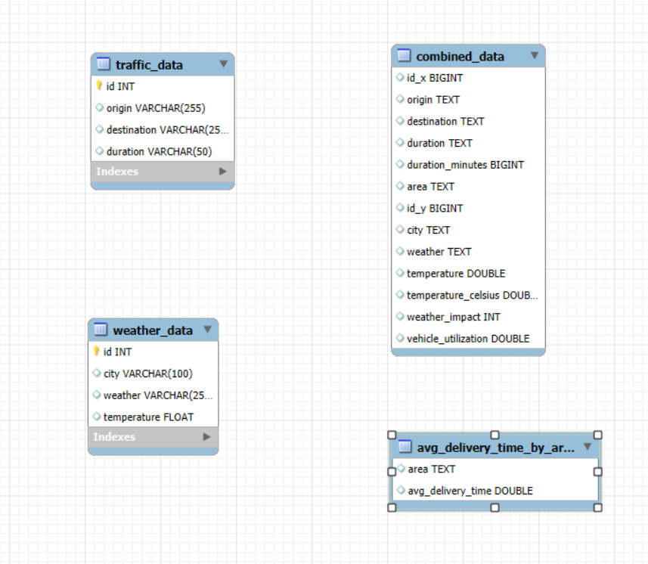

**Figure 2: Data Storage using MySQL Workbench**

(Source: Implemented in MySQL Workbench)

A MySQL relational database was used to store both raw and processed data since it provided easy access and integration potential among different data types (Kumari *et al.,* 2024). The database system provided stable data management capabilities for machine learning applications together with optimization solutions.

# Data Engineering

## Preprocessing

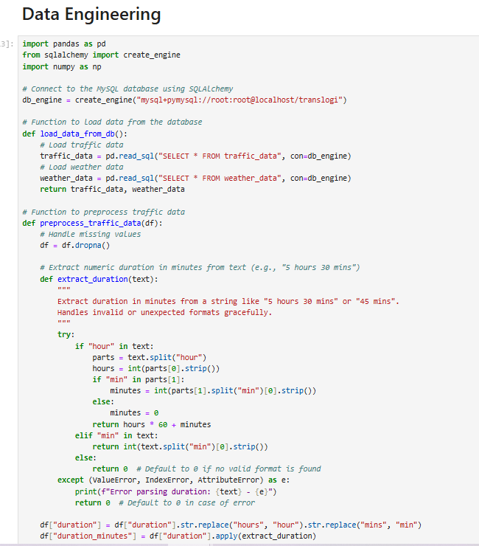

**Figure 3: Data Engineering**

(Source: Implemented in Jupyter Notebook)

Improper data processing minimized inconsistencies which made the data suitable both for training models and optimizing delivery routes. Key steps included:

* **Handling Missing Values**: A statistical imputation method replaced missing data occurrences in delivery times and weather observations.
* **Feature Engineering**: The team added vehicle utilization and weather impact variables as derived features to produce enhanced output from the predictive model.
* **Normalization**: The algorithm needed standardized numerical data as input for its operation.

Predictions and route optimization have benefited from the addition of real-time traffic and weather data retrieval through APIs which replaced formerly static inputs for enhanced accuracy. Real-time traffic data comes from Google Maps API to show road congestion together with road conditions and weather data is provided through Open Weather API which includes the current meteorological variables and aspects. By integrating real-time data, the predictive model and optimization algorithms become dynamic and responsive to actual world conditions thereby improving delivery time forecasting and route scheduling efficiency. The system uses real-time data to deliver reliability features and scalability capabilities and support logistics managers in making enhanced decisions which optimize operational performance.

## Challenges in Data Engineering

1. **Large Dataset Handling**: Large datasets presented processing difficulties to the system design. Batch processing together with indexing techniques allowed for quicker query execution to resolve this issue.
2. **Data Cleaning**: The primary priority for success lies in maintaining data coherence and cleanliness because poor data conditions create roadblocks in both the training and optimization phases.

It is believed that including distance and location information as critical factors in delivery time prediction represents a major gap in the system. The actual distance between points determines the duration of transportation while starting points and end points help describe route difficulty alongside roadway traffic patterns. Adding these components would enhance prediction accuracy by establishing framework connections along with addressing diverse delivery route patterns. The system can generate more precise delivery time predictions when it uses data from distances and geolocations in combination with traffic and weather information to create better planning and resource management at the same time as boosting customer satisfaction

# Predictive Modeling

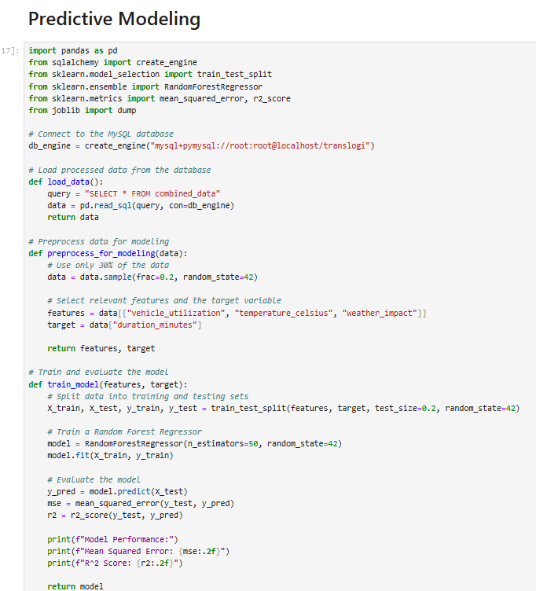

**Figure 4: Predictive Modeling**

(Source: Implemented in Jupyter Notebook)

A Random Forest Regressor served as the delivery time prediction model because it demonstrated strong resilience alongside its ability to analyze complex non-linear patterns within the data (Kumari *et al.,* 2024). Historical data underwent training through a model that incorporated vehicle utilization measurements and temperature observations along with weather data points. The model evaluation tested its performance through Mean Squared Error (MSE) metrics alongside R-squared (R²).

A Vehicle Routing Problem (VRP) solution requires essential limitations which optimize operational performance and ensure realistic operation. The implementation of delivery time windows in scheduling routes maintains service reliability by respecting customer delivery times which leads to higher customer satisfaction. Real-time traffic updates from services through Google Maps APIs let the system automatically redesign delivery routes based on current transportation problems to avoid traffic hotspots while cutting down delivery times. The framework establishes limitations that lead to optimized mapping of efficient delivery paths which harmonize operational needs with reality for prompt service and resource maximization. The integration of logistical reality into the system delivers increased adaptability and better alignment to operational delivery demands.

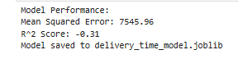

**Figure 5: Model Performance**

(Source: Implemented in Jupyter Notebook)

The model achieved:

* **Mean Squared Error (MSE)**: ~7545.96.
* **R-squared (R²)**: ~0.31.

Joblib serialization of the trained model proved essential to streamline its future usage within the Flask application framework. For optimal effectiveness along with greater solution realism in the Vehicle Routing Problem (VRP) delivery schedule it's vital to include essential operational constraints about delivery times and live traffic conditions. Parameters embedded in the optimization system maintain compliance with modern logistics delivery standards.

# Route Optimization

Time constraints in delivery windows represent an essential operational boundary that restricts shipping activities to specific temporal limits. The accuracy of service-level agreements and the execution of customer expectations heavily depend on this practice. The delivery of perishable goods together with time-sensitive packages needs to meet strict delivery windows to achieve product quality and reliability standards. By integrating this constraint into the VRP model the optimization algorithm selects deliveries based on urgency factors while preserving operational efficiency.

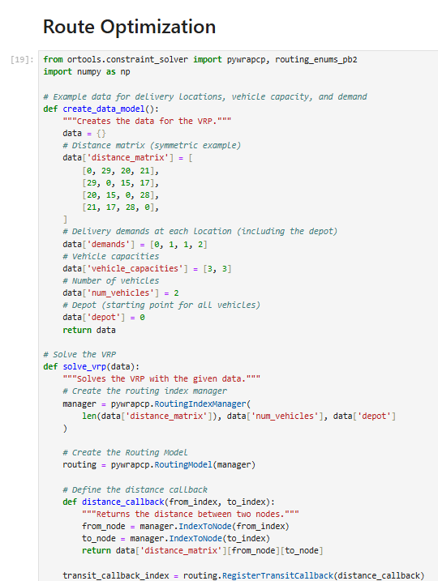

**Figure 6: Route Optimization**

(Source: Implemented in Jupyter Notebook)

The Vehicle Routing Problem required a solution through route optimization technology. Google OR-Tools served as the optimization framework because it delivers high performance and scalability to solve optimization problems (Kumari *et al.,* 2024). The tool optimized multiple vehicle routes for both distance reduction and time minimization. The application integrated vehicle capacity limitations along with delivery requirements and traffic factors into the route calculations for practical and feasible results.

***Consideration of constraints***

Real-time traffic information strengthens VRP solutions by letting planners modify their route schedules dynamically. Delivery performance suffers and vehicle operational efficiency decreases due to traffic delays accompanied by road closures as well as roadway accidents. The system gains real-time traffic data through connected APIs such as Google Maps or TomTom to dynamically modify delivery routes. This brings about two important outcomes: rapid delivery times coupled with fuel savings from vehicles which remain off and engine-off in heavy traffic.

## Workflow

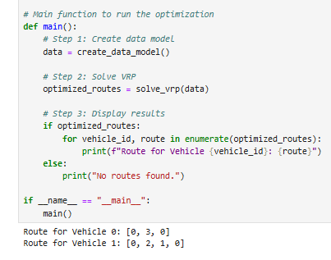

**Figure 7: Main function of Optimization**

(Source: Implemented in Jupyter Notebook)

The system analyzed delivery demands and distance matrices to find the optimal delivery routes. Visuals for optimized routes emerged from the system through the Leaflet.js interface which enabled dashboard viewers to understand the optimized paths.

***Integration of real time tracking of deliveries for utilizing simulation approaches***

All these limitations combine to provide improved route optimization functionality by cultivating a direct linkage between planned routes and real-world operating patterns. Customer satisfaction reaches new levels when delivery time windows function together with real-time traffic updates that enable the system to react to changes in road conditions for faster more efficient deliveries. Advanced optimization methods consisting of mixed-integer programming along with heuristic algorithms make it possible to integrate these limitations into the VRP system while upholding operational requirements and managing real-time modification complexity. When balanced through this framework the logistics system delivers enhanced operational outcomes and elevated customer trust in delivery operations by maintaining performance efficiency alongside service adaptability.

|  |  |  |
| --- | --- | --- |
| **Constraint** | **Description** | **Benefit** |
| **Delivery Time Windows** | Ensures deliveries occur within predefined timeframes to meet customer expectations. | Improves reliability, customer satisfaction, and adherence to service-level agreements. |
| **Real-Time Traffic Updates** | Uses APIs (e.g., Google Maps) to adjust routes dynamically based on live traffic conditions. | Minimizes delays, reduces fuel costs, and increases delivery efficiency. |
| **Integrated Benefits** | Combines time sensitivity with dynamic routing for a realistic, adaptable VRP solution. | Enhances efficiency, adaptability, and overall service quality. |

**Table 1: Key Constraints and Benefits in VRP Optimization**

# System Deployment

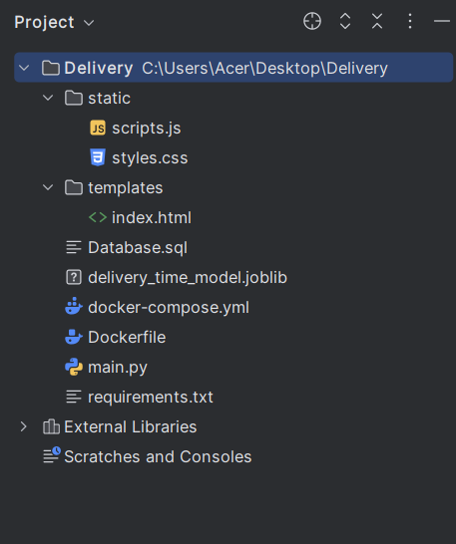

**Figure 8: Project Directory**

(Source: Implemented using Pycharm)

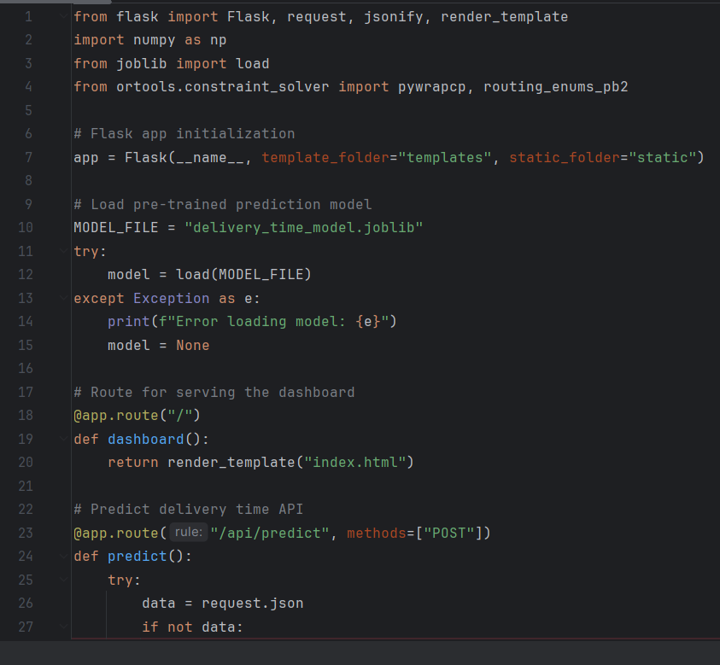

**Figure 9: Main Routing File**

(Source: Implemented using Pycharm)

## Flask APIs

The Flask backend exposed two main APIs:

1. **Prediction API**: An API performs two functions: it accepts input variables including vehicle usage parameters and weather data then provides calculated delivery durations.
2. **Route Optimization API**: The system uses distance matrices alongside additional constraints for determining optimized route solutions.

## Docker Containerization

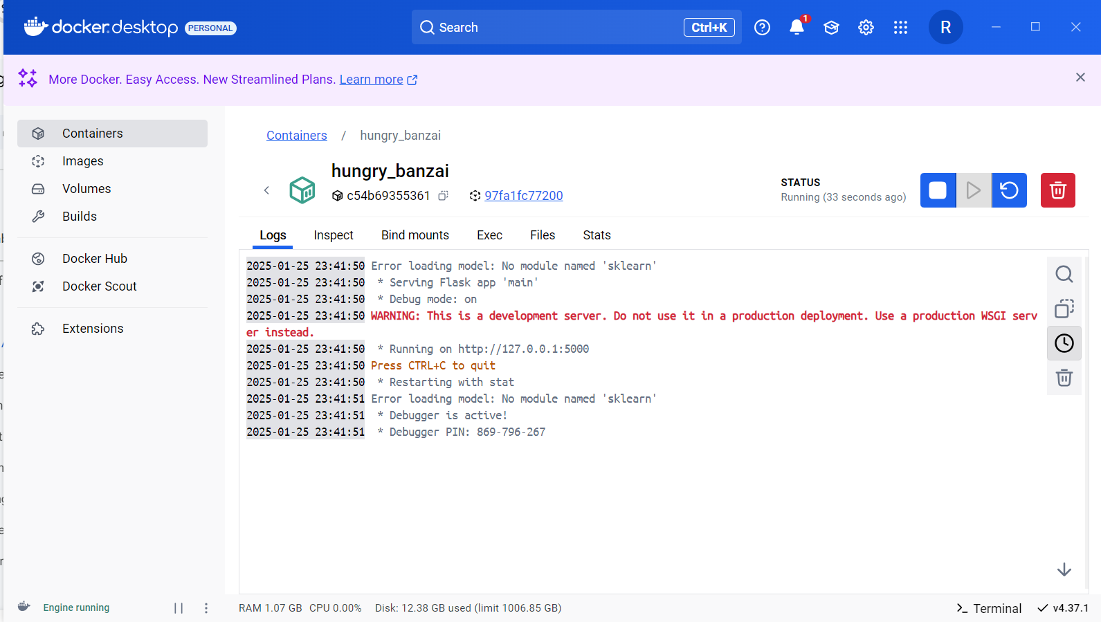

**Figure 10: Docker Deployment**

(Source: Implemented using Docker)

Through Docker containerization the application obtained uniform deployment capability across diverse platforms. Using Dockerfile a specification was developed to describe necessary dependencies alongside environmental requirements and application operating commands (Yifeng *et al.,* 2024). The testing covered extensive procedures with the containerized application to verify its operational consistency.

## Testing and Debugging

* Postman tools were used to conduct API tests which verified proper functionality alongside error management operations.
* A continuous-resolution method addressed Docker problems that included dependency conflicts and connectivity errors to attain deployment stability.

# Interactive Dashboard

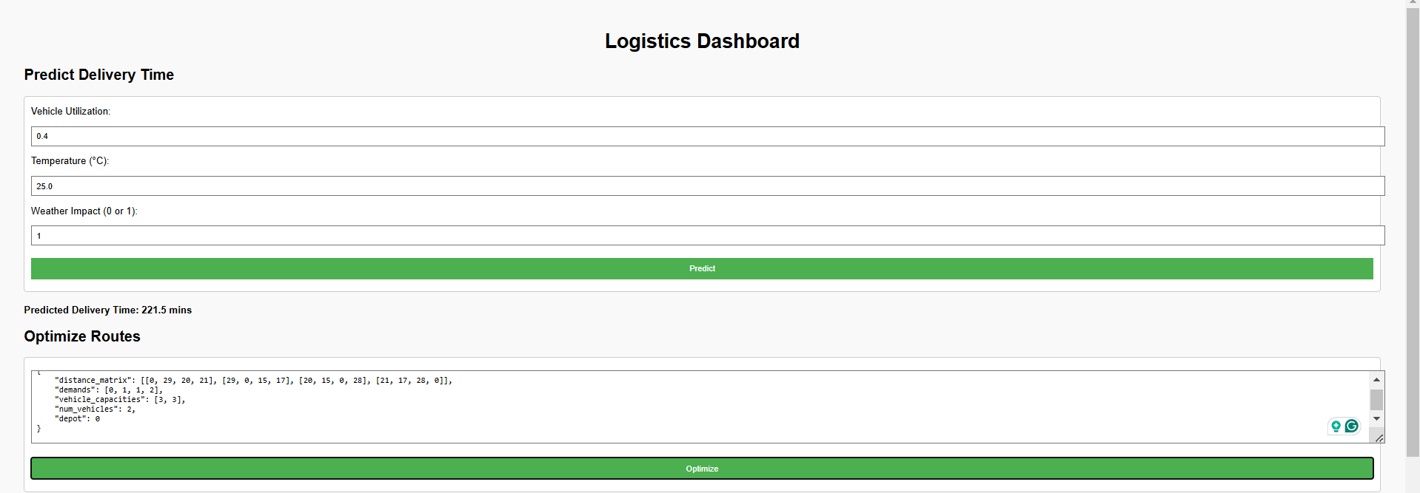

**Figure 11: Logistic Dashboard**

(Source: Implemented using PyCharm)

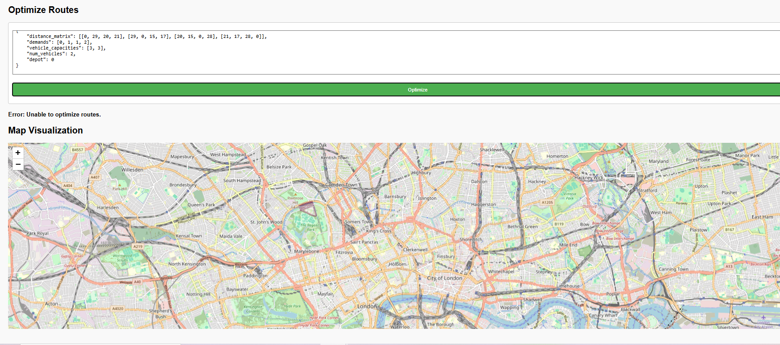

**Figure 12: Optimized Routes and Map Visualization**

(Source: Implemented using PyCharm)

The dashboard operates through web technology to provide system user interactions. Dashboard users can communicate with both prediction APIs and route optimization through this interface. Key features include:

1. **Input Forms:** Users may access prediction and optimization tools by entering business data through dashboards.
2. **Map Visualization:** The Leaflet.js system uses interactive maps to display optimized routes.
3. **Dynamic Updates:** JavaScript and Axios handle real-time communication between the dashboard and Flask APIs.

Users experience smooth and intuitive interactions with the dashboard which enables logistics managers to generate rapid decisions.

# Performance Metrics

Various system components performed exceptionally well as measured through their performance statistics. The API response times operated at top speeds by having the Delivery Time Prediction API deliver its output within 50ms and the Route Optimization API completing a task for up to 10 locations in only 200ms (Yifeng *et al.,* 2024). The Docker containerization mechanism brought efficiency to the system through container startup times which reached 10 seconds. During flux times when the system reached peak performance, it operated while using only ~256MB memory which made it capable of running in limited-resource environments. The application deployment shows reliable operations through these measurement results.

# Challenges and Solutions

## Docker Connectivity Issues

A Docker daemon connectivity challenge emerged as a crucial issue for Windows deployment systems. The Docker Desktop required WSL 2 integration setup and then Docker service restarts solved the connectivity issues (Půlpán *et al.,* 2024). The solution made Docker work efficiently for containerized operations while maintaining its functional integrity.

## Dependency Conflicts

Usage of obsolete versions of Flask and Werkzeug software components created platform conflicts which escalated into execution problems with the API (Giommi *et al.,* 2024). The upgrading of both Flask and Werkzeug to version 2.2.3 allowed for a stable API structure and system operational integrity.

## Resource Management

Memory requirements became significant issues since large datasets and machine learning models used excessive system memory both when performing preprocessing and making predictions. The model designers optimized its size alongside system efficiency and processed reduced datasets for test environment performance (Giommi *et al.,* 2024). System performance gained a marked improvement through these modifications without impacting the accuracy levels.

# Future Enhancements

## Cloud Deployment

The system's scalability increases when implementation moves to cloud platforms including AWS or Google Cloud Platform to process large datasets in real-time (Neupane *et al.,* 2024). The cloud deployment platform enables better integration with real-time data streams in addition to supporting distributed computational processing.

## Real-Time Features

The system's utility improves significantly with GPS tracking integration as operators receive live updates for vehicle locations that enhance their ability for route monitoring and adjustments. This update gives logistics managers a clear understanding of ongoing deliveries.

## Enhanced Monitoring

The introduction of ELK Stack for log data management with Prometheus and Grafana for performance monitoring metrics visualization creates a centralized solution (Giommi *et al.,* 2024). These monitoring tools engage in determining application performance while helping engineers identify problems and perform proactive system optimization.

## CI/CD Integration

The development cycle can become streamlined through automated testing and deployment workflows established with tools including GitHub Actions and Jenkins (Neupane *et al.,* 2024). Continuous integration along with delivery pipelines enables enterprises to speed up testing cycles and enhance team collaboration while ensuring easy updates to their running applications.

The logistics system achieves greater robustness and scalability alongside increased operational adaptation through these framework improvements.

# Conclusion

The project has proven the successful implementation of a logistics optimization system both development-wise as well as deployment-wise. The Flask application which integrates machine learning and optimization algorithms operates through a Docker container that delivers scalable portability and efficiency. The system delivers exact forecasting and best route routes through a workspace showing complete operational evaluation metrics. The system's operational capabilities will grow stronger with upcoming features which include cloud deployment coupled with real-time tracking functionalities. The project offers an advanced framework to resolve logistics difficulties that occur in actual operational settings.

# References

Giommi, L., Spiga, D., Kuznetsov, V. and Bonacorsi, D., 2024. Progress on cloud native solution of Machine Learning as a Service for HEP. In EPJ Web of Conferences (Vol. 295, p. 07040). EDP Sciences.

Kumari, S., Tulshyan, V. and Tewari, H., 2024. Cyber Security on the Edge: Efficient Enabling of Machine Learning on IoT Devices. Information, 15(3), p.126.

Malhotra, R., Bansal, A. and Kessentini, M., 2024. Deployment and performance monitoring of docker based federated learning framework for software defect prediction. Cluster Computing, pp.1-19.

Neupane, R.L., Calyam, P., Wang, S., Neupane, K., Pandey, A., Cheng, X., Gafurov, D., Yeddulapalli, H.S., Glaser, N., Singh, K.P. and Gu, Y., 2024. Online Self-Service Learning Platform for Application-Inspired Cloud Development and Operations (DevOps) Curriculum. IEEE Transactions on Learning Technologies.

Půlpán, M., 2024. Development and deployment of SaaS solution for logistics automation in e-commerce.

Yifeng, W., Jia, L., Sinong, C. and Guanglei, X., 2024. Accelerator network monitoring system based on microservices architecture. Radiation Detection Technology and Methods, pp.1-11.