Game Design Document

Fill up the following document

1. Write the title of your project.

Space Shooting

1. What is the goal of the game?

To destroy the enemy spaceship and protect the space from dangerous enemies

1. Write a brief story of your game.

Once there were a guardian of the galaxy who are really a good fighters

And they try to protect the galaxy from many enemies who always come to conquer the galaxy and want to become the king of the galaxy , so the guardian fight with them and try to make the galaxy free from those enemies.

1. Which are the playing characters of this game?

* Playing characters are the ones who respond to the user based on the input from the user.
* Cars, monkeys, dinos, wizards, etc., are the playing characters in the game.

|  |  |  |
| --- | --- | --- |
| Number | Character Name | What can this character do? |
| 1 | Guardian Spaceship | It will shoot to enemies |
| 2 |  |  |
| 3 |  |  |
| 4 |  |  |
| 5 |  |  |
| 6 |  |  |
| 7 |  |  |
| 8 |  |  |

1. Which are the Non-Playing Characters of this game?

* Non-Playing characters are the ones that don't have an action or behavior when the user interacts with the game.
* Hurdles, stones, bananas, coins, etc., are non-playing characters in the game.

|  |  |  |
| --- | --- | --- |
| Number | Character Name | What can this character do? |
| 1 | Enemies Spaceship | It will shoot to guardian spaceship |
| 2 | Boss Spaceship | It will shoot heavily to guardian spaceship |
| 3 |  |  |
| 4 |  |  |
| 5 |  |  |
| 6 |  |  |
| 7 |  |  |
| 8 |  |  |

Draw your imagination of this game. What does this game look like?

* Draw the game either on your computer or on paper.
* Add images of the game scenes to show each of the playing and non-playing characters at least once.

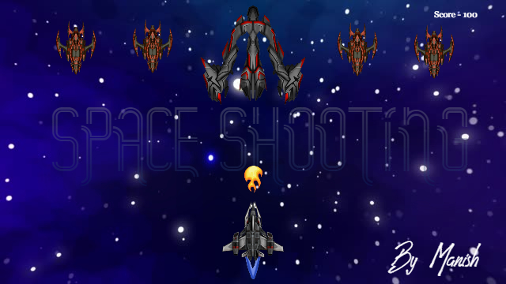

How do you plan to make your game engaging?

I can make it more interesting and engaging by adding some difficulties and

Some skillful controls by which the user will try to play it and want to become master of the game.