<https://www.slideshare.net/slideshow/database-management-systems-question-paperpdf/256341031>

<https://javatcorner.com/anu-mca-1-semester-dbms-previous-papers/>

<https://www.indianuniversityquestionpapers.com/2021/02/anna-university-if-5191-advanced-data-BASES-APRIL-MAY-2019-Question-Paper.html>



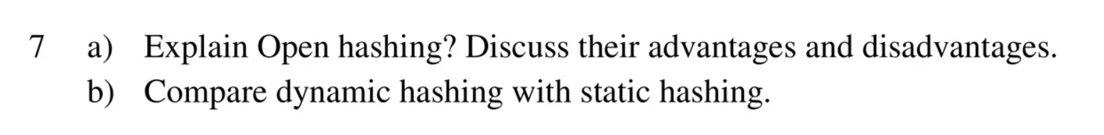



Explain Sapital B-tree index and define the arrival of fence from it.

What is indexing? Explain the types of indexing?