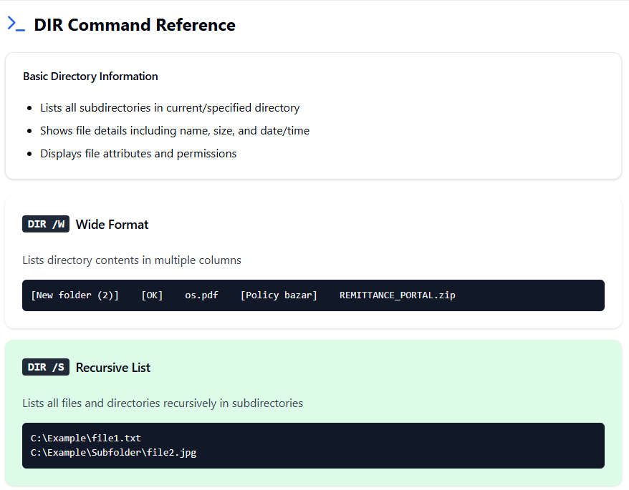

**DIR (also known as switches – because modify the output format)**

**FORMAT**

