<https://www.studytrigger.com/previous-year-questions-papers-2/data-structure-question-paper/>

<https://www.studytrigger.com/previous-year-questions-papers-2/question-paper-mca-data-structure/>

<https://cse.poriyaan.in/topic/concept-of-hashing-50905/>

<https://samagracs.com/database-management-system-nta-ugc-net-question-analysis/>

<https://sharikatr.in/cst-204-database-management-systems/>

**What is the need for hashing? OR Benefits of hashing?**

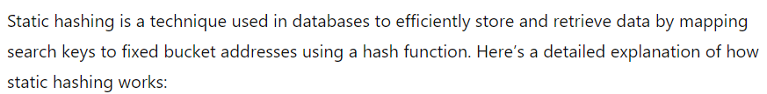

**OPEN HASHING**