CTI-BTP Platform — Workflow Guide
Cross-Organisational Cyber Threat Intelligence Sharing with PR-RABE Encryption
Flask + React | SQLite | PR-RABE (charm-crypto on WSL/Linux)

Architecture Overview
Layer | Tech | Role
Frontend | React + Vite (port 5173) | SPA dashboard
Backend | Flask (port 5000, WSL) | REST API + crypto
Crypto | charm-crypto (bilinear pairings) | PR-RABE encryption
Database | SQLite (data/cti.db) | Persistent storage

Case 1: Existing User Login

Step 1 — Landing Page
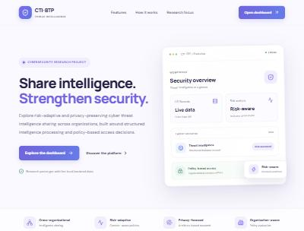
Landing Page
- Public page. Click Open dashboard (top-right) or Explore the dashboard.
- Shows platform features: cross-org sharing, risk scoring, conflict visibility.

Step 2 — Sign In
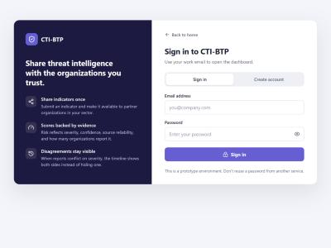
Login Page
- Enter your email and password, click Sign in.
- Token is stored in sessionStorage (1-hour expiry).
- On success → redirects to Dashboard Overview.
Demo accounts (from seed script):
Email | Password | Organisation
alice@alphabank.com | alice123 | Alpha Bank (Finance)
bob@cityhospital.com | bob123 | City Hospital (Healthcare)
carol@deltainsurance.com | carol123 | Delta Insurance (Finance)

Case 2: New User Registration

Step 1 — Create Account
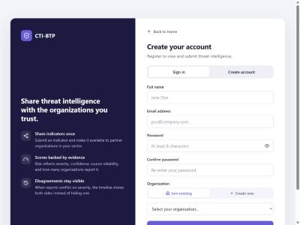
Register Page
- Click Create account tab on the login screen.
- Fill: Full name, Email, Password (min 8 chars), Confirm password.
- Organisation — two options:
- • Join existing: Select from dropdown of registered organisations.
- • Create new: Enter org name + sector → creates the org and assigns you to it.
- Click Create account → auto-login → Dashboard.

Dashboard Pages (Global Workspace)
After login, the sidebar shows 8 pages under Global Workspace.

1. Overview
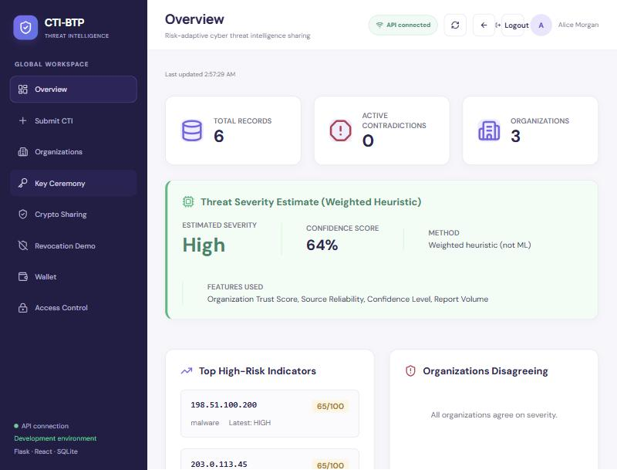
Dashboard Overview
- KPI strip: Total Records, Active Contradictions, Organisations count.
- Threat Severity Estimate: Weighted heuristic score — estimated severity, confidence %, features used.
- Top High-Risk Indicators: Ranked by temporal risk score (severity + volume + cross-sector impact + time decay).
- Organisations Disagreeing: Flags when different orgs report conflicting severities for the same indicator.

2. Submit CTI
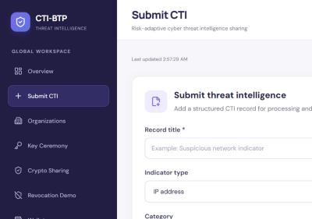
Submit CTI Form
- Form to submit a new threat intelligence record.
- Fields: Title*, Indicator type (IP/domain/URL/SHA-256/CVE), Indicator value, Category, Severity, Confidence, Sharing sector, Source type, Source reliability, Observation date, Description*.
- Your organisation is auto-populated from your login.
- On submit → record is processed, normalised, STIX bundle generated, risk scored, and stored.

3. Organisations
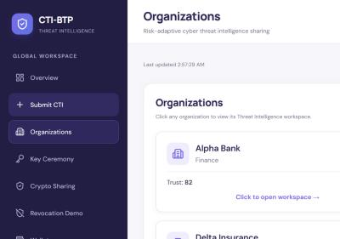
Organisations Page
- Card grid of all registered organisations.
- Each card shows: Name, Sector, Trust Score, Policy Violations count.
- Click Add Organisation to create a new one.
- Click any org card → enters that org's Workspace (see below).

4. Key Ceremony (PR-RABE Setup)
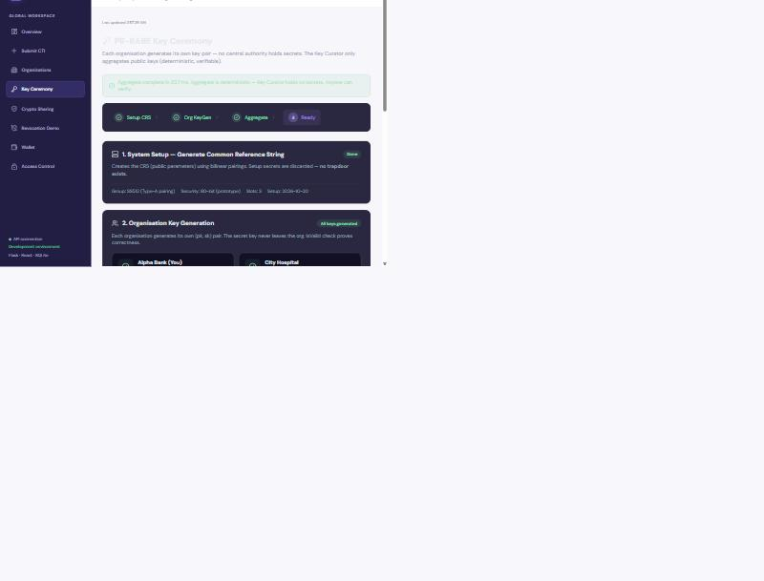
Key Ceremony
4-step progress bar. Must be completed before encryption/decryption works.
- Initialise CRS — Generates Common Reference String using bilinear pairings (SS512, Type-A). Setup secrets discarded (no trapdoor).
- Org Key Generation — Each org generates (pk, sk). Secret key never leaves the org. Attributes assigned: SECTOR:{sector} + TRUST:{HIGH|MEDIUM|LOW} based on dynamic trust score.
- Aggregate — Key Curator combines all public keys into Master Public Key (mpk). Deterministic — curator holds no secrets.
- Ready — System can now encrypt/decrypt using PR-RABE.
(You) label shows next to your org. All orgs must register keys before aggregation.

5. Crypto Sharing
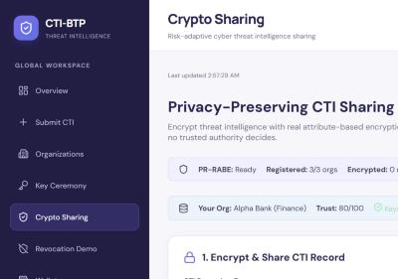
Crypto Sharing
- Status bar: PR-RABE state (Ready/Not initialised), registered orgs count, your org info.
- Encrypt: Select a CTI record → policy auto-generated from severity+sector (e.g., SECTOR:FINANCE AND TRUST:HIGH) → encrypted using PR-RABE with policy hiding.
- Decrypt: Select an encrypted record → attempts decryption with your org's attributes. Shows success/failure + timing.
- Revoke: Revoke an attribute from your org (triggers AGK rotation).
Only organisations whose attributes satisfy the LSSS policy can decrypt. The policy is hidden — unauthorised orgs cannot even see what attributes are required.

6. Revocation Demo
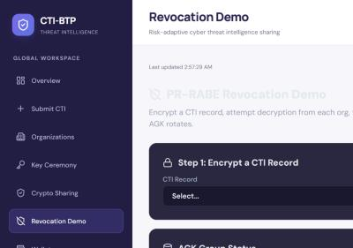
Revocation Demo
Interactive 3-step demo showing PR-RABE revocation in action.
- Encrypt a record with a chosen policy.
- Decrypt from each org — see who has access and who is blocked.
- Revoke an attribute (e.g., TRUST:HIGH from an org) → AGK rotates → re-encrypt → that org loses access without changing their private key.
Shows AGK Group Status table with version numbers and member counts. Uses demo-specific endpoints so it can test decryption as any org.

7. Wallet
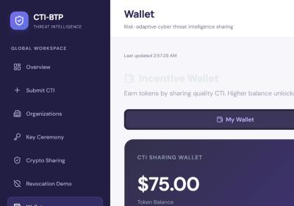
Incentive Wallet
- Token Balance: Your org's incentive wallet.
- Tier: Basic (<50) / Standard (50–99) / Premium (100+).
- Transaction History: Sharing rewards (+10), high-confidence bonuses (+5), cross-sector bonuses (+3), violation penalties (−20), revocation penalties (−50).
- Leaderboard tab: All orgs ranked by token balance.

8. Access Control
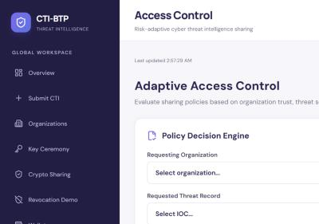
Access Control
- Policy Decision Engine: Select a requesting org + a threat record → evaluate access.
- Decision shows: GRANTED or DENIED, with context — FIPS 199 sensitivity, required LSSS policy, org trust score, org attributes, missing attributes, risk level.
- Security Audit Trail: Log of all access decisions with timestamps.

Organisation Workspace
Click any org on the Organisations page → enters that org's workspace with 4 dedicated pages.

PDF Intelligence
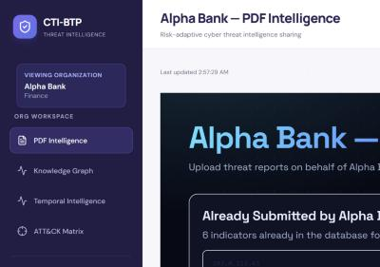
PDF Intelligence
- Upload threat PDF reports (e.g., APT analysis papers).
- AI extracts IOCs (IPs, domains, hashes, CVEs) from the PDF.
- Extracted indicators are automatically added as CTI records for that org.
- Shows already-submitted indicators for that org.

Knowledge Graph
- Interactive force-directed graph visualisation.
- Nodes = Organisations + IOCs. Links = 'submitted' relationships.
- See which orgs share common indicators (overlap = potential correlation).

Temporal Intelligence
- Timeline view of how indicators evolve over time.
- Risk score with time-decay: recent activity scores higher.
- Cross-sector impact tracking.
- Contradiction detection: flags when orgs disagree on severity.

ATT&CK Matrix
- Maps org-submitted indicators to MITRE ATT&CK techniques.
- Collaborative filtering: suggests techniques an org hasn't seen yet, based on what similar orgs report.
- Global frequency heatmap across all orgs.

PR-RABE Cryptography Flow
- Setup (Key Ceremony) — CRS generated from bilinear pairing params. Setup secrets discarded (no trapdoor).
- KeyGen (Per Org) — Each org → (pk, sk) pair. Attributes: SECTOR:X + TRUST:Y. IsValid check proves key correctness.
- Aggregate — Key Curator combines all pk → Master PK (mpk). Distributes helper keys (hk) to each org. Curator holds NO secrets.
- Encrypt (KEM-DEM Hybrid) — Policy e.g. (SECTOR:FINANCE AND TRUST:HIGH). KEM: PR-RABE encrypts symmetric key under policy. DEM: AES-GCM encrypts the actual CTI data. Policy hiding: attribute names visible, values hidden from unauthorised.
- Decrypt — Org uses sk + hk + mpk. If attributes satisfy policy → symmetric key → AES-GCM decrypts data. If not → DecryptionFailed (no information leak).
- Revoke — Revoke attribute from org. AGK (Attribute Group Key) rotates. All records re-encrypted with new AGK. Org's private key unchanged — they can no longer derive the new AGK → decryption fails.

Trust → Attributes Mapping
Trust Score | Trust Tier | LSSS Attribute
80–100 | HIGH | TRUST:HIGH
50–79 | MEDIUM | TRUST:MEDIUM
0–49 | LOW | TRUST:LOW

Auto-Policy Generation
Record Severity | Required Trust
Critical / High | TRUST:HIGH
Medium | TRUST:MEDIUM
Low | TRUST:LOW

If the record has a specific sharing sector (e.g., Finance), the policy becomes: (SECTOR:FINANCE AND TRUST:HIGH) — both conditions required.

Dynamic Trust Score
Trust is computed from 4 weighted components (not static):
Component | Weight | How it works
Sharing | 35% | Log-growth based on CTI submissions (maxes ~20 submissions)
Violations | 30% | Each violation = −25 points on this component
Reliability | 20% | Ratio of high-confidence submissions
Base | 15% | Starting score (60 for active orgs)

Special cases: Inactive org → trust = 0. Revoked org → trust = 10.

Running the Platform

Backend (WSL terminal)
cd /mnt/c/Users/asus/Desktop/CTI-BTP
source ~/charm-env/bin/activate
python -m backend.app
Runs on http://127.0.0.1:5000

Frontend (Windows terminal)
cd C:\Users\asus\Desktop\CTI-BTP\frontend
npm run dev
Runs on http://localhost:5173

Seed demo data
cd /mnt/c/Users/asus/Desktop/CTI-BTP
source ~/charm-env/bin/activate
python -m scripts.seed_demo
Creates 3 orgs, 5 users, and sample CTI records.

Important Notes
- Key Ceremony is in-memory: If the backend restarts, re-run the ceremony (Init → Keygen all orgs → Aggregate).
- charm-crypto requires Linux/WSL: Real PR-RABE runs only on Linux. On Windows without WSL, a fallback AES engine is used (not cryptographically meaningful for ABE).
- Session token expires in 1 hour: After expiry, UI auto-detects and redirects to login.
- Trust scores are dynamic: They recalculate on every query based on current sharing history, violations, and reliability.

