**Class:** Final Year (Computer Science and Engineering)

**Year:** 2024-25 **Semester:** 1

**Course:** High Performance Computing Lab

**Practical No. 10**

**Exam Seat No :** 22520007(B6)

**Full Name** **:** Manish Namdev Barage

**Title of practical :** Analysis of MPI Programs

**Problem Statement 1:**

Execute the MPI program (Program A) with a fixed size broadcast. Plot the performance of the broadcast with varying numbers of processes (with constant messagesize). Explain the performance observed.

**Screenshot:**

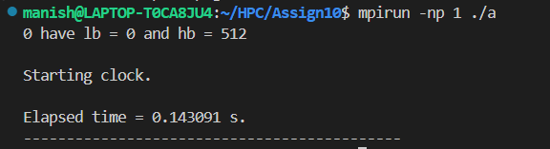

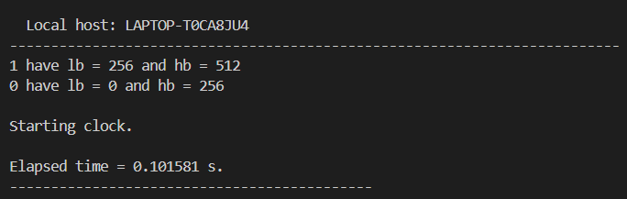

**Analysis:**

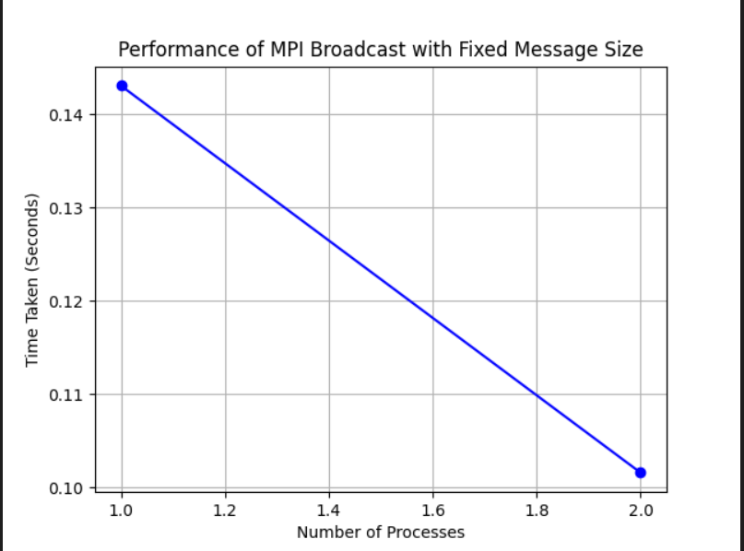

**Problem Statement 2:**

Repeat problem 2 above with varying message sizes for reduction (Program B). Explain the observed performance of the reduction operation.

**Screenshot:**

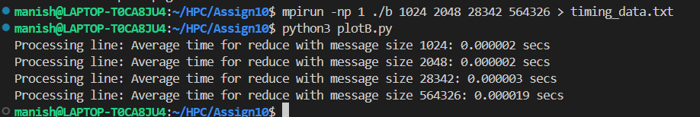

**Analysis:**

