Name: Manish Namdev Barage

PRN No: 22520007(B6)

**High Performance Computing Lab**

**Practical No. 11**

**Title of practical: Understanding concepts of CUDA Programming**

**Problem Statement 1:**

**Execute the following program and check the properties of your GPGPU.**

#include <stdio.h>

#include <stdlib.h>

int main()

{

int deviceCount;

cudaGetDeviceCount(&deviceCount);

if (deviceCount == 0)

{

printf("There is no device supporting CUDA\n");

}

int dev;

for (dev = 0; dev < deviceCount; ++dev)

{

cudaDeviceProp deviceProp;

cudaGetDeviceProperties(&deviceProp, dev);

if (dev == 0)

{

if (deviceProp.major < 1)

{

printf("There is no device supporting CUDA.\n");

}

else if (deviceCount == 1)

{

printf("There is 1 device supporting CUDA\n");

}

else

{

printf("There are %d devices supporting CUDA\n", deviceCount);

}

}

printf("\nDevice %d: \"%s\"\n", dev, deviceProp.name);

printf(" Major revision number: %d\n", deviceProp.major);

printf(" Minor revision number: %d\n", deviceProp.minor);

printf(" Total amount of global memory: %d bytes\n", deviceProp.totalGlobalMem);

printf(" Total amount of constant memory: %d bytes\n", deviceProp.totalConstMem);

printf(" Total amount of shared memory per block: %d bytes\n", deviceProp.sharedMemPerBlock);

printf(" Total number of registers available per block: %d\n", deviceProp.regsPerBlock);

printf(" Warp size: %d\n", deviceProp.warpSize);

printf(" Multiprocessor count: %d\n",deviceProp.multiProcessorCount );

printf(" Maximum number of threads per block: %d\n", deviceProp.maxThreadsPerBlock);

printf(" Maximum sizes of each dimension of a block: %d x %d x %d\n", deviceProp.maxThreadsDim[0],deviceProp.maxThreadsDim[1], deviceProp.maxThreadsDim[2]);

printf(" Maximum sizes of each dimension of a grid: %d x %d x %d\n", deviceProp.maxGridSize[0], deviceProp.maxGridSize[1], deviceProp.maxGridSize[2]);

printf(" Maximum memory pitch: %d bytes\n", deviceProp.memPitch);

printf(" Texture alignment: %d bytes\n", deviceProp.textureAlignment);

printf(" Clock rate: %d kilohertz\n", deviceProp.clockRate);

}

}  
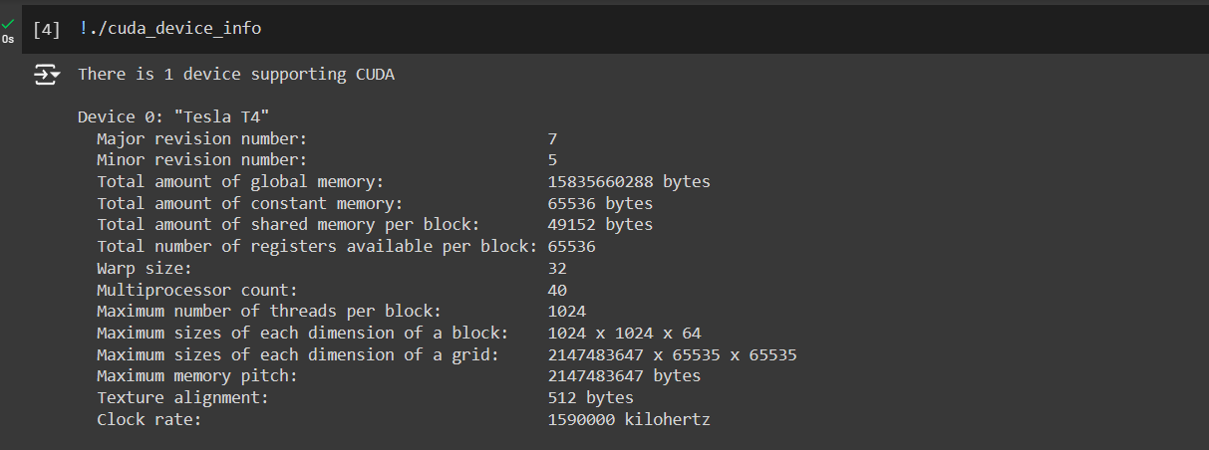

**Problem Statement 2:**

**Write a program to where each thread prints its thread ID along with hello world. Lauch the kernel with one block and multiple threads.**

**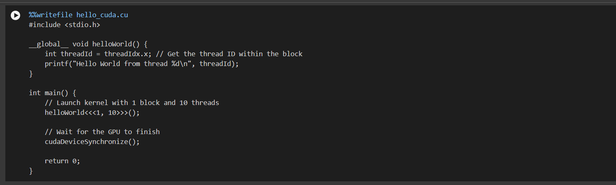  
  
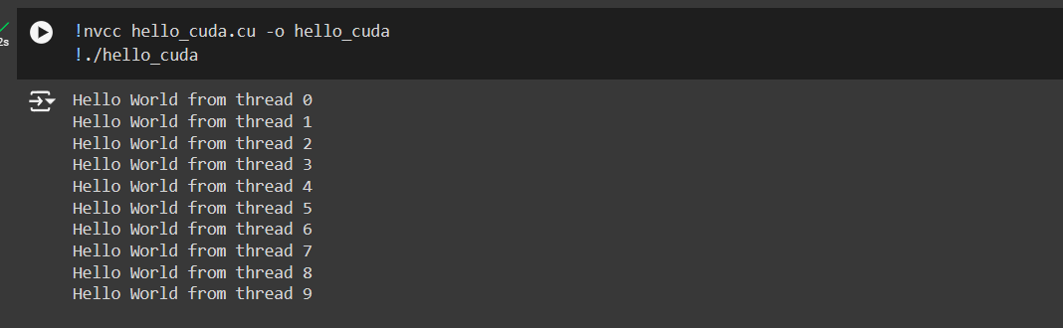**

**Problem Statement 3:**

**Write a program to where each thread prints its thread ID along with hello world. Lauch the kernel with multiple blocks and multiple threads.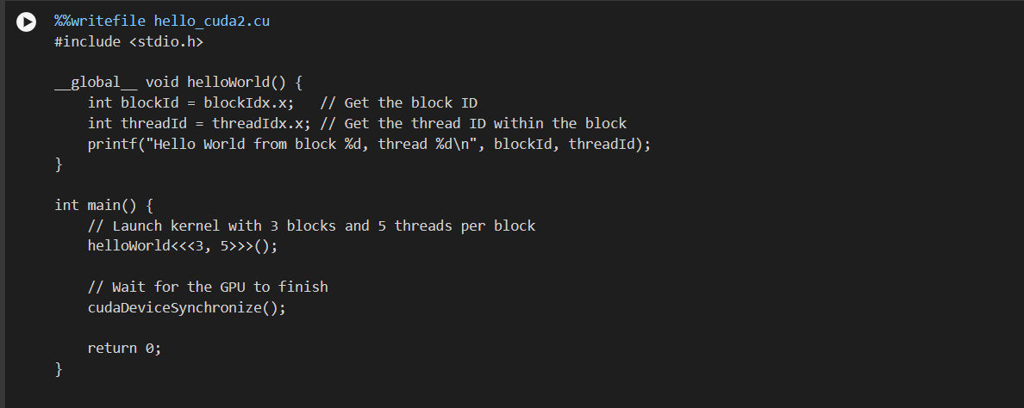  
  
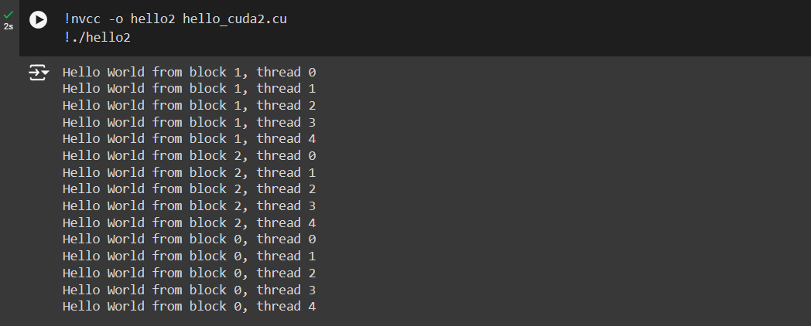**

**Problem Statement 4:**

**Write a program to where each thread prints its thread ID along with hello world. Lauch the kernel with 2D blocks and 2D threads.  
