**Class:** Final Year (Computer Science and Engineering)

**Year:** 2024-25 **Semester:** 1

**Course:** High Performance Computing Lab

## Practical No.8

PRN No : 22520007

Name : Manish Namdev Barage

# **Q1: Implement a MPI program to give an example of Deadlock.**

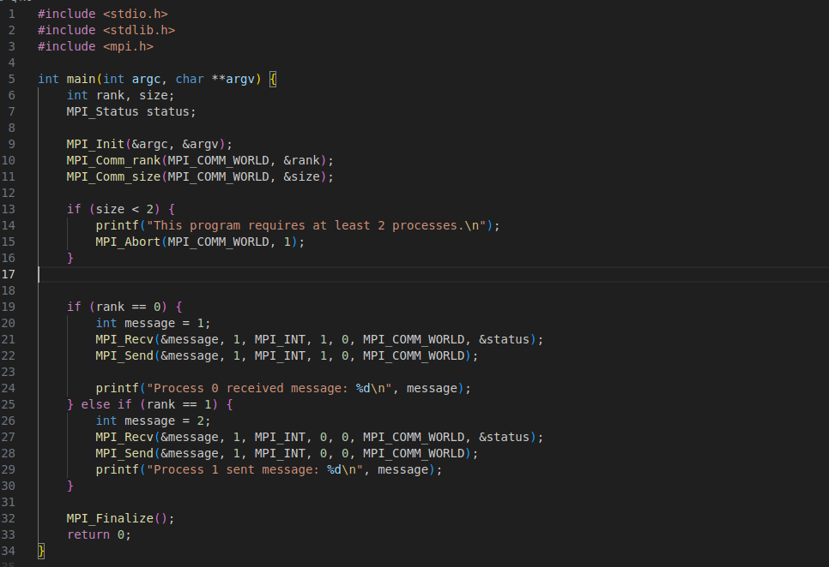

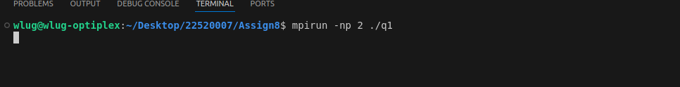

# **Q2. Implement blocking MPI send & receive to demonstrate Nearest neighbor exchange of data in a ring topology.**

# 

# 

# **Q3. Write a MPI program to find the sum of all the elements of an array A of size n. Elements of an array can be divided into two equals groups. The first [n/2] elements are added by the first process, P0, and last [n/2] elements the by second process, P1. The two sums then are added to get the final result.**

