**Practical No 9**

**Name : Manish Namdev Barage**

**PRN : 22520007(B6)**

**Implement Matrix-Vector Multiplication using MPI. Use different number of processes and analyze the performance.**

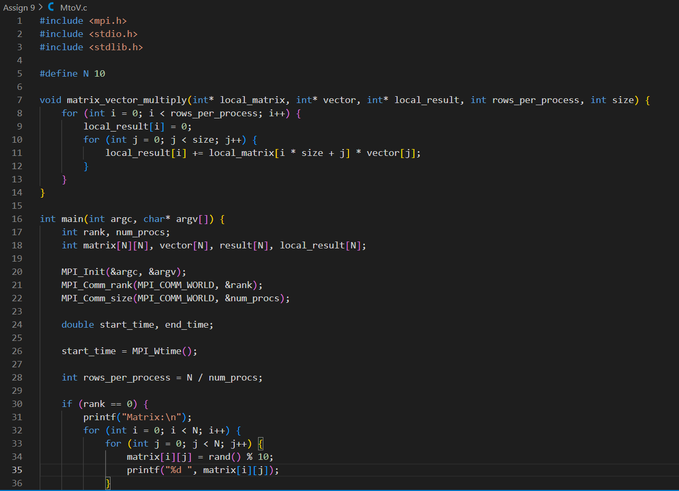

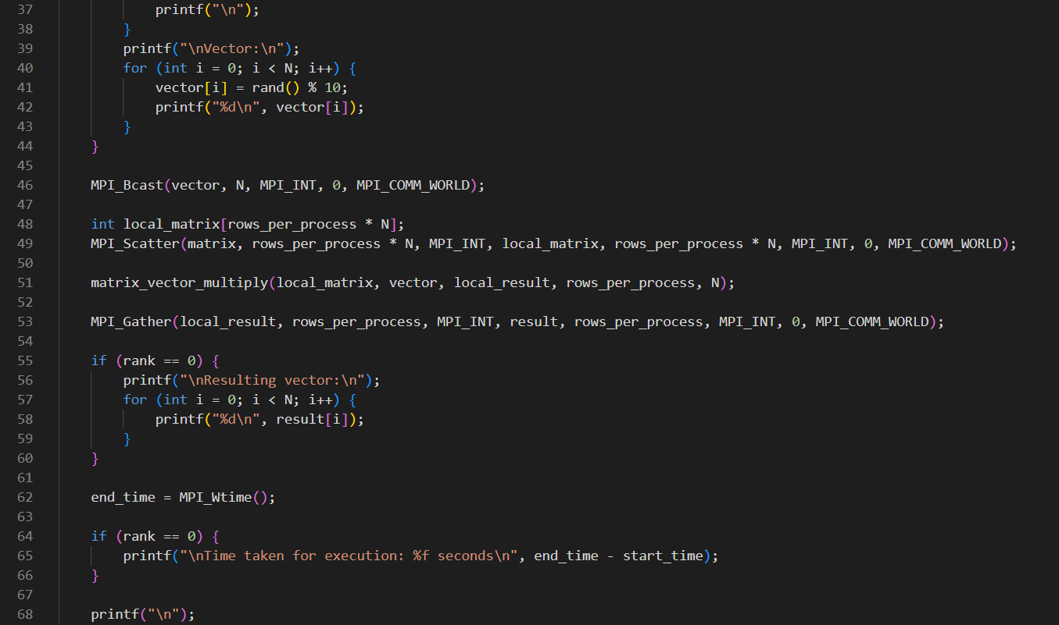

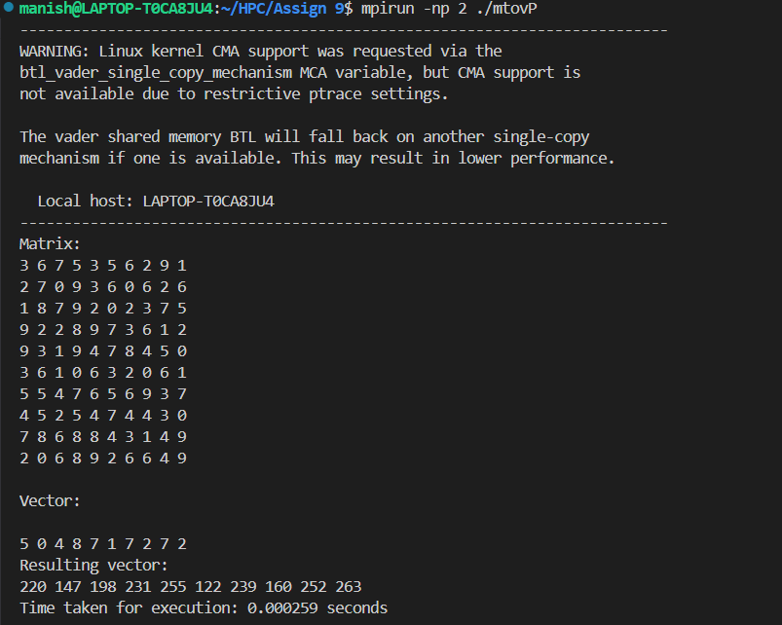

**Implement Matrix-Matrix Multiplication using MPI. Use different number of processes and analyze the performance.**

