Course: High Performance Computing Lab

Practical No 1

PRN: 22520007
Name: Manish Namdev Barage
Batch: B6

Title: Introduction to OpenMP

Problem Statement 1 – Demonstrate Installation and Running of OpenMP code in C
Recommended Linux based System:
Following steps are for windows:
OpenMP – Open Multi-Processing is an API that supports multi-platform shared-memory multiprocessing programming in C, C++ and Fortran on multiple OS. OpenMP uses a portable, scalable model that gives programmers a simple and flexible interface for developing parallel applications for platforms ranging from the standard desktop computer to the supercomputer.

To set up OpenMP,
We need to first install C, C++ compiler if not already done. This is possible through the MinGW Installer.
Note: Also install `mingw32-pthreads-w32` package.
Then, to run a program in OpenMP, we have to pass a flag `-fopenmp`.
Example:
To run a basic Hello World,

Program: Hello world basic program in C.
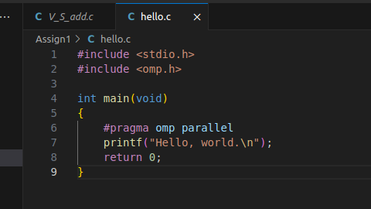

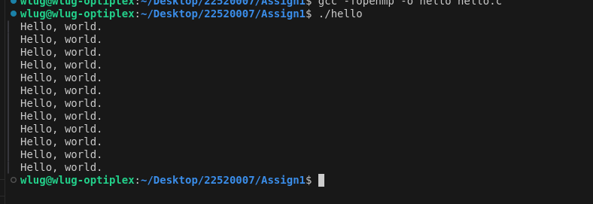

Problem Statement 2 – Print ‘Hello, World’ in Sequential and Parallel in OpenMP
We first ask the user for number of threads – OpenMP allows to set the threads at runtime. Then, we print the Hello, World in sequential – number of times of threads count and then run the code in parallel in each thread.
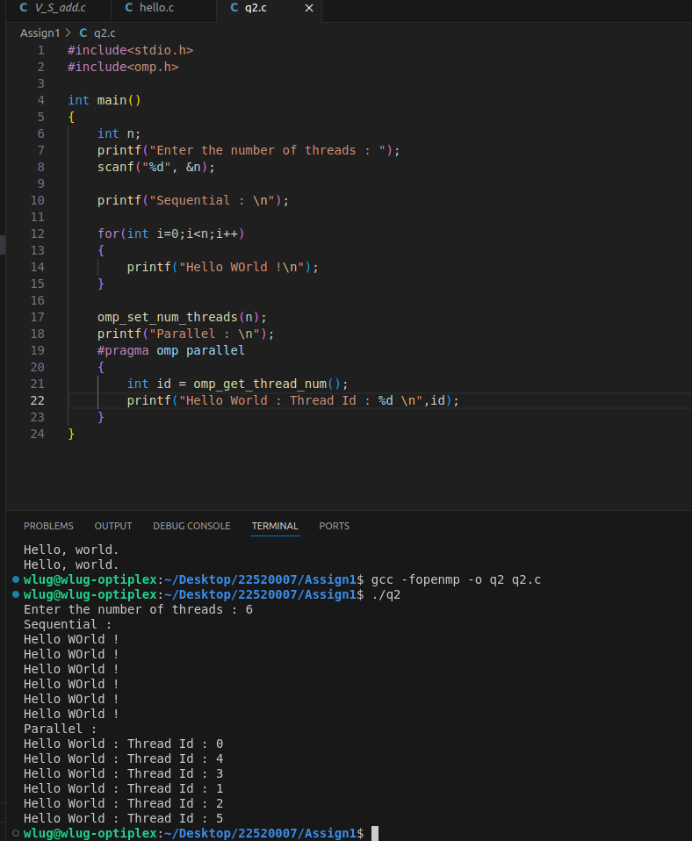

Analysis: We can provide how many threads we want to execute a task. Every thread runs the task parallely. The sequence of threads is random and any thread is selected for the execution randomly.
Problem statement 3: Calculate theoretical FLOPS of your system on which you are running the above codes.
Code snapshot:
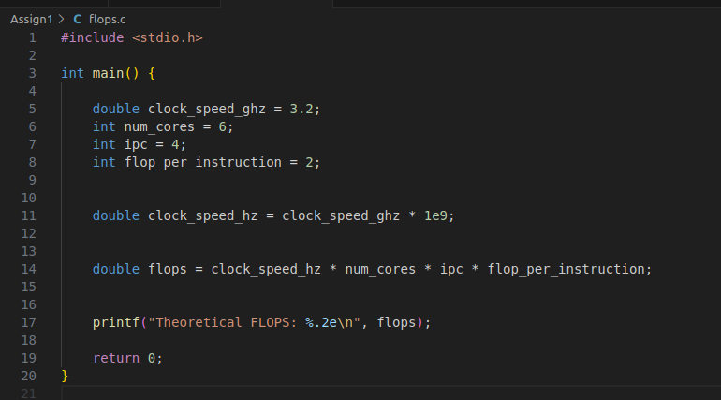
Output:
Parameters:
1. FLOPS: Floating point operations per seconds, which means how many floating point arithmetic operations such as addition, subtraction, multiplication or division can be executed by CPU in one second.
FLOPS = (Time needed for calculation) / clocks per second

2. CPU clock speed: 2.4 Ghz
Can be found using command: lscpu | grep “Ghz”
This shows the number of clock cycles performed by the CPU

