Class: Final Year (Computer Science and Engineering)
Year: 2024-25 Semester: 1
Course: High Performance Computing Lab

Practical No. 2
Exam Seat No: 22520007
Name: Manish Namdev Barage
Batch: B6

Title of practical: Study and implementation of basic OpenMP clauses
Implement following Programs using OpenMP with C:
- Vector Scalar Addition
- Calculation of value of Pi
Analyse the performance of your programs for different number of threads and Data size.

Problem Statement 1: Vector Scalar Addition
Screenshots:

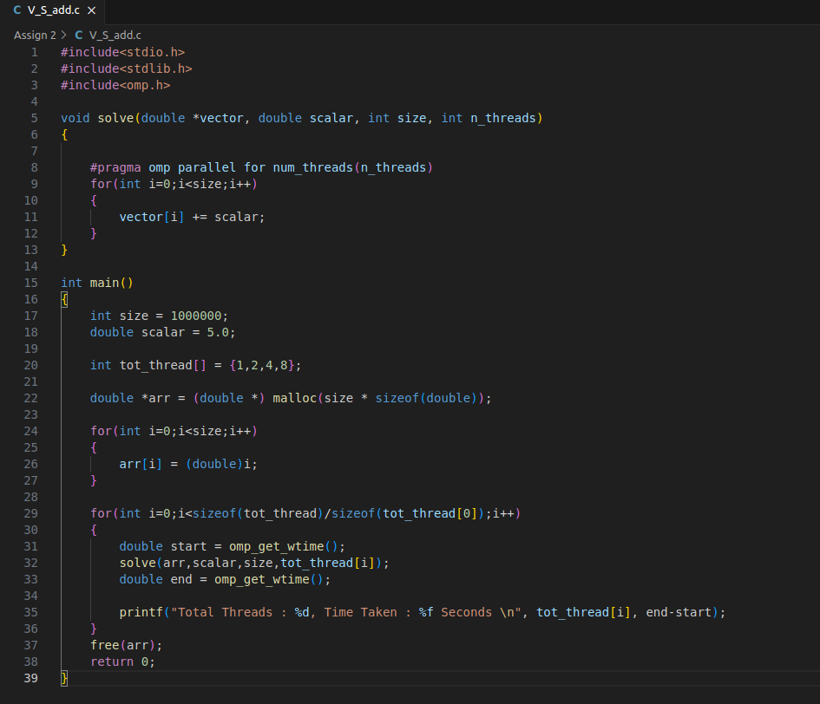


Information:
Analysis: As number of threads increase, time taken to perform the operations is reduced

Problem Statement 2: Calculation of value of Pi

Screenshots:
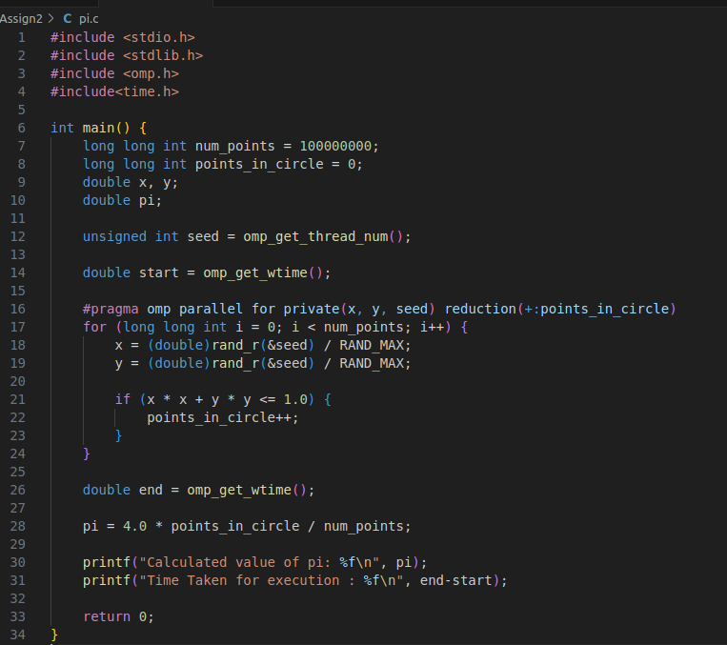



Information: Pi calculation can be done by various methods. Here the method used is Monte Carlo method of π calculation. In this method, pi is calculated using random nuber generation.

Formula Used:
π = 4 * (no_of_points_in_circle / no_of_points_in_square)

Analysis: As we increase number of points precision goes on increasing. The method relies on probabilistic sampling. As the sample size increases, the estimate of π converges to its true value.

