# Assignment 1.

**Name**: Manish Bihari.

**Username:** ManishBIhari06.

Outputs:

2.

3.

4.

5.

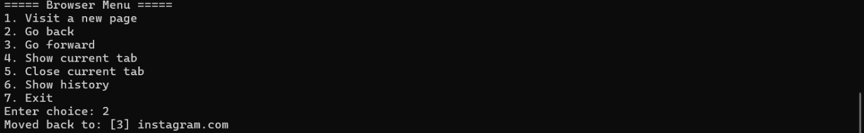

6.

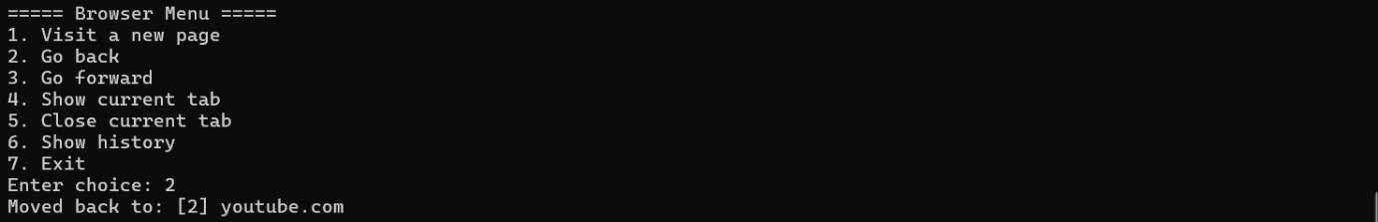

7.

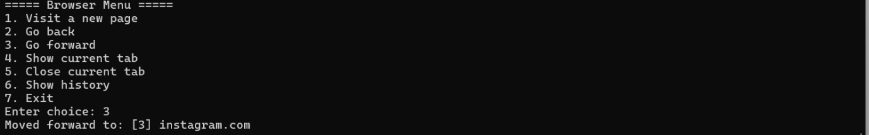

8.

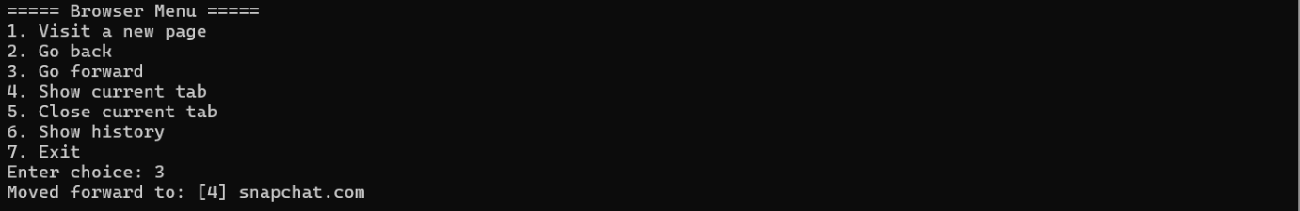

9.

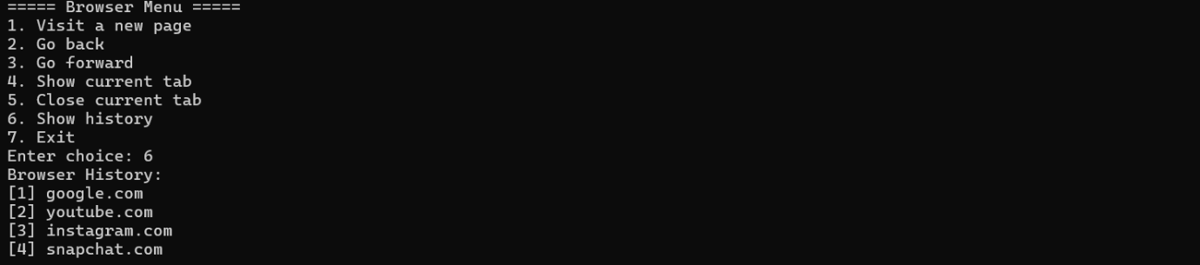

10.

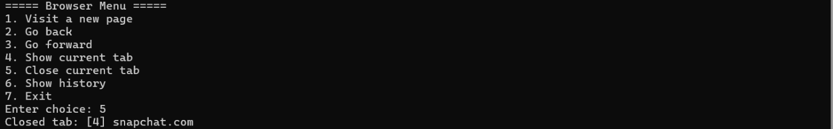

11.

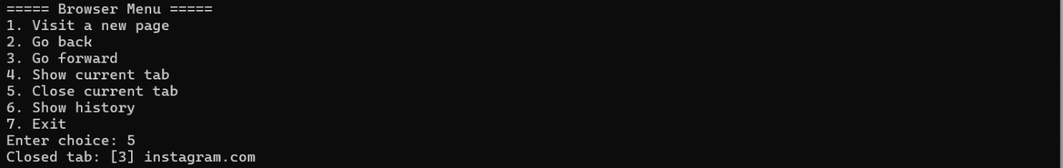

12.

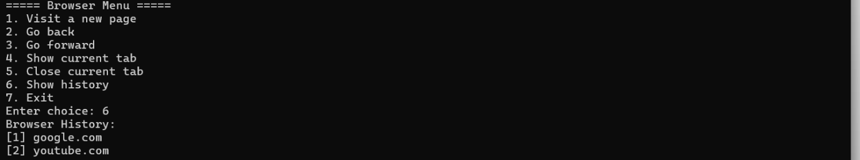

13.

