**Experiment-10**

**Aim:** Create an angular application to work with components

**Component:**

A Component in angular is a isolated entity that enables reuse and maintainability of code. Component encapsulate the data, logic, and HTML for a view - means everything user sees on screen.Components are the main building block for Angular applications. Each component consists of:

* An HTML template that declares what renders on the page
* A Typescript class that defines behaviour
* A CSS selector that defines how the component is used in a template
* Optionally, CSS styles applied to the template

**Creating a component manually:**

1. To create a new component manually:
2. Navigate to your Angular project directory.
3. Create a new file, <component-name>.component.ts.
4. At the top of the file, add the following import statement.

import { Component } from '@angular/core';

5.After the import statement, add a @Component decorator.

@Component({

//code

})

6.Choose a CSS selector for the component and define the HTML template that the component uses to display information. In most cases, this template is a separate HTML file.

@Component({

selector: 'app-componentname',

templateUrl: './componentname.component.html',

})

Every component requires a CSS selector. A selector instructs Angular to instantiate this component wherever it finds the corresponding tag in template HTML.

7.Styles to the component can be added by “styleUrls: ['./componentname.component.css']” in component decorator

8.Add a class statement that includes the code for the component.

export class ComponentNameComponent {

#code

}

Create a project:

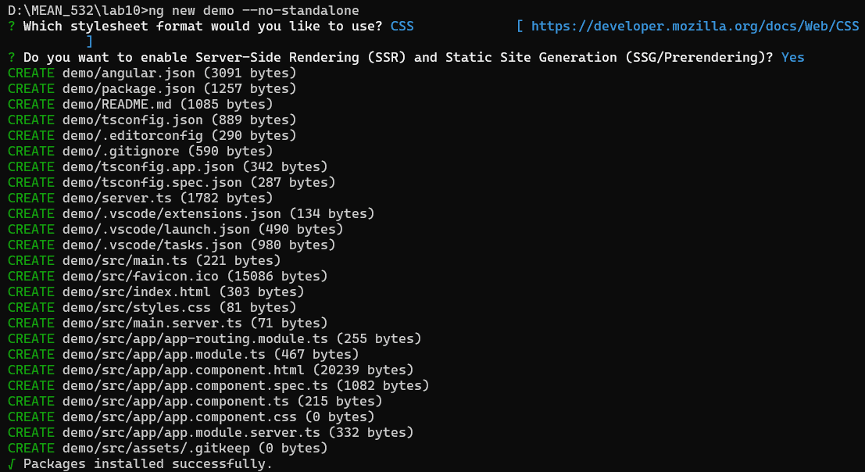

Create a folder for component product and create two files in the folder as product.component.ts and product.component.html

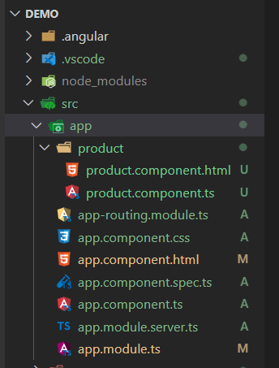

**product.component.ts**

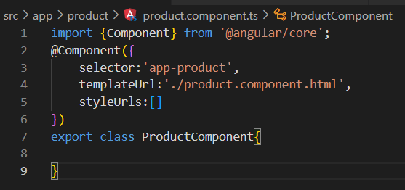

**app.module.ts**

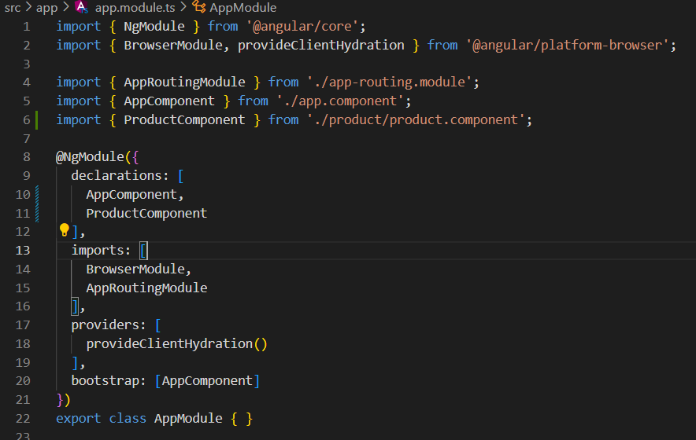

**product.component.html**



**app.componen.html**

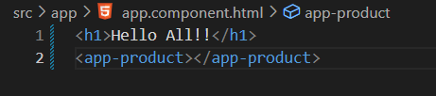

**Output:**

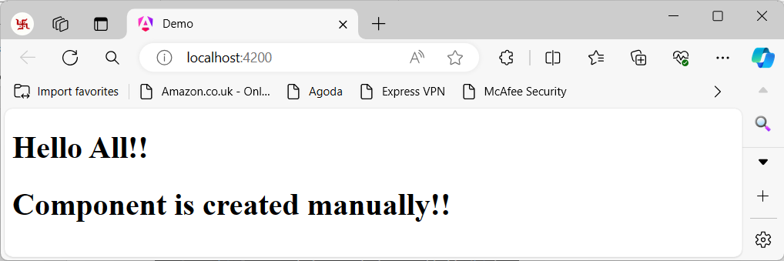

**Creating a component using angular CLI:**

>ng generate component <component-name>

where <component- name> is the name of your new component.

>ng g c <component-name>

By default, this command creates the following:

1. A directory named after the component
2. A component file, <component-name>.component.ts
3. A template file, <component-name>.component.html
4. A CSS file, <component-name>.component.css
5. A unit test specification file, <component-name>.component.spec.ts

