**Experiment-11**

**Aim:** Create an angular application to work with pipes

**Pipes:**

* Used to transform data before displaying it on in the browser.
* Pipes takes data as input and format or transform that data to some form.

**Syntax:** Expression | pipename[:parameters]

**Built-in Pipes:**

* CurrencyPipe
* DatePipe
* DecimalPipe
* JSONPipe
* LowercasePipe
* UppercasePipe
* PercentPipe
* SlicePipe
* AsyncPipe

**Program-1:**

**app.component.html**

<h1>{{name | uppercase}}</h1>

**app.component.ts**

import { Component } from '@angular/core';

@Component({

selector: 'app-root',

templateUrl: './app.component.html',

styleUrl: './app.component.css'

})

export class AppComponent {

name = 'angular';

}

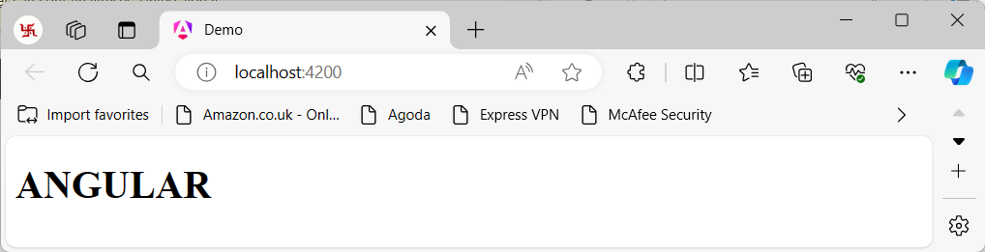

**Program-2:**

**app.component.html**

<h1>{{tutionFee | currency:'INR':'symbol'}}</h1>

**app.component.ts**

import { Component } from '@angular/core';

@Component({

selector: 'app-root',

templateUrl: './app.component.html',

styleUrl: './app.component.css'

})

export class AppComponent {

"tutionFee"=65000;

}

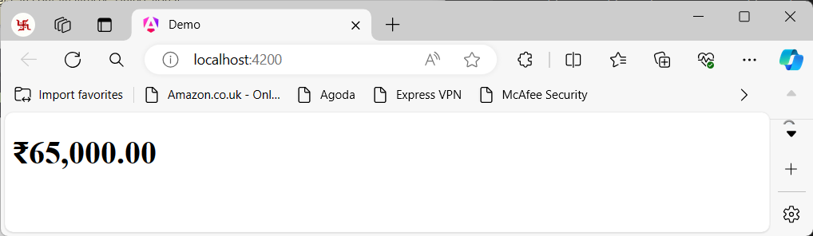

**Program-3:**

**app.component.html**

<h1>{{student | json}}</h1>

**app.component.ts**

import { Component } from '@angular/core';

@Component({

selector: 'app-root',

templateUrl: './app.component.html',

styleUrl: './app.component.css'

})

export class AppComponent {

student = {

"Name":"Manohar",

"RollNo":532,

"branch":"CSE",

"Fee":"65000 + 5000"

}

}

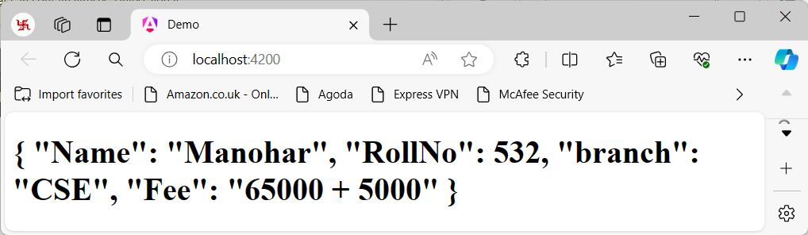

**Program-4:**

**app.component.html**

<h2>The hero's birthday is {{ birthday | date }}</h2>

**app.component.ts**

import { Component } from '@angular/core';

@Component({

selector: 'app-root',

templateUrl: './app.component.html',

styleUrl: './app.component.css'

})

export class AppComponent {

birthday = new Date(1999,9,10);//Oct 10, 1999

}

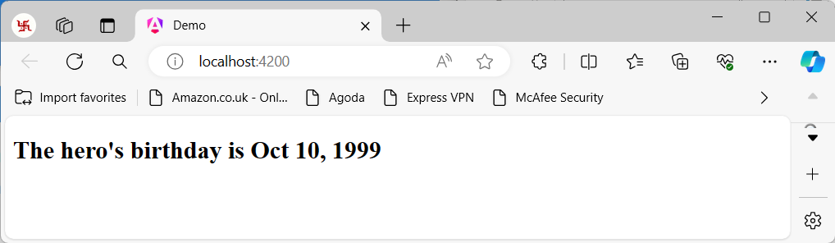

**Program-5:**

**app.component.html**

<h2>Original Number is {{ num }}</h2>

<h2>Percentage is {{ num | percent }}</h2>

**app.component.ts**

import { Component } from '@angular/core';

@Component({

selector: 'app-root',

templateUrl: './app.component.html',

styleUrl: './app.component.css'

})

export class AppComponent {

num = 0.972

}

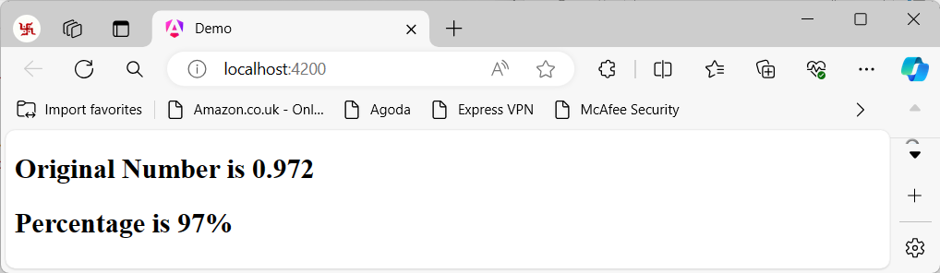

**Program-6:**

**app.component.html**

<h2>Original Array is "{{ arr }}"</h2>

<h2>Sliced Array is "{{ arr | slice:1:4 }}"</h2>

**app.component.ts**

import { Component } from '@angular/core';

@Component({

selector: 'app-root',

templateUrl: './app.component.html',

styleUrl: './app.component.css'

})

export class AppComponent {

arr = ['apple','mango','melon','orange','grape'];

}

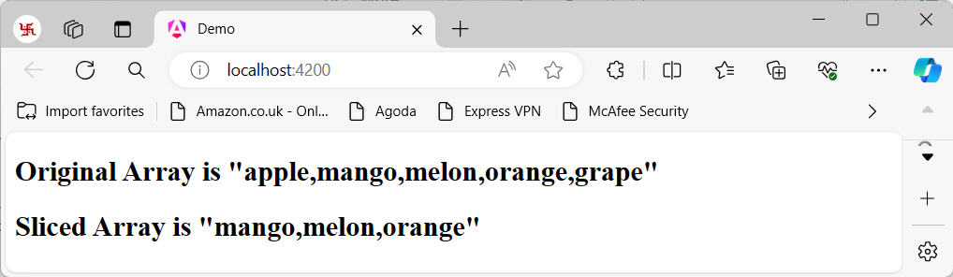

**Creating custom pipes:**

**Syntax:** ng generate pipe pipename (or) ng g p pipename

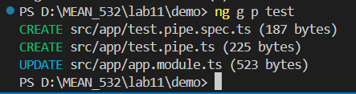

**app.component.html**

<h1>{{wish | test}}</h1>

**app.component.ts**

import { Component } from '@angular/core';

@Component({

selector: 'app-root',

templateUrl: './app.component.html',

styleUrl: './app.component.css'

})

export class AppComponent {

wish = "Good Morning!!";

}

**test.pipe.ts**

import { Pipe, PipeTransform } from '@angular/core';

@Pipe({

name: 'test'

})

export class TestPipe implements PipeTransform {

transform(value: unknown, ...args: unknown[]): unknown {

return "Hello Everyone!!..";

}

}

