**Experiment-12**

**Aim:** Create an angular application to work with directives.

**sample.html**

<html>

<script src="http://ajax.googleapis.com/ajax/libs/angularjs/1.4.8/angular.min.js">

</script>

<body>

<div ng-app=""><p>The calculated value is : {{ 5 + 5 * 8 / 2}}</p></div>

</body>

</html>

**Output:**

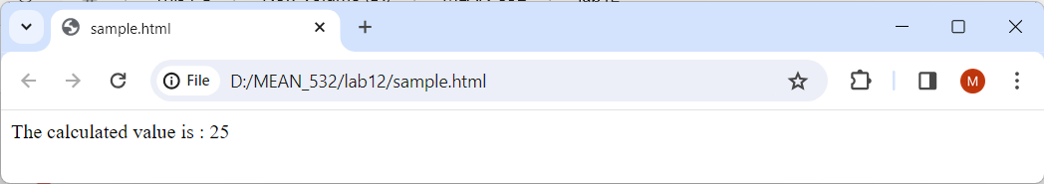

**init.html**

<html>

<script src="http://ajax.googleapis.com/ajax/libs/angularjs/1.4.8/angular.min.js">

</script>

<body>

<div ng-app="" ng-init="myText='Hello CSEA!'">

<h1>{{myText}}</h1>

<p>This is ng-init directive ,which can be used in the application.</p>

</div>

</body>

</html>

**Output:**

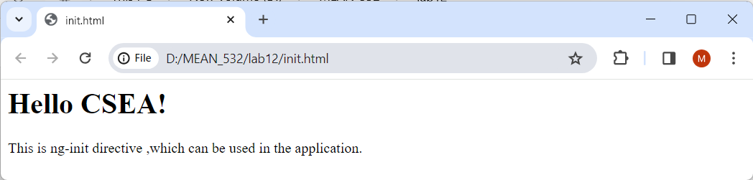

**model.html**

<html>

<script src="https://ajax.googleapis.com/ajax/libs/angularjs/1.6.9/angular.min.js">

</script>

<body>

<div ng-app="" ng-init="firstName='MEAN STACK'">

<p>Input something in the input box:</p>

<p>Name: <input type="text" ng-model="firstName"></p>

<p>You wrote: {{ firstName }}</p>

</div>

</body>

</html>

**Output:**

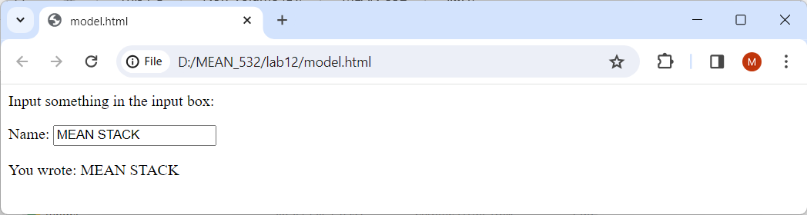

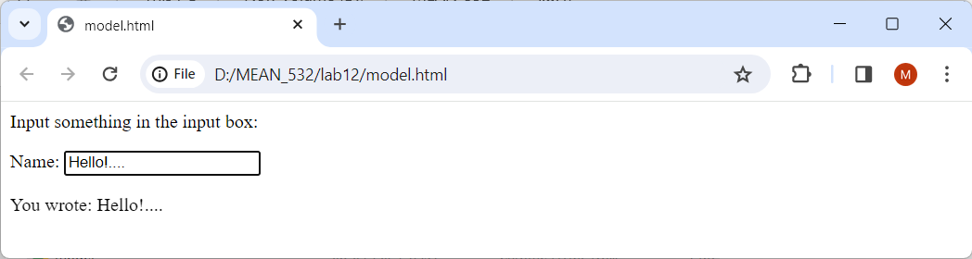

**repeat.html**

<html>

<script src="https://ajax.googleapis.com/ajax/libs/angularjs/1.6.9/angular.min.js">

</script>

<body>

<div ng-app="" ng-init="names=['Apple','Cherry','Avacado','Orange']">

<p>Looping with ng-repeat:</p>

<ul>

<li ng-repeat=" x in names ">{{ x }}</li>

</ul>

</div>

</body>

</html>

**Output:**

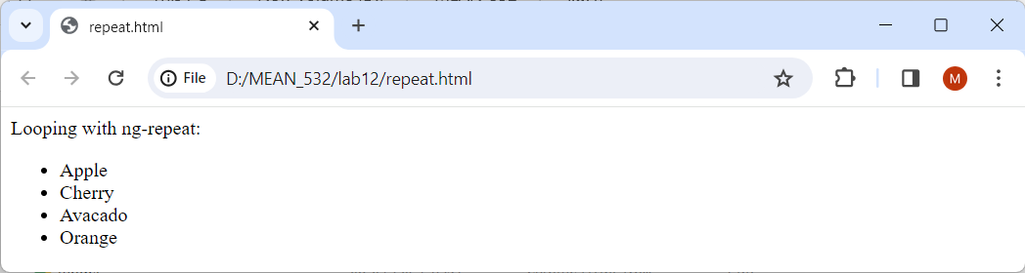

**if.html**

<html>

<script src="http://ajax.googleapis.com/ajax/libs/angularjs/1.4.8/angular.min.js">

</script>

<body ng-app="">

Keep HTML: <input type="checkbox" ng-model="myVar" ng-init="myVar = true">

<div ng-if="myVar">

<h1>Hello! ng-if</h1>

</div>

<p>If you uncheck the checkbox then DIV element will be removed.</p>

<p>If you check the checkbox then DIV element will return.</p>

</body>

</html>

**Output:**

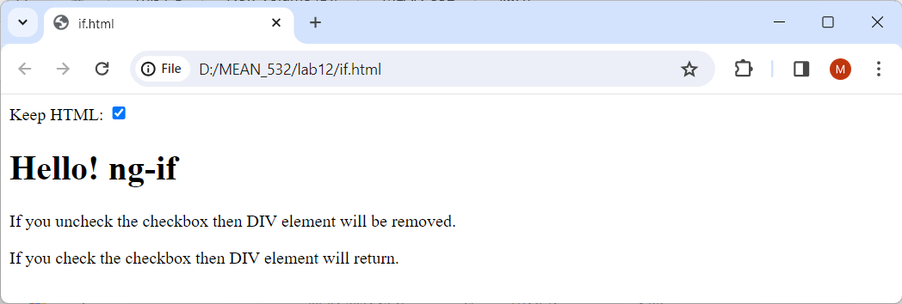

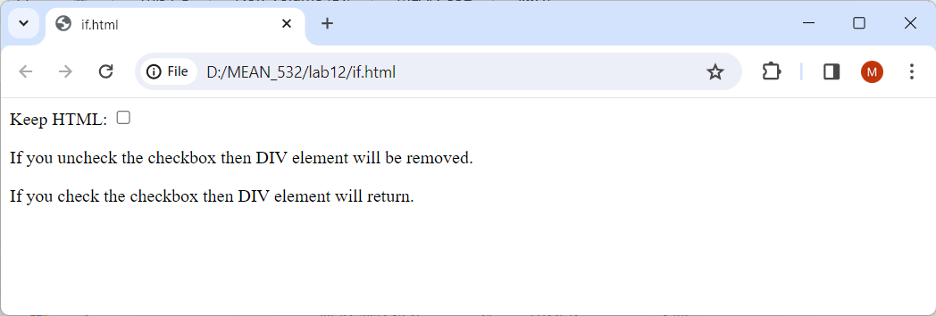

**class.html**

<html>

<script src="http://ajax.googleapis.com/ajax/libs/angularjs/1.4.8/angular.min.js">

</script>

<style>

.normal {

background-color: rgb(224, 173, 173);

padding: 20px;

font-family: 'Courier New';

}

.medium {

background-color: rgb(102, 183, 44);

padding: 30px;

font-family: 'Lucida Sans';

}

.advance {

background-color: rgb(248, 186, 93);

padding: 40px;

font-family: 'algerian';

}

</style>

<body ng-app="">

<p>Choose a class:</p>

<select ng-model="home">

<option value="normal">Normal</option>

<option value="medium">Medium</option>

<option value="advance">Advance</option>

</select>

<div ng-class="home">

<h1>Welcome CSE-A!</h1>

</div>

</body>

</html>

**Output:**

