**EXPERIMENT-3**

**AIM:** **Write Node JS program to create, access and modify an array.**

**PROGRAMS:**

**Creating an array:**

var arr = ['cat', 'dog', 'goat'];

console.log(arr);

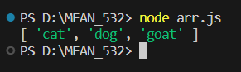

**Accessing through index:**

var arr = ['cat', 'dog', 'goat'];

console.log(arr[0]);

console.log(arr[1]);

console.log(arr[2]);

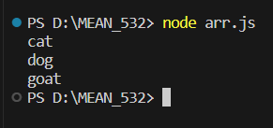

**Array functions:**

**indexOf()**

var arr = ['cat', 'dog', 'goat'];

console.log(arr);

var position = arr.indexOf("fish");

console.log(position);

console.log(arr.indexOf("goat"));

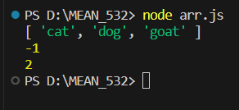

**lastIndexOf()**

var arr = ['cat', 'dog', 'goat','dog'];

console.log(arr);

var position = arr.lastIndexOf("fish");

console.log(position);

console.log(arr.lastIndexOf("dog"));

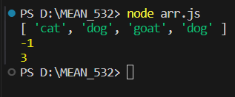

**push() and pop()**

const fruits = [];

fruits.push("banana", "apple", "melon");

console.log(fruits);

console.log(fruits.length);

fruits.push("grapes");

console.log(fruits);

console.log(fruits.pop());

console.log(fruits);

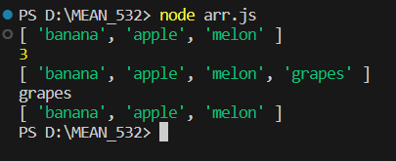

**unshift()**

var arr = ['cat', 'dog', 'goat','dog'];

console.log(arr);

arr.unshift("cow");

console.log(arr);

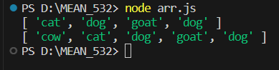

**shift()**

var arr = ['cat', 'dog', 'goat','dog'];

console.log(arr);

arr.shift();

console.log(arr);

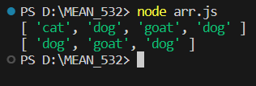

**sort()**

var arr = ['cat', 'dog', 'goat', 'dog', 'lion'];

console.log(arr);

console.log(arr.sort());

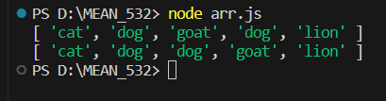

**reverse()**

var arr = ['cat', 'dog', 'goat', 'dog', 'lion'];

console.log(arr);

console.log(arr.reverse());

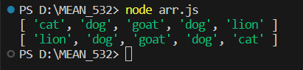

**concat()**

arr1 = ['orange', 'grapes'];

arr2 = ['mango', 'kiwi', 'apple'];

console.log(arr1);

console.log(arr2);

var new_arr = arr1.concat(arr2);

console.log("Concatenated array is", new_arr);

console.log("Concatenated array after sorting is", new_arr.sort());

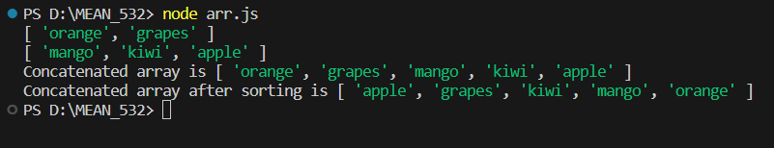

**forEach()**

arr = ['jack fruit', 'grapes', 'banana', 'apple'];

arr.forEach(function(i) {

console.log(i);

});

