**Experiment-5**

**Aim:** Install Express and create an application.

**Installation of Express:**

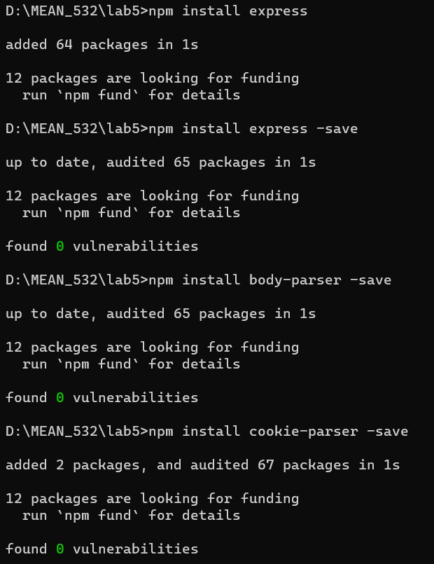

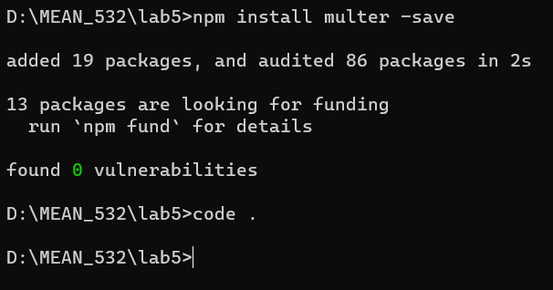

**sample.js**

var express = require('express');

var app = express();

app.get('/', function(req, res) {

res.send('<h1>Hello Everyone!.. WELCOME TO MST LAB!!</h1>');

})

var server = app.listen(8000, function() {

var host = server.address().address

var port = server.address().port

console.log("Sample app listening at http://%s:%s", host, port)

})

**Output:**

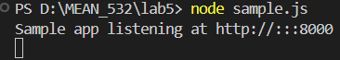

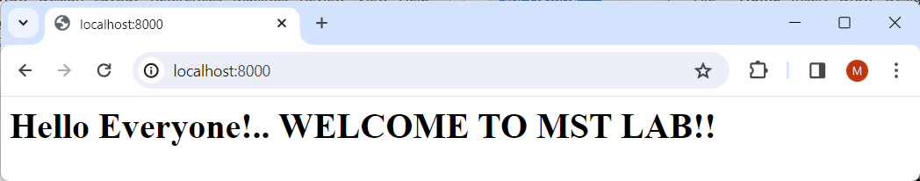

**book.js**

// Import required modules

const express = require('express');

// Create Express app

const app = express();

const port = 9000;

// Sample JSON data

const books = [

{ id: 1, title: 'The Adventures of Tom Sawyer', author: 'Mark Twain' },

{ id: 2, title: 'Treasure Island', author: 'Robert Louis Stevenson' },

{ id: 3, title: 'The Wings of Fire', author:'A.P.J.Abdul Kalam' },

{id:4,title:'Autobiography of an unknown india', author:'Niradh C. Chaudhari'}

];

// Route to get all books

app.get('/books', (req, res) => {

res.json(books);

});

// Route to get a specific book by ID

app.get('/books/:id', (req, res) => {

const id = parseInt(req.params.id);

const book = books.find(book => book.id === id);

if (book) {

res.json(book);

} else {

res.status(404).json({ error: 'Book not found' });

}

});

// Start the server

app.listen(port, () => {

console.log('Server running at http://localhost:%s/',port);

});

**Output:**

