**EXPERIMENT-9**

**AIM:** Create a simple angular application using Angular CLI and TypeScript

**ANGULAR:**

**Angular** is a front-end framework which is used to create web applications. It uses typescript by default for creating logics and methods for a class but the browser doesn’t know typescript. Here webpack comes in picture, webpack is used to compile these typescript files to JavaScript. In addition, there are so many configuration files you will need to run an angular project on your computer.

**ANGULAR CLI:**

**Angular CLI** is a tool that does all these things for you in some simple commands. Angular CLI uses webpack behind to do all this process.

**Installation of Angular CLI:**

To install the Angular CLI, open a terminal window and run the following command:

**>npm install -g @angular/cli**

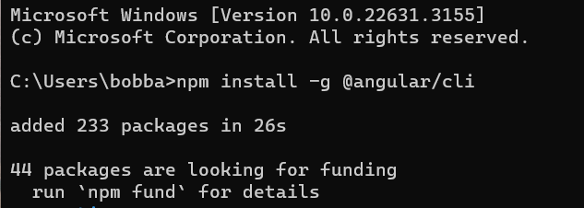

**Create a workspace and initial application:**

To create a new workspace and initial starter app:

Run the CLI command ng new and provide the name my-app, as shown here:

**>ng new SampleApp**

The ng new command prompts you for information about features to include in the initial app. Accept the defaults by pressing the Enter or Return key.

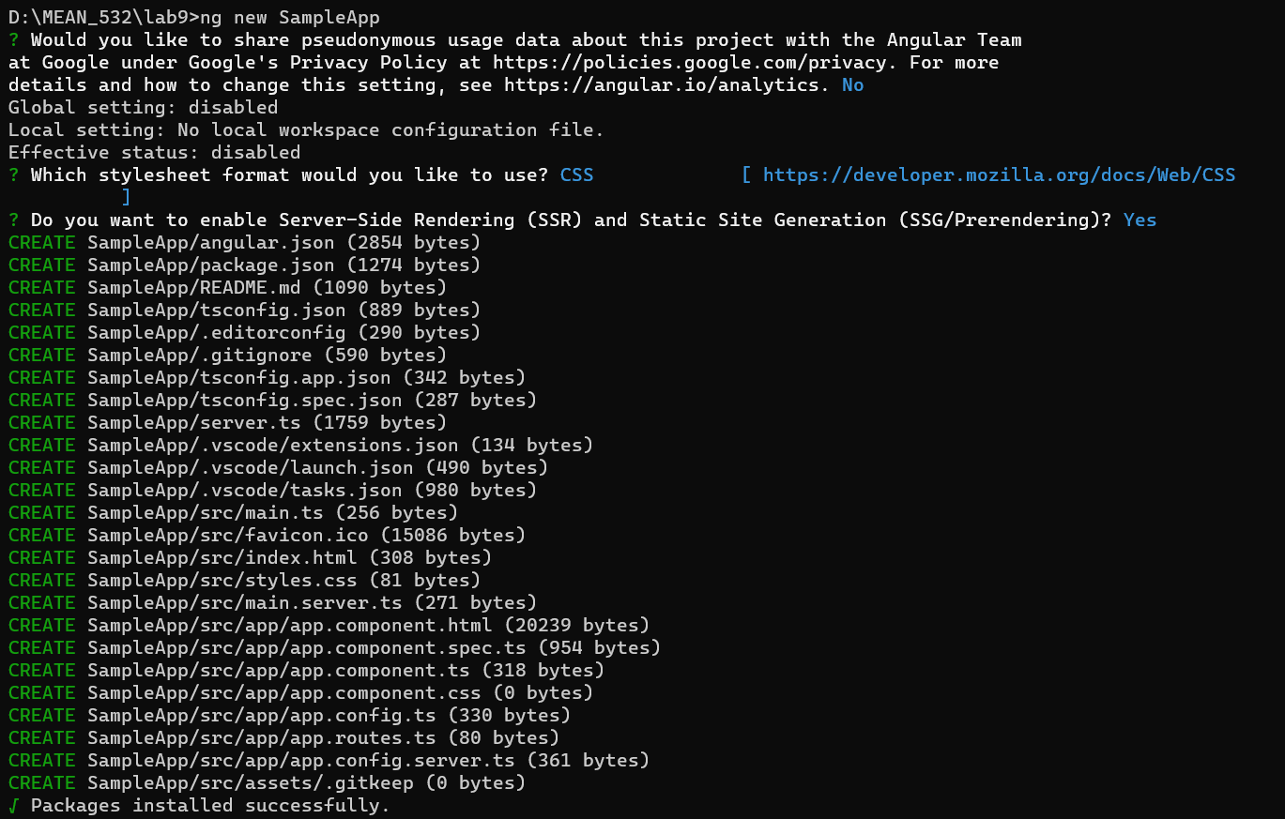

## Run the application:

**Angular CLI includes a server, for you to build and serve your app locally.**

Navigate to the workspace folder, such as my-app.

Run the following command:

**>cd SampleApp**

**>ng serve --open**

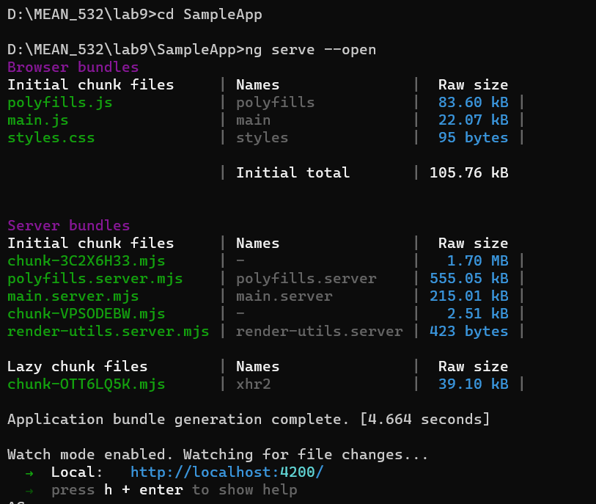

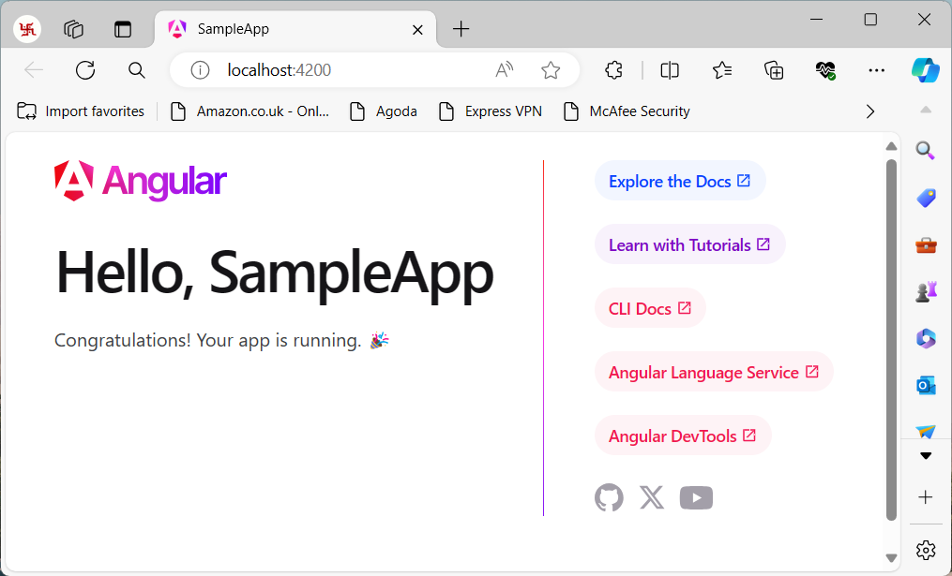

**Application using TypeScript and Angular CLI:**

VS code🡪File🡪Open Folder🡪Select the Folder🡪SampleApp🡪src🡪app🡪 app.component.html

