Assignment

**Question 1**

Write a python code for converting integer values to Indian currency notations, without

using the currency libraries

Example:

input: 504678

output: 5,04,67

**Solution code:**

def convert_to_indian_currency(number):

    # Convert the number to a string for further conversion

    number_str = str(number)

    formatted_number = ""

    if len(number_str) > 3:

        formatted_number = number_str[-3:]

        number_str = number_str[:-3]

        while len(number_str) > 2:

            formatted_number = number_str[-2:] + "," + formatted_number

            number_str = number_str[:-2]

        if number_str:

            formatted_number = number_str + "," + formatted_number

    else:

        formatted_number = number_str

    return formatted_number

number = 504678

print(convert_to_indian_currency(number)) # the output is converted here.

**Output** :

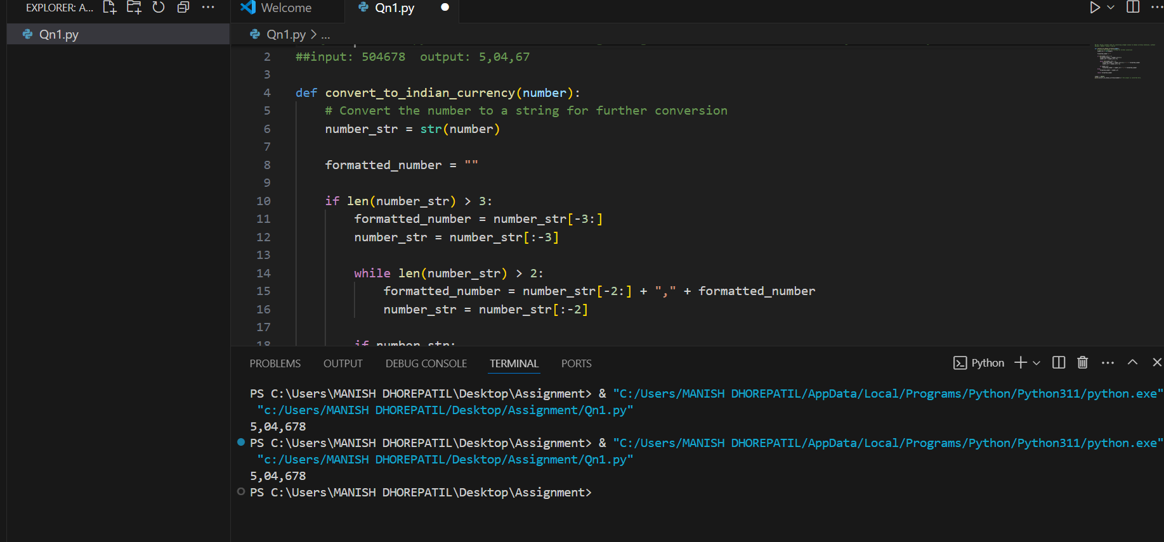

**Question 2** You won’t get caught if you hide behind someone.” Sang-Woo advises Gi-Hun to hide behind someone to avoid getting shot. Gi-Hun follows Sang-Woo's advice and hides behind Ali, who saved his life earlier. Gi-Hun and Ali both have the same height, K . Many players saw this trick and also started hiding behind Ali. Now, there are N players standing between Gi-Hun and Ali in a straight line, with the ith player having height Hi . Gi-Hun wants to know the minimum number of players who need to get shot so that Ali is visible in his line of sight.

Solution :

def count_obstructions(test_cases):

    results = []

    for i in range(test_cases):

        N, K = map(int, input().split())

        heights = list(map(int, input().split()))

        count = 0

        for height in heights:

            if height > K:

                count += 1

        results.append(count)

    # Output

    print("\n".join(map(str, results)))

if __name__ == "__main__":

    test_cases = int(input())  # Number of test cases for use

    count_obstructions(test_cases)

**output :**

