BAHRA ELECTRIC
RFP AUTOMATION
PORTAL
Technical Guide — understand it, set it up, run it

Version | 1.0
Date | July 2026
Audience | Developers, IT and system administrators
Classification | Confidential — internal use only

Note This guide is a plain-language companion to the full RFP Portal Technical Manual. It covers the same system at a level a new joiner can absorb in one sitting: what the system does, how the pieces fit together, and exactly how to get it running. It does not walk through the code file by file.

Document Control
Field | Detail
Document title | RFP Automation Portal — Technical Guide
Document number | BE-RFP-TG-002
Version | 1.0
Date | July 2026
Owner | Bahra Electric — IT Department
Classification | Confidential
Companion document | RFP Portal Technical Manual (BE-RFP-TM-001) — the deep engineering reference

Who should read this
If you are… | Start at
Completely new to the system | Part 1 — it explains what the system does and how work flows through it
A developer who has just been given the code | Part 1, then Part 3 to get it running on your machine
Supporting the live system | Part 4 (the server) and Part 5 (problems and fixes)
Looking for a specific detail | The full Technical Manual — it goes deeper than this guide

A note on secrets
Passwords, client secrets and signing keys are deliberately not printed anywhere in this document. Where a secret is needed, the guide names the setting and tells you where to obtain the value. Treat this file as confidential even so — it describes the system's internal layout.

Contents
Document Control 2
Who should read this 2
A note on secrets 2
Contents 3
Part 1 — Understanding the System 5
1. What This System Does 5
2. The Big Picture 6
3. How an RFP Travels Through the System 7
4. The Building Blocks 9
Part 2 — How It Works Inside 12
5. Where Everything Is Stored 12
6. Users, Roles and Permissions 13
7. The Outlook Reply Card 15
8. What Runs Automatically 16
Part 3 — Running It Yourself 17
9. Before You Start 17
10. Setting Up On Your Machine 17
11. Configuration — What To Set And Where 19
12. Checking That It Works 20
Part 4 — The Production Server 22
13. How Production Is Arranged 22
14. Managing The Service 23
15. Deploying An Update 23
16. Rolling Back 24
17. Where To Look When Something Breaks 25
Part 5 — Reference 26
18. Common Problems And Fixes 26
19. Known Limitations 26
20. The Folder Map 27
21. Glossary 28

Tip The contents list above is a Word field. Right-click it and choose Update Field → Update entire table to fill in the page numbers.

Part 1 — Understanding the System
What the system is for, who uses it, and how work flows through it.

1. What This System Does

1.1 The problem
Bahra Electric sells cable and electrical products to large buyers — Saudi Energy, Aramco, HADEED and others. Those buyers publish their purchase requests (RFPs — Requests for Proposal) on the SAP Ariba supplier portal.
Done by hand, every RFP means someone has to log in to Ariba, notice the new request, download a spreadsheet of the items being asked for, work out which of our products match, email the right product specialists, collect their prices and delivery times, gather the technical documents, and finally type all of it back into the portal before the deadline. Multiply that by four buyer organisations and it is slow, easy to miss, and easy to get wrong.

1.2 What the system does instead
The RFP Automation Portal does that whole loop by itself. A software robot signs in to the supplier portal on a schedule, finds new RFPs, downloads them, works out which of our products each line item refers to, and emails an interactive card to the colleague responsible for that product. That colleague types a price and a delivery time straight into the email, attaches any technical document, and presses Submit. The system stores the answer and then goes back into the supplier portal and fills the response in for them.
A web portal sits alongside it, so the same work can also be done on screen — and so managers can see every RFP, every response and every automated run in one place.

1.3 Before and after
Step | By hand | With the system
Noticing a new RFP | Someone must remember to check the portal | Checked automatically 4 times a day
Getting the item list | Download and open the spreadsheet manually | Downloaded and read automatically
Finding our matching product | Read each line and search the material list | Matched against the Material Master automatically
Reaching the right person | Work out who owns the product, then email them | Card emailed to the owner of that product line
Collecting the answer | Chase over email and collate replies | Answer captured from the card and stored
Responding on the portal | Retype everything into Ariba before the deadline | Filled in and submitted by the robot

2. The Big Picture
The system sits in the middle: people on one side, the services it depends on the other.
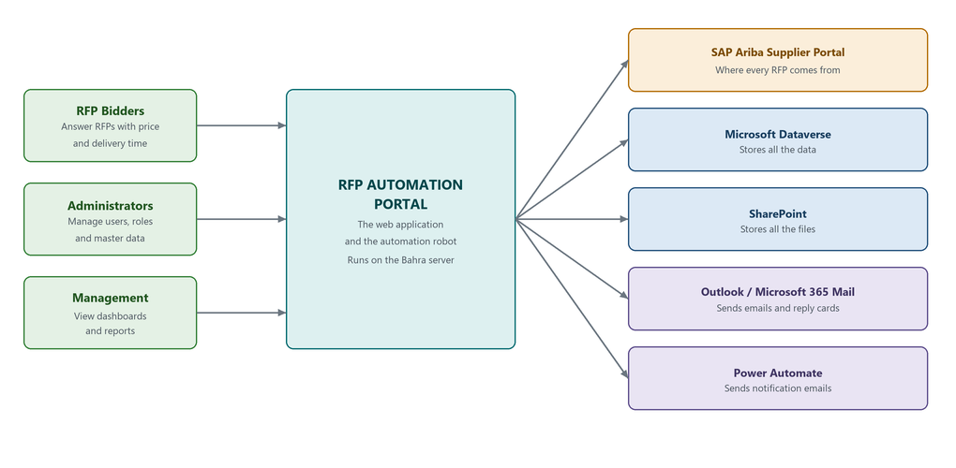
Figure 1 — The people who use the system and the services it connects to

2.1 The people
Who | What they do here
RFP bidders | Product specialists. They receive the card email and answer with a price and a delivery time, and upload technical or pricing documents.
Administrators | Create users, assign roles, maintain the material and keyword lists, and change system settings.
Management | Use the dashboard and analytics screens to see RFP volume, response rates and what the automation has been doing.

2.2 The outside services, and why each one is there
Service | What we use it for | Why this one
SAP Ariba | Reading new RFPs, downloading item lists, submitting and declining responses | It is the buyers' portal — the source of every RFP. There is no API, so the system drives it like a person would.
Microsoft Dataverse | Storing everything that is data: RFPs, responses, users, roles, settings, logs | It is the company's Microsoft data platform, already licensed and governed
SharePoint | Storing everything that is a file: item lists, technical data sheets, price documents, error evidence | Files belong in a document library where people can also open them normally
Microsoft 365 mail (Graph) | Sending the interactive card emails | The card has to be sent as raw email content, which only this path preserves
Power Automate | Sending plain notification emails and password-reset links | Simple, editable by the business without a code change
SAP Material Master | The reference list of our products, used for matching | It is the authoritative product list; it is exported into Dataverse

Note All the Microsoft services are reached with a single Azure application registration, historically named Bahra_SharePoint. One identity covers Dataverse, SharePoint, mail and card security. The name is misleading; the registration is not SharePoint-specific.

3. How an RFP Travels Through the System
This is the single most useful thing to understand. Everything else in the system exists to support these eight steps.
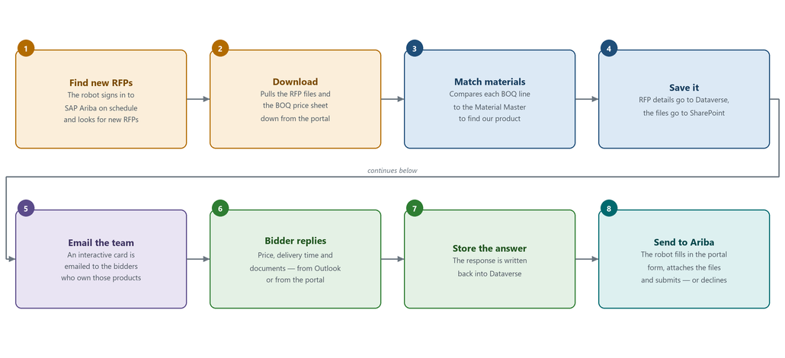
Figure 2 — The life of one RFP, from discovery to submission

3.1 The eight steps
Step 1 — Find new RFPs. Four times a day, Windows Task Scheduler tells the system to go looking. The system starts a real (but invisible) browser, signs in to SAP Ariba with the stored supplier account, and lists the RFPs for each buyer organisation.
Step 2 — Download. For each new RFP it exports the list to Excel and downloads the attachments — most importantly the BOQ (Bill of Quantities), the spreadsheet of line items the buyer wants priced.
Step 3 — Match materials. Each BOQ line is compared against our Material Master to work out which of our products it refers to. See section 3.3 — this matching is simpler than people expect.
Step 4 — Save it. The RFP header, its line items and the match results are written into Dataverse. The downloaded files are uploaded into a folder for that RFP in SharePoint.
Step 5 — Email the team. For every product line that matched, the system looks up who owns that product in the RFP Team list and emails them an Adaptive Card — an interactive form that renders inside Outlook.
Step 6 — Bidder replies. The bidder fills in price and delivery time. They can do it in the email itself, or open the portal, or use the upload link in the card to attach a technical data sheet or a price document.
Step 7 — Store the answer. The response comes back into the system and is saved against that RFP in Dataverse, along with a record of the files uploaded.
Step 8 — Send it to Ariba. When the responses are in, the robot opens the supplier portal again, walks through the multi-step response form, fills in the prices and delivery times, automatically attaches the technical files that were uploaded earlier, and submits. If we are not bidding, it declines instead.

3.2 What can happen differently
- Nothing matched. If no BOQ line matches any of our materials, nobody is emailed a card and a notification goes out instead. The match data is only as good as the Material Master.
- We decline. A bidder or an administrator can decline an RFP. The robot then clicks Decline on the portal rather than submitting.
- Nobody replied. Reminders can be sent from the Open RFPs screen. See section 19 — automatic reminders are currently not working.
- Something broke. If the robot hits an unexpected screen on Ariba it captures a screenshot and the page, bundles it up, and uploads it to SharePoint so it can be diagnosed later.

3.3 How material matching actually works
It is worth being precise about this, because the name suggests more intelligence than there is. Matching is not fuzzy. There is no score, no confidence value and no threshold to tune. The system does two things in order:
- If the 9-digit material code on the BOQ line is exactly equal to one in the Material Master, that is the match.
- Otherwise it checks whether the description contains a known keyword, or the keyword contains the description — plain substring containment in either direction — and takes the first hit it finds.
Important Because there is no scoring, a short or generic keyword such as CU can produce a confident but wrong match, and nothing in the system flags it. The only way to improve matching is to improve the Material Master and Keyword lists — there is no algorithm setting to turn up.

4. The Building Blocks
Reading top to bottom: something makes a request, IIS receives it, the application does the work, and the outside services are used as needed.
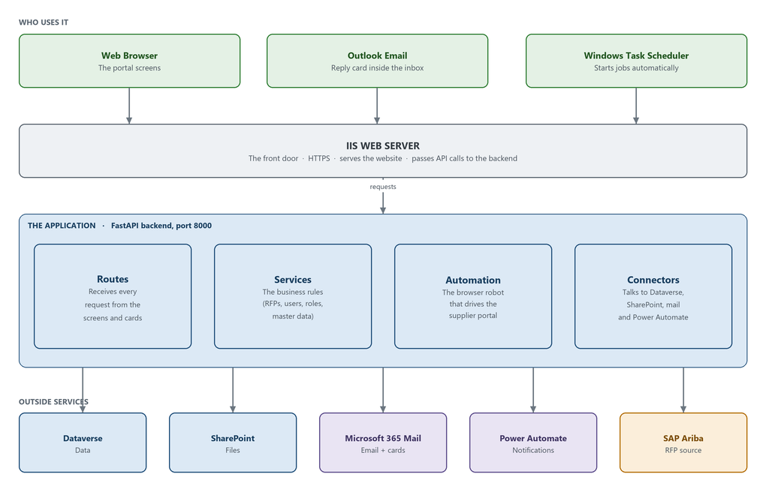
Figure 3 — How a request travels from the outside world into the application

4.1 The four parts of the backend
Part | What it is responsible for
Routes | The list of addresses the system answers on. Every screen action, every card reply and every scheduled trigger arrives here first. Routes do no real work themselves — they check permission and hand off.
Services | The business rules. What counts as a valid response, who is allowed to do what, how a user is created, how master data is imported, how the dashboard numbers are calculated.
Automation | The browser robot. This is the part that drives SAP Ariba: download, submit, decline and sync. It runs on its own background thread so the website stays responsive while a job is in progress.
Connectors | The plumbing to the outside: Dataverse, SharePoint, mail, Power Automate, plus shared jobs like signing upload links and logging failures.

4.2 The website
The screens are a single-page React application. In production it is built into static files and served by IIS; during development it runs on its own dev server that forwards API calls to the backend. The screens are:
Screen | Purpose
Dashboard | Headline numbers and recent activity
RFP Insights | Every RFP with filters, detail and export
Open RFPs | RFPs still awaiting a response; send reminders, delegate a product line
Analytics / Material Insights | Charts on volume, response rates and matched materials
Logs | What the automation did on each run
Admin → Users, Roles | User accounts and what each role is allowed to do
Admin → Master Data | Materials, keywords and the RFP team routing list
Admin → System Settings, Audit, SAP Logs | Runtime settings, the audit trail and supplier-portal credential history

4.3 What it is built with, and where each piece is used
Technology | Where it is used | Why
Python 3.10 | The whole backend | The automation and data libraries the project needs are Python-first
FastAPI | Every API address the system answers on | Fast to write, validates input automatically
Playwright | Driving SAP Ariba | Controls a real Chromium browser — required, because Ariba has no API
pandas / openpyxl | Reading BOQ spreadsheets | Handles both .xls and .xlsx reliably
MSAL | Signing in to every Microsoft service | Microsoft's own library for app-to-app tokens
React + TypeScript | All the screens | Standard, well-supported, typed
Vite | Building and serving the frontend | Fast builds and a dev server with API forwarding built in
Tailwind + Radix | The look of every screen | Consistent, accessible components without hand-written CSS
TanStack Query / Table | Loading and displaying data | Caching and large tables without custom code
IIS | The production front door | Already the company's web server; terminates HTTPS
Windows Task Scheduler | Starting jobs on a schedule | Runs on the server itself; no cloud dependency

Part 2 — How It Works Inside
Where the data lives, how people are let in, and what runs without anyone pressing anything.

5. Where Everything Is Stored
There is a clean split, and it is worth memorising: data goes to Dataverse, files go to SharePoint. Nothing important is stored on the server's own disk — the local folders are working space only.
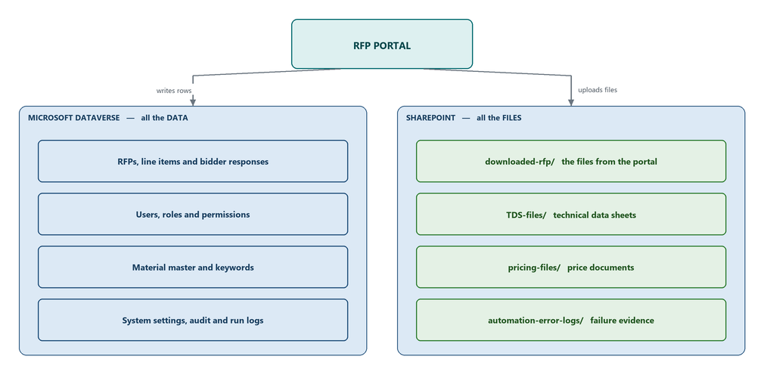
Figure 4 — The split between Dataverse and SharePoint

5.1 Dataverse — the data
Dataverse is Microsoft's managed data platform. Think of it as the database, except it is a service rather than a server we run. The tables group into five areas:
Area | What is kept there
RFPs and responses | The RFP record and its line items, the match results, each bidder's price and delivery time, delegations and reminder history
People and access | User accounts, roles, the permissions each role grants, and account status such as lockouts
Master data | The Material Master, the matching keywords, the RFP team routing list and the definitions of its columns
Settings | Runtime settings that can be changed from the portal without a code change, plus supplier-portal credentials
Logs | One row per automation run, a per-RFP activity timeline, and the security audit trail

5.2 SharePoint — the files
Every RFP gets its own folder tree in the SharePoint document library, so the files can also be opened by hand if needed.
Folder | Contents
ALLRFPs/{Company}/{RFP}/downloaded-rfp/ | What was downloaded from the supplier portal, including the BOQ
ALLRFPs/{Company}/{RFP}/TDS-files/ | Technical data sheets uploaded by bidders — these are attached automatically when the response is submitted
ALLRFPs/{Company}/{RFP}/pricing-files/ | Price documents uploaded by bidders
ALLRFPs/{Company}/{RFP}/rfp-upload-file/ | The completed spreadsheet used for submission
automation-error-logs/ | Screenshots and page captures from failed automation runs

5.3 Two things about Dataverse that catch everyone out
These two quirks are behind a large share of the confusing bugs in this system, so they are worth knowing before you touch any data code.
Important Table names in the API are not predictable. Dataverse invents a plural form for each table and it is not consistent — cr673_bahra_roles becomes cr673_bahra_roleses, while cr673_bahra_rfp_team becomes cr673_bahra_rfp_teams. Never guess it. Every table is therefore declared twice in the configuration — a real name and an API name — and the API name must be copied from what Dataverse reports, not derived.

Important Dates are already local time. Dataverse hands back timestamps that look like UTC (they end in Z) but are already Saudi local time. Converting them shifts every date by three hours. Read the numbers as they are and do not apply a timezone conversion.

6. Users, Roles and Permissions
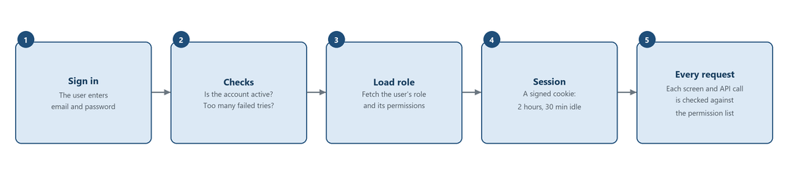
Figure 5 — From signing in to being allowed to do something

6.1 Signing in
The portal has its own user accounts — it does not use a Windows or Microsoft 365 login. When someone signs in, the system checks the password, checks the account is active and not locked, loads the permissions attached to that person's role, and issues a signed session cookie. Forgotten passwords are handled by emailing a link that is valid for 30 minutes.

6.2 Roles and permissions
Access is controlled by role, and a role is simply a named bundle of permissions. There are 42 individual permissions defined, covering things like creating a user, editing master data, running an automation job or revealing a stored secret. Two roles ship with the system and cannot be deleted:
Role | Gets
Admin | All 42 permissions, granted automatically — if a new permission is added to the system, Admin gets it without any change
RFP Bidder | 10 permissions — enough to see RFPs and respond to them, and nothing more

Any number of further roles can be created from the Roles screen and given whatever combination of permissions is needed.
Note Permissions are enforced on the server, not just hidden in the interface, so a hidden button cannot be worked around. Permission changes are cached for 5 minutes — if a change does not appear to take effect, wait or have the user sign in again.

6.3 Password and session rules
Rule | Value
Minimum password length | 8 characters
Must contain | At least one capital letter and one number
Password expires after | 90 days
Failed sign-ins before lockout | 5
Lockout lasts | 30 minutes
Session lifetime | 2 hours
Signed out after inactivity | 30 minutes
Password-reset link valid for | 30 minutes

7. The Outlook Reply Card
This is the feature people notice most, and the one with the most moving parts, so it gets its own section.

7.1 Why it exists
A bidder is a busy product specialist. Asking them to open a portal, sign in and find the right RFP adds friction and delays responses. Instead the email itself contains a small interactive form — an Adaptive Card — with the matched product lines, a box for the price, a box for the delivery time, and Submit and Decline buttons. It is answered without leaving Outlook.

7.2 The round trip
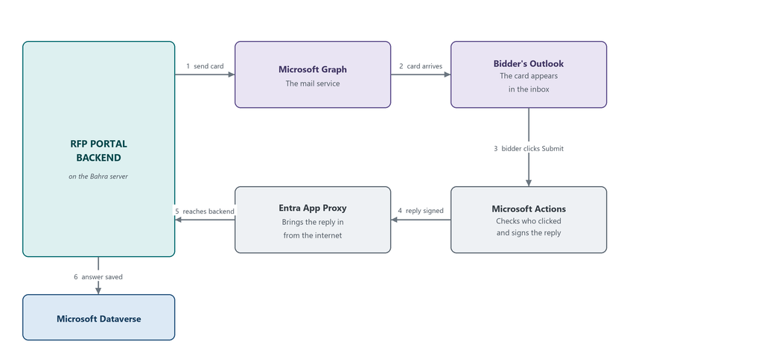
Figure 6 — How a click inside Outlook reaches the server
The interesting part is the return journey. The server sits inside the Bahra network with no inbound opening to the internet, yet Microsoft's service has to be able to deliver the reply. That is solved with Entra Application Proxy: a small connector on the server makes an outbound connection to Microsoft and replies come back down that same connection. No firewall port is opened and no public address is exposed.
Note The proxy must be set to Passthrough mode. If it is set to pre-authenticate, Microsoft's service is redirected to a sign-in page it cannot complete, and the buttons silently do nothing.

7.3 The upload link
The card also carries an Upload button. It opens a small page where the bidder can attach a technical data sheet or a price document — again with no login. The link is safe to send because it carries a signed token that names the specific RFP, recipient and product line, and expires after 72 hours. Files go straight into that RFP's SharePoint folder, up to 150 MB each.
Anything uploaded to the technical folder is picked up automatically when the response is submitted to Ariba, so the bidder never has to attach the same file twice.

8. What Runs Automatically
All recurring work is driven by Windows Task Scheduler on the server. The tasks do not do the work themselves — they call the application, which runs the job and reports back.
Job | Runs at | Allowed to take | What it does
Download | 00:00, 06:00, 12:00, 18:00 | 90 minutes | Finds and downloads new RFPs, matches materials, emails the cards
Sync | 03:00, 09:00, 15:00, 21:00 | 60 minutes | Re-reads the portal to update RFP status and deadlines

Important A finished job is not the same as a successful job. The runner reports success as long as it finished, so a run that did no useful work still looks clean. To confirm real work happened, check the automation log on the Logs screen, not just the scheduler history.

Part 3 — Running It Yourself
Everything needed to take the code and get a working system on your own machine.

9. Before You Start

9.1 Software you need installed
Item | Version | Note
Windows | 10 / 11 or Windows Server | Required. The system uses Windows-specific date handling and a Windows-only background mode for the browser robot. It will not run on Linux or macOS as-is.
Python | 3.10 | Other 3.x versions are untested against the pinned libraries
Node.js | 20 LTS | Comes with npm, which builds the frontend
Git | any | To pull the code

9.2 Access you need arranged before anything will work
The code on its own is not enough — the system is only useful when it can reach the company's services. Ask IT for the following before you begin:
- The Azure application registration details — tenant ID, client ID and client secret. One registration covers Dataverse, SharePoint and mail.
- Access to the Dataverse environment the application points at, so you can see the tables.
- Access to the SharePoint site used for RFP files.
- A portal user account for the RFP application itself, with the Admin role, so you can sign in once it starts.
- The SAP Ariba supplier credentials — but note these are read from Dataverse at runtime, not typed into a file.
Warning The application is configured to talk to a live company environment. Running the automation on your machine will reach the real supplier portal and can send real email. Confirm with the system owner which environment you are pointed at, and keep the email mode set to dev (section 11) while you are learning.

10. Setting Up On Your Machine
Six steps. Run everything from a PowerShell window at the repository root unless a step says otherwise.

Step 1 — Get the code
git clone <repository-url> RFP-automation
cd RFP-automation

Step 2 — Create the Python environment
The project expects a virtual environment in a folder called env at the repository root. Every command later assumes that exact location.
py -3.10 -m venv env

Step 3 — Install the backend libraries
env\Scripts\python.exe -m pip install -r backend\requirements.txt

Warning There are two requirements.txt files in the repository. Always use backend\requirements.txt. The older copy under backend\Support-Files\ is incomplete — a backend installed from it fails the moment it tries to read a spreadsheet.

Step 4 — Install the browser the robot drives
Playwright needs its own copy of Chromium. This is a separate download from the Python libraries and is easy to forget.
env\Scripts\python.exe -m playwright install

Step 5 — Install the frontend libraries
cd frontend
npm install
cd ..

Step 6 — Fill in the configuration
Open backend\config\config.py and set the values described in section 11. This file is not tracked in version control, so you will not receive it with the code and a later git pull will never overwrite it. Get the values from IT or copy them from an existing installation.

Running it
Two processes, in two terminals. The backend must be started from inside the backend folder — that is what puts its modules on the import path and anchors its working folders. Starting it from the repository root fails, or quietly writes files in the wrong place.
# Terminal 1 — the backend, on port 8000
cd backend
..\env\Scripts\python.exe dashboard_main.py

# Terminal 2 — the frontend dev server, on port 3000
cd frontend
npm run dev

Then open http://localhost:3000 and sign in. The dev server forwards all API calls to the backend on port 8000, so you only ever use port 3000 in the browser.
Note dashboard_main.py is the one and only entry point. It starts the API, the screens, the card callback and the automation, all in a single process. There is a second file called automation_main.py — it is legacy and nothing should be added to it.

11. Configuration — What To Set And Where
Configuration lives in two places, and knowing which is which saves a lot of confusion.
Where | What lives there | How it is changed
backend\config\config.py | Connection details that rarely change: the Azure app, the Dataverse address, table names, SharePoint locations, security rules | Edit the file. The application must be restarted — nothing re-reads this file while running.
System Settings screen | Values the business may need to change: email recipients, the public upload address, mail flow addresses and secrets | Change it in the portal. Takes effect after the settings cache refreshes, or immediately using the Reload Cache button.

11.1 The settings you must fill in
Setting | What it is | Where to get it
TENANT_ID | Your Microsoft tenant | Azure portal
CLIENT_ID | The application registration | Azure portal
CLIENT_SECRET | Its password | Azure portal — secret, never commit it
RESOURCE_URL | The Dataverse environment address | Power Platform admin centre
SHAREPOINT_HOSTNAME, SITE_PATH | Which SharePoint site holds the files | SharePoint
FLOW_URL | The notification email flow | Power Automate — copy the trigger address
FORGOT_PASSWORD_FLOW_URL | The password reset email flow | Power Automate
UPLOAD_TOKEN_SECRET | Signs the upload links | Any long random string — changing it breaks every link already sent
EMAIL_MODE | dev sends everything to one test address; prod sends to real recipients | Set to dev while developing

11.2 Settings worth knowing about
Setting | Default | Meaning
SESSION_TIMEOUT_SECONDS | 7200 | Session lifetime — 2 hours
IDLE_TIMEOUT_SECONDS | 1800 | Signed out after 30 minutes of inactivity
RBAC_CACHE_TTL_SECONDS | 300 | How long permissions are cached — why a role change can take 5 minutes
ACCOUNT_LOCKOUT_THRESHOLD | 5 | Failed sign-ins before lockout
ACCOUNT_LOCKOUT_DURATION_MINUTES | 30 | How long the lockout lasts
PASSWORD_MAX_AGE_DAYS | 90 | Password expiry
DASHBOARD_TTL_SECONDS | 300 | How long dashboard figures are cached

Important config.py contains real credentials and is deliberately kept out of version control. Never commit it, never paste it into a ticket, and never email it.

12. Checking That It Works
Work down this list. Each check proves the one before it.
# | Check | What a good result looks like
1 | curl http://localhost:8000/health | Reports healthy and shows Dataverse connected — this single check proves the Azure credentials work and that a table can be read
2 | Open http://localhost:3000 | The sign-in page appears
3 | Sign in with your portal account | The dashboard loads with figures on it — proves Dataverse reads are working end to end
4 | Open Admin → Master Data | Materials and keywords are listed
5 | Open an RFP and click its SharePoint link | The folder opens — proves the SharePoint connection
6 | Run a download job from the Automation screen | A browser window opens and drives the supplier portal, and a row appears on the Logs screen

Tip If step 1 fails, nothing else will work — fix it first. The usual causes are a wrong or expired client secret, or a RESOURCE_URL pointing at the wrong environment.

Part 4 — The Production Server
How the live system is arranged, and how to deploy, restart and roll it back.

13. How Production Is Arranged
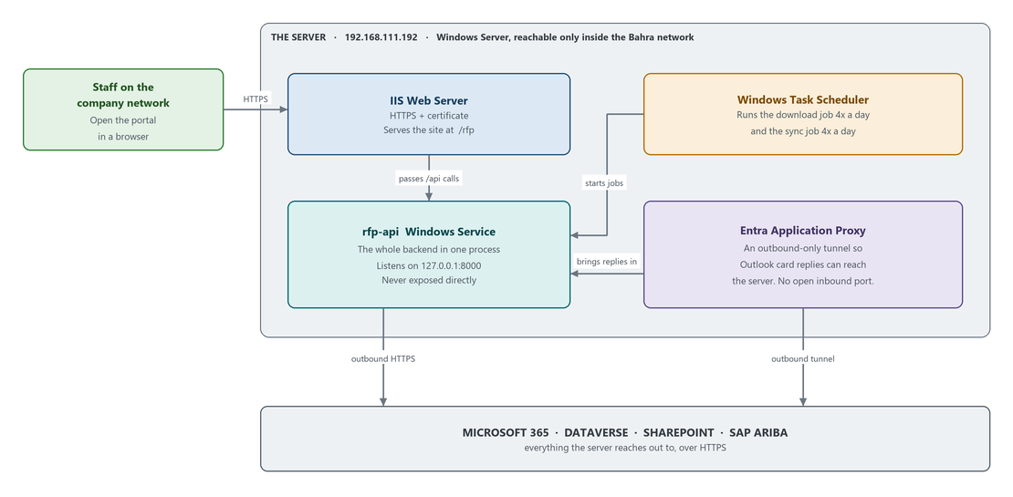
Figure 7 — The live system on the Bahra server
Item | Value
Server | 192.168.111.192 — Windows Server, reachable only from inside the Bahra network
Portal address | https://be-aramco-01.bahra-cables.com/rfp
Install folder | C:\Bahra-Automation-RFP-System
Backend | Runs as a Windows service called rfp-api, listening on 127.0.0.1:8000 only
Front door | IIS — terminates HTTPS and forwards API calls to the backend
Screens | The built React files, served straight from frontend\dist
Scheduling | Windows Task Scheduler, in the \Bahra-RFP\ folder
Card replies | Entra Application Proxy — an outbound-only tunnel

Important The portal is served at the /rfp path of a shared address, not on its own subdomain, because the same server also hosts the COA application. Never change COA's site, bindings or services — only the RFP site is in scope.

Note The install folder on the server is not the same path as a development machine. Every command in this part assumes C:\Bahra-Automation-RFP-System.

14. Managing The Service
One service runs everything — the API, the screens, the card callback and the automation jobs. There is no separate automation service.
# Check it
Get-Service rfp-api

# Restart it (needed after any config.py change)
Restart-Service rfp-api

# Prove the backend itself is alive
Invoke-WebRequest http://127.0.0.1:8000/health -UseBasicParsing

Important Editing config.py on the server does nothing until the service is restarted. This is the single most common cause of "I changed it and nothing happened".

15. Deploying An Update
Run every step from an elevated PowerShell session on the server, in order. Two files are not restored by a git pull and are the reason step 1 exists:
- config.py is untracked, so a pull leaves it alone — good.
- The IIS web.config is not in the repository at all, and npm run build deletes it every single time. Losing it takes the portal offline.
# 1. Record where you are, and save the IIS config
cd C:\Bahra-Automation-RFP-System
git rev-parse --short HEAD # write this down for rollback
Copy-Item frontend\dist\web.config $env:TEMP\web.config.bak

# 2. Stop the service and confirm it really stopped
Stop-Service rfp-api
Get-Service rfp-api # Status must be Stopped

# 3. Pull the new code
git pull

# 4. Update the Python libraries
.\env\Scripts\python.exe -m pip install -r backend\requirements.txt

# 5. Rebuild the screens - stop here if the build fails
cd frontend
npm install
npm run build
if ($LASTEXITCODE -ne 0) { throw 'frontend build failed - do not start' }
cd ..

# 6. Put the IIS config back into the freshly built folder
Copy-Item $env:TEMP\web.config.bak frontend\dist\web.config

# 7. Start
Start-Service rfp-api

15.1 Then verify
Check | Expected
Invoke-WebRequest http://127.0.0.1:8000/health | Healthy, Dataverse connected
Get-Service rfp-api | Running
Open the portal over HTTPS from a network machine | The sign-in page renders — this is what proves web.config was restored
Get-ScheduledTask -TaskPath '\Bahra-RFP\' | Both tasks present and Ready
Trigger one automation job by hand | It completes and writes a row to the automation log

Note If a release changed config.py, the restart in step 7 is what makes it take effect. Neither the Application Proxy nor its connector is affected by a code deployment.

16. Rolling Back
Use the commit you recorded in step 1.
Stop-Service rfp-api
cd C:\Bahra-Automation-RFP-System
Copy-Item frontend\dist\web.config $env:TEMP\web.config.bak

git checkout <the-commit-you-wrote-down>
.\env\Scripts\python.exe -m pip install -r backend\requirements.txt

cd frontend ; npm install ; npm run build ; cd ..
Copy-Item $env:TEMP\web.config.bak frontend\dist\web.config

Start-Service rfp-api

Note Restarting during an automation run abandons that run. Nothing is corrupted — the RFP is left as it was and the next scheduled trigger picks it up — but avoid restarting while a submission is in flight.

17. Where To Look When Something Breaks
Start with the top of this list and work down. The first three answer most questions.
Look at | Where | Tells you
Logs screen | In the portal | What each automation run did, how many RFPs it handled, and the error summary
Health check | /health | Whether the backend is alive and can reach Dataverse
Service output log | Path set in the service's XML file | Request log, crashes and full error traces
Scheduler log | backend\LOGS\scheduler\ | One line per trigger — proves whether a scheduled job actually fired
Robot evidence | backend\LOGS\ | Screenshots and page captures from the moment a portal step failed
Failure bundles | SharePoint automation-error-logs/ | The same evidence, uploaded so it can be shared
Windows Event Log | Applications → rfp-api | Service start, stop and crash codes
Task Scheduler history | \Bahra-RFP\ | Whether the trigger fired and what it returned
Audit log screen | In the portal | Who signed in, who changed a user, a role or a setting

Part 5 — Reference

18. Common Problems And Fixes
Symptom | Cause and fix
A config change had no effect | Nothing re-reads config.py while running. Restart-Service rfp-api.
A scheduled run reports success but processed nothing | Playwright installs its browser per Windows account, and the service runs as a system account. Install Chromium for the account the service runs as. Re-check after every Playwright upgrade.
The portal loads but every request fails after a rebuild | npm run build erased the IIS web.config. Put it back.
Card buttons appear but clicking does nothing | The Application Proxy is set to pre-authenticate. It must be Passthrough.
A query on a new table returns nothing | The API table name is wrong. Ask Dataverse for the real one and correct the _API value in config.py — never guess it.
A permission change is not taking effect | Permissions are cached for 5 minutes. Wait, or have the user sign in again.
Emails only arrive at one test address | EMAIL_MODE is set to dev. Set it to prod and confirm the recipients in System Settings.
Card links or upload links stopped working | The public address changed. Update the callback address and the upload address, then restart the service.
Setup script reports "column already exists" | Dataverse reports this as a plain error rather than a conflict. The setup scripts are safe to re-run — it can be ignored.
An automation job appears stuck and will not start again | The "job is running" flag lives in memory only. Restarting rfp-api clears it.

19. Known Limitations
These are real, current and deliberately listed. Do not tell users a feature works when it appears in this table.
Item | What it means | Status
Automatic reminder emails do not send | Deadline reminder emails are not going out. Manual reminders from the Open RFPs screen are the only reliable route. | Open
The Schedule Automation screen does nothing | Saving a schedule in the portal appears to succeed but changes nothing. The real schedule is owned by Windows Task Scheduler, which that screen does not control. | Open
The card callback is published more broadly than intended | To make the card reply work, the published address covers the whole site rather than just the callback. Neighbouring addresses may therefore be reachable from outside. | Open — highest-priority security item
Material matching is not fuzzy | Exact code match, then plain substring containment. A short keyword can give a confident but wrong match. Only the master data can be improved — there is no setting to tune. | By design
The Dataverse environment carries a UAT name | The environment serving production has a UAT-style name. Confirm this is intended before any deployment. | Open
Two requirements.txt files exist | backend\requirements.txt is the correct one. The copy under Support-Files\ is an incomplete leftover. | Open
No automated tests | There is no test suite in the repository. Changes must be verified by hand. | By design
The RBAC tables cannot be recreated from code | The four access-control tables exist in Dataverse, but the script that created them has been removed. A brand-new environment would need them built by hand. | Open

20. The Folder Map
Enough to find your way around. Folders, not files.
Folder | What is in it
backend\routes\ | The addresses the system answers on
backend\services\ | The business rules
backend\rfp\ | The browser robot — download, submit, decline, reminders
backend\helpers\ | Connections to Dataverse, SharePoint, mail and Power Automate
backend\core\ | Shared utilities and activity logging
backend\middleware\ | The permission checks applied to requests
backend\config\ | Configuration — not in version control
backend\Support-Files\ | One-off setup and migration scripts. Not used by the running application.
backend\LOGS\, ALLRFPs\, automation-error-logs\ | Working folders created at runtime. Nothing here is the system of record.
frontend\src\pages\ | One file per screen
frontend\src\components\ | Reusable interface pieces
frontend\dist\ | The built site IIS serves — holds the IIS web.config
scripts\ | The PowerShell scripts that register and trigger the scheduled jobs
docs\ | The full documentation set

21. Glossary
Term | Meaning
Adaptive Card | The interactive form that renders inside an Outlook email, letting a bidder answer without opening the portal
Ariba | SAP's supplier network — the portal every RFP comes from
BOQ | Bill of Quantities — the spreadsheet of line items the buyer wants priced
Dataverse | Microsoft's managed data platform; this system's database
Entra ID | Microsoft's identity service, previously called Azure Active Directory
Application Proxy | An Entra service that lets an internal server receive traffic through an outbound-only tunnel
Passthrough | The Application Proxy mode that does no sign-in check — required here
Playwright | The library that drives a real browser against the supplier portal
RBAC | Role-Based Access Control — permissions bundled into roles
RFP | Request for Proposal — the buyer's invitation to quote
TDS | Technical Data Sheet — the product document attached to a response
TIR | Technical Information Requirement — a document the bidder uploads for a product line
WinSW | The wrapper that runs the backend as a Windows service

End of document

