

RFP Portal User Manual
Bahra Electric
Version 1.0 | June 2026
Audience: All Users — Administrators and RFP Bidders

Table of Contents
Table of Contents 2
1. Introduction 6
1.1 Document Conventions 6
2. System Overview 7
2.1 Who Uses the Portal 7
2.2 How the System Works (End to End) 7
2.3 Roles and Permissions 7
3. Getting Started 9
3.1 Logging In 9
3.2 Forgot Password 9
3.3 Navigation Overview 10
4. Dashboard 12
4.1 Metric Cards 13
4.2 RFP Management Section 13
4.3 RFP Table 14
Match % Column Details 14
Available Actions by Status 15
4.4 Sync Portal 15
5. Key Workflows 16
5.1 Submit an RFP 16
5.2 Decline an RFP 17
5.3 Download RFPs 18
5.4 Download RFP Excel File 18
5.5 Respond to RFP Email (Adaptive Card) 19
5.5.1 Uploading TIR and Pricing Files 19
6. RFP Insights 21
6.1 Stats Overview 21
6.2 Advanced Filters 21
6.3 Column Visibility 21
6.4 Results Table 21
7. Open RFP Tracker 22
7.1 Open RFP Table 22
7.2 Response Detail 23
7.3 Sending Reminders 23
7.4 Delegating a Response 24
8. Material Insights 25
8.1 Stats Overview 25
8.2 Tabs: Materials vs Keywords 25
8.3 Charts 25
8.4 Filters 25
8.5 Expandable Table 25
9. Activity Logs 27
9.1 Statistics Cards 27
9.2 Controls 27
9.3 Run Cards 27
9.4 Run Detail Modal 28
10. Analytics 29
10.1 Key Metrics 29
10.2 Interactive Charts 29
10.3 Participation by Company 29
11. Administration (Admin Only) 30
11.1 User Management 30
Creating a User 31
Editing, Unlocking, or Deleting a User 31
11.2 Role & Permission Management 31
Creating or Editing a Role 31
11.3 Audit Trail 32
11.4 Master Data 32
11.4.1 Material Codes 32
11.4.2 Keywords 32
11.4.3 RFP Team 32
11.4.4 Column Configuration 33
11.5 System Settings 33
11.6 SAP Password Logs 33
12. Automation Settings 33
12.1 Schedule Automation 34
12.2 Change SAP Password 34
13. Profile Settings 35
13.1 Update Profile Information 35
13.2 Change Password 35
14. Automation Status Indicator 36
15. Quick Reference 37
15.1 Status Colors 37
15.2 Match % Thresholds 37
15.3 Quick Action Buttons 37
15.4 Automation Run Statuses 37
15.5 Supported Companies 38
15.6 Tips and Shortcuts 38
15.7 Roles at a Glance 38
15.8 Administration Quick Reference 38
16. Troubleshooting and FAQ 40
I can’t log in 40
The dashboard shows no data 40
RFP submission failed 40
I don’t see certain menu items 40
My session expired 40
The Submit/Decline button is grayed out 40
I entered an RFP ID but got an error in the Submit/Decline dialog 41
Excel download is not working 41
How do I know if my Adaptive Card response was saved? 41
How do I change my display name? 41
Can I use the portal on a mobile device? 41
I'm an administrator but can't see the Users or Roles pages 41
How do I give a user access to a new page? 41
A new user can't log in 42
Changes I made in System Settings aren't taking effect 42
Why didn't a team member receive an RFP email? 42
Appendix A: Glossary 43
Appendix B: Permission Reference 43

Note: To update this table of contents in Microsoft Word, right-click anywhere in the table above and select 'Update Field', then choose 'Update entire table'.

1. Introduction
The Bahra Electric RFP Portal is a web-based system that automates the end-to-end management of Requests for Proposal (RFPs) across multiple supplier portals. It discovers and downloads RFPs from company portals, matches their line items against your material master and keywords, routes them to the right bidders by email, lets your team submit or decline directly from the portal, and records every action with a full audit trail — all from a single dashboard. The portal serves two kinds of users: general users (RFP Bidders) who work with RFPs day to day, and administrators who manage users, roles, reference data, and system configuration.
What you can do with this portal:
- View all downloaded RFPs organized by company and status
- Submit or decline RFPs with automated portal interaction
- Track material and keyword matches for each RFP
- Monitor automation runs and review activity logs
- View analytics and participation reports
- Download RFP Excel files for offline review
- Receive email notifications with interactive Adaptive Cards in Outlook
Administrators can additionally:
- Manage user accounts, roles, and granular permissions
- Maintain material codes, keywords, and RFP team assignments
- Configure system settings, schedules, and SAP credentials
- Review complete audit trails of every user action

Supported Companies:
- Saudi Electricity Company
- Aramco e-Marketplace
Browser Requirements:
Google Chrome (latest version recommended) is the supported browser for the RFP Portal.

1.1 Document Conventions
The following conventions are used throughout this manual:
- Bold text indicates a clickable user interface element (button, menu item, or link).
- Italic text indicates user-entered values or field names.
- "Tip:" prefixed paragraphs provide helpful shortcuts or best practices.
- "Important:" prefixed paragraphs highlight critical warnings or restrictions.
- Figures are numbered sequentially and captioned below each screenshot.

2. System Overview
This section explains what the portal does from end to end and how access is controlled. It is useful for both administrators and general users.

2.1 Who Uses the Portal
The portal serves two broad audiences:
- General Users (RFP Bidders) — work with RFPs day to day: view the dashboard, download RFPs, submit or decline them, respond to RFP emails, and track open RFPs.
- Administrators — additionally manage the system: user accounts, roles and permissions, reference (master) data, system settings, automation schedules, and audit history.
What each user can see and do is controlled by their assigned role. If a menu item or button described in this manual does not appear for you, your role does not include that permission — contact your administrator.

2.2 How the System Works (End to End)
A typical RFP flows through the system as follows:
- Discover & Download — The automation signs in to the supplier portals (for example, Saudi Electricity Company and Aramco e-Marketplace) and downloads new RFPs and their Bill of Quantities (BOQ) files.
- Match — Each RFP's line items are matched against the Material Master and Keywords maintained under Master Data, producing a Match % that indicates relevance to your catalogue.
- Notify & Route — The team members configured under RFP Team receive an Outlook email with an interactive Adaptive Card for the products they own.
- Respond — Bidders enter results and remarks in the card (or via the secure upload page) and submit. The Open RFP page tracks who has and hasn't responded, with reminders and delegation.
- Submit or Decline — From the dashboard, a bidder uploads the completed Excel (and optional technical PDFs) and the automation submits the RFP on the portal — or declines participation.
- Audit — Every login and every create, edit, or delete action is recorded in the Audit Trail, and every automation run is recorded in Activity Logs.

2.3 Roles and Permissions
Access is governed by Role-Based Access Control (RBAC). Each user is assigned one role, and each role grants a set of granular permissions (for example, Submit RFP or Edit Users). Permissions are independent — granting an edit permission does not automatically grant the matching view permission; each is assigned explicitly.
The system ships with two built-in (system) roles that cannot be deleted:
Role | Typical User | Access
Admin | Administrators / IT | Full access to every page and action, including all administration features.
RFP Bidder | Buyers / bidders | Dashboard, RFP Insights, Material Insights, Activity Logs, and Open RFP; can download, submit, decline, and delegate RFPs. No access to administration pages.
Administrators can create additional custom roles with any combination of permissions (see section 11.2, Role & Permission Management). A complete list of permissions is provided in Appendix B.
Tip: Your role name is shown on your Profile page. The sidebar only displays the menu items and quick actions your role permits.

3. Getting Started

3.1 Logging In
- Open the RFP Portal URL https://be-erpapp-01.bahra-cables.com/rfp/ in your browser.
- You will see the Login page with the Bahra Electric logo and "RFP Automation System" heading.
- Enter your Email address in the email field.
- Enter your Password in the password field.
- Optionally, check Remember me to stay signed in.
- Click Sign In.
After logging in, you will be redirected to the Dashboard page.
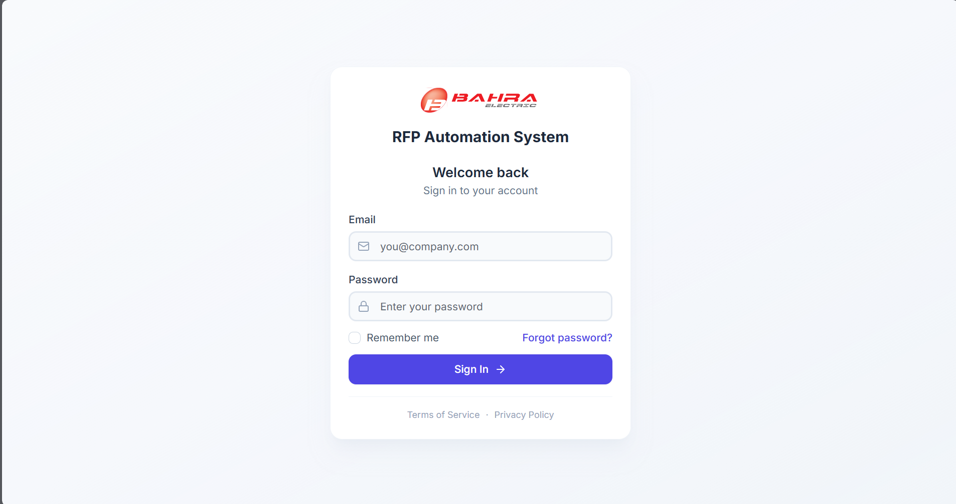
Figure 1: Login Page

3.2 Forgot Password
If you forget your password, follow these steps:
- On the Login page, click "Forgot password?" (located to the right of the Remember me checkbox).
- A dialog will appear asking for your email address.
- Enter the email associated with your account.
- Click Send Reset Link.
- Check your email inbox for a password reset link.
- Click the link in the email and follow the instructions to set a new password.
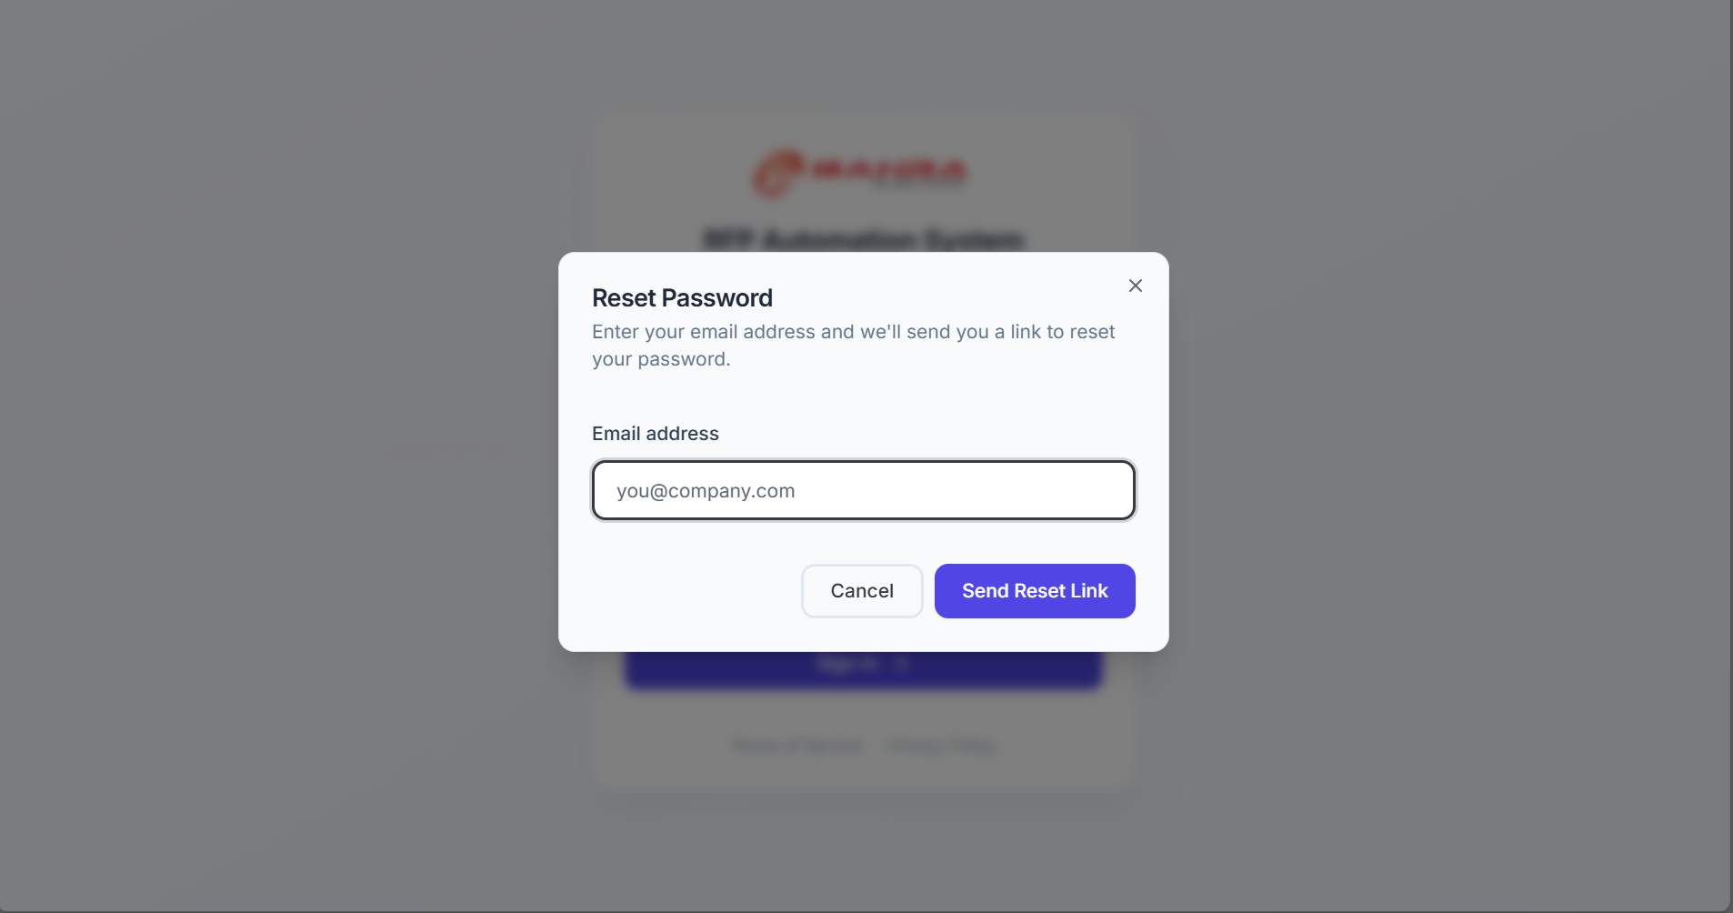
Figure 2: Forgot Password Dialog

3.3 Navigation Overview
After logging in, you will see two main areas:
Left Sidebar
Your main navigation panel containing menu items, quick actions, and an automation status indicator.
Section | Item | Description
Menu | Dashboard | Overview of RFP metrics, company tabs, and automation status
 | RFP Insights | Detailed, filterable view of all RFPs across companies
 | Material Insights | Material and keyword matching analysis
 | Activity Logs | History of automation runs with step-by-step details
 | Open RFP | Track who has and hasn't responded to RFP emails; send reminders
Administration  (Admins) | Users | Create, edit, and manage user accounts and role assignments
 | Roles | Create roles and assign granular permissions
 | Audit Logs | Authentication, user, role, and system event history
 | Analytics | Visual charts and drill-downs of RFP activity
 | SAP Logs | History of SAP credential changes
 | Master Data | Material codes, keywords, RFP team, and column configuration
 | System Config | Email recipients and system configuration settings
Quick Actions | Download RFPs | Download (scrape) RFPs from company portals
 | Submit RFP | Submit an RFP with file uploads
 | Decline RFP | Decline participation in an RFP
Settings  (Admins) | Schedule | Configure an automated RFP download schedule
 | SAP Password | Update the SAP portal credentials used by automation
Status Footer | Automation Status | Shows whether automation is Ready or Running, with live progress

The sidebar can be collapsed by clicking the arrow icon at the top-right corner of the sidebar, and expanded again by clicking the expand arrow. When collapsed, hovering over icons shows tooltip labels.
Top Header
Displays the page title, description, and page-specific action buttons. The header also includes a user profile dropdown with options to view your profile or log out.
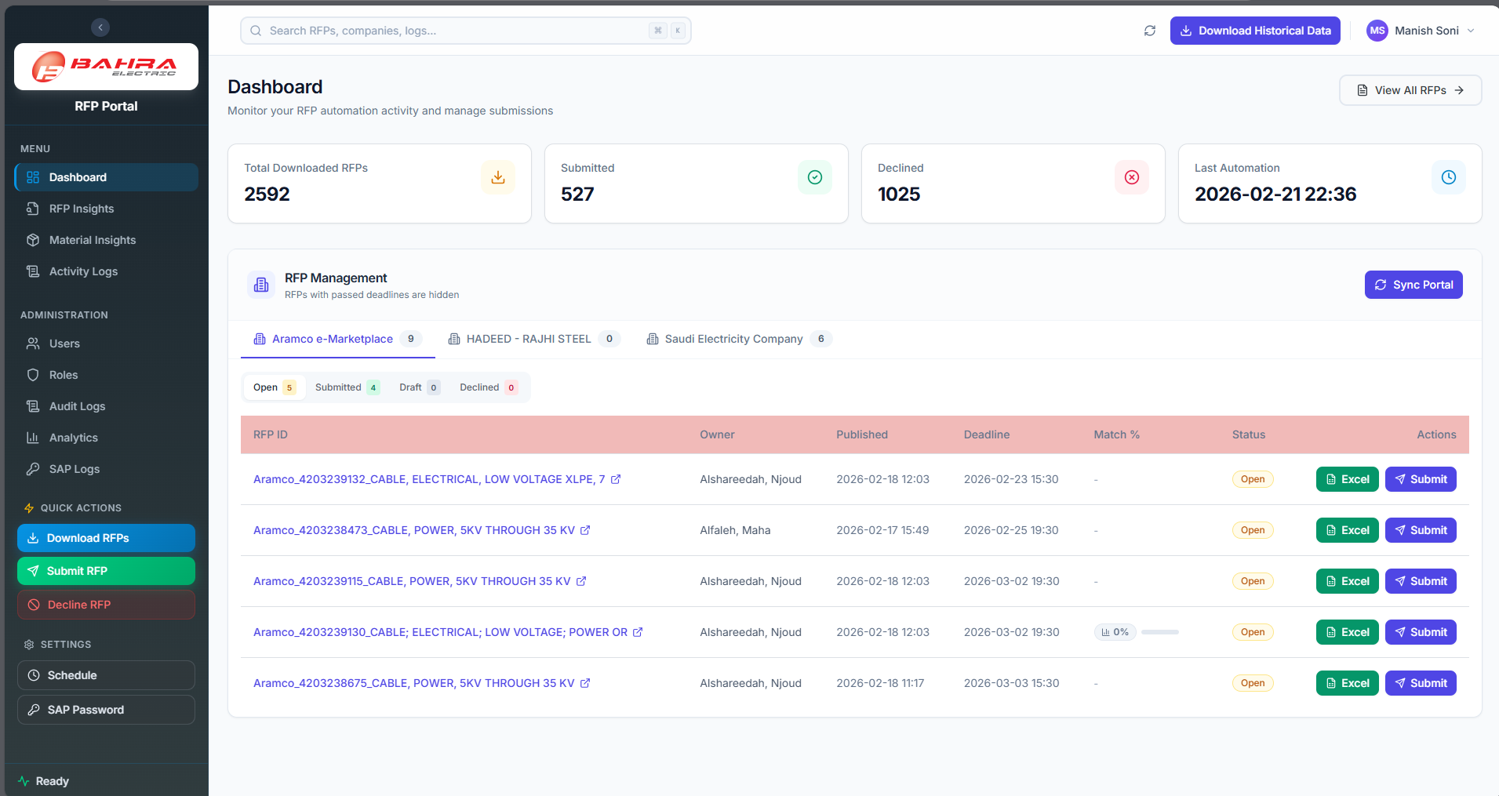
Figure 3: Portal Layout with Expanded Sidebar
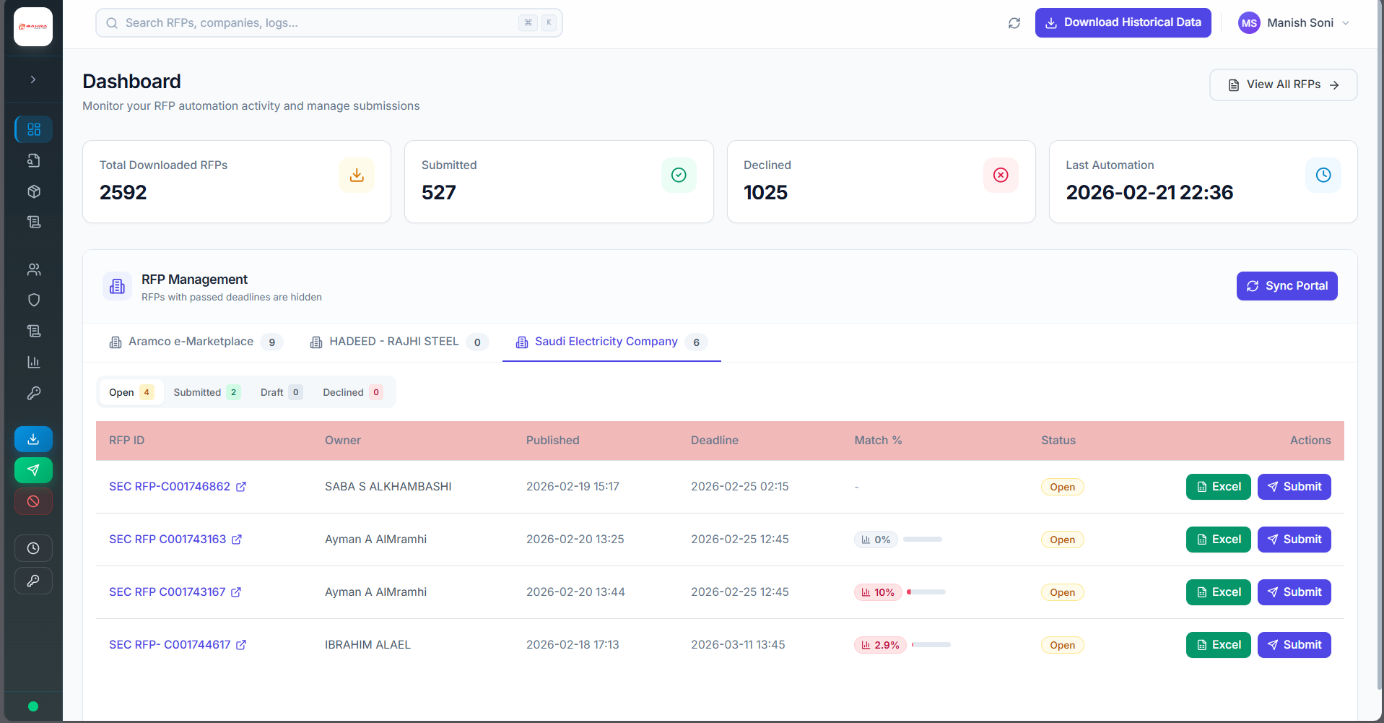
Figure 4: Collapsed Sidebar

4. Dashboard
The Dashboard is your home page and provides a quick overview of all RFP activity.

4.1 Metric Cards
At the top of the page, you will see four summary cards:
Card | Description
Total Downloaded RFPs | Total number of RFPs downloaded from all portals
Submitted | Number of RFPs that have been submitted
Declined | Number of RFPs that have been declined
Last Automation | Timestamp of the last automation run
Tip: Clicking on the Total, Submitted, or Declined cards navigates to the RFP Insights page with the corresponding filter pre-applied.
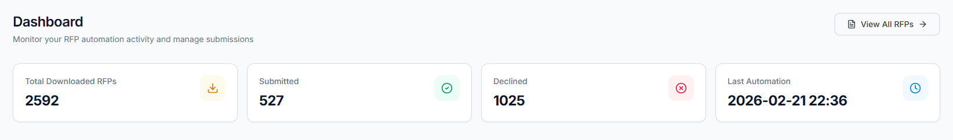
Figure 5: Dashboard Metric Cards

4.2 RFP Management Section
Below the metrics, you will find the main RFP Management area, organized in two levels of tabs:
Company Tabs (top row): Each tab represents a company (e.g., Saudi Electricity Company, Aramco e-Marketplace). A badge next to each company name shows the total number of active RFPs.
Status Sub-Tabs (second row): Within each company tab, RFPs are split by status:
Status Tab | Badge Color | Meaning
Open | Amber | RFPs awaiting action – can be submitted or declined
Submitted | Green | RFPs already submitted to the portal
Draft | Gray | RFPs saved as draft on the portal
Declined | Red | RFPs where participation was declined
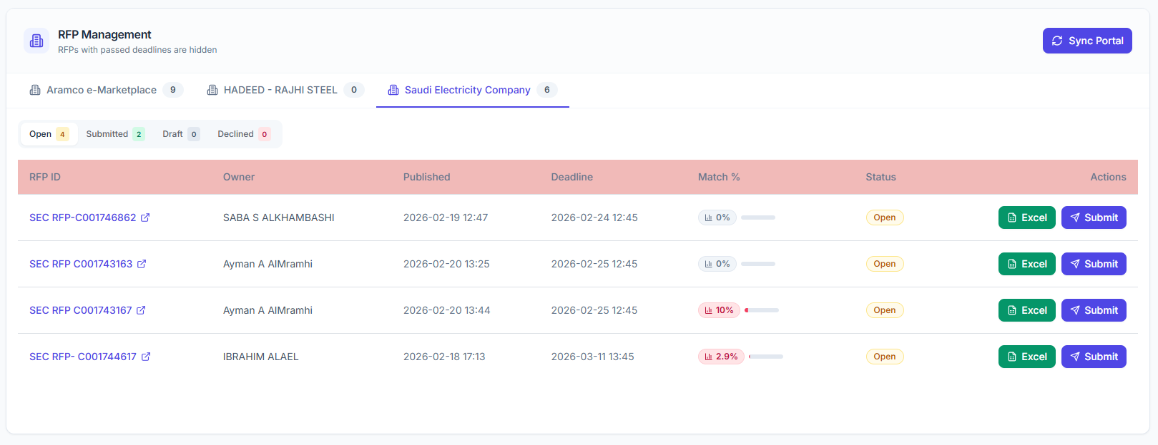
Figure 6: RFP Management Section

4.3 RFP Table
Each status tab shows a table with the following columns:
Column | Description
RFP ID | Unique identifier. Click to open the RFP on the external portal (opens in a new tab).
Owner | The RFP owner name from the portal.
Published | Date the RFP was published.
Deadline | RFP submission deadline date.
Match % | Material match percentage – how well this RFP matches your company’s materials.
Status | Current status badge (Open, Submitted, Draft, Declined).
Actions | Action buttons available for this RFP.

Match % Column Details
The Match % shows a color-coded badge and a mini progress bar:
Color | Range | Meaning
Green | 80% and above | Strong material match
Amber | 50% – 79% | Moderate match
Red | Below 50% | Weak match

Hover over a row and click the eye icon next to the Match % to view a detailed Material Breakdown dialog showing exactly which materials matched.

Available Actions by Status
Status | Actions
Open | Submit button, Excel download button
Submitted | Excel download button
Draft | Mark Submitted button, Excel download button
Declined | Excel download button
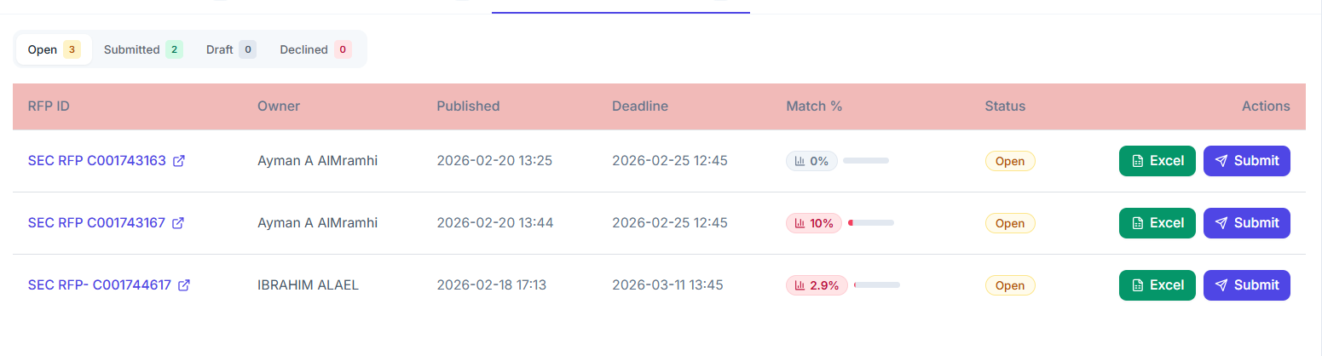
Figure 7: RFP Table with Actions

4.4 Sync Portal
Click the Sync Portal button (top-right of the RFP Management section) to refresh data from the company portals. This fetches the latest RFP statuses and updates the dashboard.
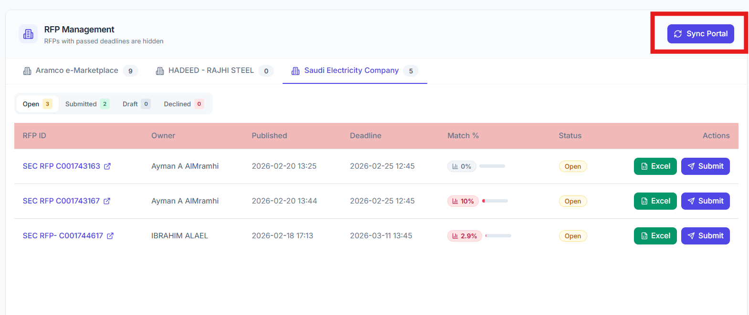

5. Key Workflows

5.1 Submit an RFP
You can submit an RFP in two ways:
Method 1: From the Dashboard Table
- Navigate to Dashboard.
- Select the company tab, then the Open status tab.
- Find the RFP you want to submit.
- Click the Submit button in the Actions column.
- The Submit RFP dialog opens with the RFP ID pre-filled.
Method 2: From the Sidebar Quick Action
- Click Submit RFP (green button) in the sidebar’s Quick Actions section.
- The Submit RFP dialog opens with a blank RFP ID field.
Submit RFP Dialog Steps:
- RFP ID – Enter or confirm the RFP ID. The system validates it automatically: a green checkmark appears if the RFP is found, or a red error if it is not found (it must be downloaded first).
- Company – Auto-populated based on the RFP record. This field is locked when the RFP is validated.
- Upload Excel File (required) – Click the dashed upload area to select your filled RFP Excel file (.xls or .xlsx).
- Technical PDF Files (optional) – Click to upload one or more PDF files (Technical Data Sheets). You can remove uploaded PDFs by clicking the X button next to each file.
System Will Automatically Show the Technical File Related to this RFP if TDS files are exist on SharePoint, So you can Choose TDS Fle to here
- Click Submit RFP to start the automation.
The system will:
- Upload files to SharePoint
- Navigate to the company portal
- Fill in the submission form
- Upload the Excel and technical files
- Save the RFP as a draft on the portal
Tip: Any TIR/TDS files that team members uploaded earlier through the RFP email's Upload button are picked up automatically from SharePoint, matched to their material codes, and attached during submission. The Technical PDF Files field above is only for additional documents you want to add manually.
A success notification will appear when the process starts. You can track progress via the Automation Status indicator in the sidebar footer.
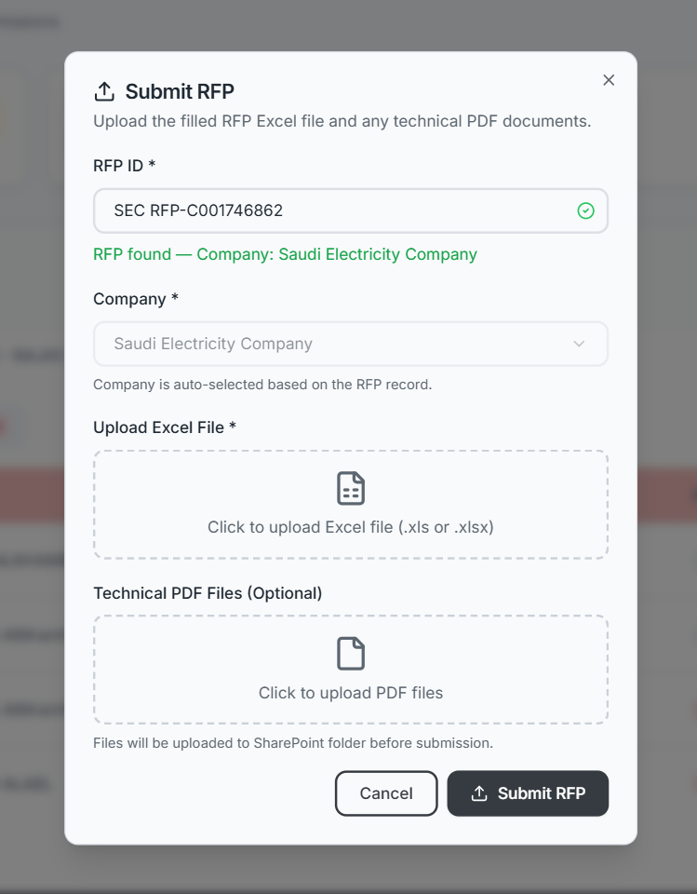
Figure 8: Submit RFP Dialog

5.2 Decline an RFP
- Click Decline RFP (red button) in the sidebar’s Quick Actions section.
- The Decline RFP dialog opens.
- RFP Title – Enter the exact RFP title. The system validates it: a green checkmark means the RFP is found, a red error means it is not in the database.
- Company – Auto-populated and locked after validation.
- Click Decline RFP (red button) to confirm.
The system will navigate to the portal and decline the RFP. A success notification appears when the process starts.
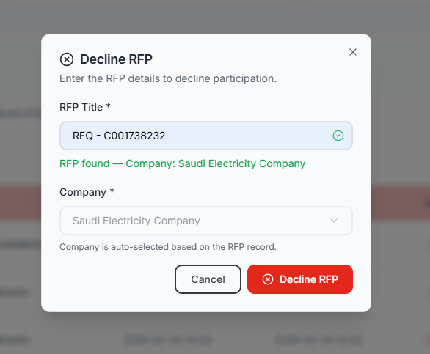

5.3 Download RFPs
- Click Download RFPs (blue button) in the sidebar’s Quick Actions section.
- The Download dialog opens with two options:
- All Companies – Download from all configured company portals.
- Specific Company – Select a single company from the dropdown.
- Review the information about what the automation will do.
- Click Yes, Start Download to begin.
The automation will:
- Navigate to the selected company portal(s)
- Scrape RFP listings and download RFP files
- Save information to the database
- Send email notifications for new RFPs found
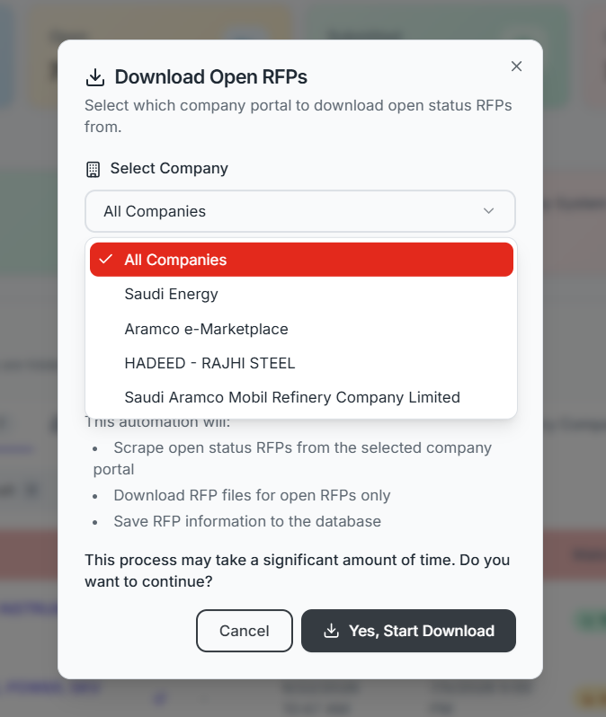
Figure 9: Download RFPs Dialog

5.4 Download RFP Excel File
To download the Excel file for any individual RFP:
- Find the RFP in the Dashboard table (any status tab).
- Click the green Excel button in the Actions column.
- The file will download to your browser’s default download location.
- A success notification confirms the download.
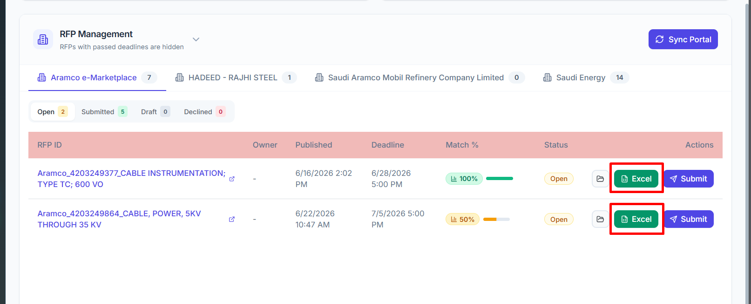

5.5 Respond to RFP Email (Adaptive Card)
When a new RFP is found, team members receive an email notification in Microsoft Outlook with an interactive Adaptive Card.
How to respond:
- Open the email notification in Outlook. You will see:
  - RFP details (ID, company, deadline)
  - A table listing all assigned team members (your name is highlighted)
- Input fields for Results and Remarks
- Fill in your Results (your assessment or bid information).
- Fill in your Remarks (any additional notes or comments).
- Upload File button ( see section 5.5.1)
- Click the Submit button within the email card.
- The card updates in-place to show your submission was recorded.

What happens next:
Once all team members have submitted their responses, a consolidated summary email is automatically sent to the configured stakeholders.

5.5.1 Uploading TIR and Pricing Files
Besides entering Results and Remarks, the Adaptive Card includes an Upload button for your assigned product. Use it to submit your technical and pricing documents straight into SharePoint.
- In the RFP email, click the Upload button. A secure upload page opens in your browser. The link is valid for 72 hours — request a reminder if it expires.
- Under TIR Files (required), add your technical documents. Use the “Upload TIR files” tab to add one or more files together, or the “Material wise upload” tab to attach one file per material code.
- Under Pricing Files (required), add your pricing documents.
- Submit the form. Accepted file types are PDF, Word, Excel, images (PNG/JPG/JPEG), and ZIP — up to 150 MB each.
Your files are stored in the RFP's SharePoint folder: TIR files under the TDS-files folder and pricing files under the pricing-files folder.
Tip: When this RFP is later submitted (see section 5.1), the system automatically finds your uploaded TIR/TDS files in SharePoint, matches them to their material codes, and attaches them to the submission — you do not need to upload them again.
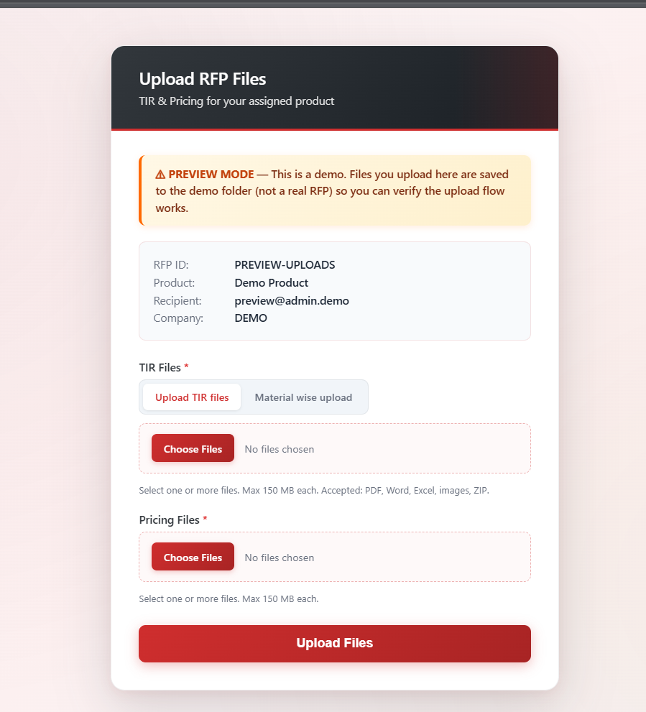

6. RFP Insights
Navigate to RFP Insights from the sidebar menu. This page provides a detailed, filterable view of all RFPs across all companies.

6.1 Stats Overview
Five stat cards at the top show:
Stat | Description
Total RFPs | All RFPs in the system
Submitted | RFPs that have been submitted
Declined | RFPs that were declined
Not Participant | RFPs with no participation action taken
Open | Currently open RFPs

6.2 Advanced Filters
The filter panel lets you narrow down RFPs using multiple criteria:
Filter | Options
Status | All, Open, Submitted, Declined, Not Participant
Company | Dropdown populated from your data
Start Date / End Date | Date range pickers
Material Match | All, Matched, Not Matched
Keyword Match | All, Matched, Not Matched
Participation | All, Participated, Not Participated, Declined
Search | Free-text search by RFP ID, company, or owner
Click Apply to filter the results. Click Reset to clear all filters.

6.3 Column Visibility
Click the Column Visibility dropdown (gear icon) to toggle which columns appear in the table. Your selection is saved automatically and persists across sessions.

6.4 Results Table
The table displays filtered results with infinite scroll — as you scroll down, more rows load automatically. Each row shows:
- Status badge with icon
- Participation status
- Portal link button (opens RFP on the external portal)
- Download Excel button
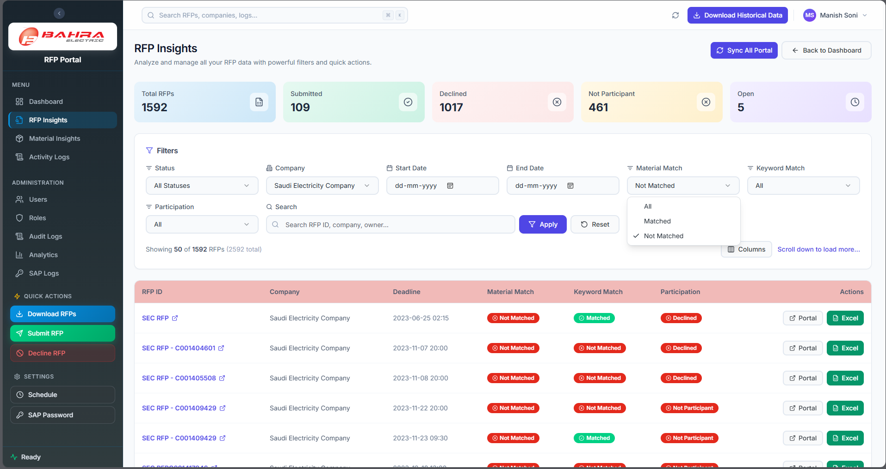
Figure 10: RFP Insights Page

7. Open RFP Tracker
Navigate to Open RFP from the sidebar menu. This page tracks who has and hasn't responded to each RFP actionable-card email, and lets you send reminders to non-responders or delegate a response to someone else.
[ Screenshot placeholder — add a capture of the Open RFP page here. ]

7.1 Open RFP Table
Use the toolbar to narrow the list:
- Search — by RFP ID, company name, or owner name.
- Company filter — show a single company or all companies.
- Participated filter — Open, Submitted, Declined, or Saved Draft.
- Clear — resets all filters and sorting (appears only when a filter is active).
- Refresh — re-fetches the latest data from the server.
Each row shows the following columns:
Column | Description
RFP ID | Unique RFP identifier.
Company | Issuing company (click the header to sort).
End Date | RFP submission deadline.
Email Sent | When the actionable-card email was sent.
Participated | Current status badge: Open, Submitted, Declined, or Saved Draft.
Responded | How many recipients have responded (e.g., 3 / 5).
Pending | How many recipients still owe a response.
Action | View button to open the detail panel.

7.2 Response Detail
Click View to open the detail panel for an RFP. The header summarizes how many recipients have responded and how many are still pending. The team members table lists each assigned recipient:
Column | Description
Product | The product line the recipient owns.
Email | Recipient email (alternates appear on separate lines; shows 'Delegated to …' when reassigned).
Results / Remarks | The recipient's submitted response (blank while pending).
Status | Pending, Responded, Delegated, or Former (no longer on the team).
Reminders | Number of reminders sent and the date of the last one.
Action | Remind or Delegate buttons for pending recipients.

7.3 Sending Reminders
- Open the RFP detail panel by clicking View.
- To remind one person, click Remind on their row. To remind everyone outstanding, click Remind All Pending at the top of the panel.
- A confirmation shows how many recipients were notified. All reminders are listed under Reminder History at the bottom of the panel, with who sent them and whether delivery succeeded.
Important: Sending reminders requires the Send RFP Reminder permission. If you do not see these buttons, your role does not include it.
Each reminder re-sends the RFP's Adaptive Card email to the recipient (with the subject prefixed “Reminder:”). The card carries the same response fields and the same Upload button, so a reminder also serves as a request for the recipient's TIR and Pricing files. Every reminder is recorded under Reminder History with the time sent, the recipient, who sent it, and the delivery status.

7.4 Delegating a Response
If a recipient cannot respond, you can hand the task to an alternate by email:
- On a pending row, click Delegate.
- In the Delegate RFP dialog, the Current Email is shown for reference. Enter the New Email and New Name of the person who should take over, then confirm.
- The new recipient immediately receives the RFP by email, and the original row now reads “Delegated to …”.
The delegation email is an Adaptive Card (subject prefixed “Delegated:”) with a banner that reads “This RFP was delegated to you by …”. From that email the new recipient can enter Results and Remarks and use the Upload button to submit the TIR and Pricing files on the original recipient's behalf. The delegation is recorded for audit and appears in the Reminder History.
Delegating requires the Delegate RFP permission.

8. Material Insights
Navigate to Material Insights from the sidebar menu. This page analyzes how your company’s materials and keywords match against RFPs.

8.1 Stats Overview
Four stat cards show:
- Unique Materials – Number of distinct material codes in the system
- Unique Keywords – Number of distinct keywords tracked
- RFPs with Matches – How many RFPs had at least one material or keyword match
- Submitted RFPs – How many matched RFPs were submitted

8.2 Tabs: Materials vs Keywords
Toggle between two views using the tabs:
- Materials – Analysis by material code
- Keywords – Analysis by keyword

8.3 Charts
Depending on the selected tab:
- Bar Chart – Top 10 Materials (or Keywords) ranked by RFP count
- Pie Chart – Keyword frequency distribution (visible on Keywords tab)

8.4 Filters
Filter | Options
Company | Filter by specific company
Participation | All, Submitted, Declined, Open
Search | Search by material code or keyword

8.5 Expandable Table
The main table shows materials or keywords as parent rows. Each row shows:
- Code/Keyword, Description, RFP Count, Companies, Submitted Count
Click the expand arrow on any row to reveal the individual RFPs that matched:
- RFP ID, Company, Deadline, Match Method (Exact or Keyword), Participation status
The table supports infinite scroll for large datasets.
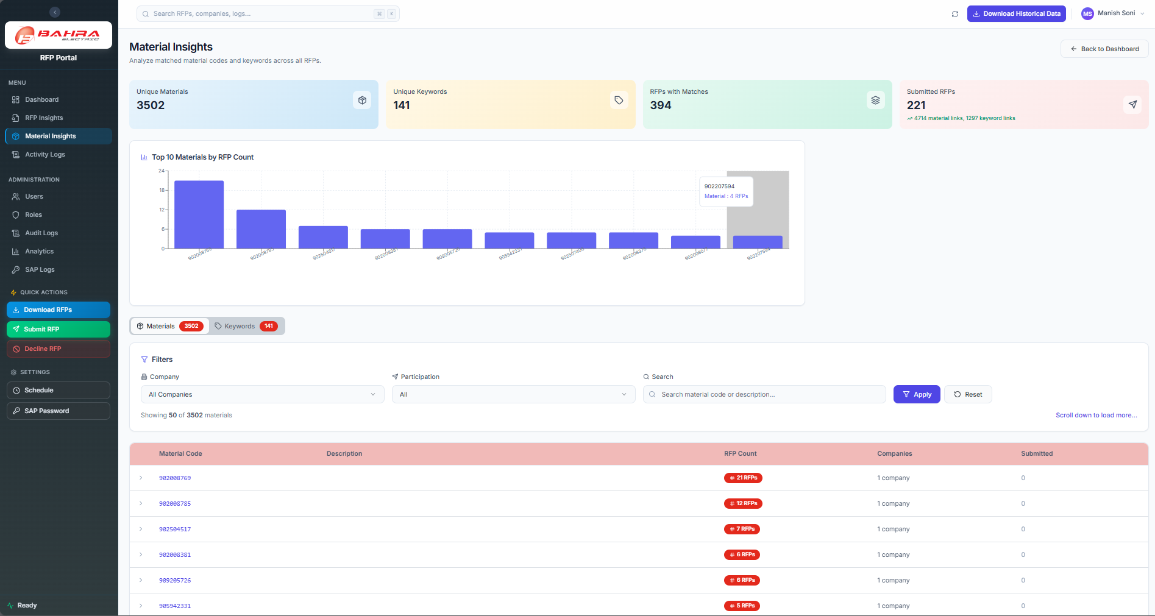
Figure 11: Material Insights Page

9. Activity Logs
Navigate to Activity Logs from the sidebar menu. This page shows the history of all automation runs.

9.1 Statistics Cards
Four clickable cards at the top:
- Total Runs – All automation runs
- Completed – Successfully completed runs (click to filter)
- Failed – Runs that encountered errors (click to filter)
- Running – Currently active runs (click to filter)

9.2 Controls
- Search box – Search by RFP ID, action, or run ID
- Page size selector – Choose how many logs to show (50, 100, 200, or 500)

9.3 Run Cards
Each automation run is displayed as a card with:
- Left color bar: Green = Completed, Red = Failed, Blue = Running
- Status icon: Checkmark, X, or spinner
- RFP ID and status badge
- Action name (e.g., Download, Submit, Decline)
- Start/End time
- Step progress (e.g., 5 success / 0 failed / 5 total)
- View Details button
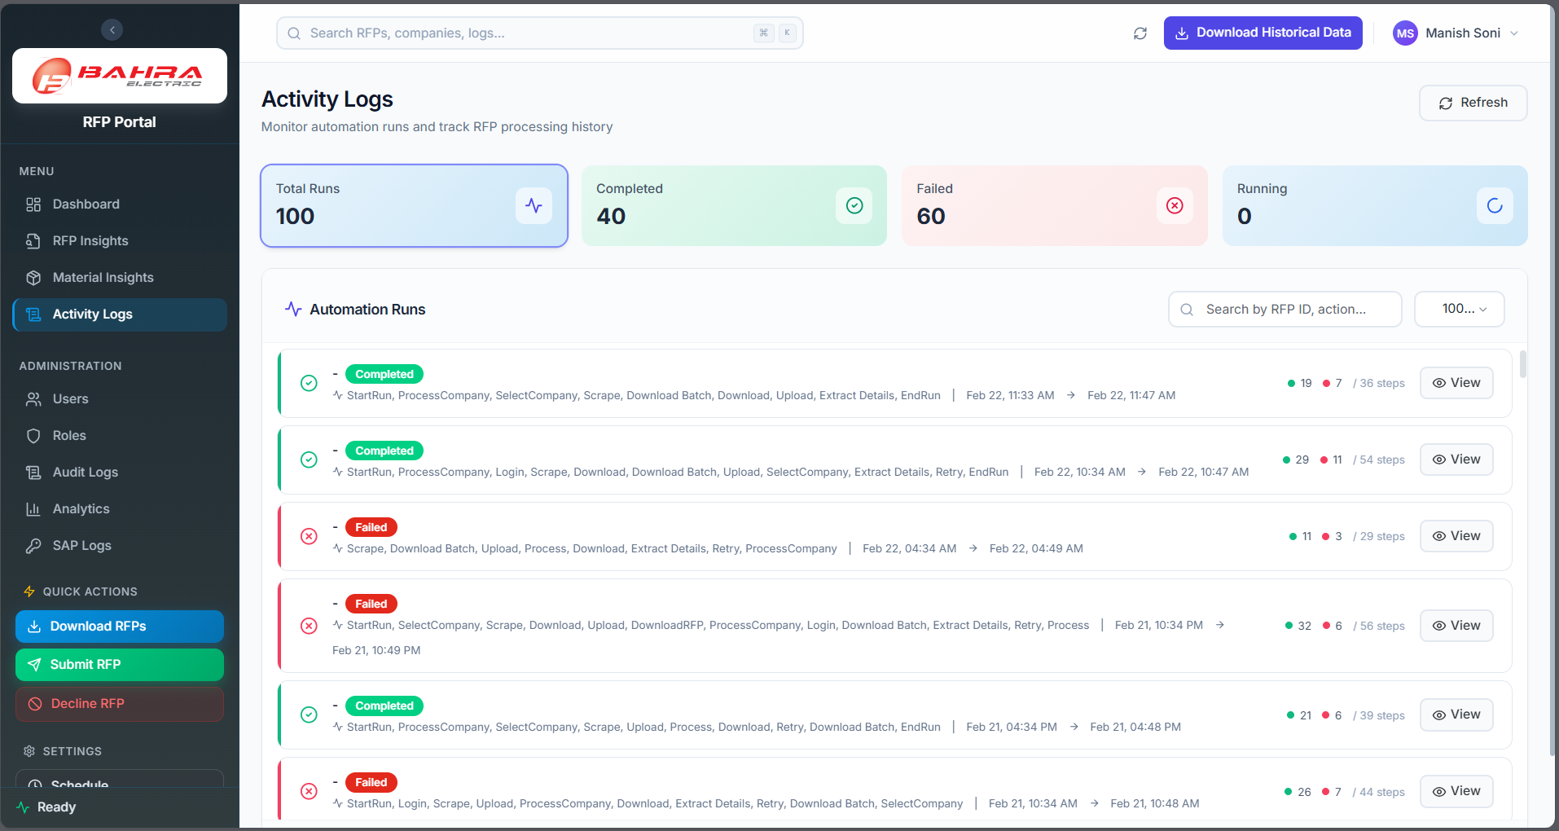
Figure 12: Activity Logs Page

9.4 Run Detail Modal
Click View Details to open a modal with three tabs:
Timeline Tab
A vertical timeline showing each step of the automation:
- Timestamp, action type, status, and details for each step
- Color-coded dots: Green = success, Red = failure, Gray = skipped
Error Report Tab
If the run encountered errors, this tab shows:
- Error type and summary
- Context information
- Full traceback
- Suggested actions to resolve
Screenshots Tab
If the automation captured browser screenshots during failure, they are displayed here for visual debugging.

10. Analytics
Navigate to Analytics from the sidebar menu. This page provides visual charts and interactive drill-downs.

10.1 Key Metrics
Four cards at the top:
- Total RFPs – All RFPs in the system
- Submitted – Submitted count with participation rate percentage
- Material Matched – Count and percentage of RFPs with material matches
- Keyword Matched – Count and percentage of RFPs with keyword matches
Tip: Click any metric card to navigate to RFP Insights with the relevant filter applied.

10.2 Interactive Charts
The page displays four charts in a 2-column layout:
Chart | Type | What It Shows
RFP Status Distribution | Donut chart | Breakdown by Submitted (green), Open (amber), Declined (red)
Top 5 Companies | Horizontal bar chart | Companies ranked by RFP count
Material Matching | Donut chart | Material Matched vs Not Matched
Keyword Matching | Donut chart | Keyword Matched vs Not Matched
Drill-Down: Click on any chart segment or bar to navigate to the RFP Insights page with the corresponding filter pre-applied.

10.3 Participation by Company
Below the charts, a horizontal stacked bar chart shows participation breakdown per company:
- Participated (green), Not Participated (gray), Declined (red)
Click any segment to drill down to the corresponding filtered view.
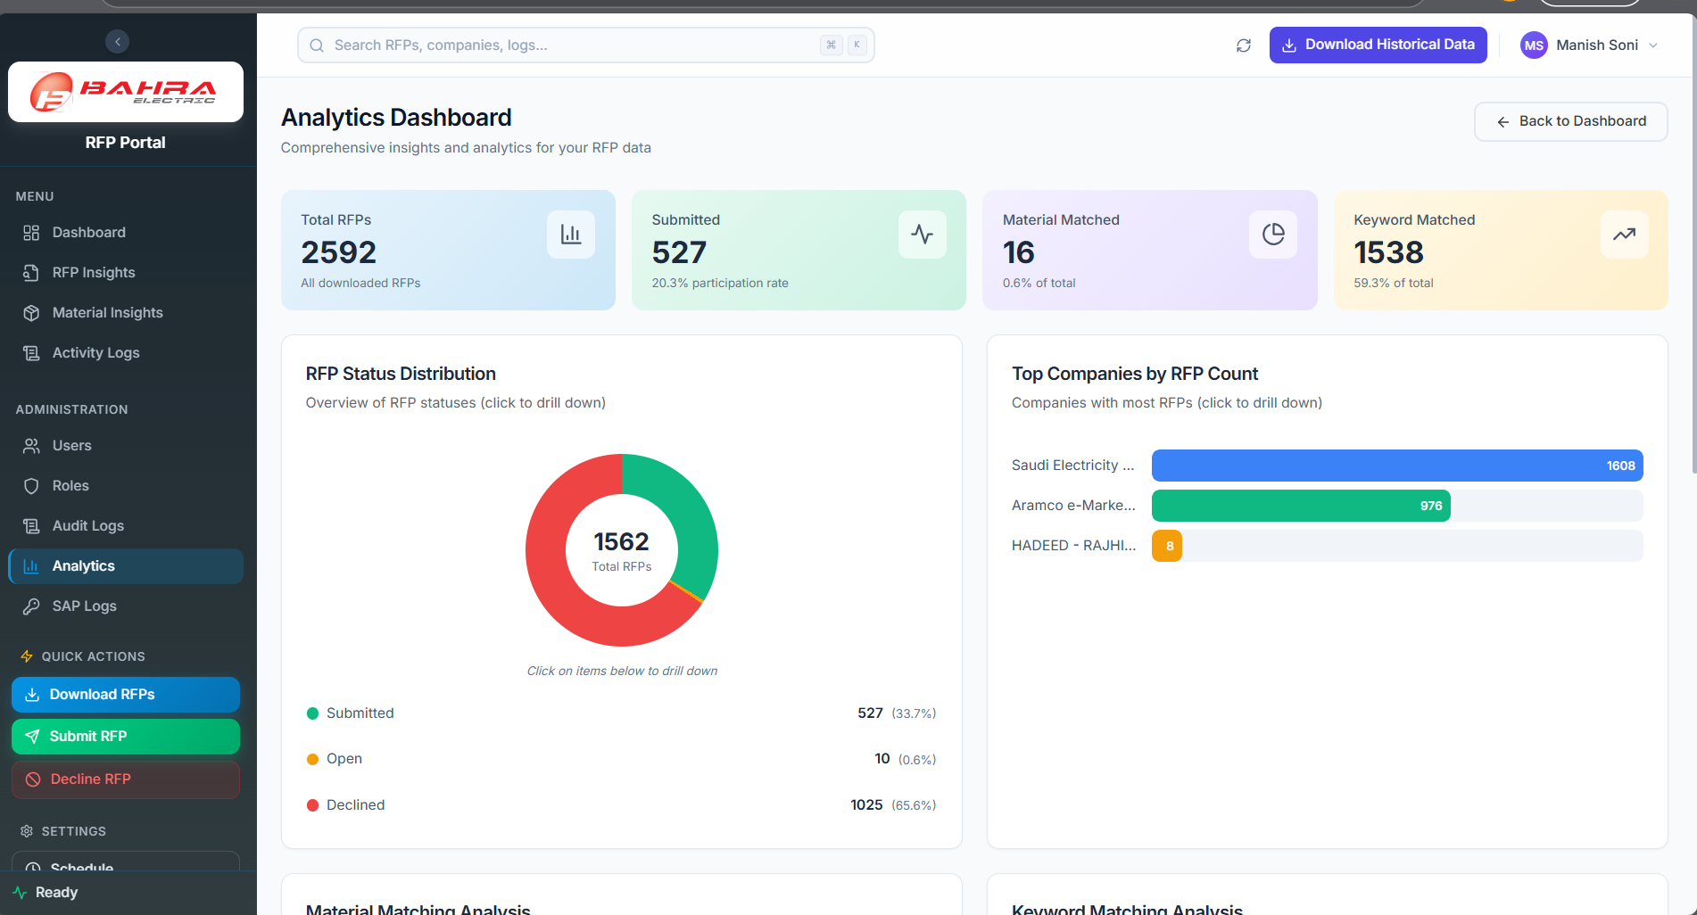
Figure 13: Analytics Dashboard

11. Administration (Admin Only)
The Administration section of the sidebar is visible only to users whose role includes at least one administration permission (for example, View Users or View System Settings). It groups all system-management pages.

11.1 User Management
Go to Users in the Administration section. The page header reads “User Management — Manage system users and their permissions.” The table lists every account:
Column | Description
Name | The user's display name.
Email | Login email (also the unique identifier).
Role | Assigned role (e.g., Admin, RFP Bidder).
Status | Active, Inactive, or Locked (after repeated failed logins).
Created / Last Updated | Account timestamps.
Actions | Edit, Unlock (locked accounts only), and Delete.
[ Screenshot placeholder — add a capture of the User Management page here. ]

Creating a User
- Click Add User (top right).
- Enter the Name and Email, and choose a Role.
- Set a Password — type one, or click Generate to create a strong 12-character password, then Copy to share it securely. Passwords must be at least 8 characters and include an uppercase letter and a number.
- Click Create User.

Editing, Unlocking, or Deleting a User
- Edit — change the name, email, role, or status. Set Status to Inactive to disable login without deleting the account. Leave the password blank to keep the current one.
- Unlock — for a Locked account, click Unlock to clear the lockout immediately.
- Delete — click the delete icon and confirm. This permanently removes the account and cannot be undone.
Available actions depend on your permissions: Create, Edit, and Delete Users are granted separately.

11.2 Role & Permission Management
Go to Roles. The page header reads “Role Management — Create and manage roles with granular permissions.” The table lists every role:
Column | Description
Role Name | The name of the role.
Description | What the role is for.
Permissions | Number of permissions granted.
Type | System (built-in, e.g., Admin / RFP Bidder) or Custom.
Status | Active or Inactive.
Actions | Edit, toggle Active/Inactive, and Delete (custom roles only).

Creating or Editing a Role
- Click Create Role, or click Edit on an existing role.
- Enter a Role Name and an optional Description.
- Expand the permission groups (Sidebar Menus, RFP Operations, User Management, Role Management, Master Data, System Settings, SAP Password) and tick the permissions to grant. Use Select All / Deselect All within each group.
- Click Create Role or Update Role.
Use the toggle button to activate or deactivate a custom role without deleting it. Deleting a custom role permanently removes it and its permission mappings; users with that role lose access.
Important: The Admin role is protected — it cannot be deactivated or deleted, and always holds every permission.

11.3 Audit Trail
Go to Audit Logs. The page header reads “Audit Trail” and shows a complete record of authentication, user, role, and system events. Filter the log with:
- Category — AUTH, USER, ROLE, RFP, or SYSTEM.
- Action — a specific event such as LOGIN, LOGIN_FAILED, USER_CREATED, or ROLE_PERMISSIONS_UPDATED.
- Actor Email — who performed the action.
- From / To — a date range.
- Clear Filters — reset to all events.
Each entry records the Timestamp, Category, Action, Actor (name and email), Target, Details, and IP Address. Results are paginated. Viewing the audit trail requires the Audit Logs permission.

11.4 Master Data
Go to Master Data. This page maintains the reference data that drives RFP matching and email routing, organized into four tabs. Each tab supports search and, with the appropriate permissions, Add, Edit, Delete, Import (CSV/Excel), and Export (CSV).

11.4.1 Material Codes
The SAP Material Master used to match RFP line items. Columns: Material Code, Description, Bahra Item Code, and Created. Add or edit a material with its code, description, and optional Bahra item code. Imports require a material_code column (optional: description, bahra_item_code).

11.4.2 Keywords
Keywords used to match RFP document content. Columns: Keyword and Created. Keywords are stored and displayed in UPPERCASE. Imports require a keyword column.

11.4.3 RFP Team
Maps products to the people who should receive RFP emails. The core columns are Products, Name, and Email, plus any custom columns you define (see Column Configuration). The Email field accepts several comma-separated addresses as alternates — anyone listed can respond, and the first reply wins. Imports require product, name, and email columns.

11.4.4 Column Configuration
Defines the columns used in the RFP Team table, the Outlook Adaptive Card emails, and the response forms. Columns: Order, Key, Label, Type (Text, Dropdown, Yes/No, Button), Category (Display or Input), and Required.
- Reorder columns with the up/down arrows; the order applies to the table, the email, and the forms.
- Add Column — choose a key, label, type, and category. Dropdown types take a JSON list of options; Button types can link to the built-in upload page or a custom URL.
- Preview Email — see how the Adaptive Card will appear in Outlook with the current columns.
- The core fields Products, Name, and Email are protected and cannot be deleted.
Tip: Adaptive Cards have limited width in Outlook — keep the number of columns under six for the best readability.

11.5 System Settings
Go to System Config. The page header reads “System Settings — View and manage system configuration. Changes take effect immediately.” Each setting is shown with its Name, Key, Value, and Type. A coloured dot indicates impact (green = low, orange = medium, red = high); Critical settings are marked Protected and are read-only in the portal.
- Find a setting using the search box.
- Click Edit and change the value. The editor adapts to the type — a checkbox for Yes/No, a number box, a JSON editor (validated on save), or a list editor for email recipients (one address per line).
- Click Save Changes. Sensitive values are masked with a reveal (eye) button, and every change is logged.
After editing values directly in Dataverse, click Reload Cache to refresh the portal's cached settings. Editing settings requires the Edit System Settings permission.

11.6 SAP Password Logs
Go to SAP Logs. The page header reads “SAP Password Change Logs — View history of SAP password changes.” The table shows Username, Password (masked, with reveal and copy buttons), Changed By, Created, and Status. This page is read-only; to change the SAP password, see section 12.2. Viewing requires the SAP Logs permission.

12. Automation Settings
The Settings group at the bottom of the sidebar (visible to administrators) provides two configuration dialogs.

12.1 Schedule Automation
Click Schedule to configure an automated RFP download schedule.
- Set the Interval (a number) and the Frequency (Minute, Hour, Day, Week, or Month) — for example, every 6 Hours.
- Choose the Time zone.
- Optionally set a Start time for the first run.
- Expand Show advanced options to set Max concurrency or add Notes.
- Click Save Schedule.
Managing schedules requires the Schedule & Automation permission.

12.2 Change SAP Password
Click SAP Password to update the SAP portal credentials used by the automation.
- Enter the Username.
- Enter the new Password and Confirm Password.
- Click Save.
Each change is recorded in SAP Password Logs (section 11.6). This action requires the Change SAP Password permission.

13. Profile Settings
Navigate to Profile by clicking your profile icon in the header or navigating to the profile page.

13.1 Update Profile Information
The Profile Information card shows:
- Display Name – Editable. Change your name and click Save Changes.
- Email – Read-only. Contact an administrator to change your email.
- Mobile Number – Optional. Add or update your phone number.
- Role – Read-only. Shows your assigned role (e.g., RFP Bidder).

13.2 Change Password
The Change Password card has three fields:
- Current Password – Enter your existing password.
- New Password – Enter a new password that meets these requirements:
- Minimum 8 characters
- At least one uppercase letter
- At least one number
- Confirm New Password – Re-enter the new password.
Click Change Password to update. A success notification confirms the change.

14. Automation Status Indicator
The bottom of the sidebar shows the Automation Status.
When Idle (Ready):
- A green dot with the text "Ready" appears.
- This means no automation is currently running.
When Running:
- The indicator changes to yellow/amber with "Running" text and an animated pulse.
- A progress bar appears showing the percentage complete.
- Detailed progress shows which operation is running:
- Download: Shows current/total count and the current item being processed
- Submit: Shows processing status message
- Decline: Shows processing status message
Important: While automation is running, the corresponding Quick Action button in the sidebar is disabled (grayed out) to prevent duplicate runs. You can continue using other parts of the portal normally.
When the sidebar is collapsed, the automation status is shown as a small colored dot (green = Ready, amber = Running). Hover over it to see details.

15. Quick Reference

15.1 Status Colors
Status | Color | Badge Style
Open | Amber/Orange | Amber background, amber text
Submitted | Green | Green background, green text
Draft / Saved Draft | Gray | Gray background, gray text
Declined | Red | Red/Rose background, red text

15.2 Match % Thresholds
Range | Color | Meaning
80% and above | Green | Strong match – high relevance
50% – 79% | Amber | Moderate match – review recommended
Below 50% | Red | Weak match – low relevance
No data | Gray dash | No material match data available

15.3 Quick Action Buttons
Button | Color | Action
Download RFPs | Blue gradient | Opens download dialog to scrape RFPs from portals
Submit RFP | Green gradient | Opens submit dialog to upload files and submit
Decline RFP | Red outline | Opens decline dialog to decline participation

15.4 Automation Run Statuses
Status | Indicator | Meaning
Completed | Green bar + checkmark | Run finished successfully
Failed | Red bar + X icon | Run encountered a fatal error
Running | Blue bar + spinner | Run is currently in progress

15.5 Supported Companies
Company | Portal
Saudi Electricity Company | SEC procurement portal
Aramco e-Marketplace | Aramco procurement portal
SABIC – Saudi Basic Industries Corp. | SABIC procurement portal
HADEED – RAJHI STEEL | HADEED procurement portal

15.6 Tips and Shortcuts
Tip / Shortcut | Description
Click metric cards | Navigate directly to filtered RFP Insights
Click chart segments | Drill down to the corresponding filtered view
Hover on Match % eye icon | View detailed material breakdown for an RFP
Column Visibility gear icon | Toggle which columns appear in the RFP Insights table
Sidebar collapse arrow | Toggle between full and compact sidebar view
Infinite scroll | Scroll down to automatically load more rows in tables

15.7 Roles at a Glance
Role | Type | Access Summary
Admin | System | Every page and action, including all administration features.
RFP Bidder | System | Dashboard, RFP Insights, Material Insights, Activity Logs, Open RFP; download, submit, decline, delegate. No admin pages.
Custom roles | Custom | Any combination of permissions chosen by an administrator.

15.8 Administration Quick Reference
Page | Purpose | Key Permission
Users | Manage accounts and role assignments | View / Create / Edit / Delete Users
Roles | Define roles and permissions | View / Create / Edit / Delete Roles
Audit Logs | Review system activity | Audit Logs
Master Data | Material codes, keywords, RFP team, columns | Master Data (per tab)
System Config | Email recipients and configuration | View / Edit System Settings
SAP Logs | SAP credential change history | SAP Logs
Schedule | Automated download schedule | Schedule & Automation
SAP Password | Update SAP credentials | Change SAP Password

16. Troubleshooting and FAQ

I can’t log in
- Check your credentials: Make sure you’re using the correct email and password.
- Account locked: After 5 failed login attempts within 5 minutes, your account is locked for 30 minutes. Wait and try again, or contact your administrator to unlock it.
- Password expired: Passwords must be changed every 90 days. Use the Forgot Password link to reset.

The dashboard shows no data
- First time? Click the Download RFPs button in the sidebar to download RFPs from the portals.
- Data stale? Click the Sync Portal button in the RFP Management section header to refresh.
- Check Activity Logs to see if a download automation has run recently.

RFP submission failed
- Go to Activity Logs and find the failed run.
- Click View Details and check the Error Report tab for the error message.
- Common causes: portal was unavailable, file format was incorrect, or session timed out.
- If the issue persists, contact your administrator.

I don’t see certain menu items
- Menu items are based on your role and permissions. RFP Bidder users may not see admin sections like Users, Roles, or Audit Logs.
- If you need access, contact your administrator to update your role permissions.

My session expired
- Sessions time out after 2 hours of activity or 30 minutes of inactivity.
- You will be redirected to the login page. Simply log in again to continue.
- Your unsaved form data (e.g., in a Submit dialog) will be lost — complete submissions promptly.

The Submit/Decline button is grayed out
- This means the corresponding automation is already running. Check the Automation Status indicator at the bottom of the sidebar.
- Wait for the current operation to complete before starting a new one.

I entered an RFP ID but got an error in the Submit/Decline dialog
- The message "RFP not found in database" means the RFP must be downloaded first before it can be submitted or declined.
- Use the Download RFPs action to download it, then try again.

Excel download is not working
- Ensure your browser allows file downloads and pop-ups from the portal URL.
- Check if the RFP has an associated Excel file — some newly downloaded RFPs may not have files yet.

How do I know if my Adaptive Card response was saved?
- After clicking Submit in the Outlook Adaptive Card, the card should update to show a confirmation message.
- If the card doesn’t update, check your internet connection and try again.
- Your responses are saved in the system — check with your administrator if unsure.

How do I change my display name?
- Navigate to Profile Settings (click your profile icon in the top-right header). Edit the Display Name field and click Save Changes.

Can I use the portal on a mobile device?
- The portal is optimized for desktop browsers. While it may work on mobile browsers, the full experience is best on Google Chrome (latest version) on a desktop or laptop.

I'm an administrator but can't see the Users or Roles pages
- The Administration section appears only if your role includes an administration permission. Confirm your role is Admin (or a custom role with the relevant view permission) on your Profile page.

How do I give a user access to a new page?
- Edit the user's role under Roles (or assign them a different role under Users) and grant the matching permission. Changes apply on the user's next login, or within a few minutes.

A new user can't log in
- Check that the account Status is Active (not Inactive or Locked) under Users. Unlock a locked account with the Unlock button, and confirm the user is using the email and password you set.

Changes I made in System Settings aren't taking effect
- Most settings apply immediately. If you edited values directly in Dataverse, click Reload Cache on the System Config page.

Why didn't a team member receive an RFP email?
- Confirm they are listed for that product under Master Data → RFP Team and that their email is correct. Remember the Email field can hold several comma-separated alternate addresses.

For additional support, contact your system administrator.

Appendix A: Glossary
Term | Definition
RFP | Request for Proposal – a formal document issued by a company inviting suppliers to submit bids for products or services.
Adaptive Card | An interactive email component in Microsoft Outlook that allows users to respond to RFP notifications directly within the email.
Match % | The percentage of materials in an RFP that match your company’s product catalog, indicating relevance.
Automation Run | A single execution of the portal automation (download, submit, or decline) tracked in Activity Logs.
SharePoint | Microsoft cloud storage where RFP files (Excel, PDFs) are uploaded during submission.
Portal | An external procurement website of a company (e.g., SEC, Aramco) where RFPs are published and managed.
TDS | Technical Data Sheet – PDF documentation describing product specifications, uploaded during RFP submission.
Sync | The process of refreshing data from external company portals to update the dashboard with the latest RFP statuses.
Draft | An RFP submission saved on the company portal but not yet finalized or officially submitted.
Quick Action | Sidebar buttons (Download, Submit, Decline) that provide one-click access to common workflows.

Appendix B: Permission Reference
The table below lists every permission in the system, grouped by module. Administrators assign these to roles on the Roles page. Permissions are independent — each must be granted explicitly.
Module | Permission Key | What It Allows
User Management | user_management.view | View the user list
 | user_management.create | Create new users
 | user_management.edit | Edit existing users
 | user_management.delete | Delete users
Role Management | role_management.view | View roles and permissions
 | role_management.create | Create new roles
 | role_management.edit | Edit roles and assign permissions
 | role_management.delete | Delete roles
RFP Operations | rfp.view | View RFP insights and details
 | rfp.download | Download RFPs from the portal
 | rfp.submit | Submit RFPs
 | rfp.decline | Decline RFPs
 | rfp.open.view | View the Open RFP reminder tracker page
 | rfp.open.remind | Send reminder emails to team members who haven't responded
 | rfp.open.delegate | Delegate an RFP product line to a different recipient
 | rfp.sharepoint.view | Open the SharePoint folder for an RFP
Dashboard & Insights | dashboard.view | View the main dashboard
 | material_insights.view | View material insights
 | analytics.view | View the analytics dashboard
Logs | logs.view | View automation activity logs
 | audit_logs.view | View audit trail logs
Master Data — Material Master | material_master.view | View material codes
 | material_master.create | Add new material codes
 | material_master.edit | Edit material codes
 | material_master.delete | Delete material codes
Master Data — Keyword Master | keyword_master.view | View keywords
 | keyword_master.create | Add new keywords
 | keyword_master.edit | Edit keywords
 | keyword_master.delete | Delete keywords
Master Data — RFP Team | rfp_team.view | View RFP team assignments
 | rfp_team.create | Add RFP team members
 | rfp_team.edit | Edit RFP team members
 | rfp_team.delete | Delete RFP team members
Master Data — Column Configuration | column_config.view | View column configuration
 | column_config.create | Add column definitions
 | column_config.edit | Edit column definitions
 | column_config.delete | Delete column definitions
System Settings | system_settings.view | View system settings and configuration
 | system_settings.edit | Edit system settings and configuration
SAP Password | sap_password.view | View SAP password change logs
 | sap_password.change | Change the SAP password
Schedule & Automation | schedule_automation.manage | Manage automation schedules



Bahra Electric Company
© 2026 Bahra Electric. All rights reserved.

