Bahra Electric - RFP Portal User Manual
Version: 1.0
Last Updated: February 2026
Audience: End Users (RFP Bidders)

Table of Contents
- Introduction
- Getting Started
- Dashboard
- Key Workflows
  - Submit an RFP
  - Decline an RFP
  - Download RFPs
  - Download RFP Excel File
  - Respond to RFP Email (Adaptive Card)
- RFP Insights
- Material Insights
- Activity Logs
- Analytics
- Profile Settings
- Automation Status Indicator
- Quick Reference
- Troubleshooting & FAQ

1. Introduction
The Bahra Electric RFP Portal is a web-based system that automates the management of Requests for Proposal (RFPs) across multiple supplier portals. It handles downloading RFPs from company portals, matching materials and keywords, submitting or declining RFPs, and sending email notifications — all from a single dashboard.
What you can do with this portal:
- View all downloaded RFPs organized by company and status
- Submit or decline RFPs with automated portal interaction
- Track material and keyword matches for each RFP
- Monitor automation runs and review activity logs
- View analytics and participation reports
- Download RFP Excel files for offline review
- Receive email notifications with interactive Adaptive Cards
Supported Companies:
- Saudi Electricity Company
- Aramco e-Marketplace
- SABIC - Saudi Basic Industries Corp.
- HADEED - RAJHI STEEL
Browser Requirements: Google Chrome (latest version recommended)

2. Getting Started

2.1 Logging In
- Open the RFP Portal URL in your browser.
- You will see the Login page with the Bahra Electric logo and “RFP Automation System” heading.
- Enter your Email address in the email field.
- Enter your Password in the password field.
- Optionally, check Remember me to stay signed in.
- Click Sign In.
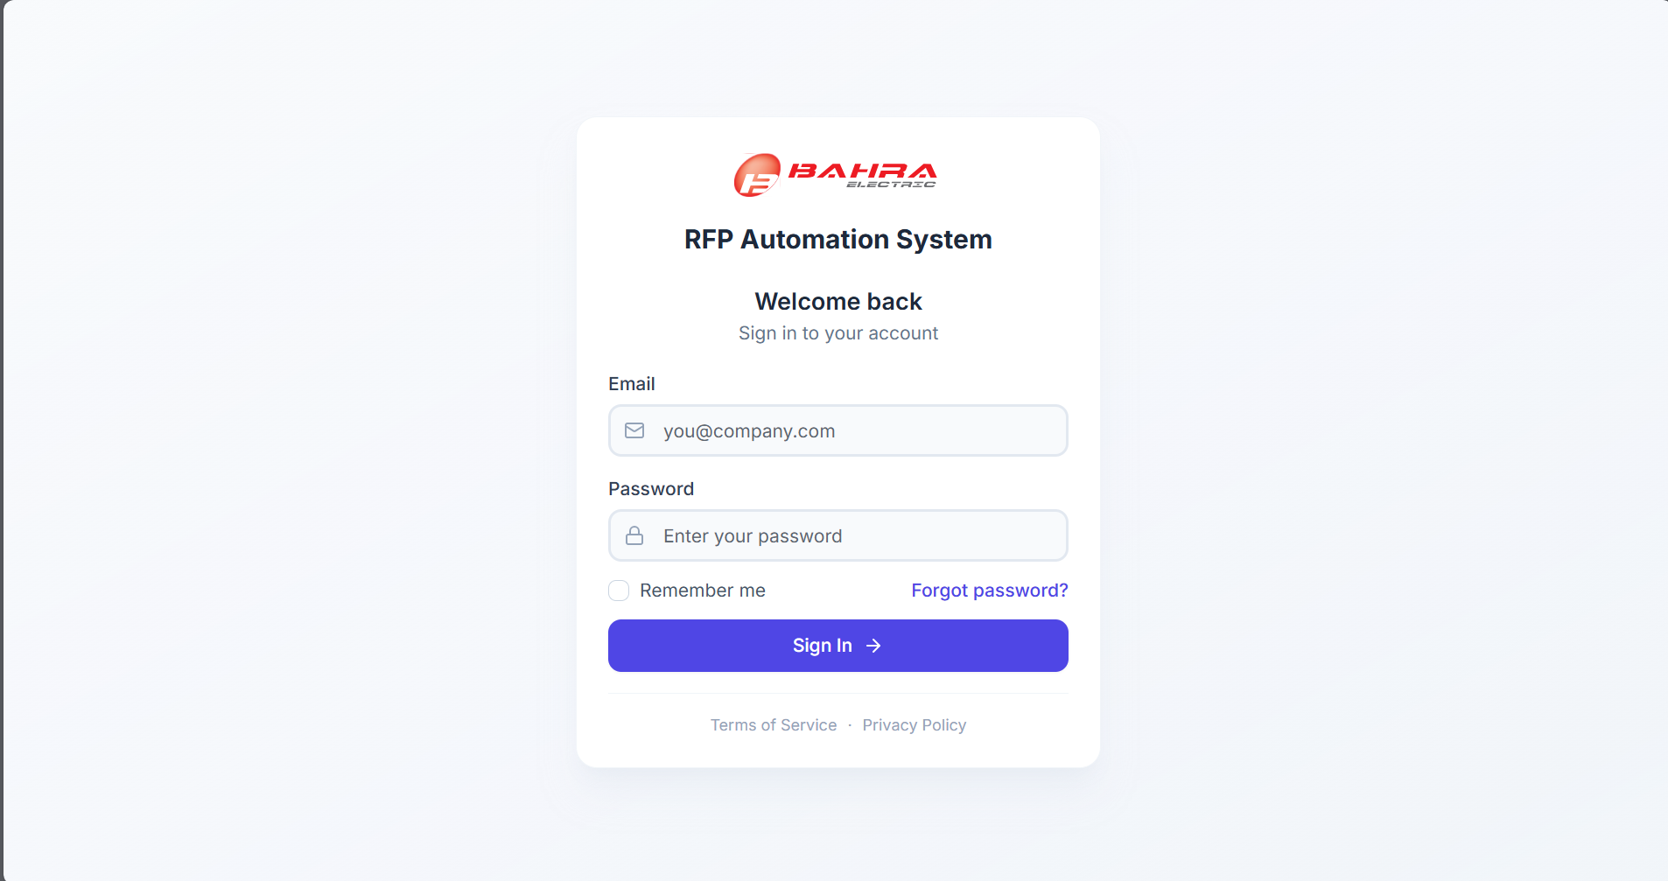
After logging in, you will be redirected to the Dashboard page.

2.2 Forgot Password
If you forget your password:
- On the Login page, click “Forgot password?” (located to the right of the Remember me checkbox).
- A dialog will appear asking for your email address.
- Enter the email associated with your account.
- Click Send Reset Link.
- Check your email inbox for a password reset link.
- Click the link in the email and follow the instructions to set a new password.
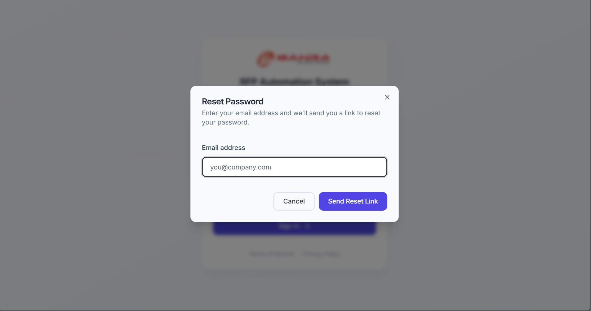

2.3 Navigation Overview
After logging in, you will see two main areas:
Left Sidebar — Your main navigation panel. It contains:
Section | Items | Description
Menu | Dashboard | Main overview with RFP metrics and management
 | RFP Insights | Detailed RFP data with advanced filters
 | Material Insights | Material and keyword matching analysis
 | Activity Logs | Automation run history and details
Quick Actions | Download RFPs | Trigger RFP download from company portals
 | Submit RFP | Submit an RFP with file uploads
 | Decline RFP | Decline participation in an RFP
Status Footer | Automation Status | Shows whether automation is Ready or Running
The sidebar can be collapsed by clicking the arrow icon at the top-right corner of the sidebar, and expanded again by clicking the expand arrow. When collapsed, hovering over icons shows tooltip labels.
Top Header — Displays the page title, description, and page-specific action buttons (e.g., “View All RFPs”).

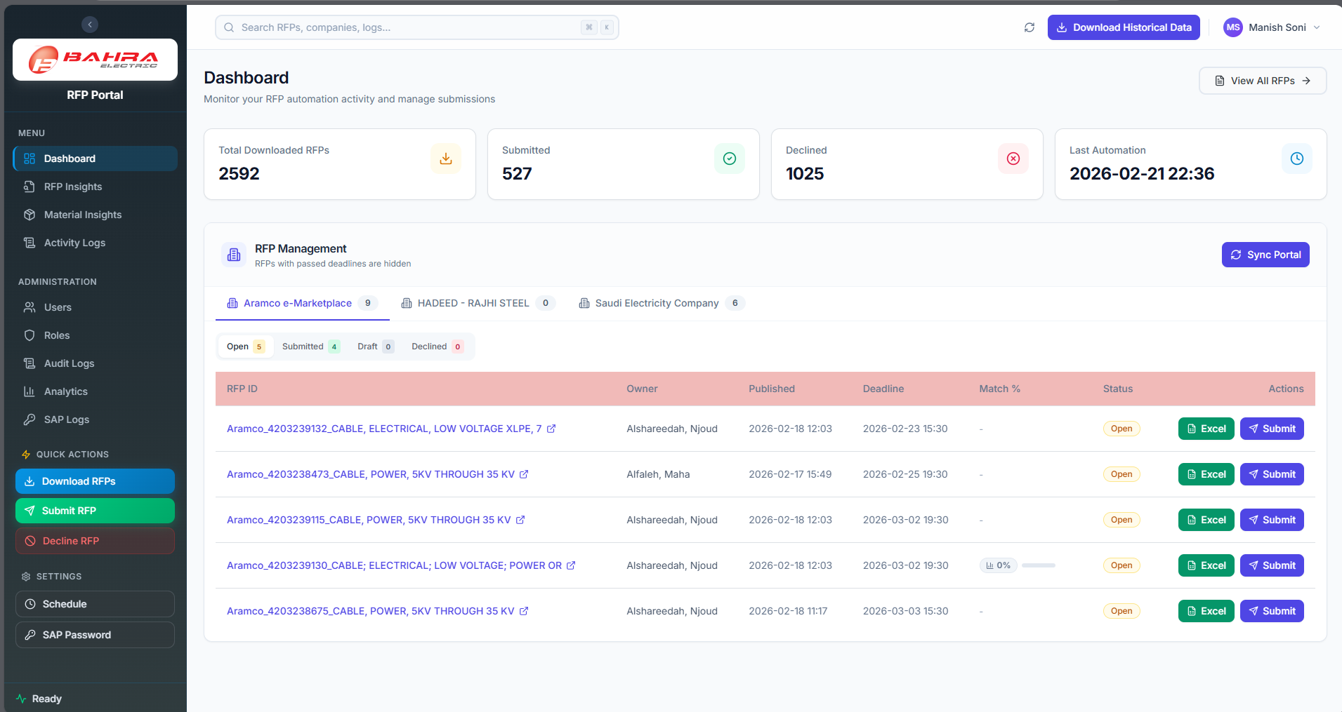
Main Dashboard Sidebar Collapsed

3. Dashboard
The Dashboard is your home page and provides a quick overview of all RFP activity.

3.1 Metric Cards
At the top of the page, you will see four summary cards:
Card | Description
Total Downloaded RFPs | Total number of RFPs downloaded from all portals
Submitted | Number of RFPs that have been submitted
Declined | Number of RFPs that have been declined
Last Automation | Timestamp of the last automation run
Tip: Clicking on the Total, Submitted, or Declined cards navigates to the RFP Insights page with the corresponding filter pre-applied.
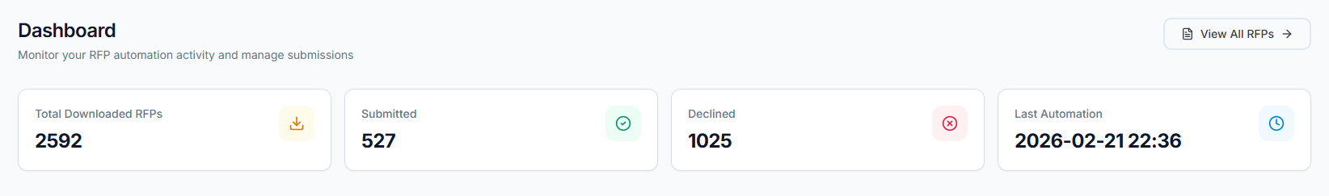

3.2 RFP Management Section
Below the metrics, you’ll find the main RFP Management area. This is organized in two levels of tabs:
Company Tabs (top row): Each tab represents a company (e.g., “Saudi Electricity Company”, “Aramco e-Marketplace”). A badge next to each company name shows the total number of active RFPs for that company.
Status Sub-Tabs (second row): Within each company tab, RFPs are split by status:
Status Tab | Badge Color | Meaning
Open | Amber | RFPs awaiting action — can be submitted or declined
Submitted | Green | RFPs already submitted to the portal
Draft | Gray | RFPs saved as draft on the portal
Declined | Red | RFPs where participation was declined

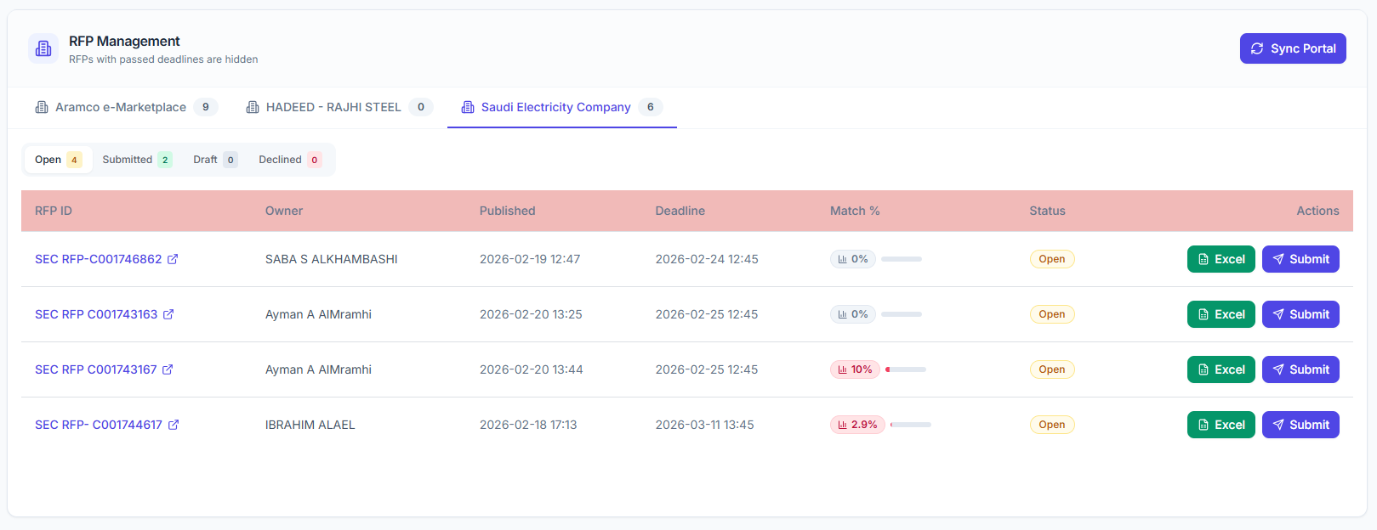

3.3 RFP Table
Each status tab shows a table with the following columns:
Column | Description
RFP ID | Unique identifier. Click to open the RFP on the external portal (opens in a new tab).
Owner | The RFP owner name from the portal.
Published | Date the RFP was published.
Deadline | RFP submission deadline date.
Match % | Material match percentage — how well this RFP matches your company’s materials.
Status | Current status badge (Open, Submitted, Draft, Declined).
Actions | Action buttons available for this RFP.
Match % Column Details:
The Match % shows a color-coded badge and a mini progress bar:
Color | Range | Meaning
Green | 80% and above | Strong material match
Amber | 50% – 79% | Moderate match
Red | Below 50% | Weak match
Hover over a row and click the eye icon next to the Match % to view a detailed Material Breakdown dialog showing exactly which materials matched.
Available Actions by Status:
Status | Actions
Open | Submit button, Excel download button
Submitted | Excel download button
Draft | Mark Submitted button, Excel download button
Declined | Excel download button

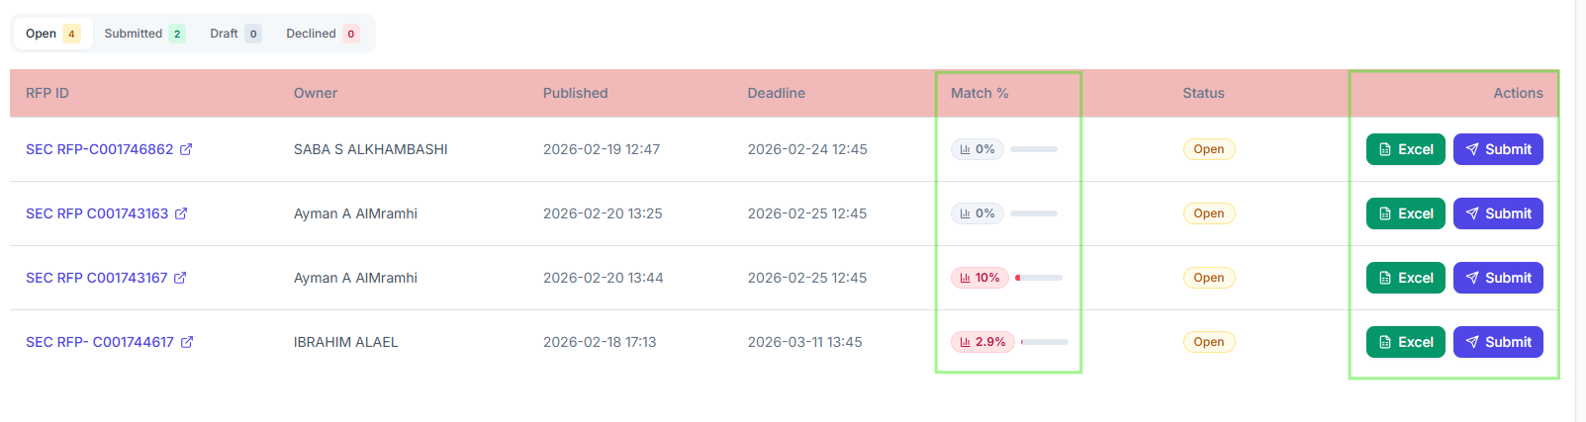

3.4 Sync Portal
Click the Sync Portal button (top-right of the RFP Management section) to refresh data from the company portals. This fetches the latest RFP statuses and updates the dashboard.

4. Key Workflows

4a. Submit an RFP
You can submit an RFP in two ways:
Method 1: From the Dashboard table
- Navigate to Dashboard.
- Select the company tab, then the Open status tab.
- Find the RFP you want to submit.
- Click the Submit button in the Actions column.
- The Submit RFP dialog opens with the RFP ID pre-filled.
Method 2: From the Sidebar Quick Action
- Click Submit RFP (green button) in the sidebar’s Quick Actions section.
- The Submit RFP dialog opens with a blank RFP ID field.
Submit RFP Dialog Steps:
- RFP ID — Enter or confirm the RFP ID. The system validates it automatically:
  - A green checkmark appears if the RFP is found in the database.
  - A red error appears if the RFP is not found (it must be downloaded first).
- Company — Auto-populated based on the RFP record. This field is locked when the RFP is validated.
- Upload Excel File (required) — Click the dashed upload area to select your filled RFP Excel file (.xls or .xlsx).
- Technical PDF Files (optional) — Click to upload one or more PDF files (Technical Data Sheets). You can remove uploaded PDFs by clicking the X button next to each file.
- Click Submit RFP to start the automation.
The system will:
- Upload files to SharePoint
- Navigate to the company portal
- Fill in the submission form
- Upload the Excel and technical files
- Save the RFP as a draft on the portal
A success notification will appear when the process starts. You can track progress via the Automation Status indicator in the sidebar footer. 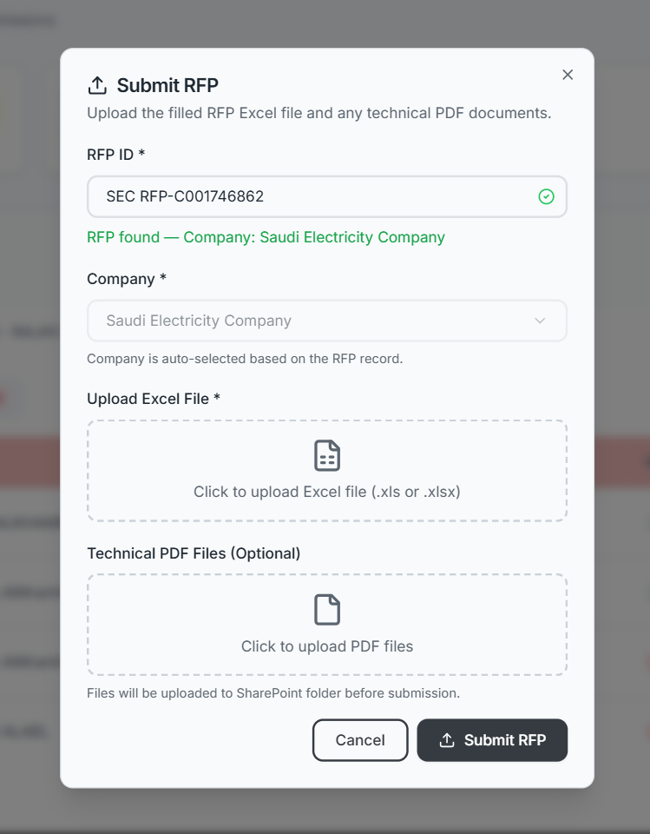

4b. Decline an RFP
- Click Decline RFP (red button) in the sidebar’s Quick Actions section.
- The Decline RFP dialog opens.
- RFP Title — Enter the exact RFP title. The system validates it:
  - Green checkmark = RFP found.
  - Red error = RFP not found in the database.
- Company — Auto-populated and locked after validation.
- Click Decline RFP (red button) to confirm.
The system will navigate to the portal and decline the RFP. A success notification appears when the process starts.

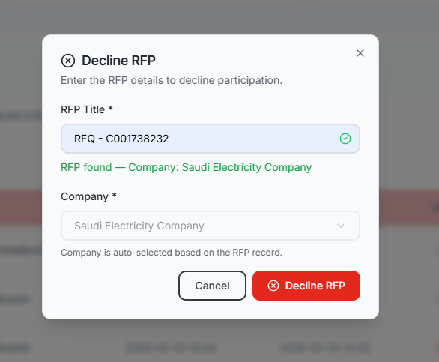 4c. Download RFPs
- Click Download RFPs (blue button) in the sidebar’s Quick Actions section.
- The Download dialog opens with two options:
  - All Companies — Download from all configured company portals.
  - Specific Company — Select a single company from the dropdown.
- Review the information about what the automation will do.
- Click Yes, Start Download to begin.
The automation will:
- Navigate to the selected company portal(s)
- Scrape RFP listings and download RFP files
- Save information to the database
- Send email notifications for new RFPs found
[SCREENSHOT: Download RFPs Dialog — showing company dropdown set to “All Companies” and the confirmation details]

4d. Download RFP Excel File
To download the Excel file for any individual RFP:
- Find the RFP in the Dashboard table (any status tab).
- Click the green Excel button in the Actions column.
- The file will download to your browser’s default download location.
- A success notification confirms the download.

4e. Respond to RFP Email (Adaptive Card)
When a new RFP is found, team members receive an email notification in Microsoft Outlook with an interactive Adaptive Card.
How to respond:
- Open the email notification in Outlook. You will see:
  - RFP details (ID, company, deadline)
  - A table listing all assigned team members (your name is highlighted)
  - Input fields for Results and Remarks
- Fill in your Results (your assessment or bid information).
- Fill in your Remarks (any additional notes or comments).
- Click the Submit button within the email card.
- The card updates in-place to show your submission was recorded.
What happens next: Once all team members have submitted their responses, a consolidated summary email is automatically sent to the configured stakeholders.
[SCREENSHOT: Outlook Adaptive Card Email — showing the RFP details, team member table with highlighted row, Results/Remarks input fields, and Submit button]
[SCREENSHOT: Adaptive Card After Submission — showing the updated card with confirmation message]

5. RFP Insights
Navigate to RFP Insights from the sidebar menu. This page provides a detailed, filterable view of all RFPs across all companies.

5.1 Stats Overview
Five stat cards at the top show:
Stat | Description
Total RFPs | All RFPs in the system
Submitted | RFPs that have been submitted
Declined | RFPs that were declined
Not Participant | RFPs with no participation action taken
Open | Currently open RFPs

5.2 Advanced Filters
The filter panel lets you narrow down RFPs using multiple criteria:
Filter | Options
Status | All, Open, Submitted, Declined, Not Participant
Company | Dropdown populated from your data
Start Date / End Date | Date range pickers
Material Match | All, Matched, Not Matched
Keyword Match | All, Matched, Not Matched
Participation | All, Participated, Not Participated, Declined
Search | Free-text search by RFP ID, company, or owner
Click Apply to filter the results. Click Reset to clear all filters.

5.3 Column Visibility
Click the Column Visibility dropdown (gear icon) to toggle which columns appear in the table. Your selection is saved automatically and persists across sessions.

5.4 Results Table
The table displays filtered results with infinite scroll — as you scroll down, more rows load automatically. Each row shows:
- Status badge with icon
- Participation status
- Portal link button (opens RFP on the external portal)
- Download Excel button
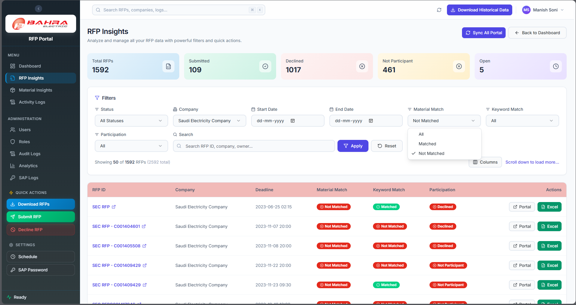

6. Material Insights
Navigate to Material Insights from the sidebar menu. This page analyzes how your company’s materials and keywords match against RFPs.

6.1 Stats Overview
Four stat cards show:
- Unique Materials — Number of distinct material codes in the system
- Unique Keywords — Number of distinct keywords tracked
- RFPs with Matches — How many RFPs had at least one material or keyword match
- Submitted RFPs — How many matched RFPs were submitted

6.2 Tabs: Materials vs Keywords
Toggle between two views using the tabs:
- Materials — Analysis by material code
- Keywords — Analysis by keyword

6.3 Charts
Depending on the selected tab:
- Bar Chart — Top 10 Materials (or Keywords) ranked by RFP count
- Pie Chart — Keyword frequency distribution (visible on Keywords tab)

6.4 Filters
Filter | Options
Company | Filter by specific company
Participation | All, Submitted, Declined, Open
Search | Search by material code or keyword

6.5 Expandable Table
The main table shows materials or keywords as parent rows. Each row shows:
- Code/Keyword, Description, RFP Count, Companies, Submitted Count
Click the expand arrow on any row to reveal the individual RFPs that matched:
- RFP ID, Company, Deadline, Match Method (Exact or Keyword), Participation status
The table supports infinite scroll for large datasets.
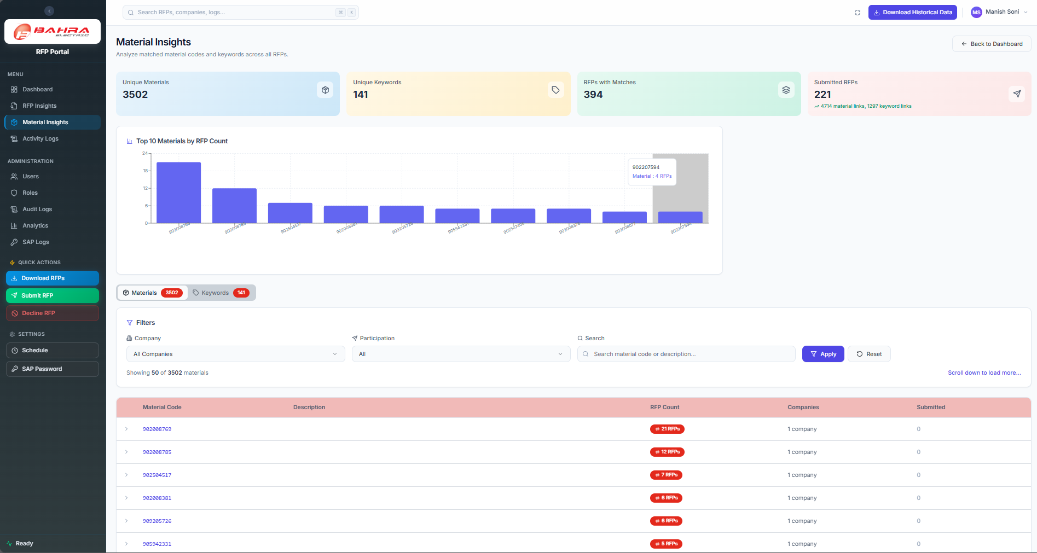

7. Activity Logs
Navigate to Activity Logs from the sidebar menu. This page shows the history of all automation runs.

7.1 Statistics Cards
Four clickable cards at the top:
- Total Runs — All automation runs
- Completed — Successfully completed runs (click to filter)
- Failed — Runs that encountered errors (click to filter)
- Running — Currently active runs (click to filter)

7.2 Controls
- Search box — Search by RFP ID, action, or run ID
- Page size selector — Choose how many logs to show (50, 100, 200, or 500)

7.3 Run Cards
Each automation run is displayed as a card with:
- Left color bar: Green = Completed, Red = Failed, Blue = Running
- Status icon: Checkmark, X, or spinner
- RFP ID and status badge
- Action name (e.g., Download, Submit, Decline)
- Start/End time
- Step progress (e.g., 5 success / 0 failed / 5 total)
- View Details button

7.4 Run Detail Modal
Click View Details to open a modal with three tabs:
Timeline Tab: A vertical timeline showing each step of the automation:
- Timestamp, action type, status, and details for each step
- Color-coded dots: Green = success, Red = failure, Gray = skipped
Error Report Tab: If the run encountered errors, this tab shows:
- Error type and summary
- Context information
- Full traceback
- Suggested actions to resolve
Screenshots Tab: If the automation captured browser screenshots during failure, they are displayed here for visual debugging.
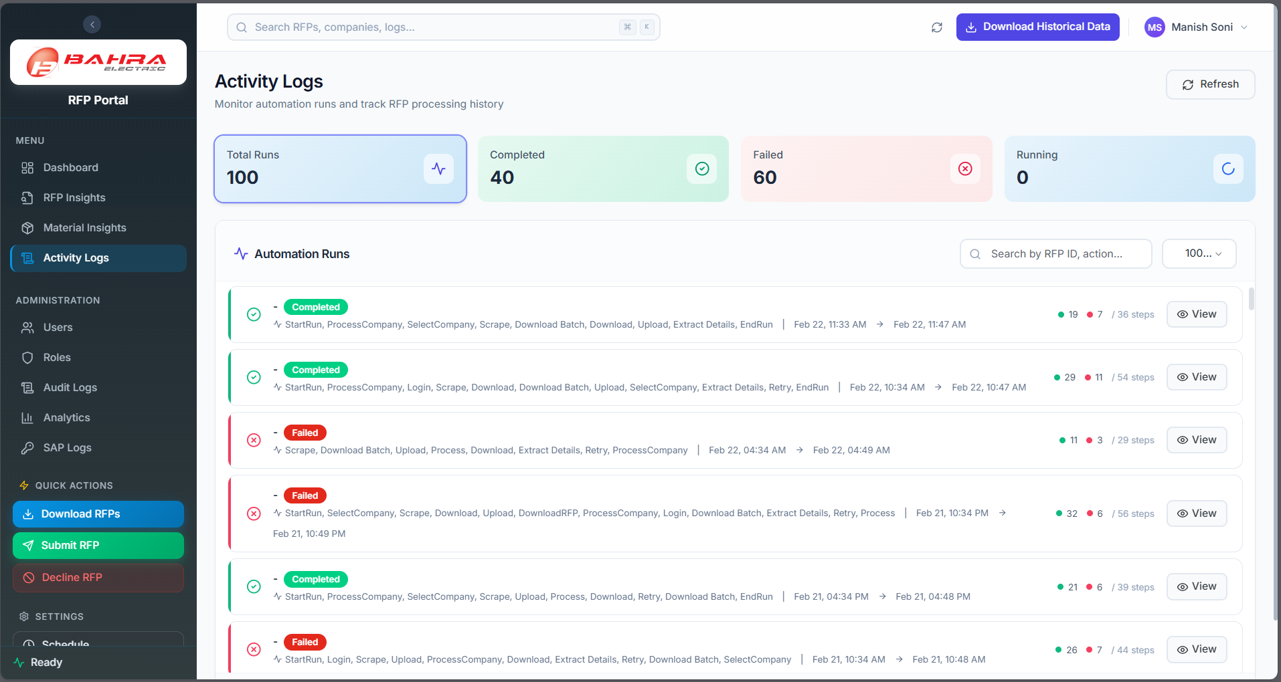
[SCREENSHOT: Run Detail Modal — showing the Timeline tab with a vertical timeline of steps]

8. Analytics
Navigate to Analytics from the sidebar menu (under Administration, if you have permission). This page provides visual charts and interactive drill-downs.

8.1 Key Metrics
Four cards at the top:
- Total RFPs — All RFPs in the system
- Submitted — Submitted count with participation rate percentage
- Material Matched — Count and percentage of RFPs with material matches
- Keyword Matched — Count and percentage of RFPs with keyword matches
Tip: Click any metric card to navigate to RFP Insights with the relevant filter applied.

8.2 Interactive Charts
The page displays four charts in a 2-column layout:
Chart | Type | What It Shows
RFP Status Distribution | Donut chart | Breakdown by Submitted (green), Open (amber), Declined (red)
Top 5 Companies | Horizontal bar chart | Companies ranked by RFP count
Material Matching | Donut chart | Material Matched vs Not Matched
Keyword Matching | Donut chart | Keyword Matched vs Not Matched
Drill-Down: Click on any chart segment or bar to navigate to the RFP Insights page with the corresponding filter pre-applied.

8.3 Participation by Company
Below the charts, a horizontal stacked bar chart shows participation breakdown per company:
- Participated (green), Not Participated (gray), Declined (red)
Click any segment to drill down to the corresponding filtered view.
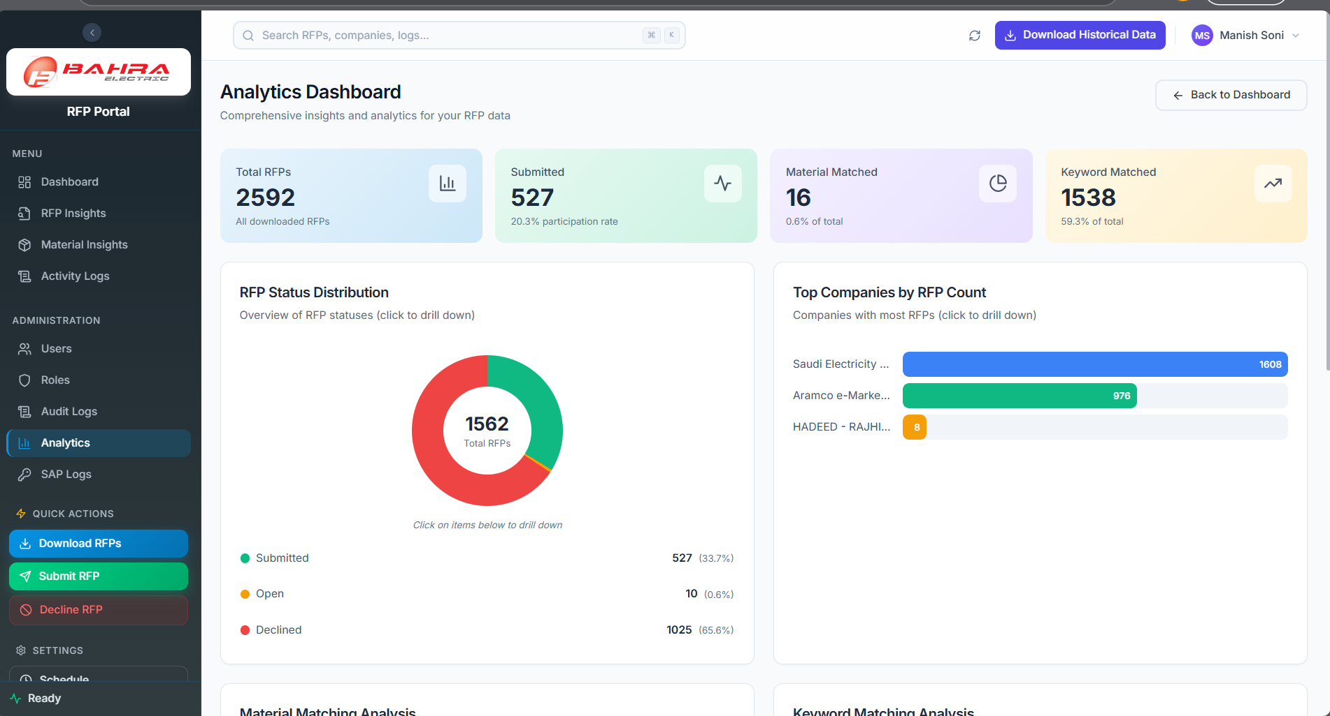

9. Profile Settings
Navigate to Profile by clicking your profile icon in the header or navigating to the profile page.

9.1 Update Profile Information
The Profile Information card shows:
- Display Name — Editable. Change your name and click Save Changes.
- Email — Read-only. Contact an administrator to change your email.
- Mobile Number — Optional. Add or update your phone number.
- Role — Read-only. Shows your assigned role (e.g., RFP Bidder).

9.2 Change Password
The Change Password card has three fields:
- Current Password — Enter your existing password.
- New Password — Enter a new password that meets these requirements:
  - Minimum 8 characters
  - At least one uppercase letter
  - At least one number
- Confirm New Password — Re-enter the new password.
Click Change Password to update. A success notification confirms the change.
[SCREENSHOT: Profile Settings Page — showing the Profile Information card and Change Password card]

10. Automation Status Indicator
The bottom of the sidebar shows the Automation Status.
When idle (Ready):
- A green dot with the text “Ready” appears
- This means no automation is currently running
When running:
- The indicator changes to yellow/amber with “Running” text and an animated pulse
- A progress bar appears showing the percentage complete
- Detailed progress shows which operation is running:
  - Download: Shows current/total count and the current item being processed
  - Submit: Shows processing status message
  - Decline: Shows processing status message
Important: While automation is running, the corresponding Quick Action button in the sidebar is disabled (grayed out) to prevent duplicate runs. You can continue using other parts of the portal normally.
When the sidebar is collapsed, the automation status is shown as a small colored dot (green = Ready, amber = Running). Hover over it to see details.

11. Quick Reference

Status Colors
Status | Color | Badge Style
Open | Amber/Orange | Amber background, amber text
Submitted | Green | Green background, green text
Draft / Saved Draft | Gray | Gray background, gray text
Declined | Red | Red/Rose background, red text

Match % Thresholds
Range | Color | Meaning
80% and above | Green | Strong match — high relevance
50% – 79% | Amber | Moderate match — review recommended
Below 50% | Red | Weak match — low relevance
No data | Gray dash | No material match data available

Quick Action Buttons
Button | Color | Action
Download RFPs | Blue gradient | Opens download dialog to scrape RFPs from portals
Submit RFP | Green gradient | Opens submit dialog to upload files and submit
Decline RFP | Red outline | Opens decline dialog to decline participation

Automation Run Statuses (Activity Logs)
Status | Indicator | Meaning
Completed | Green bar + checkmark | Run finished successfully
Failed | Red bar + X icon | Run encountered a fatal error
Running | Blue bar + spinner | Run is currently in progress

Supported Companies
Company | Portal
Saudi Electricity Company | SEC procurement portal
Aramco e-Marketplace | Aramco procurement portal
SABIC - Saudi Basic Industries Corp. | SABIC procurement portal
HADEED - RAJHI STEEL | HADEED procurement portal

12. Troubleshooting & FAQ

“I can’t log in”
- Check your credentials: Make sure you’re using the correct email and password.
- Account locked: After 5 failed login attempts within 5 minutes, your account is locked for 30 minutes. Wait and try again, or contact your administrator to unlock it.
- Password expired: Passwords must be changed every 90 days. Use the Forgot Password link to reset.

“The dashboard shows no data”
- First time? Click the Download RFPs button in the sidebar to download RFPs from the portals.
- Data stale? Click the Sync Portal button in the RFP Management section header to refresh.
- Check Activity Logs to see if a download automation has run recently.

“RFP submission failed”
- Go to Activity Logs and find the failed run.
- Click View Details and check the Error Report tab for the error message.
- Common causes: portal was unavailable, file format was incorrect, or session timed out.
- If the issue persists, contact your administrator.

“I don’t see certain menu items”
- Menu items are based on your role and permissions. RFP Bidder users may not see admin sections like Users, Roles, or Audit Logs.
- If you need access, contact your administrator to update your role permissions.

“My session expired”
- Sessions time out after 2 hours of activity or 30 minutes of inactivity.
- You will be redirected to the login page. Simply log in again to continue.
- Your unsaved form data (e.g., in a Submit dialog) will be lost — complete submissions promptly.

“The Submit/Decline button is grayed out”
- This means the corresponding automation is already running. Check the Automation Status indicator at the bottom of the sidebar.
- Wait for the current operation to complete before starting a new one.

“I entered an RFP ID but got an error in the Submit/Decline dialog”
- The message “RFP not found in database” means the RFP must be downloaded first before it can be submitted or declined.
- Use the Download RFPs action to download it, then try again.

“Excel download is not working”
- Ensure your browser allows file downloads and pop-ups from the portal URL.
- Check if the RFP has an associated Excel file — some newly downloaded RFPs may not have files yet.

“How do I know if my Adaptive Card response was saved?”
- After clicking Submit in the Outlook Adaptive Card, the card should update to show a confirmation message.
- If the card doesn’t update, check your internet connection and try again.
- Your responses are saved in the system — check with your administrator if unsure.

For additional support, contact your system administrator.

