**Report -- Solar Pond Automation**

Manish Gautam ( 1MS18ME088 )

MSRIT

# 

`

## 

**About Solar Pond**

A solar pond is a pool of [saltwater](https://en.wikipedia.org/wiki/Seawater) that collects and stores solar thermal energy. The saltwater naturally forms a vertical [salinity](https://en.wikipedia.org/wiki/Salinity) [gradient](https://en.wikipedia.org/wiki/Gradient) in which low-salinity water floats on top of high-salinity water. The layers of salt solutions increase in concentration with depth. Below a certain depth, the solution has a uniformly high salt concentration.

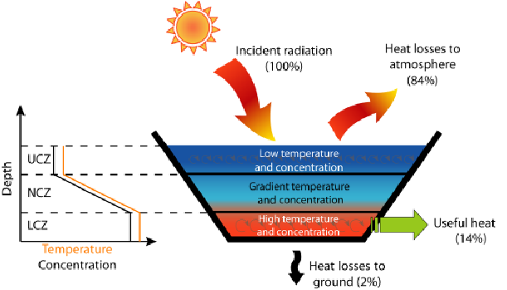

When the sun's rays contact the bottom of a shallow pool, they heat the water adjacent to the bottom. When water at the bottom of the pool is heated, it becomes less dense than the cooler water above it, and [convection](https://en.wikipedia.org/wiki/Convection) begins. Solar ponds heat water by impeding this convection. Salt is added to the water until the lower layers of water become completely [saturated](https://en.wikipedia.org/wiki/Saturated_solution). High-salinity water at the bottom of the pond does not mix readily with the low-salinity water above it, so when the bottom layer of water is heated, convection occurs separately in the bottom and top layers, with only mild mixing between the two. This greatly reduces heat loss and allows for the high-salinity water to get up to 90 °C while maintaining 30 °C low-salinity water. This hot, salty water can then be pumped away for use in electricity generation, through a [turbine](https://en.wikipedia.org/wiki/Turbine), or as a source of thermal energy.

**Table Of Contents**

1. Abstract
2. Problem Definition
3. Objectives
4. Work Plan ( Gantt chart/Critical path analysis)
5. Critical Path Analysis
6. Tools and Technology
7. Methodology
8. Financial feasibility-(Pay Back Period)
9. Result and Discussion
10. Risk feasibility
11. Conclusion
12. References (papers/pictures)

**A. Abstract**

In this project, a machine learning (Linear Regression) model was used to predict the performance parameters of a laboratory model salinity gradient solar pond (SGSP), which is used for supplying hot water. Experiments were conducted on three different solar ponds provided with and without twisted tapes in the flow passage of the in-pond heat exchanger during May 2015 at Chennai weather conditions in India. The performance parameters of the solar pond such as outlet water temperature, the efficiency of the solar pond, and effectiveness of in-pond heat exchanger were determined experimentally for two different flow rates of Reynolds numbers 1,746 and 8,729. The experimental data obtained from the observations were utilized for training, validating, and testing the proposed linear regression model. The parameters like incident solar radiation, inlet water temperature, lower convective zone (LCZ) temperature, and flow rate are responsible for the outlet water temperature of the solar pond. Based on the experimental readings as inputs a computational program was developed in Python. This program was trained using a machine-learning algorithm to predict the outlet water temperature of the in-pond heat exchanger. The results predicted using the model are in good agreement with the experimental results.

**B. Problem Definition:**

Solar ponds are continuously using in thermal power plants for steam

generation and with the help of steam power(electricity) can be developed.

But during the process of steam generation, a lot of water will be wasted, a lot of human effort and time consumption will be more.

Various gases like carbon dioxide and nitrogen are coming out from the power plants responsible for pollution in the atmosphere.

With the help of our application, we will automate the testing of solar ponds( able to predict the outlet temperature of steam) without wasting any resources like water. We will reduce time consumption as well as pollution in the atmosphere.

**C. Objectives**

* We will automate the performance analysis of the solar pond with our application.
* We will reduce human work because harmful gases like carbon dioxide, nitrogen, etc. cause lungs related diseases.
* We will reduce the time consumption for power generation.
* We will increase the accuracy of the solar pond so that it can generate more heat.
* We can save water because our application will automate the performance analysis of solar ponds.
* We can reduce thermal pollution and save the environment.

**D. Work Plan** The whole plan of this project from 20 March to 20 May 2021 is given below in the form of a flow chart. We have divided our work into different time frames to be done perfectly without any difficulty.

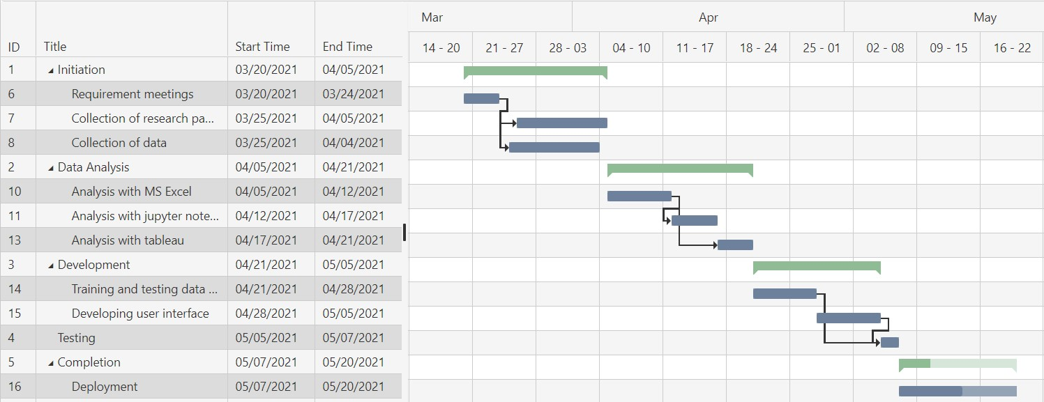

**Critical Path Analysis:**

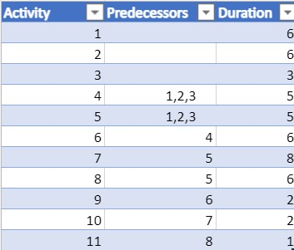

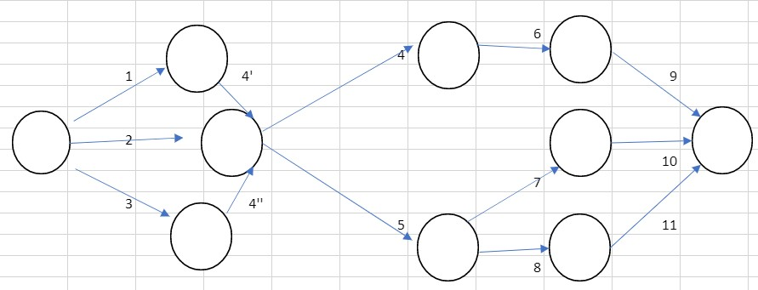

**E. Tools and Technology**

The tools and technology required for this project are available on the internet and the technical skills required are manageable. The required tools are listed below:

* **Python Programming language:** Python is a high-level, general-purpose, and very popular programming language. Python programming language (latest Python 3) is being used in Machine Learning applications and all cutting-edge technology in the software industry.
* **Machine learning (Linear Regression):** Linear Regression is a supervised machine learning algorithm where the predicted output is continuous and has a constant slope. It's used to predict values within a continuous range, (e.g. sales, price).

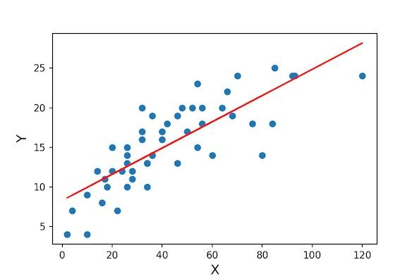

* **Jupyter Notebook:** It is an IDE that allows writing python code for data analysis and also very useful for the implementation of machine learning algorithms.



* **Development of User Interface(UI):** A model obtained by a machine learning algorithm is not useful without a user interface. HTML and CSS are used for the development of user interfaces.

**Need of user interface**

* Positive user experience
* Increased user engagement and retention
* Increased productivity



* **Deployment (Heroku platform):** This is the final stage of the project. All the code with user interface pushes into production so that people can use it for business and manufacturing purposes. For the deployment purpose, we have used the Heroku platform.

**F. Methodology**

* Collection of research papers and books for the solar pond performance data and graphs.

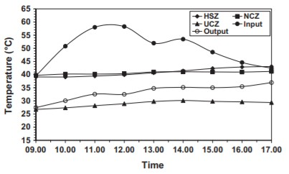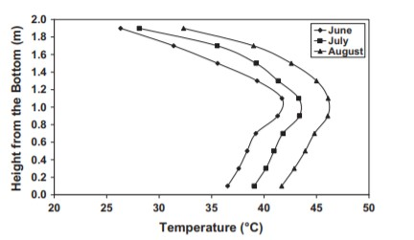

* Collection of datasets from papers and converting this data into excel format in MS Word.

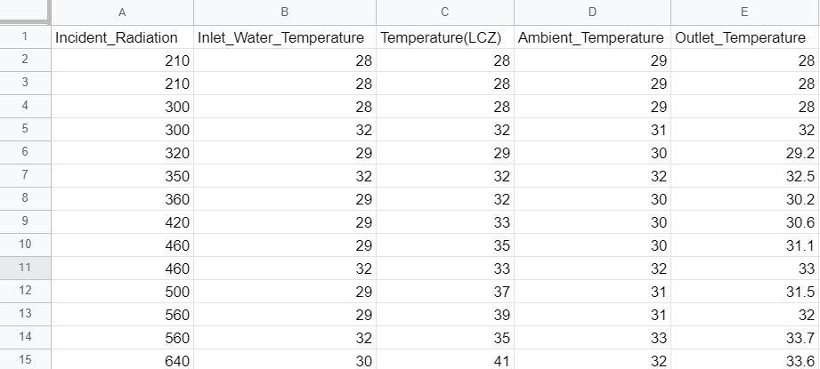

* Uploading this data into a jupyter notebook and perform data analysis for some useful information from the data.

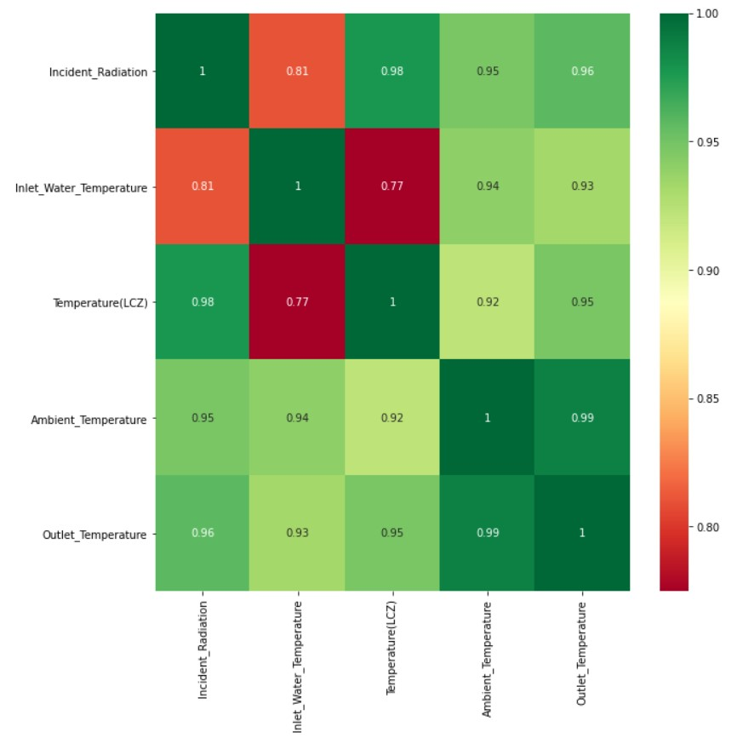

* Data will be divided into two components one is input data and another one is the output that is required data. In this case incident radiation, inlet water temperature, temperature(LCZ), ambient temperature are input features and outlet temperature is output.





* Implementation of machine learning (linear regression) algorithm to the data for the development of a model that will predict the outlet temperature. After that save a model into a pickle file for future usage.

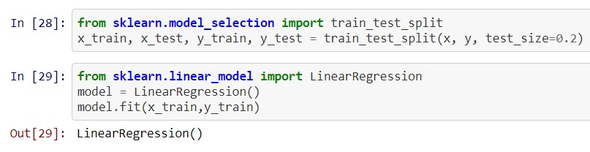

* Development of user interfaces with the help of HTML and CSS so that the productivity of the application will increase.
* Deployment of an application on the platform (Heroku)

**G.Financial feasibility**

At the initial stage of the project, the cost will be for the hosting cost only, The cost per annum is shown below:

**Python programming software:** Freely available on the internet.

**Visual Studio:** Software is freely available.

**Hosting:** A server is required for hosting applications.

|  |  |  |
| --- | --- | --- |
| **Tools/Technology** | **Cost per month** | **Cost per annum** |
| Python programming software | Rs. 0 | Rs. 0 |
| Hosting | Rs. 2300 | Rs. 27600 |
| MS Excel | Rs. 0 | Rs. 0 |
| Jupyter Notebook | Rs. 0 | Rs. 0 |
| Visual Studio | Rs.0 | Rs.0 |

**Pay Back Period:**

Payback period(Rs)= Initial investment(Rs)/Annual Income(Rs)

The initial investment = Rs.27600(Hosting) + Rs.100000(Advertisement)

Payback = (27600+100000)/50000 = 2.55

**H. Result and Discussion**

The different versions of the solar pond performance prediction applications developed in this project with the user interface are application predictions shown below.

* **iPad Pro Version**

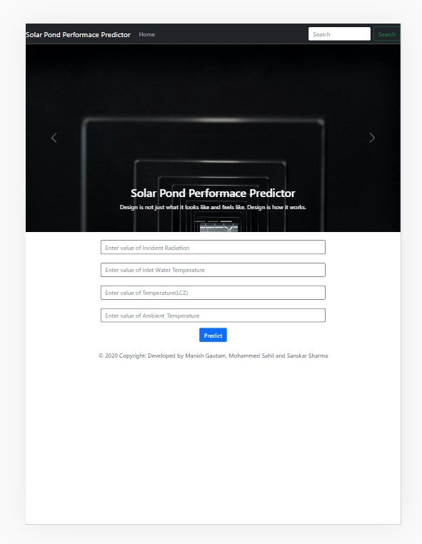

* **Computer/laptop version**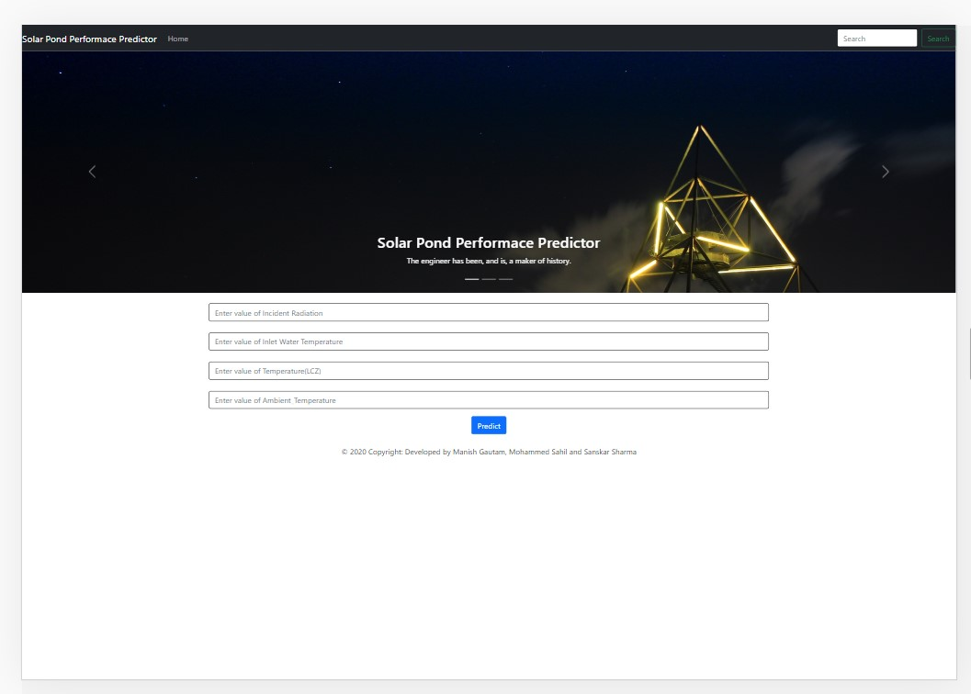

The accuracy of this application depends on the quality of data analysis that we performed at the initial stage of the project. In our condition, we made this model or application with an accuracy of 97% (Because of less data).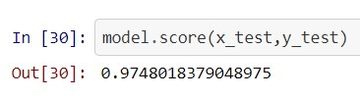

This is how applications predict the output for given input parameters.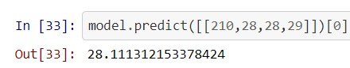

**I. Risk feasibility**

* **Related to the size of the application:** As the application does not contain very few multimedia files, the file sizes and complete project will not more than 200MB.
* **Customer-related:** The application is a general type of product (not designed for just one person), there will be some basic modifications required.
* **Resource related:** Most of the resources used in this project are freely available only some skills are required to use.
* **Technology risk:** All the technologies are very well established and old enough.

**J.Conclusion**

* **Performance:** This application will help to increase the rate of power generation in thermal power plants because of less processing time and high response time.
* **Usability and ease of use:** The user will be provided a complete user manual as a pdf. The interface is designed to make it easy for any potential user to get familiar with the system within one hour only. No additional training is required.
* **Capacity:** This application can accommodate many users at a time.
* **Availability:** The application will available for 24 hours. Meantime to failure and mean time to repair will be decided to increase the availability.

**K. References**

* <https://en.wikipedia.org/wiki/Solar_pond>
* <https://ww4.ticaret.edu.tr/ekserji2016/wp-content/uploads/sites/81/2016/05/4-Solar-Energy-Daily-performance-solar-pond.pdf>
* <http://epubs.surrey.ac.uk/841846/1/Solar%20Energy4Unmarked.pdf>
* <https://scikit-learn.org/stable/modules/generated/sklearn.linear_model.LinearRegression.html>
* <https://www.w3schools.com/html/html_css.asp>

**For pictures:**

* <https://www.researchgate.net/profile/Samir-Abu-Eishah/publication/221971602/figure/fig4/AS:340439346499585@1458178473348/b-Closer-View-of-El-Paso-Solar-Pond-USA_Q320.jpg>
* <https://www.researchgate.net/profile/Francisco-Suarez-10/publication/258020624/figure/fig1/AS:297328629043209@1447900077694/Schematic-of-a-salt-gradient-solar-pond-modified-from-Kurt-et-al-2000.png>