CUSTOMER SHOPPING BEHAVIOR
ANALYSIS REPORT
Exploratory Data Analysis (EDA) & Business Insights

Item | Details
Project Type | Internship / Data Analytics Project
Dataset | customer_shopping_behavior(2).csv
Records | 3,900 customer transactions
Variables | 18 columns
Analysis Tools | Python, Pandas, Matplotlib, Microsoft Word
Prepared By | Manish Kumar Gautam
Organization / Internship | SAM AI Technologies
Date | 5/10/2026

This report is prepared directly from the supplied customer shopping behavior dataset.

1. Executive Summary
This internship project analyzes 3,900 customer purchase records to understand customer demographics, purchasing patterns, product-category performance, seasonal behavior, payment preferences, shipping choices, subscription adoption, promotions, and purchase frequency. The dataset contains 18 fields and covers ages 18–70, purchase amounts from $20 to $100, and 50 locations.
Across all records, total recorded purchase value is $233,081, with an average transaction value of $59.76 and a median of $60. Clothing is the largest category by volume (1,737 purchases), while Spring has the highest seasonal transaction count (999). Male customers account for 2,652 records and female customers for 1,248. Payment methods are relatively balanced, with PayPal being the most used (677).

Key Findings at a Glance
- Customer age: mean 44.1 years; median 44 years.
- Average purchase amount: $59.76; total recorded purchase value: $233,081.
- Clothing leads all categories with 1,737 transactions (44.5% of all records).
- Spring has the highest transaction count at 999; Summer is lowest at 955.
- Male customers represent 68.0% of records; female customers represent 32.0%.
- PayPal is the most-used payment method (677), while Bank Transfer is the least-used (612).
- 1,053 customers have a subscription and 2,847 do not.
- 1,677 transactions show a discount applied; 1,677 show a promo code used.
- Average review rating is 3.75/5, indicating generally positive customer feedback.

2. Dataset Overview
The dataset represents customer shopping behavior at transaction level. Each row corresponds to a purchase record and includes customer demographics, item/category information, purchase value, location, season, review rating, subscription status, shipping, promotion usage, previous purchases, payment method, and purchase frequency.
Metric | Value
Rows / Transactions | 3,900
Columns | 18
Customer IDs | 3,900 unique
Locations | 50
Items Purchased | 25 unique item names
Colors | 25
Age Range | 18–70 years
Purchase Range | $20–$100
Rating Range | 2.5–5.0
Missing Values | 0
Duplicate Rows | 0

2.1 Data Quality Check
- No missing values were found across the 18 columns.
- No duplicate rows were found in the supplied dataset.
- Customer ID is unique for all 3,900 records.
- Data types are appropriate for analysis: numerical fields include age, purchase amount, review rating, and previous purchases; categorical fields cover customer and transaction attributes.
- No additional imputation was required for the supplied dataset.

2.2 Data Dictionary

Column | Description | Type
Customer ID | Unique customer identifier | Integer
Age | Customer age | Integer
Gender | Customer gender category | Categorical
Item Purchased | Specific item purchased | Categorical
Category | Product category | Categorical
Purchase Amount (USD) | Transaction value in USD | Integer
Location | Customer location | Categorical
Size | Purchased item size | Categorical
Color | Purchased item color | Categorical
Season | Season associated with purchase | Categorical
Review Rating | Customer review rating | Float
Subscription Status | Whether customer is subscribed | Categorical
Shipping Type | Selected shipping method | Categorical
Discount Applied | Whether a discount was applied | Categorical
Promo Code Used | Whether a promo code was used | Categorical
Previous Purchases | Number of previous purchases | Integer
Payment Method | Payment channel used | Categorical
Frequency of Purchases | Customer purchase frequency | Categorical

3. Customer Demographics Analysis
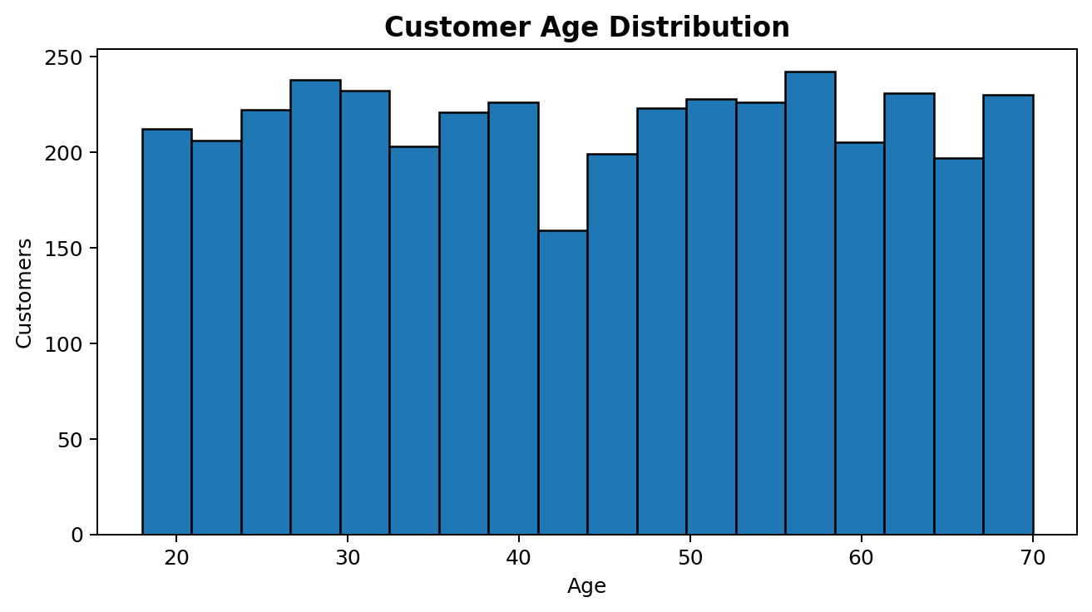
The customer age distribution spans 18 to 70 years. The average age is 44.1 years and the median is 44 years. The distribution is spread across the adult age range rather than being concentrated in only one narrow age group.
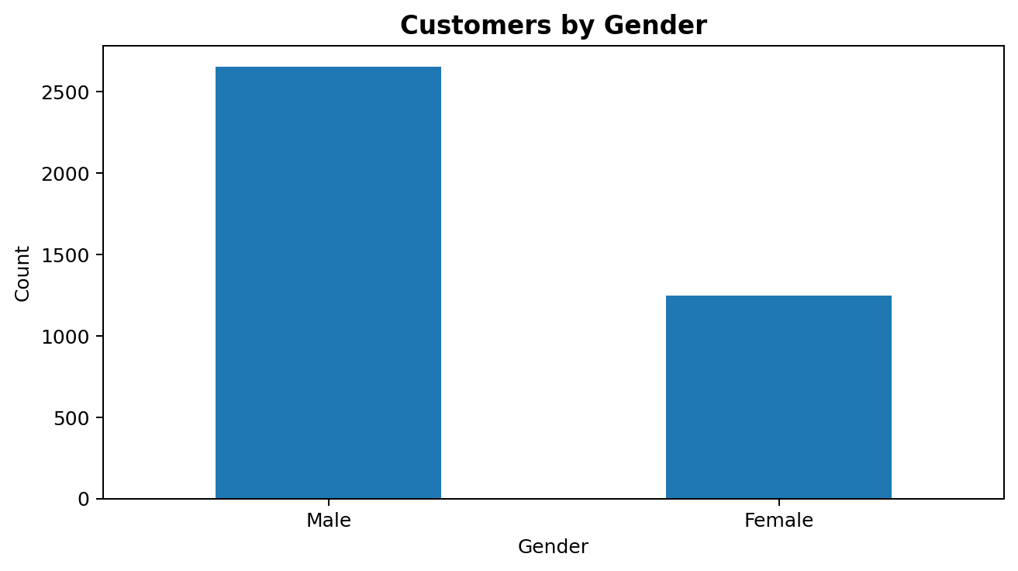

Gender-wise, the dataset contains 2,652 male records and 1,248 female records. Male records represent 68.0% of the dataset, while female records represent 32.0%.
Gender | Transactions | Avg_Purchase | Total_Purchase | Avg_Rating
Female | 1248 | 60.25 | 75191 | 3.74
Male | 2652 | 59.54 | 157890 | 3.75

4. Purchase Behavior Analysis
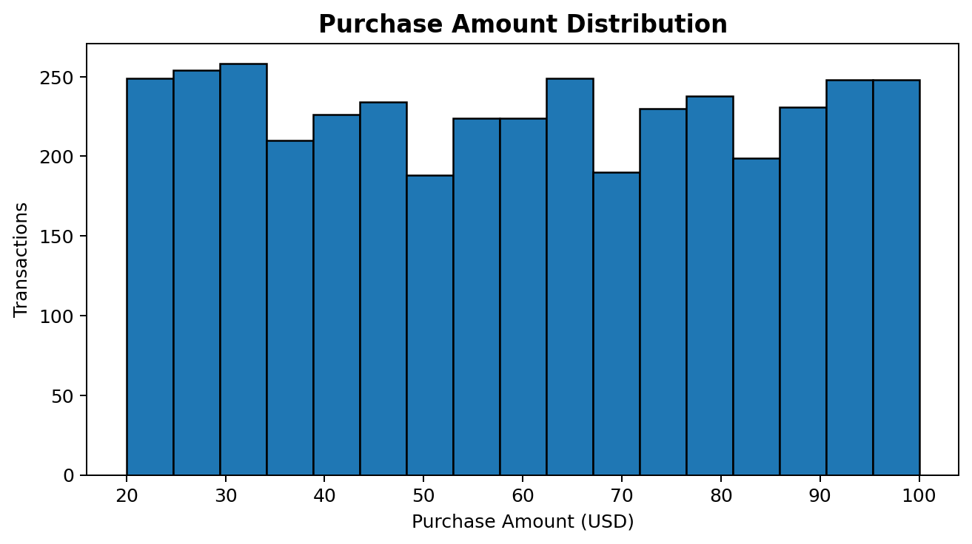
Purchase amounts range from $20 to $100. The mean transaction value is $59.76, while the median is $60. The distribution is fairly broad and does not indicate a small number of extremely large purchases dominating the dataset.

4.1 Category Performance
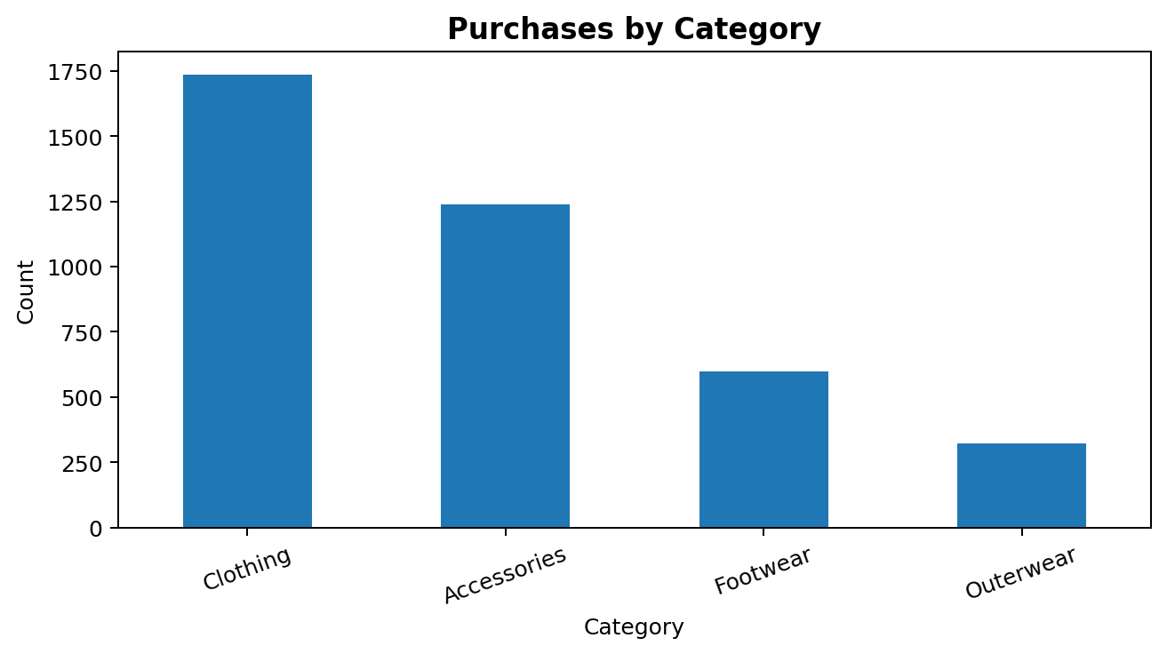
Category | Transactions | Share | Avg_Purchase | Total_Purchase | Avg_Rating
Clothing | 1737 | 44.54 | 60.03 | 104264 | 3.72
Accessories | 1240 | 31.79 | 59.84 | 74200 | 3.77
Footwear | 599 | 15.36 | 60.26 | 36093 | 3.79
Outerwear | 324 | 8.31 | 57.17 | 18524 | 3.74

Clothing is the strongest category by volume with 1,737 purchases (44.5%). Accessories follow with 1,240. Footwear contributes 599, while Outerwear has the lowest volume at 324. Footwear has the highest average purchase value among categories at $60.26.

4.2 Seasonal Analysis
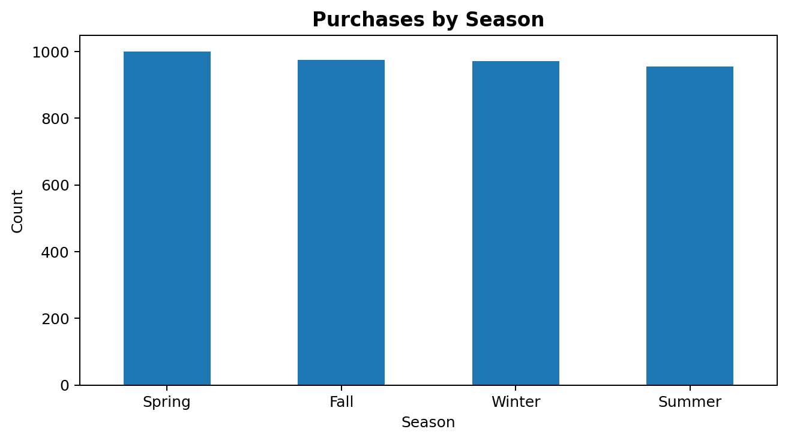
Season | Transactions | Avg_Purchase | Total_Purchase | Avg_Rating
Spring | 999 | 58.74 | 58679 | 3.79
Summer | 955 | 58.41 | 55777 | 3.72
Fall | 975 | 61.56 | 60018 | 3.73
Winter | 971 | 60.36 | 58607 | 3.75

Spring has the highest number of transactions (999), while Summer has the lowest (955). Fall records the highest average purchase value at $61.56. Seasonal transaction volumes are relatively close, suggesting that demand is distributed across the year.

5. Payment Method Analysis
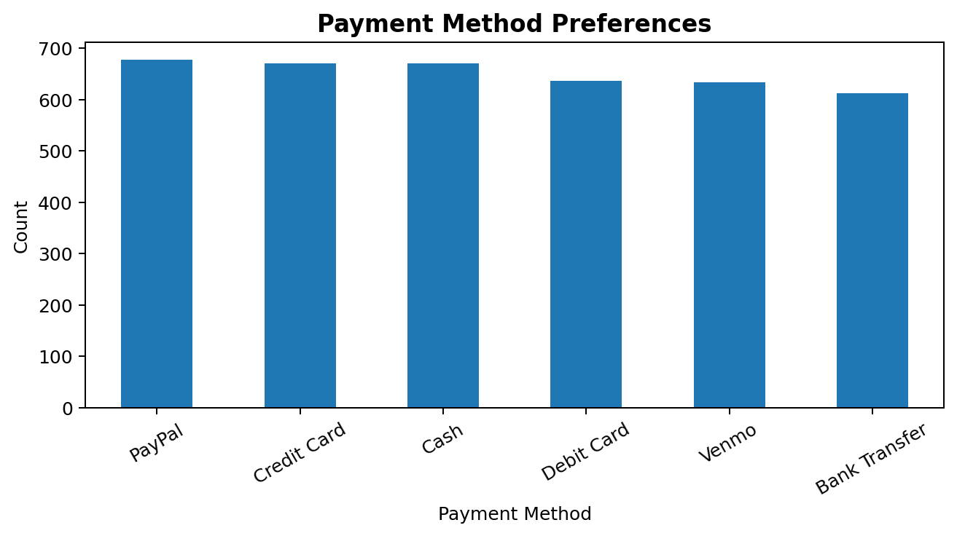
Payment Method | Transactions | Avg_Purchase | Total_Purchase
PayPal | 677 | 59.25 | 40109
Credit Card | 671 | 60.07 | 40310
Cash | 670 | 59.7 | 40002
Debit Card | 636 | 60.92 | 38742
Venmo | 634 | 58.95 | 37374
Bank Transfer | 612 | 59.71 | 36544

Payment usage is well distributed. PayPal is the most-used method with 677 transactions, followed by Credit Card (671) and Cash (670). Bank Transfer is the least-used with 612. Debit Card has the highest average transaction value among payment methods at $60.92.

6. Subscription, Discount & Promotion Analysis
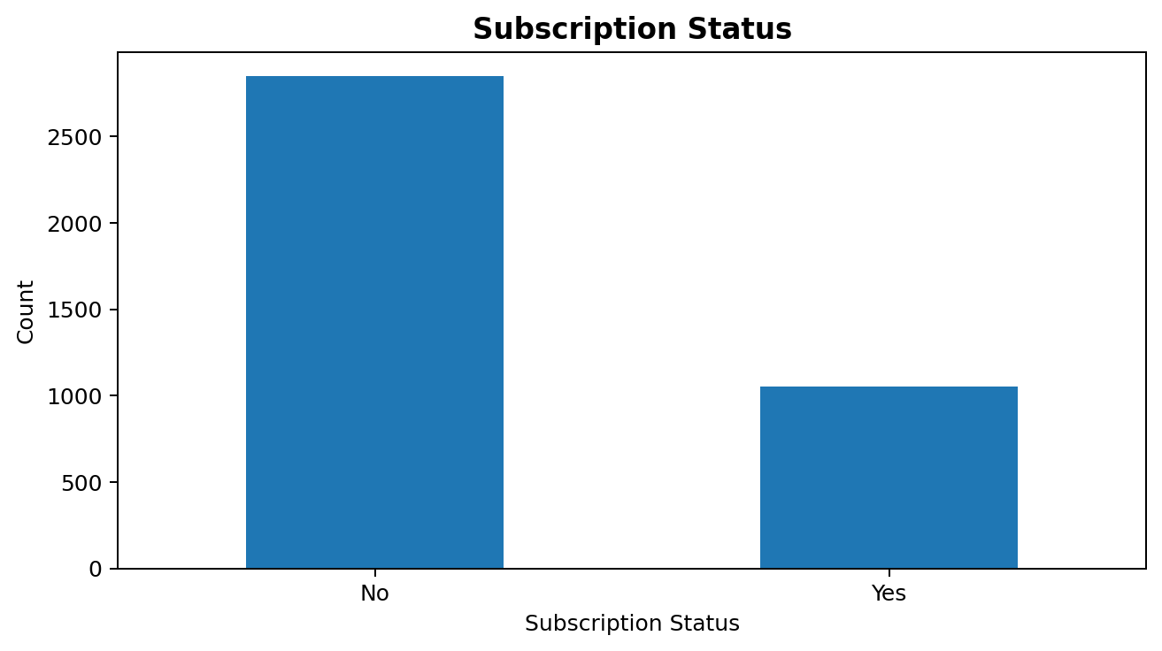
Subscription Status | Transactions | Share | Avg_Purchase | Total_Purchase
No | 2847 | 73.0 | 59.87 | 170436
Yes | 1053 | 27.0 | 59.49 | 62645

Only 1,053 records (27.0%) are marked as subscribed, compared with 2,847 non-subscribed records (73.0%). The average purchase values are similar between the two groups, so subscription status does not show a large transaction-value difference in this dataset.
Promotion Indicator | Transactions | Share
Discount Applied = Yes | 1,677 | 43.0%
Discount Applied = No | 2,223 | 57.0%
Promo Code Used = Yes | 1,677 | 43.0%
Promo Code Used = No | 2,223 | 57.0%

Discount application and promo-code usage have identical counts in the dataset: 1,677 transactions use a discount/promo indicator and 2,223 do not. This suggests the two fields may be closely aligned in the source data.

7. Shipping & Purchase Frequency
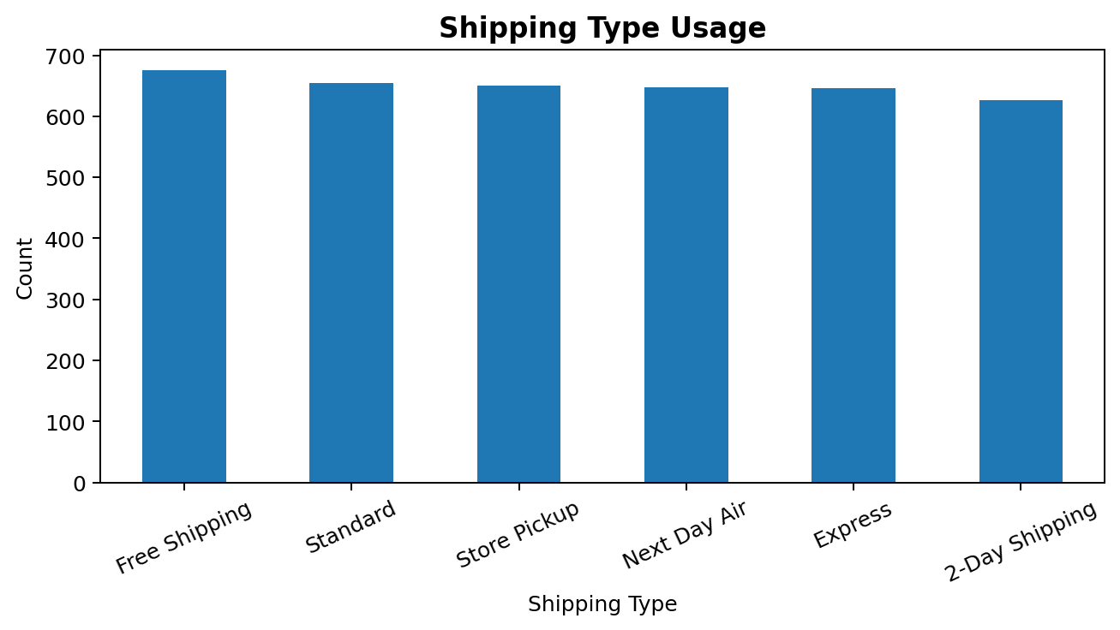
Shipping Type | Transactions | Avg_Purchase | Avg_Rating
Free Shipping | 675 | 60.41 | 3.71
Standard | 654 | 58.46 | 3.82
Store Pickup | 650 | 59.89 | 3.71
Next Day Air | 648 | 58.63 | 3.72
Express | 646 | 60.48 | 3.77
2-Day Shipping | 627 | 60.73 | 3.76

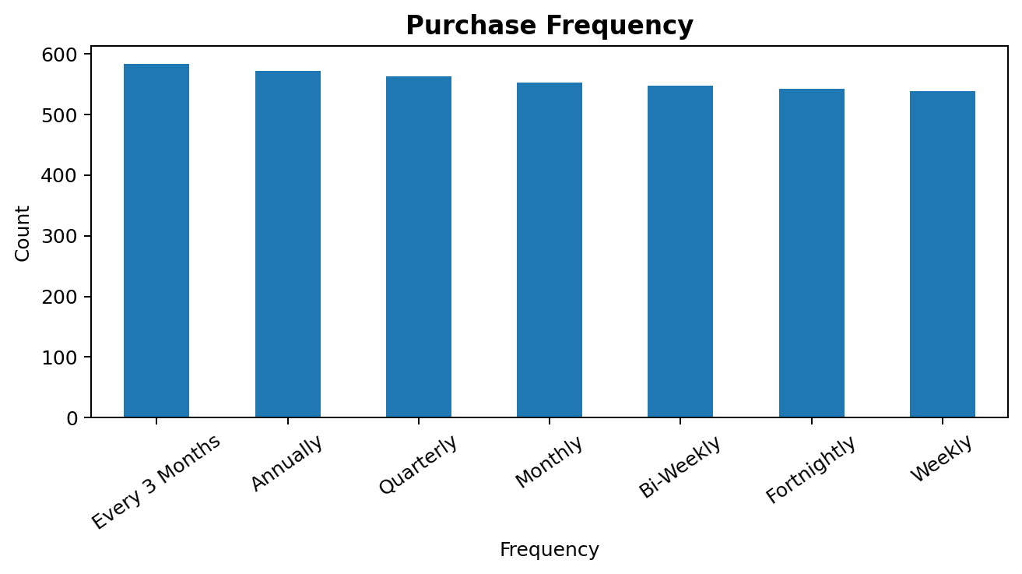

Frequency of Purchases | Transactions | Avg_Purchase | Total_Purchase
Every 3 Months | 584 | 60.08 | 35088
Annually | 572 | 60.17 | 34419
Quarterly | 563 | 59.98 | 33771
Monthly | 553 | 59.33 | 32810
Bi-Weekly | 547 | 60.69 | 33200
Fortnightly | 542 | 59.05 | 32007
Weekly | 539 | 58.97 | 31786

Purchase frequency is spread across weekly, fortnightly, bi-weekly, monthly, quarterly, every-three-months, and annual patterns. No single frequency dominates the dataset, indicating a mixed customer lifecycle.

8. Product, Location, Size & Review Insights
Top 10 items by transaction count:
Item Purchased | Transactions | Avg_Purchase | Total_Purchase
Blouse | 171 | 60.88 | 10410
Pants | 171 | 59.01 | 10090
Jewelry | 171 | 58.54 | 10010
Shirt | 169 | 61.14 | 10332
Dress | 166 | 62.17 | 10320
Sweater | 164 | 57.7 | 9462
Jacket | 163 | 56.74 | 9249
Belt | 161 | 59.84 | 9635
Coat | 161 | 57.61 | 9275
Sunglasses | 161 | 59.93 | 9649

Top 10 locations by transaction count:
Location | Transactions | Total_Purchase
Montana | 96 | 5784
California | 95 | 5605
Idaho | 93 | 5587
Illinois | 92 | 5617
Alabama | 89 | 5261
Minnesota | 88 | 4977
Nebraska | 87 | 5172
Nevada | 87 | 5514
New York | 87 | 5257
Delaware | 86 | 4758

Size distribution and performance:
Size | Transactions | Share | Avg_Purchase | Avg_Rating
M | 1755 | 45.0 | 59.92 | 3.71
L | 1053 | 27.0 | 58.56 | 3.75
S | 663 | 17.0 | 61.04 | 3.79
XL | 429 | 11.0 | 60.09 | 3.8

Average review rating is 3.75/5, with observed ratings ranging from 2.5 to 5.0. The average number of previous purchases is 25.35, which provides a useful indicator of customer repeat-purchase history.

9. Business Insights & Recommendations
Protect the Clothing category: Clothing generates the highest transaction volume and the highest category-level total purchase value. Maintain assortment depth, availability, and merchandising in this category.
Increase focus on Accessories and Footwear: Accessories is the second-largest category, while Footwear has a slightly higher average transaction value than the other categories. Cross-selling can combine these categories with Clothing.
Use seasonal campaigns: Transaction counts are relatively balanced across seasons. Rather than relying only on one peak season, campaigns can be planned continuously with seasonal product themes.
Maintain multiple payment options: Payment method usage is distributed across PayPal, Credit Card, Cash, Debit Card, Venmo, and Bank Transfer. Keeping multiple options reduces payment friction.
Improve subscription conversion: Only 27.0% of records are subscribed. Loyalty benefits, member-only offers, early access, or personalized recommendations could be tested to increase adoption.
Measure promotion effectiveness: Discount and promo-code indicators occur in the same number of records. Future analysis should test whether discounts increase conversion or repeat purchases while protecting average order value.
Optimize customer retention: Purchase frequency is distributed across several lifecycle patterns. Customer segmentation by frequency and previous purchases can support targeted retention campaigns.
Use location-level targeting: The dataset covers 50 locations. Location-specific demand analysis can be used for regional promotions, inventory planning, and shipping optimization.

10. Methodology / Project Workflow
- Data collection: imported the supplied CSV dataset.
- Data understanding: reviewed dimensions, columns, data types, and categorical values.
- Data quality: checked missing values, duplicate rows, and customer ID uniqueness.
- Descriptive analysis: calculated counts, percentages, averages, totals, ranges, and category-level summaries.
- Exploratory Data Analysis: examined age, purchase amount, category, season, gender, payment, subscription, shipping, frequency, product, and location patterns.
- Visualization: created histograms and bar charts to communicate major distributions and comparisons.
- Business interpretation: translated descriptive findings into practical recommendations for retail/customer analytics.
- Reporting: compiled the results into an internship-ready documentation report.

10.1 Tools & Technologies
Tool / Technology | Purpose
Python | Core analysis environment
Pandas | Data loading, cleaning, aggregation and analysis
Matplotlib | Data visualization
Microsoft Word / DOCX | Project documentation and presentation
CSV | Source dataset format

11. Limitations & Future Scope
- The dataset is transaction-level and does not provide a timestamp, so month-by-month or day-of-week trends cannot be analyzed.
- The data does not include profit, cost, margin, customer acquisition cost, or marketing spend, so profitability cannot be evaluated.
- The analysis is descriptive; it identifies patterns but does not establish causal relationships.
- Subscription and promotion fields should be investigated further because discount and promo-code counts are identical.
- Future work can include customer segmentation using RFM (Recency, Frequency, Monetary) analysis if transaction dates become available.
- Predictive models can be developed for purchase amount, repeat purchase probability, churn risk, or product recommendation.
- An interactive dashboard can be created in Power BI, Tableau, or Streamlit for management-level monitoring.

12. Conclusion
The customer shopping behavior dataset provides a useful view of 3,900 purchase records across demographics, products, categories, seasons, payment methods, promotions, shipping, and purchasing frequency. The analysis shows a broad customer age range, an average transaction value of $59.76, strong demand for Clothing and Accessories, balanced seasonal demand, and broadly distributed payment preferences.
From an internship/project perspective, the dataset demonstrates the complete analytics workflow: data inspection, quality validation, exploratory analysis, visualization, interpretation, and business recommendation. The resulting insights can serve as a foundation for customer segmentation, retention analysis, campaign optimization, and interactive business intelligence reporting.

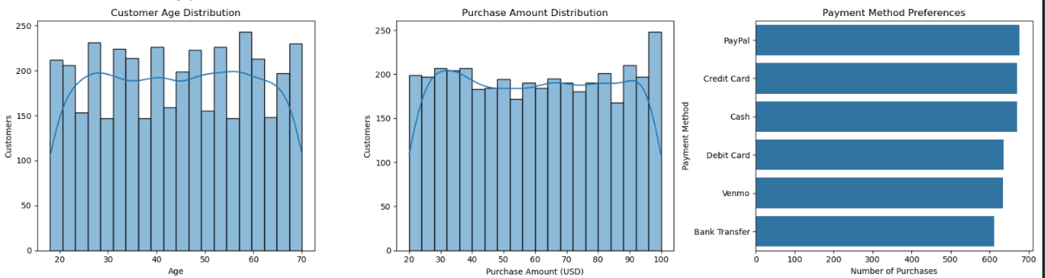
Appendix A: Core Dataset Statistics

Statistic | Result
Total Transactions | 3,900
Total Purchase Value | $233,081
Average Purchase | $59.76
Median Purchase | $60
Average Age | 44.07
Average Review Rating | 3.75 / 5
Average Previous Purchases | 25.35
Most Common Category | Clothing (1,737)
Most Common Season | Spring (999)
Most Common Payment Method | PayPal (677)
Most Common Size | M (1,755)
Most Common Shipping Type | Free Shipping (675)
Most Common Frequency | Every 3 Months (584)


