# Project: Summarizing and Analyzing Research Papers

## Submission Template

**Learner Name**: Manish

**Learner Email**: 21f27.manish@sjec.ac.in

**Topic**: Environmental Science

**Research Paper**:

<https://biointerfaceresearch.com/wp-content/uploads/2020/07/20695837111.78607870.pdf>

### Initial Prompt

**Description (50 words max)**:

In the first iteration, the prompt given was "Summarize the research paper in 100 words." I first copied the entire research paper, pasted it into the search bar, and then entered the prompt.

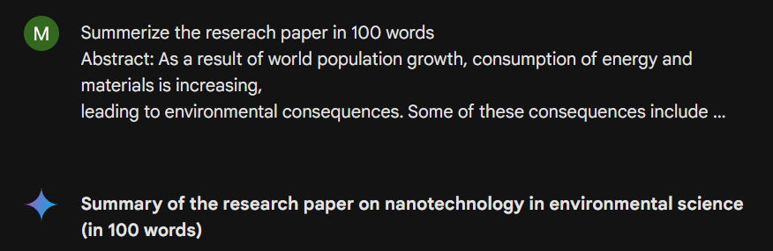

**Generated Summary (100 words max)**:

**Summary of the research paper on nanotechnology in environmental science (in 100 words)**

This paper discusses how nanotechnology can be used to address environmental problems like air and water pollution, waste management, and clean water scarcity.

* Nanoparticles' high surface area makes them ideal for various environmental applications.
* The paper explores how nanofilters, nanoparticles, and photocatalysts can be used in waste treatment, air filtration, and water purification.
* Nanosensors can be used for continuous monitoring of air and water quality.
* While nanotechnology offers potential benefits, there are also safety concerns regarding the potential risks of nanoparticles on human health and the environment.
* Further research is needed to address these safety concerns.

### Iteration 1

### **Description (50 words max)**:

### 

The prompt requests a concise and condensed overview of the entire document. It specifies a word limit of 100 words, indicating the need for a brief yet informative summary of the key points.

**Generated Summary (100 words max)**:

This report explores nanotechnology's potential to address environmental issues like pollution and waste management.

* Nanoparticles' high surface area makes them ideal for tasks like filtering pollutants and converting waste into usable materials.
* Applications include nanofilters for water treatment, nanosensors for air quality monitoring, and photocatalysts for breaking down contaminants.
* Safety concerns exist due to the unique properties of engineered nanoparticles, which may pose risks to human health and the environment.

The paper concludes that nanotechnology offers promising solutions but emphasizes the need for careful research to ensure its safe and sustainable use in environmental applications.

### Iteration 2

**Description (50 words max)**:

The second prompt is to **Provide a summary of the paper's exploration of new or innovative nanotechnology applications not currently in practice.** To identify the informative as well what else that are currently not in other research paper.

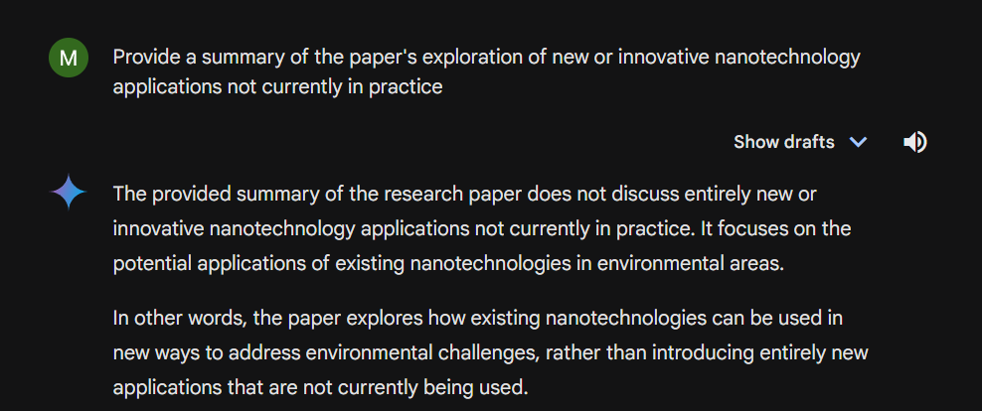

**Generated Summary (100 words max)**:

The provided summary of the research paper does not discuss entirely new or innovative nanotechnology applications not currently in practice. It focuses on the potential applications of existing nanotechnologies in environmental areas.

In other words, the paper explores how existing nanotechnologies can be used in new ways to address environmental challenges, rather than introducing entirely new applications that are not currently being used.

Python

# Based on the summary of the research paper, there is no explicit mention of entirely new or

# innovative nanotechnology applications not currently in practice.

# The paper discusses potential applications of existing nanotechnologies in various environmental areas.

# Examples include:

# * Nanofilters for water treatment

# * Nanosensors for air quality monitoring

# * Photocatalysts for breaking down contaminants

# * Converting waste into usable materials

print("The provided summary of the research paper does not discuss entirely new or innovative nanotechnology applications not currently in practice. It focuses on the potential applications of existing nanotechnologies in environmental areas.")

Use code with caution.

### Final Prompt

**Description (50 words max)**:

Based on the information provided, suggest the best potential groundbreaking applications of nanotechnology in the environmental science in 100 words. The above was specifically requests suggestions based on the given information, implying that the response should be grounded in the provided text while also demonstrating creative thinking in 100 words.

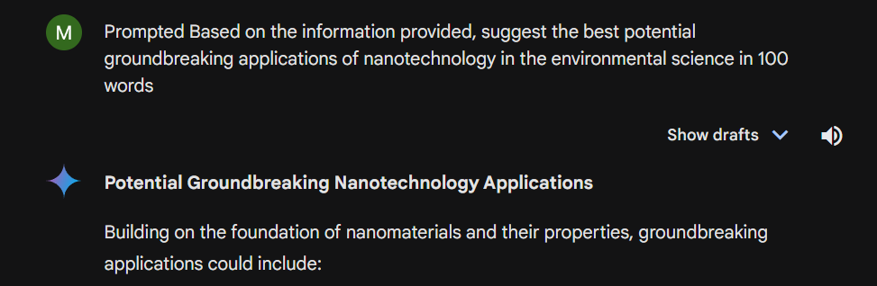

**Generated Summary (100 words max)**:

While the provided text primarily focuses on established nanotechnology applications, it hints at innovative possibilities. For instance, building upon nanofilter technology could lead to self-cleaning, energy-efficient filtration systems. Nanophotocatalysts could be integrated into building materials for air purification. Nanosensors might evolve into autonomous environmental monitoring drones. Exploring the combination of nanomaterials like carbon nanotubes with renewable energy sources could yield breakthroughs in energy storage and efficiency

### Insights and Applications

**Key Insights (150 words max)**:

The research paper explores the potential of nanotechnology to address environmental issues like pollution and waste management. Nanoparticles' high surface area makes them ideal for tasks like filtering pollutants and converting waste into usable materials. Applications include nanofilters for water treatment, nanosensors for air quality monitoring, and photocatalysts for breaking down contaminants.

The paper acknowledges safety concerns due to the unique properties of engineered nanoparticles, which may pose risks to human health and the environment. Specifically, nanoparticles can easily enter the body through the skin or lungs and their long-term effects are unknown. The paper suggests nanotechnology offers promising solutions for environmental problems, but emphasizes the need for careful research to ensure its safe and sustainable use.

**Potential Applications (150 words max)**:

The research highlights nanotechnology's potential to revolutionize environmental management. By harnessing the unique properties of nanoparticles, scientists and engineers can develop innovative solutions for pressing ecological challenges. From purifying water and air to managing waste, nanotechnology offers a promising avenue for addressing pollution and resource scarcity. However, the study also underscores the importance of rigorous safety assessments to mitigate potential risks associated with nanomaterial production and application. Ultimately, the successful integration of nanotechnology into environmental practices hinges on a careful balance between technological advancement and environmental protection

### Evaluation

**Clarity (50 words max)**:

The summary is clear and concise, effectively conveying the core findings of the research. It highlights both the potential benefits and risks of nanotechnology in environmental applications, providing a balanced overview.

**Accuracy (50 words max)**:

The summary accurately reflects the core points of the research, highlighting the potential of nanotechnology to address environmental challenges while acknowledging the need for further research to ensure its safe and sustainable application. Additionally, the summary emphasizes the importance of continued research and development to fully realize the potential of nanotechnology in addressing environmental issues

**Relevance (50 words max)**:

The insights and applications presented are relevant to the growing global concern over environmental degradation. Nanotechnology offers potential solutions to pressing environmental issues, such as pollution, resource scarcity, and climate change. The focus on nanomaterials for filtration, sensing, and remediation aligns with current research trends and societal needs, demonstrating the potential of nanotechnology to address the most critical environmental challenges of our time.

### Reflection

**(250 words max)**:

This assignment was an excellent opportunity to apply and expand the knowledge I gained. Utilizing AI tools like ChatGPT and Gemini has become much easier and more effective. I learned that crafting the right prompts is crucial previously, my directive prompts sometimes yielded incorrect information. Through this course, I discovered how to refine my prompts for better results.

For instance, when working on an assignment related to environmental science, I used Gemini AI to research and summarize a lengthy research paper from Google Scholar into a concise 150-word summary. This experience has significantly improved my ability to use AI tools effectively, including ChatGPT, Gemini, Runway, Kaiber, Midjourney, and Adobe Firefly.

And the live class on Ai marketing mastery by Suchita Vishnoi and masterclass on generative AI by Dr. Prabhjot Singh Manocha was more informative along with the course. And the live example of AI marketing made me to learn more about AI in marketing field. And final live class about the project was really helpful for doing the project report.

Overall, my skills with these tools have greatly improved compared to before, and I am excited to apply what I have learned in future projects.

Thank you