AIPP LAB TEST
Name – Manish Kumar
Roll no- 2503b09903
Course- MCA

Set 5
9. Q1. Generate Python code for the Fibonacci sequence with Cursor AI. Refine your
prompts to handle only positive integers and record the changes and outcomes.
Answer:-

Prompt 1:
“Write a simple Python program that prints the first n Fibonacci numbers.”
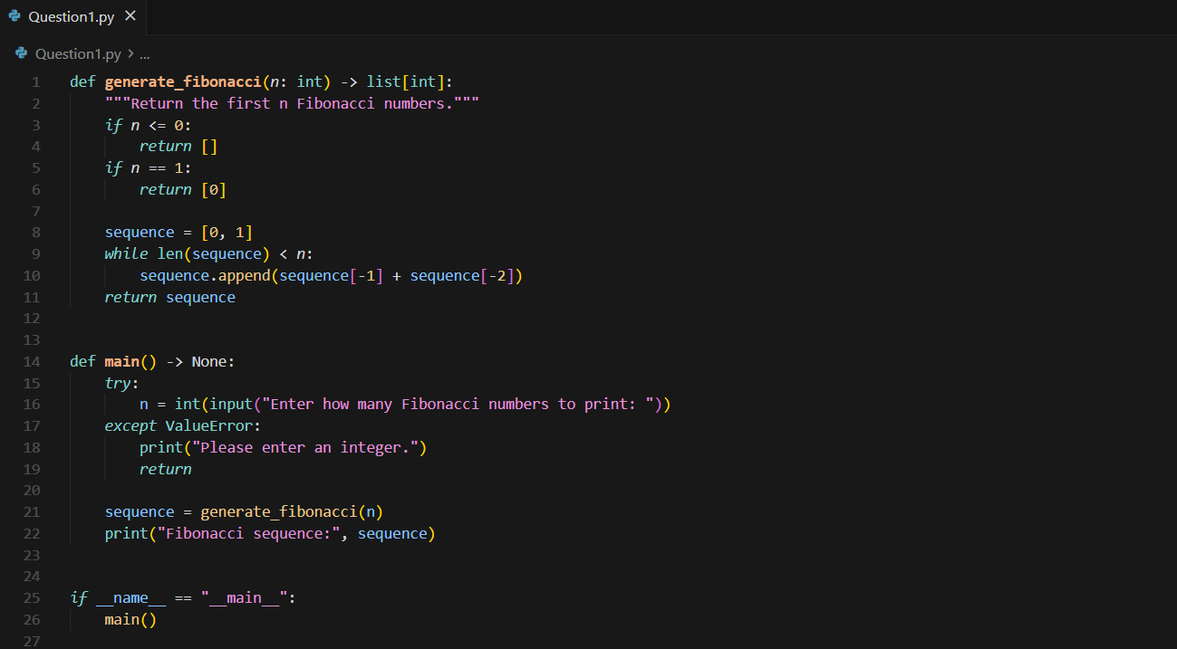
Output:-
Prompt 2:
“Improve the program so it accepts only positive integers.
If the user enters 0, negative value, or non-integer, show an error and ask again.”
Then
Output:-
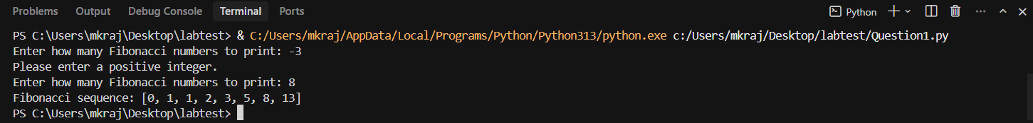
Prompt 3:
“Refactor the code so the fibonacci function returns a list instead of printing.
Print the final list from main(). Keep positive integer validation.”
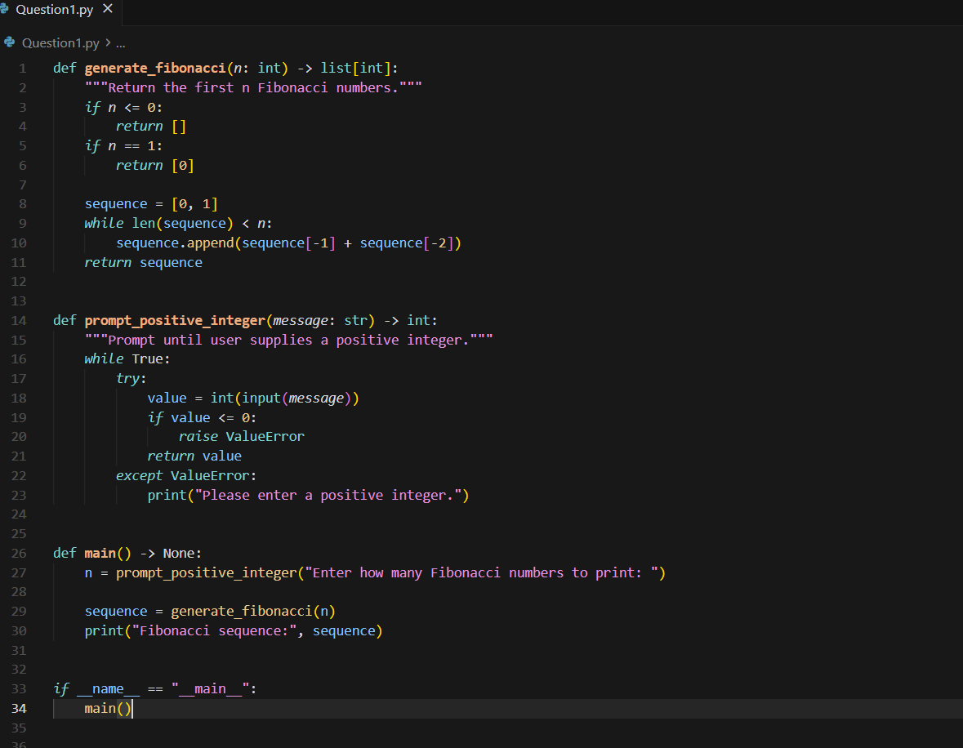
Final output:-

Q2. Write a Python queue class (`enqueue`, `dequeue`, `peek`). Use an AI assistant and
test the class with multiple scenarios. Describe how AI-generated code manages edge
cases and how you improved it.

Prompt:-
Write a Python program that creates a Queue class with enqueue, dequeue, peek, is_empty, and size. Add a user-input menu so the user can choose operations. Handle edge cases like dequeue/peek on an empty queue and show meaningful messages. Give the full code in one block.

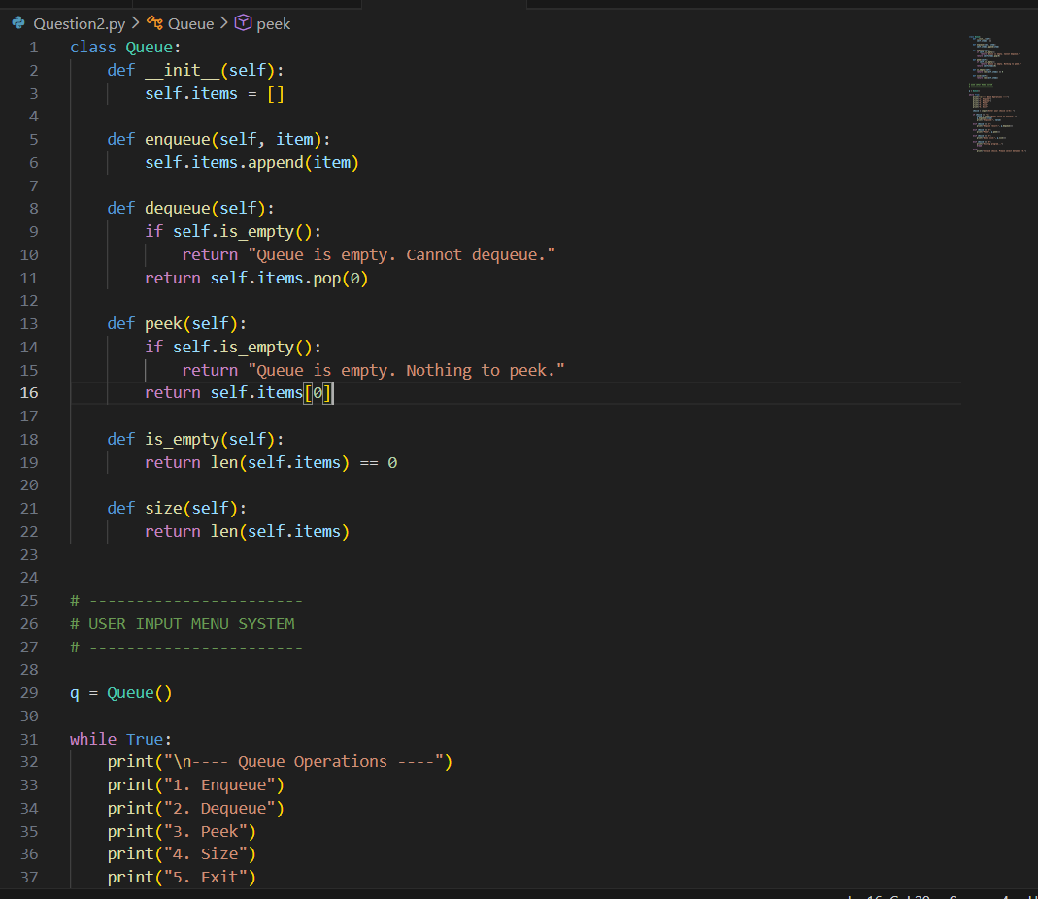
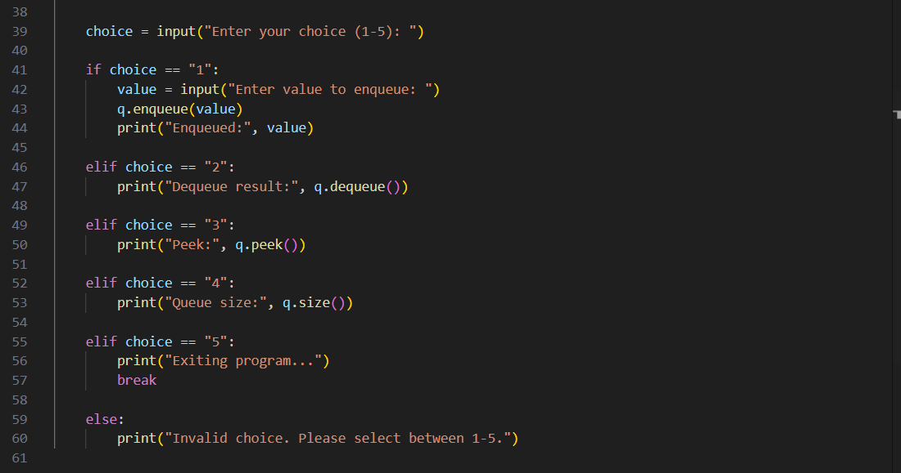
Output:-
