**Group 4: - Project for Admission Process for a College**

**Aim: Create a group project that will have all the necessary technologies to display all the admission process of a college.**

**Submitted to Raffic Sir,**

**Group Members--**

**1.Paryag Singla – (paryag.singla@newgen.co.in)**

**2.Manish Kumar-(manish-s-kumar@newgen.co.in)**

**3.Julee Mallah-(julee.mallah@newgen.co.in)**

**4.Manoj Saruk – (manoj.saruk@newgen.co.in)**

**5.Kushal Sardar - (kushal.sardar@newgen.co.in)**

**6.Masoom Soni -(masoom.soni@newgen.co.in)**

**7.Mansi kothavade (Mansi.kothavade@newgen.co.in)**

**Project Layout**

1-Home Page (Demo School)

Content-

Name - (Text Box)

Address- (Text Box)

Further a table will show the various courses that are available along with their price detail & Duration.

Course Name- (text Box)

Phone No. (Number)

Age- (Number)

Gender- (Text Box)

E-mailed- (Specific mail-Id)

Initial Amount-(Number)

Submit-(Button)- After Pressing Submit Button will be there so that once they click another screen will be opened in the browser where a confirmation message will be shown as a part of the confirmation.

CSS Requirement-

Color-(Light)blue

3-Picture (College photo, Group Photo, Playground)

Font-Aerial-black

Marquee scroll some text (Hostel, library pass, Seats Available)

**Use of Java Script:**

Amount can’t be less than 10000

Mail id cannot be blank

Phone Number digits must be equal to 10 digits

**Use of SQL**

This is for Basic Details of Student

|  |  |  |  |  |  |  |
| --- | --- | --- | --- | --- | --- | --- |
| Name  Varchar (30) | Father Name  Varchar(30) | Phone Number  (Varchar(30)) | DOB  (Date) | Amount(integer) | Phone Number(int) | Address(varchar) |
|  |  |  |  |  |  |  |
|  |  |  |  |  |  |  |

**Team Distribution** as well co-ordination

|  |  |  |  |  |
| --- | --- | --- | --- | --- |
| html | CSS | JavaScript | java | SQL |
| Mansi | Mansi, Manoj | Kushal | Manish | Masoom |
| Masoom | Paryag | Paryag | Julee | Manish |

**Submitting Data :**

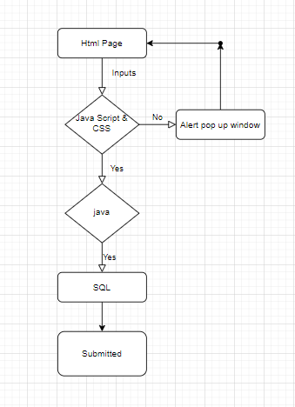

Show registered student

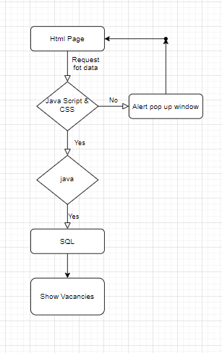

Sql Query -

create table student( stuName varchar(30), stuFather varchar(30), date varchar(30), email varchar(30),mob Integer, gender varchar(20), address varchar(40), city varchar(15), country varchar(15), Course varchar(15), amount Integer );

select * from student