INCEPTION MODEL

We are using Inception V3 model here

Data Used

Here we are using augmented data set which we made from our original data set

It contains Training and Validation data

Training Data has 12319 images for both tanks and non tanks

Validation Data has 3503 images for both tanks and non-tanks

DATA DIMENSION

Images are in three channels (RGB)

Dimension of images are 512*512*3

Images are than rescaled with (rescale = 1/255) function of keras Datagenerator

INCEPTION v3 MODEL

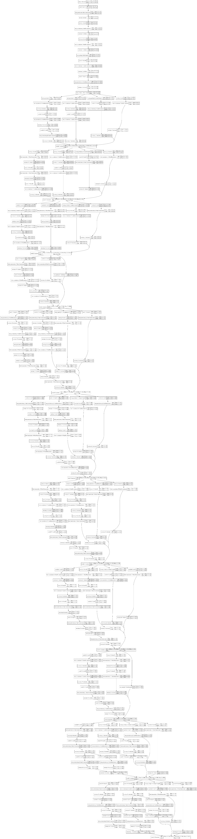

Parameters for Inception Model

The weights used are of ‘imagenet’

The Dense Layers are not connected and include_top= false

DENSE LAYERS CREATED BY US:

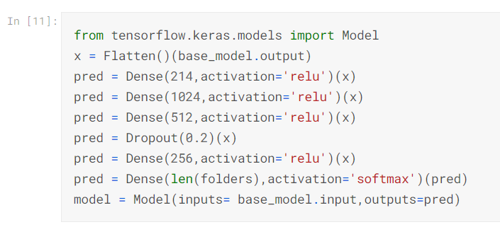

PARAMETERS FOR TRAINING

1. Optimizer : Adam with learning rate = 0.004
2. Loss Function is Binary Cross Entropy
3. Trained for 7 epochs

RESULTS

