Market Dynamics Analysis: Study of S&P 500, VIX and Inflation (2010-2023)
STAT-S 650: Time Series Analysis
Manish Suresh Maudgalya

Abstract
This project is analysis of the time series relationship of the S&P 500 equity index, CBOE Volatility Index(VIX) and The Consumer Price Index (CPI) over a 13 year economic cycle from January 2010 to December 2023. Financial markets move as interconnected and sensitive systems where monetary policy, inflation and risk dictate asset price. From the 168 monthly data points, we apply econometric frameworks to test whether inflation and market fear drive equity return with leading or contemporaneous indicators. After processing the equity data with Log Scale and Differencing to make the data stationary, the ARIMA and SARIMAX models with contemporaneous indications describe the market conditions the best with AIC of -716.59. To check how all variables affect each other by applying a Vector Autoregressive model, with Granger Causality test of p= 0.024 that shows the inflation drives the market. Applying more methods like the Johansen Cointegration Test with r=1 shows a shared long run equilibrium, an ARMA-GARCH(1,1) shows highly persistent volatility clustering with alpha + beta = 0.89.

Data Set, Variables and Hypotheses
The dataset spans from January 2010 through December 2023, giving us 168 monthly datapoints. The data was sourced using the quantmod package in R for the S&P 500 and VIX through Yahoo Finance and CPI data through Federal Reserve Economic Data (FRED) database.
Variables:
- S&P 500 (^GSPC) : The primary output variable transformed into log return of the adjusted close to achieve stationarity and correct for dividend and splits.
- CBOE Volatility Index (VIX): The index to represent market fear and implied volatility.
- Consumer Price Index(CPIAUCSL): the explanatory input, transformed into a monthly log change to show the inflation rate.

Hypotheses:
- Hypothesis 1 (H1): Rising inflation (CPI) negatively affects the S&P 500 log returns as higher inflation leads to tightening from the central bank by raising rates and lowering equity evaluations.
- Hypothesis 2 (H2): Market fear VIX and market returns move in opposite directions simultaneously and with rising CPI acting as an indicator for implied volatility.
- Hypothesis 3 (H3): Financial time series over a 13 year period are subject to structural breaks and volatility clustering making basic linear models insufficient for capturing market dynamics.

#Data Extraction and Transformations
getSymbols("^GSPC", from = "2010-01-01", to = "2023-12-31", periodicity = "monthly")
getSymbols("^VIX", from = "2010-01-01", to = "2023-12-31", periodicity = "monthly")
getSymbols("CPIAUCSL", src = "FRED")
log_data <- log(na.omit(merge(GSPC[,6], VIX[,4], CPIAUCSL)))
stat_data <- na.omit(diff(log_data))
Time Series data visualization
The time series data was plotted in its raw form (Index Level for S&P 500, VIX Level, and CPI Index Number) to understand raw trends and major economic shocks over the 13 year period. Log differenced transformation was applied to stabilize the variance and to achieve stationarity for modeling. The resulting stationary plots for S&P 500 Monthly Log Returns, VIX, and Monthly Inflation Rate show the volatility clustering during known periods of market stress like the 2020 pandemic. Squared returns were plotted as a proxy for realized variance, providing visual justification for the later implementation of GARCH models. 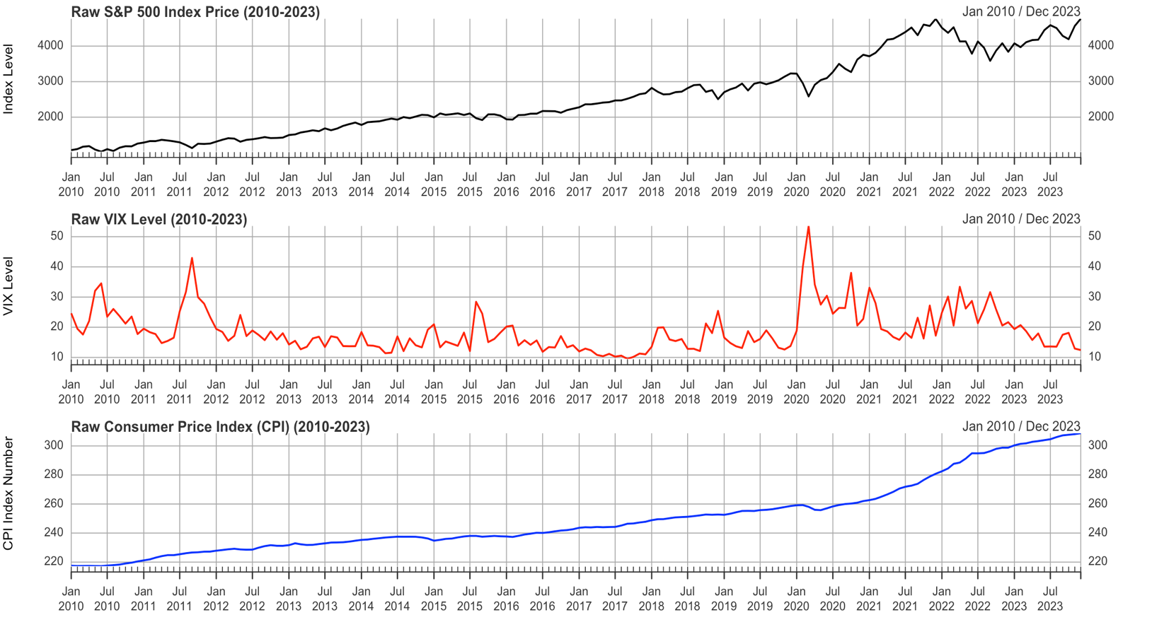
Raw Time Series Data

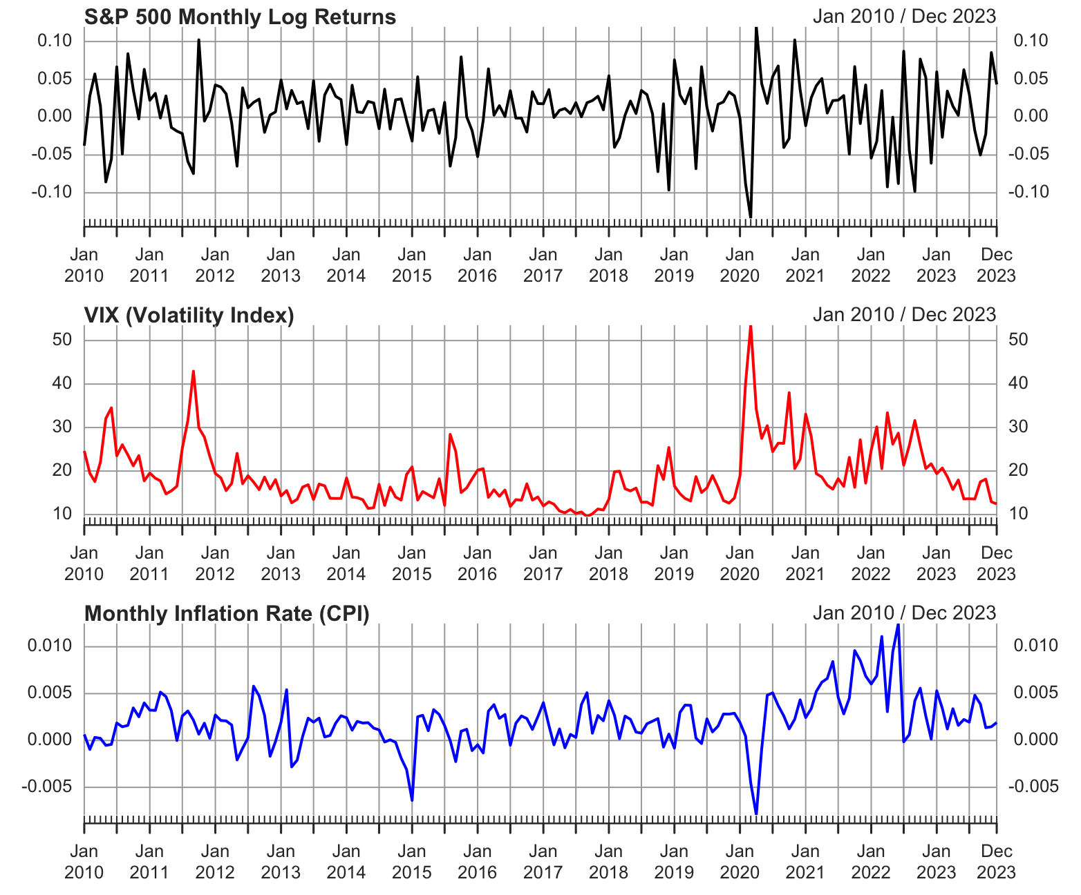
Log Transformed Time Series Data
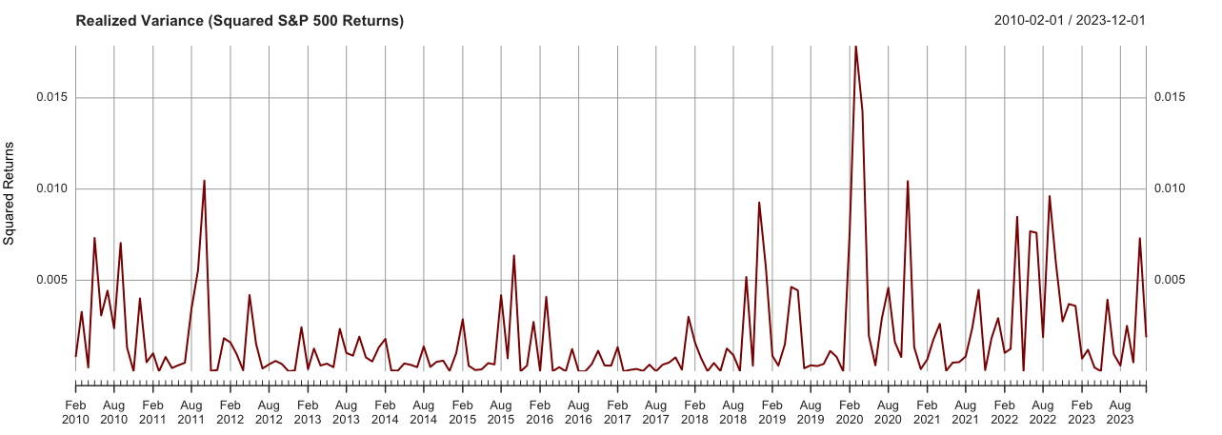
Squared S&P 500 Returns
Autocorrelations and Cross-Correlations
The Auto Correlation Function (ACF) or the S&P 500 log returns represent white noise likely aligning with efficient market hypothesis. ACF of the VIX and CPI shows slower decay indicating persistence.
The Cross Correlation Function (CCF) measured the Lead/Lag relationships. The CCF plot of the VIX and S&P 500 shows a significant spike at lag 0 which confirms that spikes in fear happen simultaneously with market sell-offs. 24-month rolling correlation further demonstrated that this inverse relationship fluctuates but remains deeply negative throughout the 13 year period.

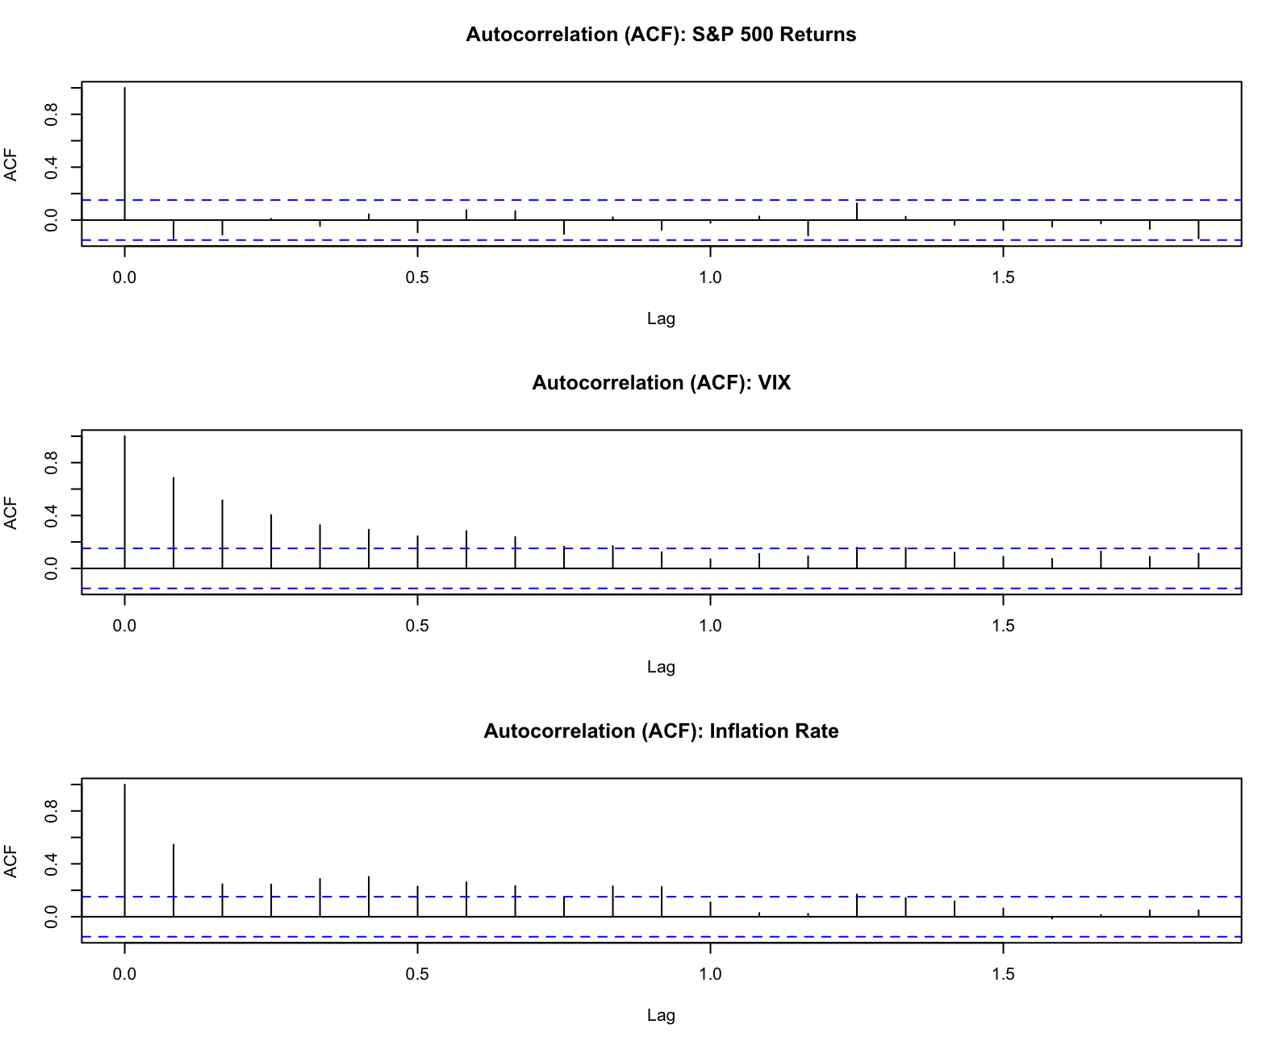
Auto correlations plots(ACF)
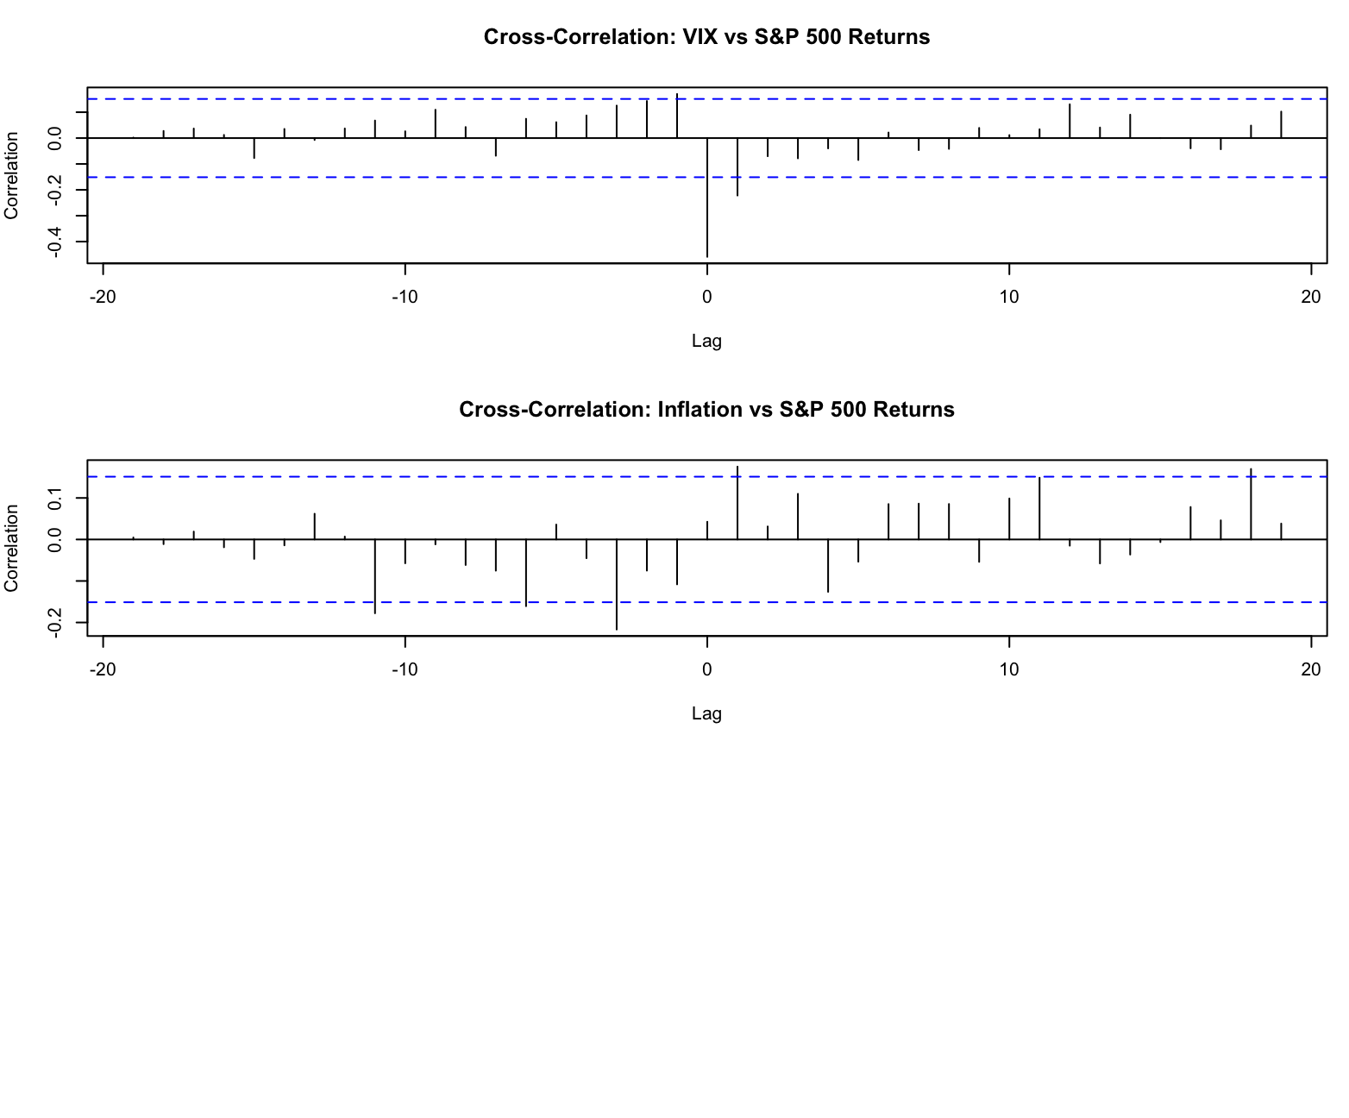
Cross Correlation Plot (CCF)
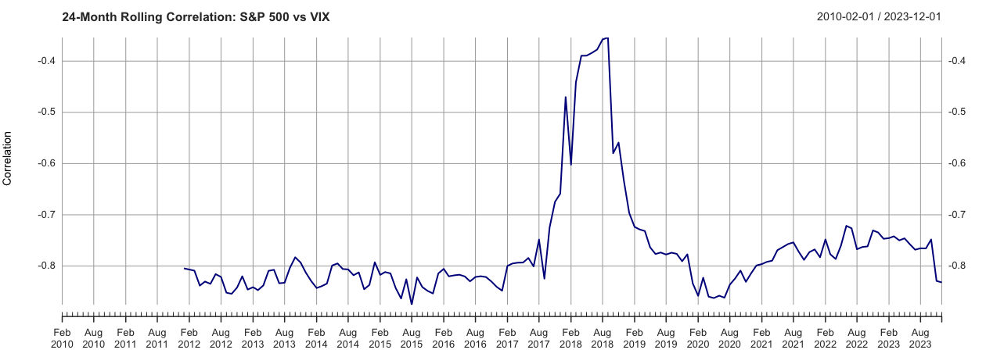
24 Month Rolling Correlation
Spectral Analysis
The spectrum for the S&P 500 returns is relatively flat across all frequencies, likely white noise like as we observed in the ACF. The periodograms for the VIX and CPI show peaks at lower frequencies likely corresponding to cycles like market stress and macroeconomic cycles.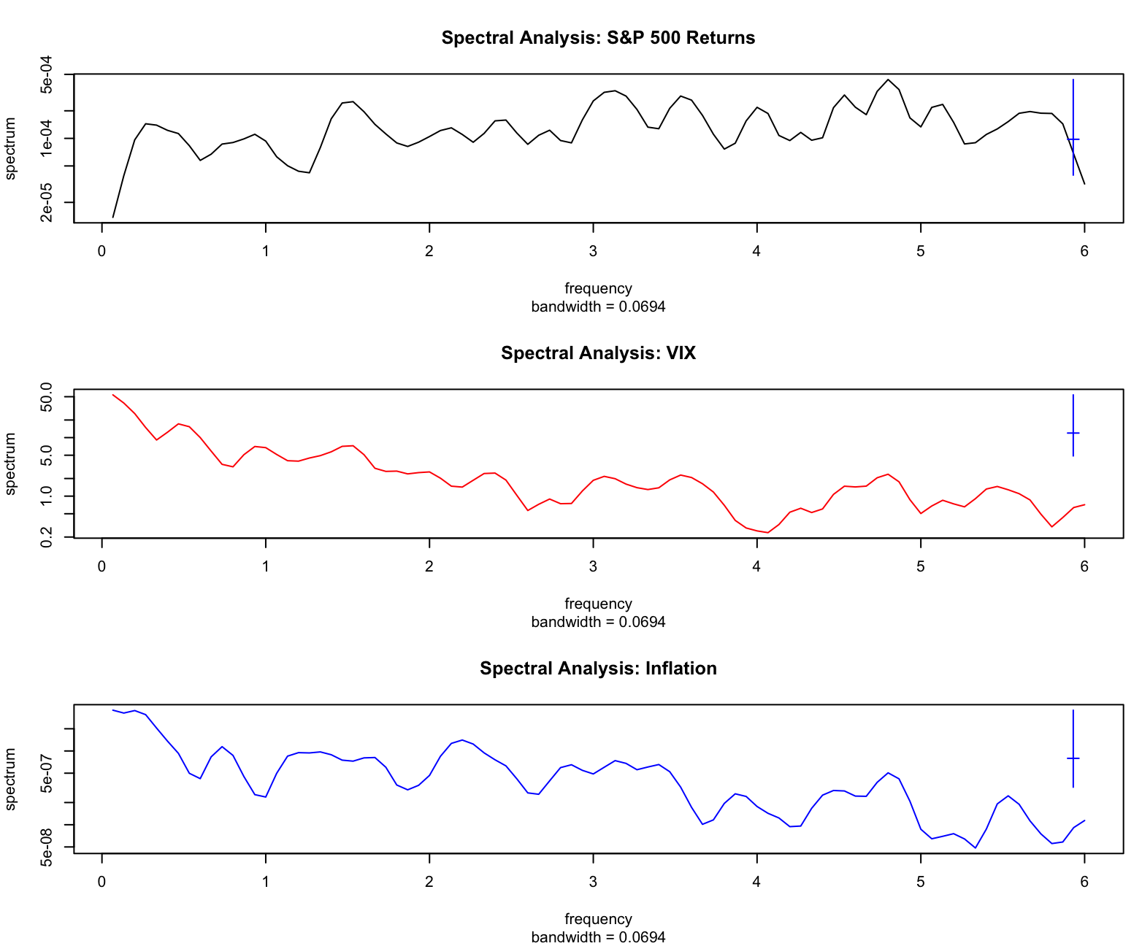
Linear Dynamic Model Testing and Comparison
ARIMA vs SARIMAX (Transfer Functions) model comparison
Fitting a normal ARIMA model to S&P 500 return gave us an AIC of -578.41. This ignored the exogeneous economic variables. The Contemporaneous SARIMAX model treated VIX and CPI as external regressors. The AIC improved to -716.59, this shows us that inflation and fear are critical components of market pricing.
Residual checks were performed on the ARIMA(1,0,2)(2,0,0)[12] errors. The Ljung-Box test returned a p-value of 0.6489. Because p > 0.05, we conclude the residuals are strictly White Noise, showing that the linear model parameters are valid.
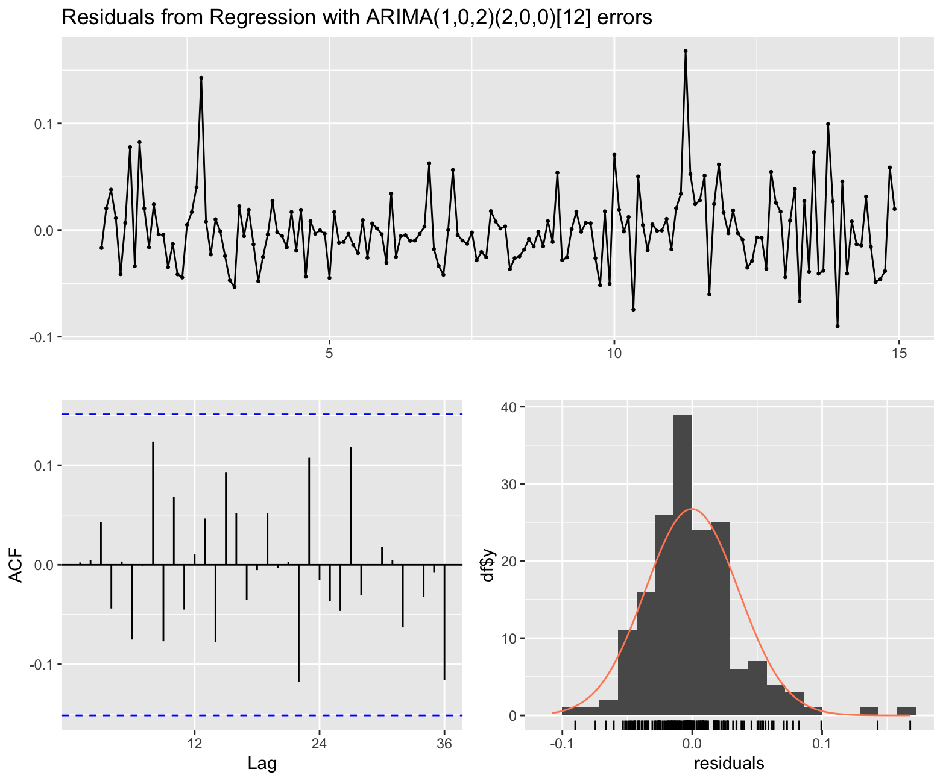

Vector Autoregression (VAR)
Applying a VAR model to solve the problem of endogeneity by using systemic feedback loops where market crashes might affect future inflation policy. Granger Causality tests on the VAR system returned an F-Test statistic of 2.2298 with a p-value of 0.02435. Because p < 0.05, we formally reject the null hypothesis and statistically confirm the treatment effect: CPI (inflation) Granger-causes changes in the S&P 500 and VIX system.
Granger causality H0: CPI_Inf do not Granger-cause SP500_Ret VIX_Ret
F-Test = 2.2298, df1 = 8, df2 = 450, p-value = 0.02435
Impulse Response Functions (IRF) following a one-standard-deviation CPI shock, the IRF shows an initial burst of volatility, but the responses stabilize rapidly and revert within the 95% bootstrap confidence intervals. The issue here is that Standard VAR model need the data to be differenced and stationary. Differencing the data destroyed any potential long-term equilibrium between the raw price levels.
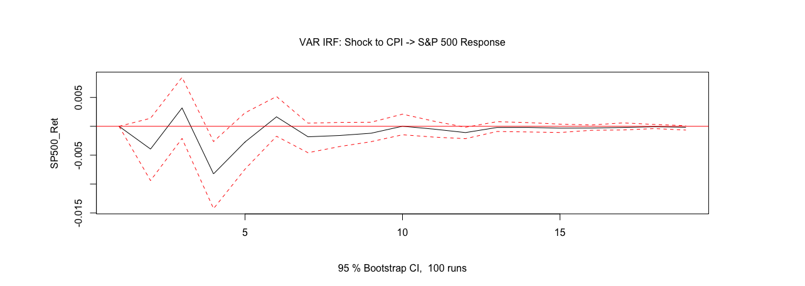

Johansen Cointegration, GARCH and Structural Breaks
- Johansen Cointegration: Applied to log level data to determine if long term data was lost in the VAR model. The test statistic for r=0 was 53.68, exceeding the 5% critical value of 32.00. Therefore, we reject the null hypothesis of zero cointegrating vectors, proving the S&P 500, VIX, and CPI share at least one long-term stochastic trend (r=1), Allowing us to use a Vector Error Correction Model (VECM).
- Volatility Clustering (GARCH): Residual diagnostics of the linear models show heteroskedasticity. Linear models assume constant variance, but financial returns show volatility clustering. To fix this, an ARMA(1,1)-GARCH(1,1) model was implemented. The model gave an Alpha 1of 0.368 and Beta1 of 0.523, the sum of these coefficients around 0.89 indicate that volatility shocks are highly persistent. Ljung-Box tests on the standardized squared residuals returned high p-values (>0.56), confirming the GARCH model successfully captured the volatility clustering.

Conditional Variance Dynamics: sGARCH(1,1)
alpha1 0.368119 Std. Error 0.164844 t value 2.2331 Pr(>|t|) 0.025540
beta1 0.523067 Std. Error 0.165868 t value 3.1535 Pr(>|t|) 0.001613
shape 5.975892 Std. Error 3.155643 t value 1.8937 Pr(>|t|) 0.058263
- Structural Break (Bai-Perron): Running a single model over 13 years assumes parameter stability. To test if the relationship between inflation and the market fractured during the 2020 pandemic or the 2022 rate hike cycle. The Bai-Perron test detected a significant regime shift at observation 142 around late 2021/early 2022.
Optimal (m+1)-segment partition:
m = 1 142
m = 2 28 142
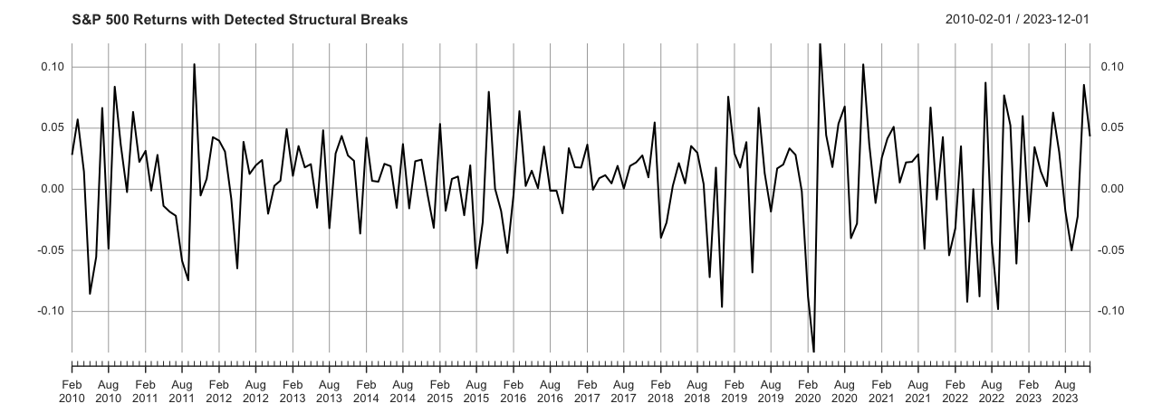

Discussion and Sectoral Impacts
The mathematical findings of this study align with the empirical mechanics of modern financial markets. When interpreting CPI, market participants are looking to gauge central bank reaction functions. A single high CPI print causes immediate jerk in volatility driven by high frequency algorithms responding to spikes in Treasury yields. This immediate shock does not dictate medium term equity returns unless it persistently alters the trajectory of corporate margins or consumer demand.
A primary limitation of this study is the inherent nature of the data: CPI is a backward looking metric, whereas equities are forward looking discounting mechanisms. Because markets price in real time expectations, the monthly CPI release validates existing market pricing rather than acting as a leading predictive variable. This fundamental dynamic explains why the Contemporaneous SARIMAX model so drastically outperformed its lagged counterpart in predicting S&P 500 returns.

Conclusions
This analysis gives several macroeconomic conclusions. The SARIMAX AIC improvements and Granger Causality test with p=0.024 confirm Hypothesis 1 and 2 that market return and fear levels are intrinsically tied to and predicted by inflationary data. Evaluations in this analysis also prove Hypothesis 3 that basic linear models are insufficient in financial econometrics. To capture market dynamics, analysts must account for cointegrated equilibriums with the Johansen test r=1, volatility clustering GARCH persistence of 0.89 and parameter instability during crises with the Bai-Perron regime shifts around 2022.
The code with all outputs is available on my GitHub at:
https://github.com/ManishMaudgalya/SP500-VIX-CPI-Analytics

References
[1] How Does CPI Data Affect Stock Market — A Guide, Bitget, 2026. https://www.bitget.com/wiki/how-does-cpi-data-affect-stock-market.
[2] T. Bollerslev, Generalized Autoregressive Conditional Heteroskedasticity, Journal of Econometrics, vol. 31, no. 3, pp. 307–327, 1986.
[3] J. Bai and P. Perron, Estimating and Testing Linear Models with Multiple Structural Changes, Econometrica, vol. 66, no. 1, pp. 47–78, 1998.
[4] S. Johansen, Estimation and Hypothesis Testing of Cointegration Vectors in Gaussian Vector Autoregressive Models, Econometrica, vol. 59, no. 6, pp. 1551–1580, 1991.
[5] T. Chang, How are VIX and Stock Index ETF related? An Empirical Analysis using VAR Models, Erasmus University Repository, 2016.
[6] L. Tuysuzoglu, The Effects of Macroeconomic Data Surprises on Implied Volatility, NYU Stern, 2008. https://www.stern.nyu.edu/sites/default/files/assets/documents/con_043248.pdf

