STAT-S 650 Time Series Analysis
Assignment 5
Manish Suresh Maudgalya

Theory
- Do the 5 estimated parameters b0, b1, b2, b3, √ MSE match the true parameters?
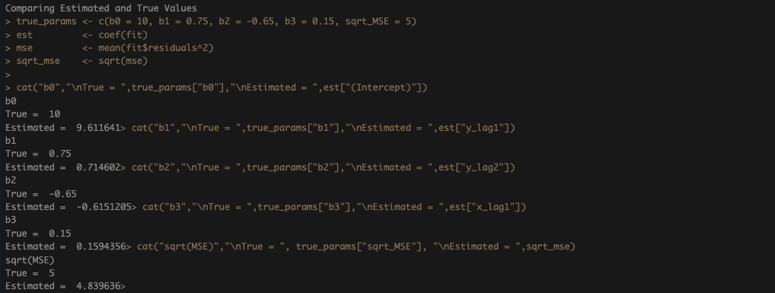 Looks like the Estimated Values are very Close to the True Values. Since we know the regressors are predetermined, OLS here is consistent.
- What is the R² for the model?
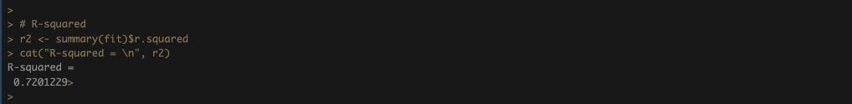
The R-Squared value is 0.7201229.

- Plot the predicted values from the model against the observed values. Do the predictions match the observed very well?
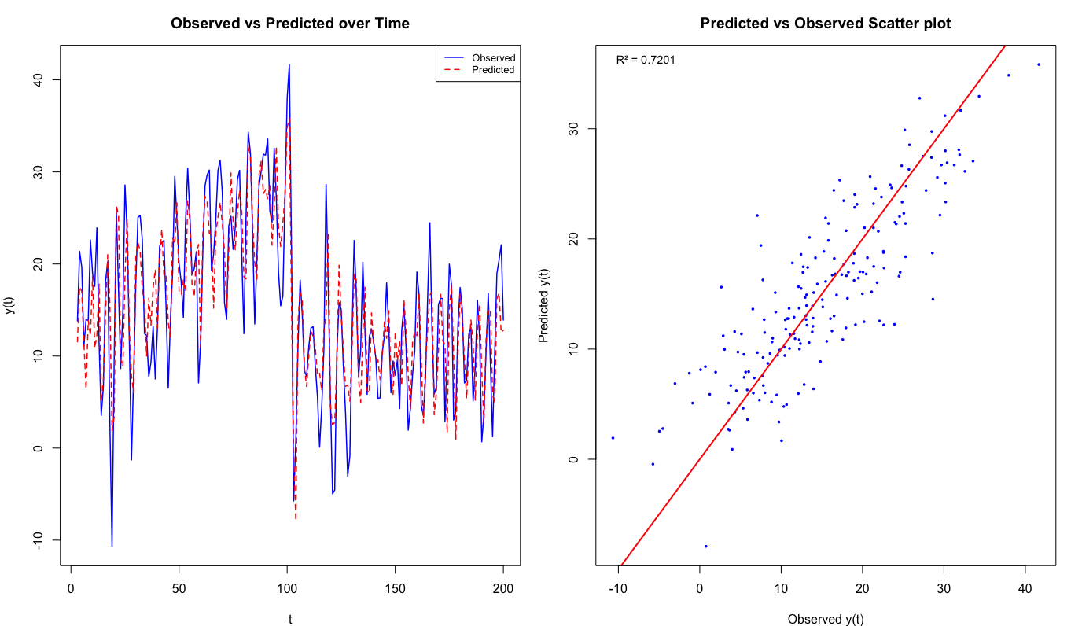
As we can see in the line chart that the estimated values follow the observed lines quite closely. In the Scatter plot, the predicted and observed values also quite close to each other.

Practical
- Pick at least one output variable and at least one input variable from your data set. Formulate at least two models, a simple and a complex, with the simple being nested within the complex. Formulate a third model that is not nested within the other two models.
- Fit the models using a linear regression program and assume white noise inputs.
All three models were fit using OLS assuming white noise errors, with a R² of 0.9045 for mode 10.9047 for model 2 and 0.6450 for model 3.

- Compare the complex and nested models using an F test
The F-test (F = 4.08, p = 0.017) rejects the null hypothesis that the lag terms are jointly zero, meaning Model 2 is statistically better than Model 1.

- Compare the non-nested model to the other two using BIC and AIC.
AIC and BIC: Model 2 has the lowest AIC −34330.94, but BIC is better in Model 1 −34307.88 vs −34299.45 due to its more complexity penalty, and Model 3 is bad on both criteria (AIC = −29045, BIC = −29013).
- Choose the best model of the three you compared. Justify your choice.
Model 2 is the best overall because it wins on AIC and also by the F-test, and the marginal BIC difference from Model 1 is small while the lag terms do add statistically significant explanation.

- Examine the residuals of the model to see if they are white noise using autocovariance on the residuals and spectral analysis of the residuals.
The Ljung-Box test (χ² = 76.75, p = 1.39×10⁻⁸) strongly rejects the null that residuals are white noise, indicating significant remaining autocorrelation in Model 2's residuals.

- If the residuals are not white noise, add more output feedback terms (increase the lag p of the output feedback) and see if this reduces the residuals to white noise.
Adding a third lag (Model 2 extended) did not resolve it. The Ljung-Box test remained highly significant and both AIC and BIC became worse, so increasing lag order is not enough to make the residuals white noise.

- Interpret the parameters of the model. What do they imply for the effect of the lagged feedback? Is the model stable? What do they imply for the effect of the input on the output?
The NASDAQ coefficient of 0.802 means a 1% NASDAQ return gives a 0.80% S&P 500 return on the same day. The model is not stable, roots have moduli of 0.097 and 0.106, both below 1, not quite stable.

Plot the model predictions for the output and compare these to the observed.
