STAT-S 650 Time Series Analysis
Homework 6
Manish Suresh Maudgalya

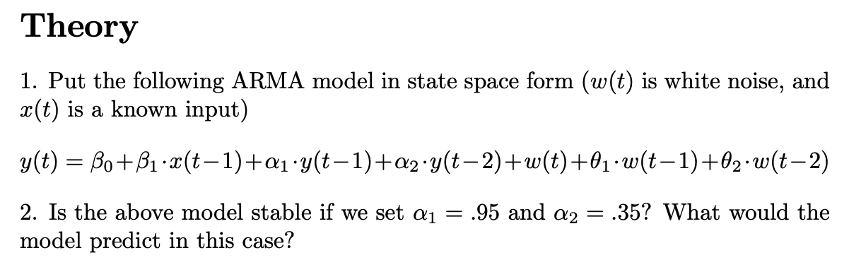

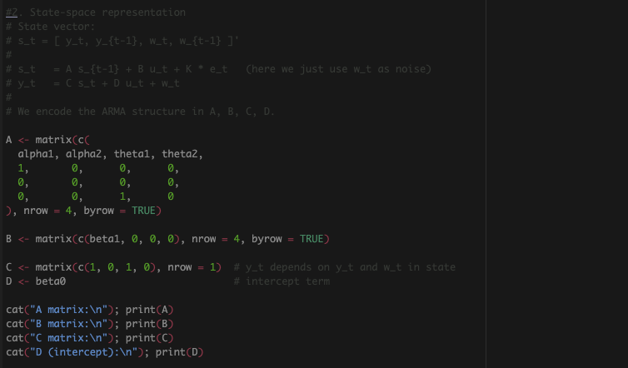

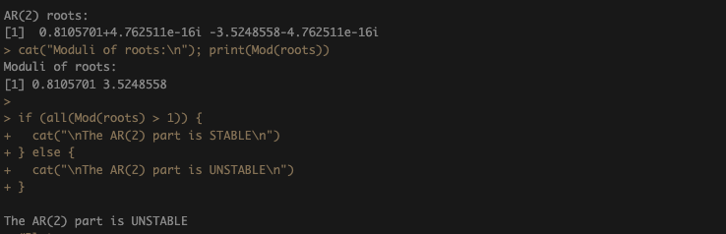
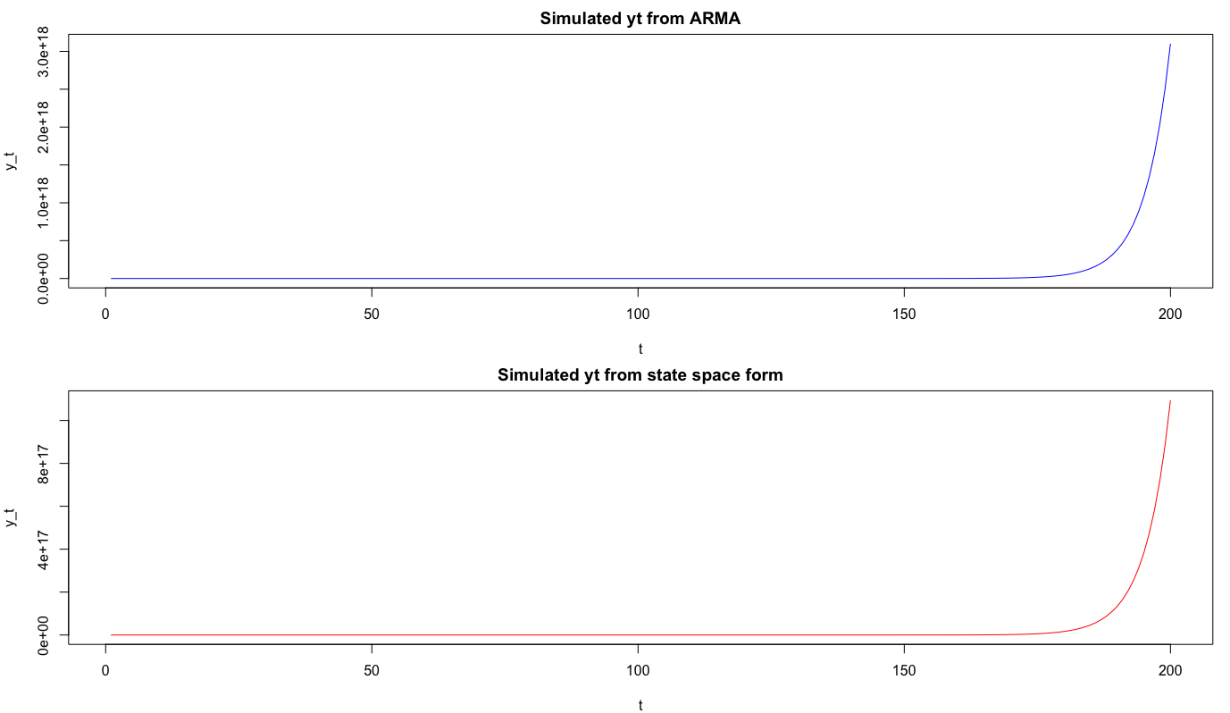
As we can see the explosion upward, the Model is UNSTABLE.

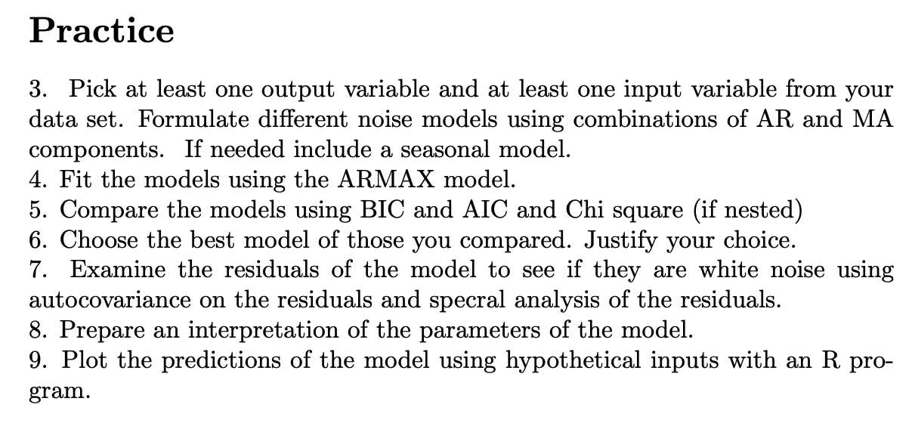
Models Used:
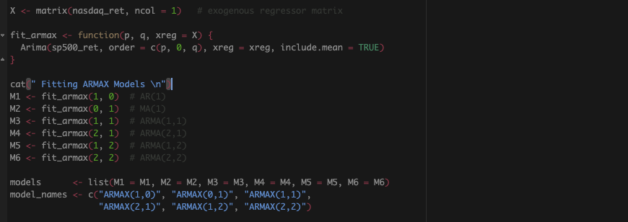

AIC and BIC values for the Models
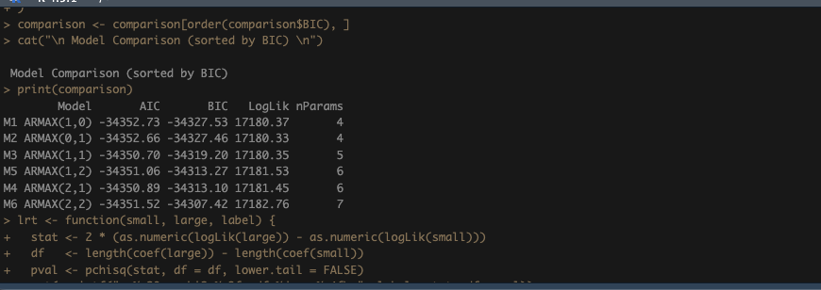
CHI Squared Test for the Nested Models
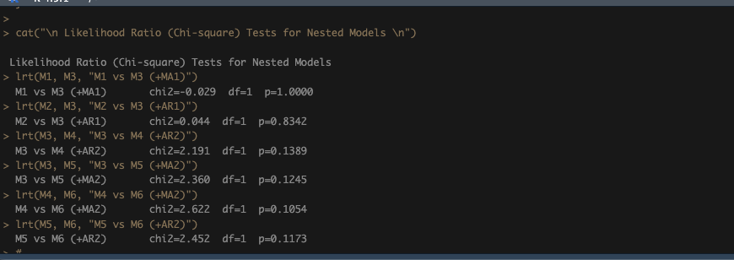

BEST Model:
Here I am using the ARMAX(1,0) model. BIC is the most reliable criterion here because it penalizes complexity more heavily than AIC, which matters when differences between models are small. M1 has the lowest BIC of -34327.53. AIC prefers M1 (−34352.73)
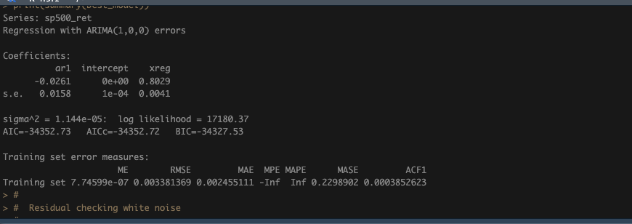
Periodogram, ACF, PACF and Histogram of the Residuals.
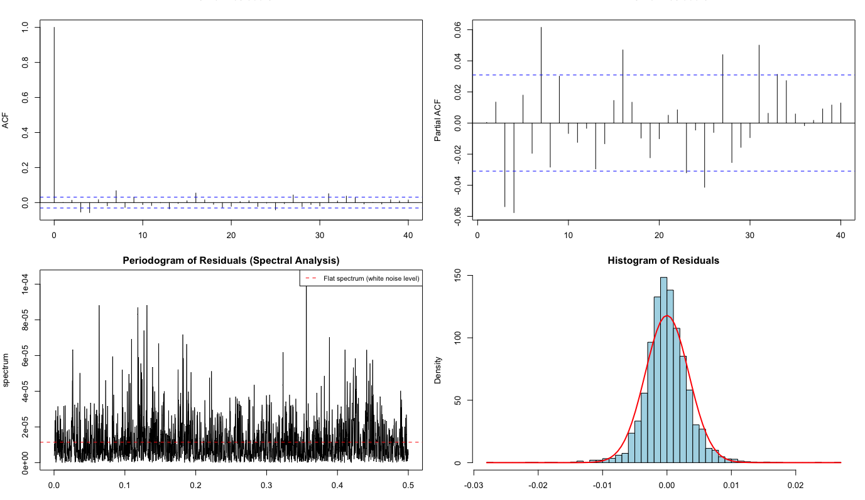

Interpretation of the Parameters of the Model:
XREG coefficient: elasticity of S&P 500 log return to Nasdaq log return. A coefficient near 1 means the two indices move almost one-for-one.
AR coefficients (ar1, ar2): describe autocorrelation in the noise after removing the exogenous Nasdaq effect.
MA coefficients (ma1, ma2): capture moving-average structure in the noise; reflect how shocks to S&P 500 beyond what Nasdaq explains persist over 1-2 days.
Intercept / mean: average daily S&P 500 log return not explained by Nasdaq.

Prediction Plot:
