Theory based question and answers
1. What is unsupervised learning in machine learning?
Unsupervised learning is a type of machine learning where the model learns patterns from data without labeled outputs.
Example:
You give customer data to the model, but you do not tell it which customer belongs to which group. The model tries to find groups or patterns by itself.
Common unsupervised learning techniques:
- Clustering
- Dimensionality reduction
- Association rule mining

2. How does K-Means clustering algorithm work?
K-Means groups data into K clusters.
Steps:
- Choose the number of clusters, called K.
- Randomly select K points as initial cluster centers, called centroids.
- Assign each data point to the nearest centroid.
- Recalculate the centroid of each cluster.
- Repeat the process until centroids stop changing much.
Example:
If K = 3, the algorithm will divide the data into 3 groups.

3. Explain the concept of a dendrogram in hierarchical clustering.
A dendrogram is a tree-like diagram used in hierarchical clustering.
It shows how data points or clusters are merged step by step.
At the bottom, each data point starts as its own cluster. As we move upward, similar clusters are joined together.
The height of the connection shows how different the clusters are.

4. What is the main difference between K-Means and Hierarchical Clustering?
The main difference is:
K-Means requires you to decide the number of clusters before running the algorithm.
Hierarchical clustering does not always need the number of clusters in advance.
K-Means creates flat clusters, while hierarchical clustering creates a tree-like structure of clusters.

5. What are the advantages of DBSCAN over K-Means?
DBSCAN has several advantages over K-Means:
- It can find clusters of any shape.
- It does not require the number of clusters in advance.
- It can detect noise or outliers.
- It works well when clusters are not circular.
K-Means usually works best when clusters are round and similar in size.

6. When would you use Silhouette Score in clustering?
You use Silhouette Score to evaluate how good your clustering result is.
It tells you:
- How close a point is to its own cluster.
- How far it is from other clusters.
It is commonly used to compare different numbers of clusters and choose the best clustering result.

7. What are the limitations of Hierarchical Clustering?
Limitations of hierarchical clustering:
- It is slow for large datasets.
- Once a merge or split is done, it cannot be undone.
- It is sensitive to noise and outliers.
- Choosing the right number of clusters from the dendrogram can be difficult.
- Different linkage methods can give different results.

8. Why is feature scaling important in clustering algorithms like K-Means?
Feature scaling is important because K-Means uses distance to form clusters.
If one feature has very large values, it can dominate the distance calculation.
Example:
- Age: 18 to 60
- Salary: 20,000 to 200,000
Salary will affect the clustering much more than age unless scaling is applied.
Common scaling methods:
- Standardization
- Min-Max scaling

9. How does DBSCAN identify noise points?
DBSCAN identifies noise points as data points that do not belong to any dense region.
A point is considered noise if:
- It is not a core point.
- It is not reachable from any core point.
In simple words, if a point is too far away from other points, DBSCAN treats it as noise or an outlier.

10. Define inertia in the context of K-Means.
Inertia is the sum of squared distances between each data point and its assigned cluster centroid.
Lower inertia means data points are closer to their centroids.
But very low inertia does not always mean better clustering, because increasing the number of clusters usually reduces inertia.

11. What is the elbow method in K-Means clustering?
The elbow method is used to choose the best value of K in K-Means.
Steps:
- Run K-Means for different values of K.
- Calculate inertia for each K.
- Plot K against inertia.
- Find the point where the decrease in inertia slows down.
That point looks like an “elbow” and is considered a good value for K.

12. Describe the concept of density in DBSCAN.
In DBSCAN, density means how many points are present in a small area.
DBSCAN uses density to form clusters.
A dense region has many nearby points. A sparse region has very few points.
DBSCAN groups dense regions as clusters and marks points in sparse areas as noise.

13. Can hierarchical clustering be used on categorical data?
Yes, hierarchical clustering can be used on categorical data, but we need a suitable distance or similarity measure.
For numerical data, Euclidean distance is common.
For categorical data, we can use measures like:
- Hamming distance
- Jaccard distance
- Gower distance
So, it depends on choosing the correct distance metric.

14. What does a negative Silhouette Score indicate?
A negative Silhouette Score means that a data point may have been assigned to the wrong cluster.
It indicates that the point is closer to another cluster than to its own cluster.
In general:
- Score close to 1: good clustering
- Score close to 0: overlapping clusters
- Score below 0: poor clustering

15. Explain the term linkage criteria in hierarchical clustering.
Linkage criteria decides how the distance between two clusters is calculated.
Common linkage methods:
- Single linkage: shortest distance between two clusters
- Complete linkage: largest distance between two clusters
- Average linkage: average distance between points in two clusters
- Ward linkage: minimizes variance within clusters
Different linkage methods can produce different cluster structures.

16. Why might K-Means perform poorly on data with varying cluster sizes or densities?
K-Means assumes clusters are roughly circular and similar in size.
It may perform poorly when:
- Clusters have different sizes.
- Clusters have different densities.
- Clusters are non-circular.
- There are many outliers.
This happens because K-Means assigns points based on distance from centroids.

17. What are the core parameters in DBSCAN, and how do they influence clustering?
The two main parameters in DBSCAN are:
1. eps
This defines the maximum distance around a point to search for neighbors.
2. min_samples
This defines the minimum number of points needed to form a dense region.
Effect:
- Large eps may merge different clusters.
- Small eps may mark many points as noise.
- Large min_samples creates stricter clusters.
- Small min_samples creates more clusters.

18. How does K-Means++ improve upon standard K-Means initialization?
K-Means++ improves the way initial centroids are chosen.
Standard K-Means selects centroids randomly, which can lead to poor clustering.
K-Means++ chooses initial centroids that are far apart from each other.
This helps:
- Improve clustering quality
- Reduce chances of bad initialization
- Make convergence faster

19. What is agglomerative clustering?
Agglomerative clustering is a type of hierarchical clustering.
It follows a bottom-up approach.
Steps:
- Each data point starts as its own cluster.
- The closest clusters are merged.
- This process continues until all points form one large cluster or the desired number of clusters is reached.
It is commonly shown using a dendrogram.

20. What makes Silhouette Score a better metric than just inertia for model evaluation?
Silhouette Score is often better than inertia because it considers both:
- How close points are to their own cluster
- How far they are from other clusters
Inertia only measures how close points are to their centroids.
The problem with inertia is that it always decreases when K increases.
So, inertia alone can be misleading.
Silhouette Score gives a more balanced idea of cluster quality
Practical Based question and answers
21. import matplotlib.pyplot as plt
from sklearn.datasets import make_blobs
from sklearn.cluster import KMeans

X, y = make_blobs(n_samples=300, centers=4, random_state=42)

kmeans = KMeans(n_clusters=4, random_state=42)
labels = kmeans.fit_predict(X)

plt.scatter(X[:, 0], X[:, 1], c=labels)
plt.scatter(kmeans.cluster_centers_[:, 0], kmeans.cluster_centers_[:, 1], marker='X', s=200)
plt.title("K-Means Clustering with 4 Centers")
plt.xlabel("Feature 1")
plt.ylabel("Feature 2")
plt.show()
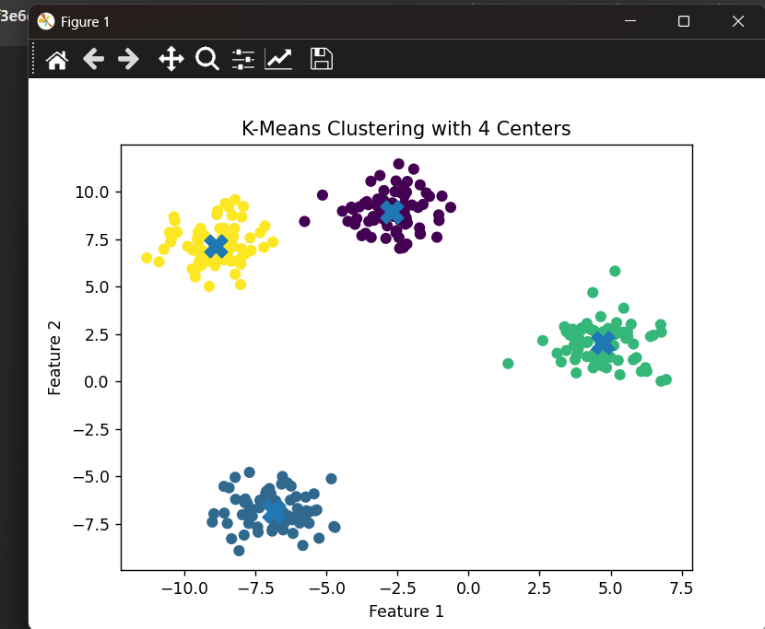

22. from sklearn.datasets import load_iris
from sklearn.cluster import AgglomerativeClustering

iris = load_iris()
X = iris.data

model = AgglomerativeClustering(n_clusters=3)
labels = model.fit_predict(X)

print("First 10 predicted labels:")
print(labels[:10])
First 10 predicted labels:
Output:
[1 1 1 1 1 1 1 1 1 1]

23. import matplotlib.pyplot as plt
from sklearn.datasets import make_moons
from sklearn.cluster import DBSCAN
from sklearn.preprocessing import StandardScaler

X, y = make_moons(n_samples=300, noise=0.08, random_state=42)

X_scaled = StandardScaler().fit_transform(X)

dbscan = DBSCAN(eps=0.3, min_samples=5)
labels = dbscan.fit_predict(X_scaled)

plt.scatter(X_scaled[:, 0], X_scaled[:, 1], c=labels)
plt.scatter(X_scaled[labels == -1, 0], X_scaled[labels == -1, 1], marker='x', s=100)
plt.title("DBSCAN on make_moons Data")
plt.xlabel("Feature 1")
plt.ylabel("Feature 2")

plt.show()
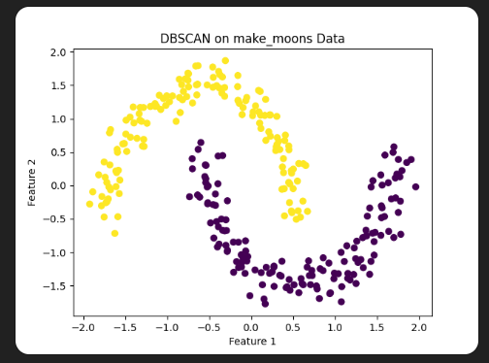

24, from sklearn.datasets import load_wine
from sklearn.preprocessing import StandardScaler
from sklearn.cluster import KMeans
import pandas as pd

wine = load_wine()
X = wine.data

scaler = StandardScaler()
X_scaled = scaler.fit_transform(X)

kmeans = KMeans(n_clusters=3, random_state=42)
labels = kmeans.fit_predict(X_scaled)

cluster_sizes = pd.Series(labels).value_counts().sort_index()

print("Cluster sizes:")
print(cluster_sizes)
Output:
Cluster sizes:
0 65
1 51
2 62
Name: count, dtype: int64
25.
import matplotlib.pyplot as plt
from sklearn.datasets import make_circles
from sklearn.cluster import DBSCAN
from sklearn.preprocessing import StandardScaler
X, y = make_circles(n_samples=400, factor=0.5, noise=0.05, random_state=42)
X_scaled = StandardScaler().fit_transform(X)
dbscan = DBSCAN(eps=0.2, min_samples=5)
labels = dbscan.fit_predict(X_scaled)
plt.scatter(X_scaled[:, 0], X_scaled[:, 1], c=labels)
plt.title("DBSCAN Clustering on make_circles Data")
plt.xlabel("Feature 1")
plt.ylabel("Feature 2")
plt.show()
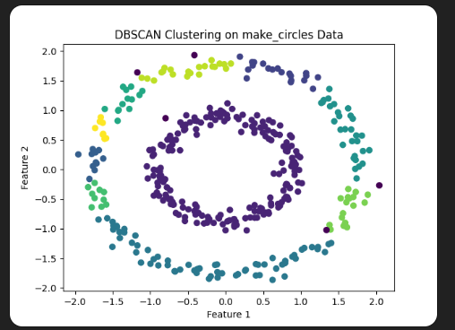

26. from sklearn.datasets import load_breast_cancer
from sklearn.preprocessing import MinMaxScaler
from sklearn.cluster import KMeans

cancer = load_breast_cancer()
X = cancer.data

scaler = MinMaxScaler()
X_scaled = scaler.fit_transform(X)

kmeans = KMeans(n_clusters=2, random_state=42)
kmeans.fit(X_scaled)

print("Cluster centroids:")
print(kmeans.cluster_centers_)
Output:
Cluster centroids:
[[0.50483563 0.39560329 0.50578661 0.36376576 0.46988732 0.42226302 0.41838662 0.46928035 0.45899738 0.29945886 0.19093085 0.19112073 0.17903433 0.13086432 0.18017962 0.25890126 0.12542475 0.30942779 0.190072 0.13266975 0.48047448 0.45107371 0.4655302 0.31460597 0.49868817 0.36391461 0.39027292 0.65827197 0.33752296 0.26041387] [0.25535358 0.28833455 0.24696416 0.14388369 0.35743076 0.18019471 0.10344776 0.1306603 0.34011829 0.25591606 0.06427485 0.18843043 0.05975663 0.02870108 0.18158628 0.13242941 0.05821528 0.18069336 0.17221057 0.08403996 0.2052406 0.32069002 0.19242138 0.09943446 0.3571115 0.14873935 0.13142287 0.26231363 0.22639412 0.15437354]]

27. import matplotlib.pyplot as plt
from sklearn.datasets import make_blobs
from sklearn.cluster import DBSCAN
from sklearn.preprocessing import StandardScaler

X, y = make_blobs(
n_samples=400,
centers=3,
cluster_std=[0.3, 1.0, 2.0],
random_state=42
)

X_scaled = StandardScaler().fit_transform(X)

dbscan = DBSCAN(eps=0.3, min_samples=5)
labels = dbscan.fit_predict(X_scaled)

plt.scatter(X_scaled[:, 0], X_scaled[:, 1], c=labels)
plt.title("DBSCAN on Blobs with Varying Standard Deviations")
plt.xlabel("Feature 1")
plt.ylabel("Feature 2")
plt.show()

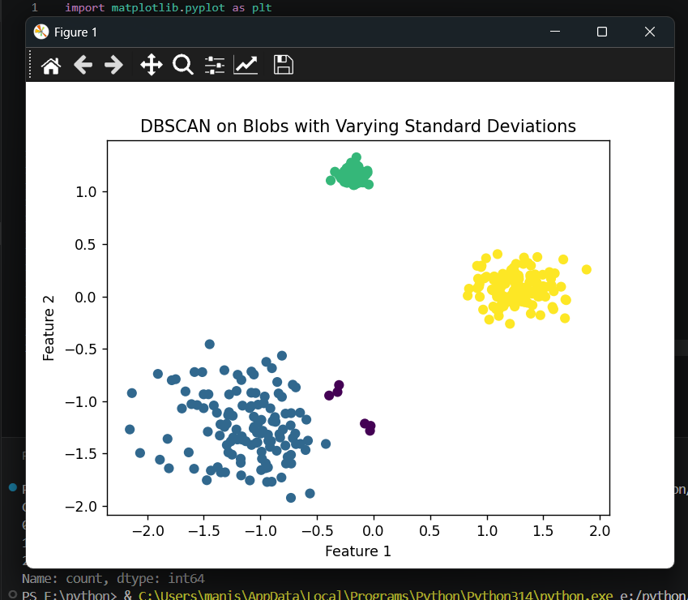

28. import matplotlib.pyplot as plt
from sklearn.datasets import load_digits
from sklearn.decomposition import PCA
from sklearn.cluster import KMeans
from sklearn.preprocessing import StandardScaler

digits = load_digits()
X = digits.data

X_scaled = StandardScaler().fit_transform(X)

pca = PCA(n_components=2)
X_pca = pca.fit_transform(X_scaled)

kmeans = KMeans(n_clusters=10, random_state=42)
labels = kmeans.fit_predict(X_pca)

plt.scatter(X_pca[:, 0], X_pca[:, 1], c=labels)
plt.title("K-Means Clustering on Digits Dataset after PCA")
plt.xlabel("PCA Component 1")
plt.ylabel("PCA Component 2")
plt.show()

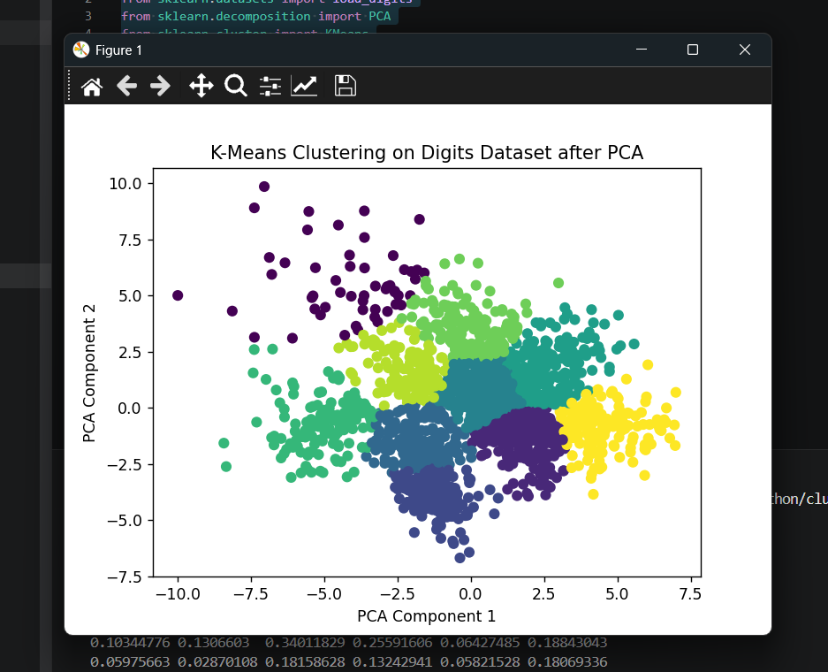

29. import matplotlib.pyplot as plt
from sklearn.datasets import make_blobs
from sklearn.cluster import KMeans
from sklearn.metrics import silhouette_score

X, y = make_blobs(n_samples=300, centers=4, random_state=42)

k_values = range(2, 6)
scores = []

for k in k_values:
kmeans = KMeans(n_clusters=k, random_state=42)
labels = kmeans.fit_predict(X)
score = silhouette_score(X, labels)
scores.append(score)

plt.bar(k_values, scores)
plt.title("Silhouette Scores for Different K Values")
plt.xlabel("Number of Clusters")
plt.ylabel("Silhouette Score")
plt.show()

print("Silhouette scores:")
for k, score in zip(k_values, scores):
print(f"K = {k}, Score = {score:.3f}")

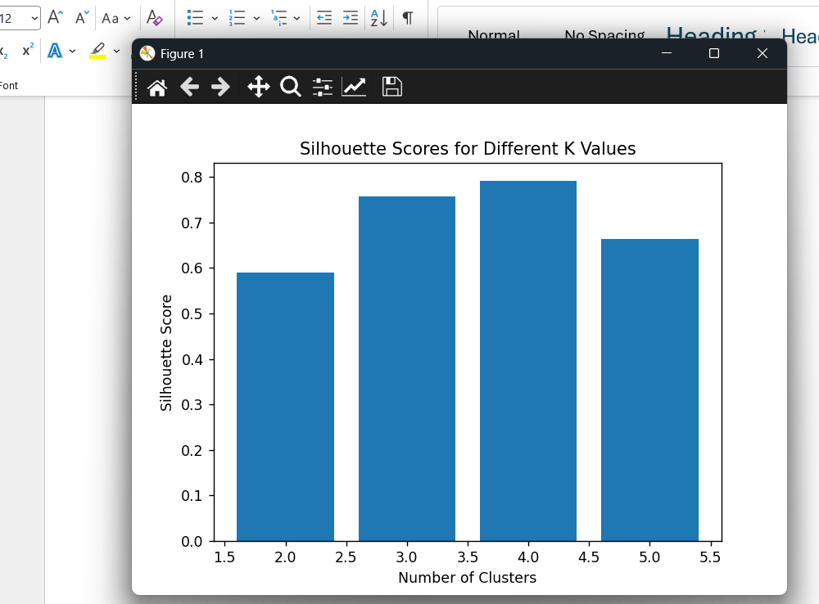

Silhouette scores:
K = 2, Score = 0.590
K = 3, Score = 0.757
K = 4, Score = 0.792
K = 5, Score = 0.664

30. import matplotlib.pyplot as plt
from sklearn.datasets import load_iris
from scipy.cluster.hierarchy import dendrogram, linkage

iris = load_iris()
X = iris.data

linked = linkage(X, method='average')

plt.figure(figsize=(10, 6))
dendrogram(linked)
plt.title("Hierarchical Clustering Dendrogram - Average Linkage")
plt.xlabel("Samples")
plt.ylabel("Distance")
plt.show()

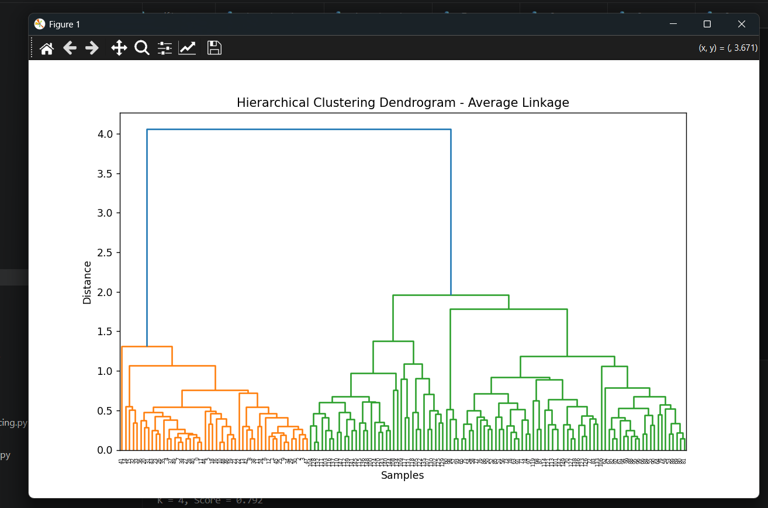

31. import numpy as np
import matplotlib.pyplot as plt
from sklearn.datasets import make_blobs
from sklearn.cluster import KMeans

X, y = make_blobs(
n_samples=300,
centers=3,
cluster_std=2.5,
random_state=42
)

kmeans = KMeans(n_clusters=3, random_state=42)
labels = kmeans.fit_predict(X)

x_min, x_max = X[:, 0].min() - 1, X[:, 0].max() + 1
y_min, y_max = X[:, 1].min() - 1, X[:, 1].max() + 1

xx, yy = np.meshgrid(
np.linspace(x_min, x_max, 300),
np.linspace(y_min, y_max, 300)
)

grid_points = np.c_[xx.ravel(), yy.ravel()]
Z = kmeans.predict(grid_points)
Z = Z.reshape(xx.shape)

plt.contourf(xx, yy, Z, alpha=0.3)
plt.scatter(X[:, 0], X[:, 1], c=labels)
plt.scatter(kmeans.cluster_centers_[:, 0], kmeans.cluster_centers_[:, 1], marker='X', s=200)
plt.title("K-Means with Decision Boundaries")
plt.xlabel("Feature 1")
plt.ylabel("Feature 2")
plt.show()

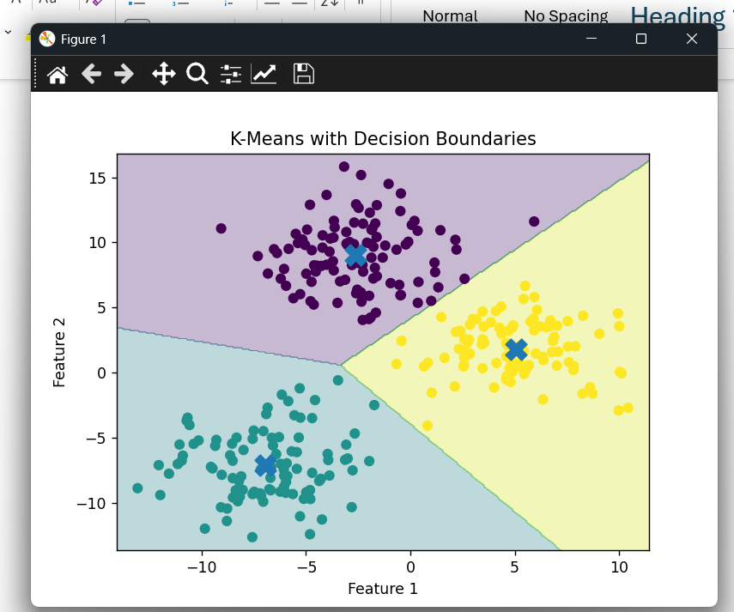

32. import matplotlib.pyplot as plt
from sklearn.datasets import load_digits
from sklearn.manifold import TSNE
from sklearn.cluster import DBSCAN
from sklearn.preprocessing import StandardScaler

digits = load_digits()
X = digits.data

X_scaled = StandardScaler().fit_transform(X)

tsne = TSNE(n_components=2, random_state=42, perplexity=30)
X_tsne = tsne.fit_transform(X_scaled)

dbscan = DBSCAN(eps=5, min_samples=5)
labels = dbscan.fit_predict(X_tsne)

plt.scatter(X_tsne[:, 0], X_tsne[:, 1], c=labels)
plt.title("DBSCAN on Digits Dataset after t-SNE")
plt.xlabel("t-SNE Component 1")
plt.ylabel("t-SNE Component 2")
plt.show()

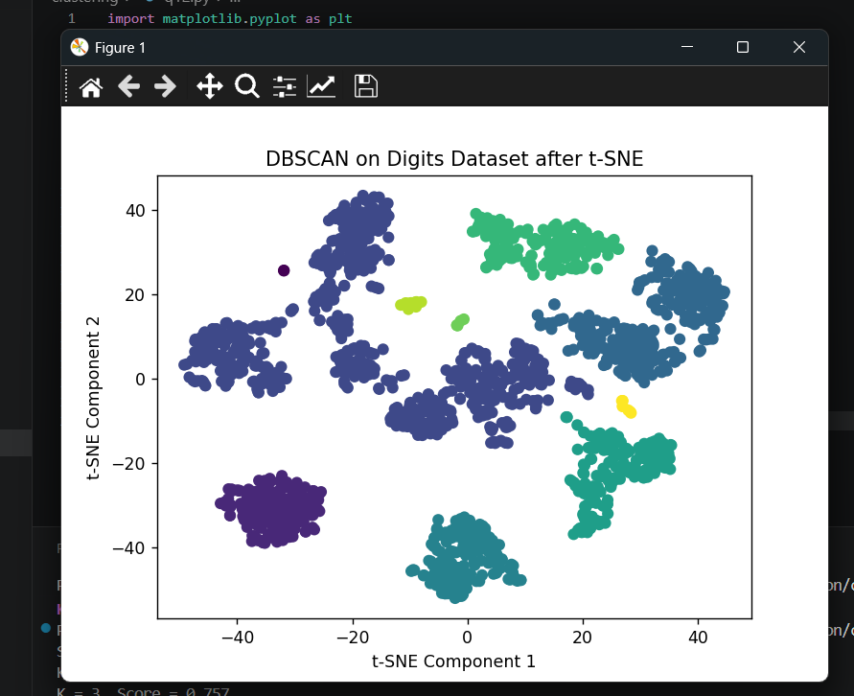

33. import matplotlib.pyplot as plt
from sklearn.datasets import make_blobs
from sklearn.cluster import AgglomerativeClustering

X, y = make_blobs(n_samples=300, centers=4, random_state=42)

model = AgglomerativeClustering(n_clusters=4, linkage='complete')
labels = model.fit_predict(X)

plt.scatter(X[:, 0], X[:, 1], c=labels)
plt.title("Agglomerative Clustering with Complete Linkage")
plt.xlabel("Feature 1")
plt.ylabel("Feature 2")
plt.show()

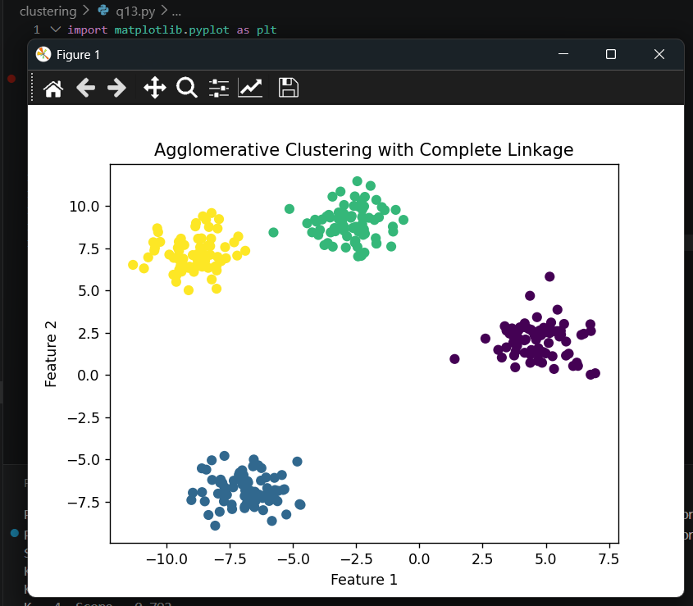

34. 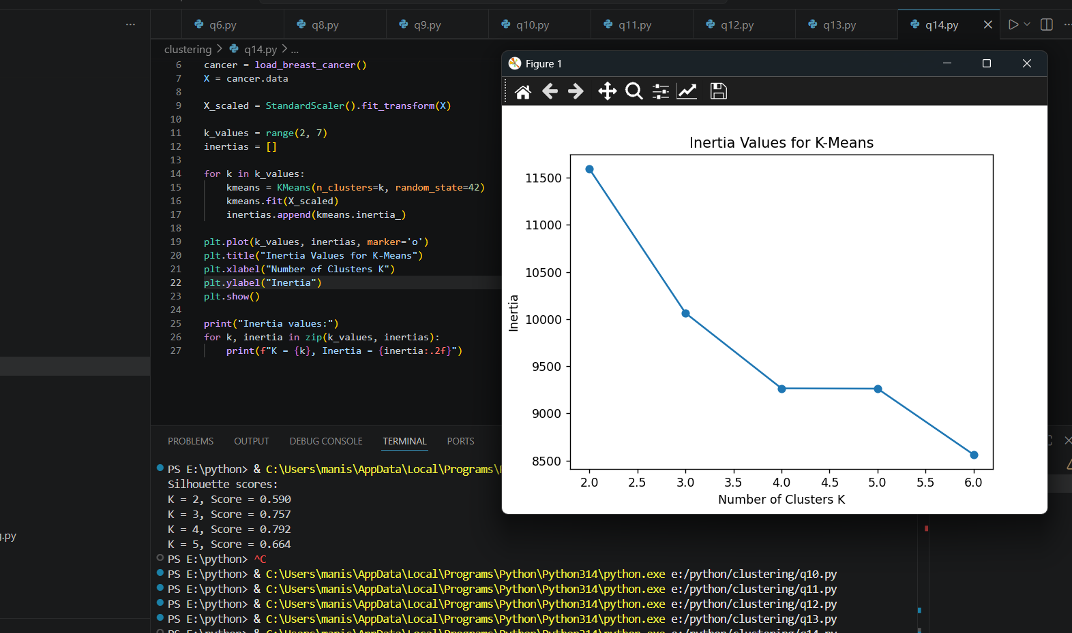

Inertia values:
K = 2, Inertia = 11595.68
K = 3, Inertia = 10066.28
K = 4, Inertia = 9266.15
K = 5, Inertia = 9263.40
K = 6, Inertia = 8562.88

35. import matplotlib.pyplot as plt
from sklearn.datasets import make_circles
from sklearn.cluster import AgglomerativeClustering

X, y = make_circles(n_samples=400, factor=0.5, noise=0.05, random_state=42)

model = AgglomerativeClustering(n_clusters=2, linkage='single')
labels = model.fit_predict(X)

plt.scatter(X[:, 0], X[:, 1], c=labels)
plt.title("Agglomerative Clustering with Single Linkage on Circles")
plt.xlabel("Feature 1")
plt.ylabel("Feature 2")
plt.show()
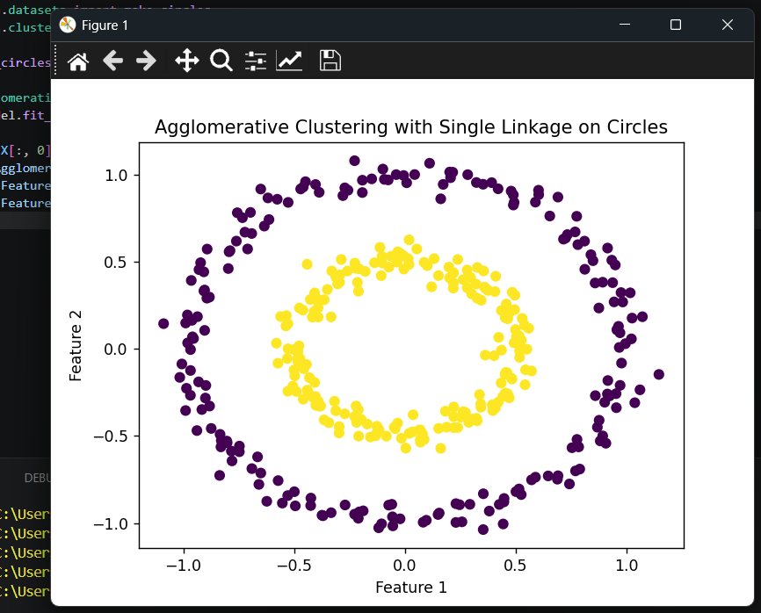

36. from sklearn.datasets import load_wine
from sklearn.preprocessing import StandardScaler
from sklearn.cluster import DBSCAN

wine = load_wine()
X = wine.data

X_scaled = StandardScaler().fit_transform(X)

dbscan = DBSCAN(eps=2.2, min_samples=5)
labels = dbscan.fit_predict(X_scaled)

unique_labels = set(labels)

if -1 in unique_labels:
unique_labels.remove(-1)

num_clusters = len(unique_labels)

print("Number of clusters excluding noise:", num_clusters)
print("Number of noise samples:", list(labels).count(-1))

Output:
Number of clusters excluding noise: 2
Number of noise samples: 55
37. import matplotlib.pyplot as plt
from sklearn.datasets import make_blobs
from sklearn.cluster import KMeans

X, y = make_blobs(n_samples=300, centers=3, random_state=42)

kmeans = KMeans(n_clusters=3, random_state=42)
labels = kmeans.fit_predict(X)

plt.scatter(X[:, 0], X[:, 1], c=labels)
plt.scatter(
kmeans.cluster_centers_[:, 0],
kmeans.cluster_centers_[:, 1],
marker='X',
s=250
)

plt.title("K-Means Clustering with Cluster Centers")
plt.xlabel("Feature 1")
plt.ylabel("Feature 2")
plt.show()
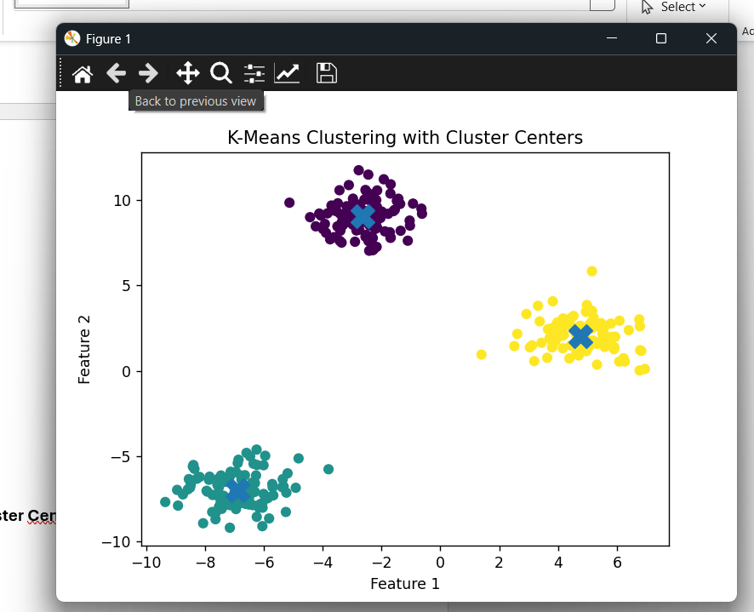

38. from sklearn.datasets import load_iris
from sklearn.preprocessing import StandardScaler
from sklearn.cluster import DBSCAN

iris = load_iris()
X = iris.data

X_scaled = StandardScaler().fit_transform(X)

dbscan = DBSCAN(eps=0.6, min_samples=5)
labels = dbscan.fit_predict(X_scaled)

noise_count = list(labels).count(-1)

print("Number of noise samples:", noise_count)
Output:
Number of noise samples: 26

39. import matplotlib.pyplot as plt
from sklearn.datasets import make_moons
from sklearn.cluster import KMeans

X, y = make_moons(n_samples=300, noise=0.08, random_state=42)

kmeans = KMeans(n_clusters=2, random_state=42)
labels = kmeans.fit_predict(X)

plt.scatter(X[:, 0], X[:, 1], c=labels)
plt.scatter(kmeans.cluster_centers_[:, 0], kmeans.cluster_centers_[:, 1], marker='X', s=200)
plt.title("K-Means on Non-Linearly Separable make_moons Data")
plt.xlabel("Feature 1")
plt.ylabel("Feature 2")
plt.show()
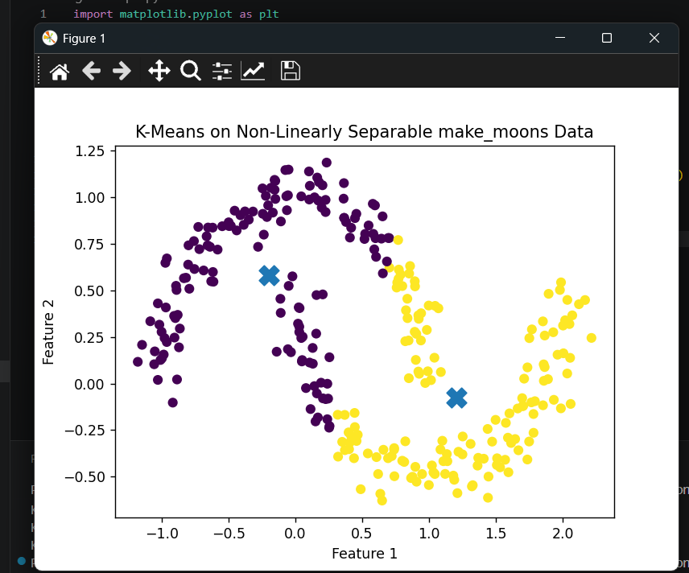

40. import matplotlib.pyplot as plt
from sklearn.datasets import load_digits
from sklearn.decomposition import PCA
from sklearn.preprocessing import StandardScaler
from sklearn.cluster import KMeans

digits = load_digits()
X = digits.data

X_scaled = StandardScaler().fit_transform(X)

pca = PCA(n_components=3)
X_pca = pca.fit_transform(X_scaled)

kmeans = KMeans(n_clusters=10, random_state=42)
labels = kmeans.fit_predict(X_pca)

fig = plt.figure(figsize=(8, 6))
ax = fig.add_subplot(111, projection='3d')

ax.scatter(X_pca[:, 0], X_pca[:, 1], X_pca[:, 2], c=labels)

ax.set_title("3D K-Means Clustering on Digits Dataset")
ax.set_xlabel("PCA Component 1")
ax.set_ylabel("PCA Component 2")
ax.set_zlabel("PCA Component 3")

plt.show()

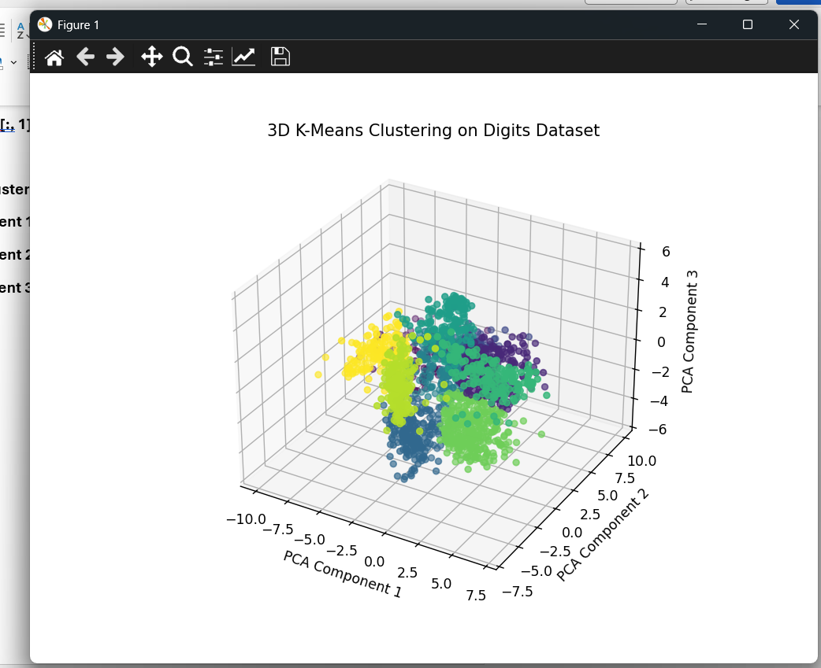

41.
from sklearn.datasets import make_blobs
from sklearn.cluster import KMeans
from sklearn.metrics import silhouette_score
import matplotlib.pyplot as plt

# Generate synthetic data
X, y = make_blobs(n_samples=500, centers=5, random_state=42)

# Apply KMeans
kmeans = KMeans(n_clusters=5, random_state=42)
labels = kmeans.fit_predict(X)

# Calculate Silhouette Score
score = silhouette_score(X, labels)

print("Silhouette Score:", score)

# Visualize clusters
plt.scatter(X[:, 0], X[:, 1], c=labels)
plt.scatter(
kmeans.cluster_centers_[:, 0],
kmeans.cluster_centers_[:, 1],
marker='X',
s=200
)
plt.title("KMeans Clustering with 5 Centers")
plt.xlabel("Feature 1")
plt.ylabel("Feature 2")
plt.show()
Output:
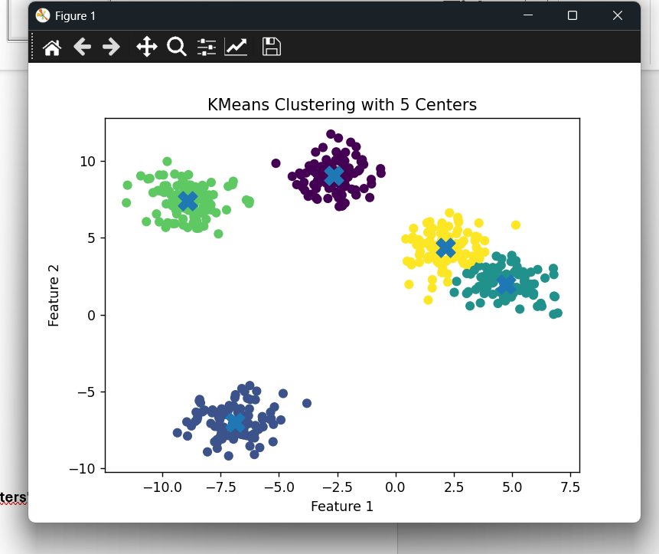
42. import matplotlib.pyplot as plt
from sklearn.datasets import load_breast_cancer
from sklearn.preprocessing import StandardScaler
from sklearn.decomposition import PCA
from sklearn.cluster import AgglomerativeClustering

# Load dataset
cancer = load_breast_cancer()
X = cancer.data

# Scale data
scaler = StandardScaler()
X_scaled = scaler.fit_transform(X)

# Reduce to 2D using PCA
pca = PCA(n_components=2)
X_pca = pca.fit_transform(X_scaled)

# Apply Agglomerative Clustering
agg = AgglomerativeClustering(n_clusters=2)
labels = agg.fit_predict(X_pca)

# Visualize
plt.scatter(X_pca[:, 0], X_pca[:, 1], c=labels)
plt.title("Agglomerative Clustering on Breast Cancer Dataset using PCA")
plt.xlabel("PCA Component 1")
plt.ylabel("PCA Component 2")
plt.show()

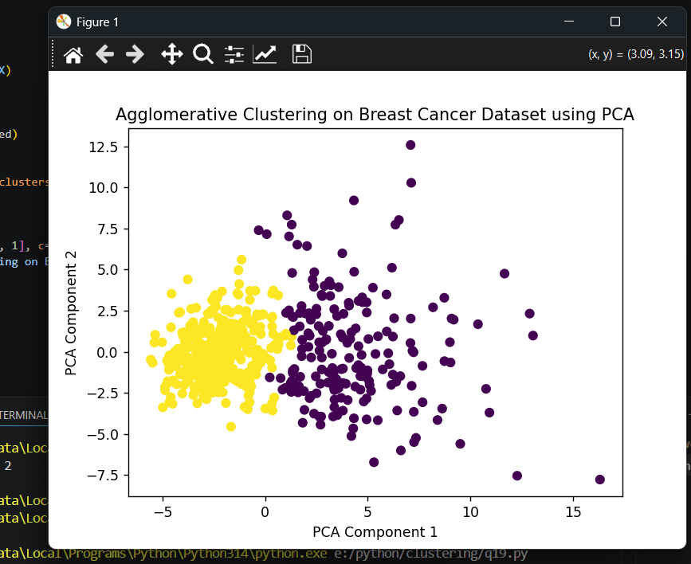

43. import matplotlib.pyplot as plt
from sklearn.datasets import make_circles
from sklearn.cluster import KMeans, DBSCAN
from sklearn.preprocessing import StandardScaler

# Generate noisy circular data
X, y = make_circles(
n_samples=500,
factor=0.5,
noise=0.08,
random_state=42
)

# Scale data
X_scaled = StandardScaler().fit_transform(X)

# Apply KMeans
kmeans = KMeans(n_clusters=2, random_state=42)
kmeans_labels = kmeans.fit_predict(X_scaled)

# Apply DBSCAN
dbscan = DBSCAN(eps=0.2, min_samples=5)
dbscan_labels = dbscan.fit_predict(X_scaled)

# Plot side-by-side
plt.figure(figsize=(12, 5))

plt.subplot(1, 2, 1)
plt.scatter(X_scaled[:, 0], X_scaled[:, 1], c=kmeans_labels)
plt.title("KMeans on Noisy Circular Data")
plt.xlabel("Feature 1")
plt.ylabel("Feature 2")

plt.subplot(1, 2, 2)
plt.scatter(X_scaled[:, 0], X_scaled[:, 1], c=dbscan_labels)
plt.title("DBSCAN on Noisy Circular Data")
plt.xlabel("Feature 1")
plt.ylabel("Feature 2")

plt.show()
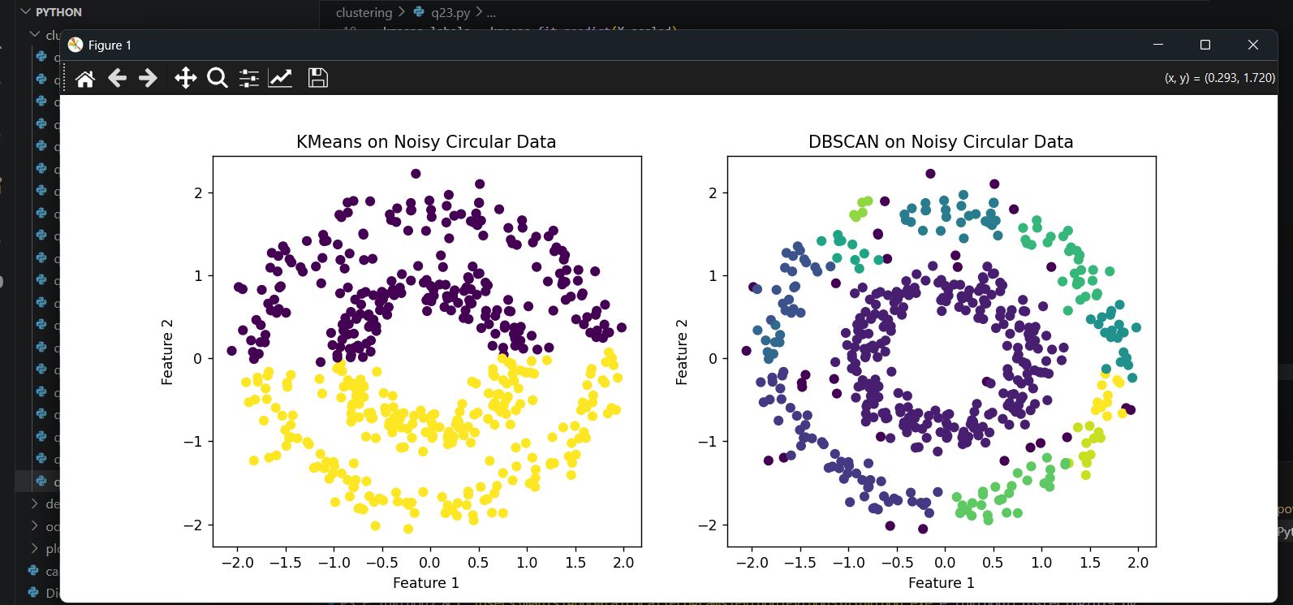

44. import numpy as np
import matplotlib.pyplot as plt
from sklearn.datasets import load_iris
from sklearn.cluster import KMeans
from sklearn.metrics import silhouette_samples, silhouette_score
from sklearn.preprocessing import StandardScaler

# Load Iris dataset
iris = load_iris()
X = iris.data

# Scale data
X_scaled = StandardScaler().fit_transform(X)

# Apply KMeans
kmeans = KMeans(n_clusters=3, random_state=42)
labels = kmeans.fit_predict(X_scaled)

# Calculate silhouette values for each sample
sample_silhouette_values = silhouette_samples(X_scaled, labels)
average_score = silhouette_score(X_scaled, labels)

print("Average Silhouette Score:", average_score)

# Plot silhouette coefficient for each sample
plt.figure(figsize=(8, 6))

y_lower = 10

for cluster in range(3):
cluster_silhouette_values = sample_silhouette_values[labels == cluster]
cluster_silhouette_values.sort()

size_cluster = cluster_silhouette_values.shape[0]
y_upper = y_lower + size_cluster

plt.fill_betweenx(
np.arange(y_lower, y_upper),
0,
cluster_silhouette_values
)

plt.text(-0.05, y_lower + 0.5 * size_cluster, str(cluster))
y_lower = y_upper + 10

plt.axvline(x=average_score, linestyle='--')
plt.title("Silhouette Plot for Iris Dataset using KMeans")
plt.xlabel("Silhouette Coefficient Values")
plt.ylabel("Cluster")
plt.show()
Output:
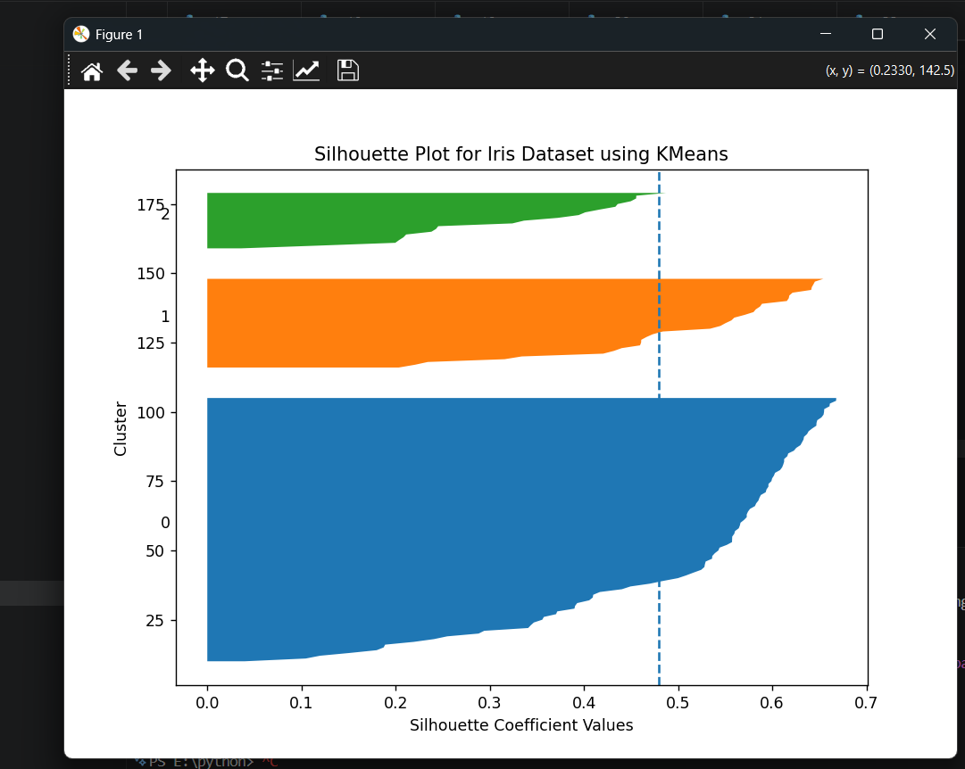
Average Silhouette Score: 0.4798814508199817

45. import matplotlib.pyplot as plt
from sklearn.datasets import make_blobs
from sklearn.cluster import AgglomerativeClustering

# Generate synthetic data
X, y = make_blobs(n_samples=300, centers=4, random_state=42)

# Apply Agglomerative Clustering with average linkage
agg = AgglomerativeClustering(n_clusters=4, linkage='average')
labels = agg.fit_predict(X)

# Visualize clusters
plt.scatter(X[:, 0], X[:, 1], c=labels)
plt.title("Agglomerative Clustering with Average Linkage")
plt.xlabel("Feature 1")
plt.ylabel("Feature 2")
plt.show()

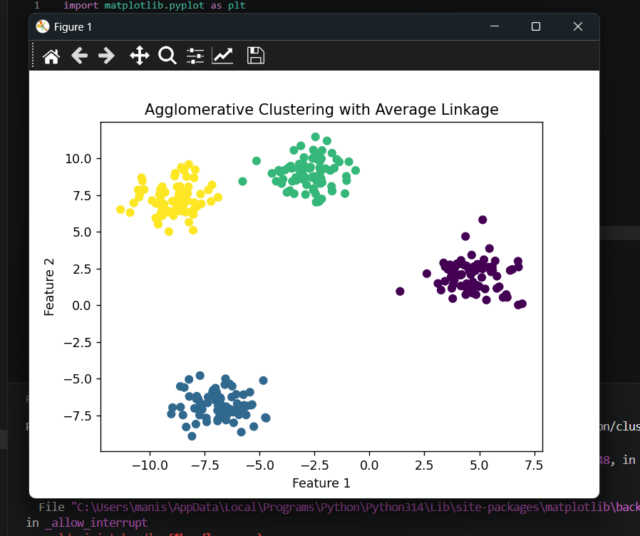
46. import pandas as pd
import seaborn as sns
import matplotlib.pyplot as plt
from sklearn.datasets import load_wine
from sklearn.cluster import KMeans
from sklearn.preprocessing import StandardScaler

# Load Wine dataset
wine = load_wine()
X = wine.data
feature_names = wine.feature_names

# Use first 4 features
X_first4 = X[:, :4]

# Scale the first 4 features
scaler = StandardScaler()
X_scaled = scaler.fit_transform(X_first4)

# Apply KMeans
kmeans = KMeans(n_clusters=3, random_state=42)
labels = kmeans.fit_predict(X_scaled)

# Create DataFrame
df = pd.DataFrame(X_first4, columns=feature_names[:4])
df["Cluster"] = labels

# Pairplot
sns.pairplot(df, hue="Cluster")
plt.show()
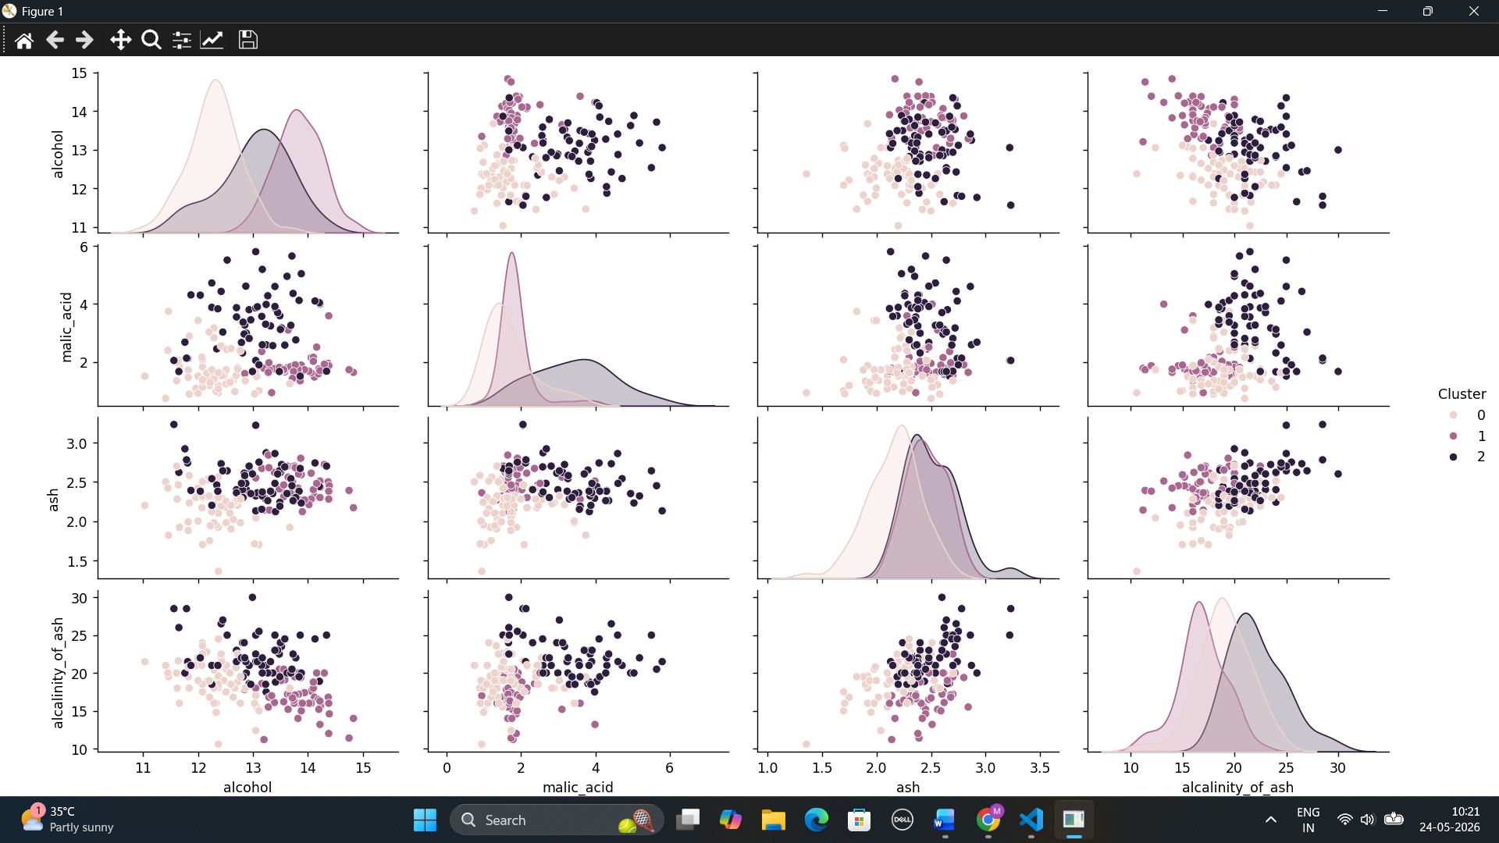
47. from sklearn.datasets import make_blobs
from sklearn.cluster import DBSCAN
from sklearn.preprocessing import StandardScaler
import matplotlib.pyplot as plt

# Generate noisy blob data
X, y = make_blobs(
n_samples=400,
centers=3,
cluster_std=1.2,
random_state=42
)

# Scale data
X_scaled = StandardScaler().fit_transform(X)

# Apply DBSCAN
dbscan = DBSCAN(eps=0.4, min_samples=5)
labels = dbscan.fit_predict(X_scaled)

# Count clusters excluding noise
unique_labels = set(labels)

if -1 in unique_labels:
unique_labels.remove(-1)

num_clusters = len(unique_labels)
num_noise = list(labels).count(-1)

print("Number of clusters:", num_clusters)
print("Number of noise points:", num_noise)

# Visualize clusters and noise
plt.scatter(X_scaled[:, 0], X_scaled[:, 1], c=labels)
plt.scatter(
X_scaled[labels == -1, 0],
X_scaled[labels == -1, 1],
marker='x',
s=100
)
plt.title("DBSCAN on Noisy Blobs")
plt.xlabel("Feature 1")
plt.ylabel("Feature 2")
plt.show()
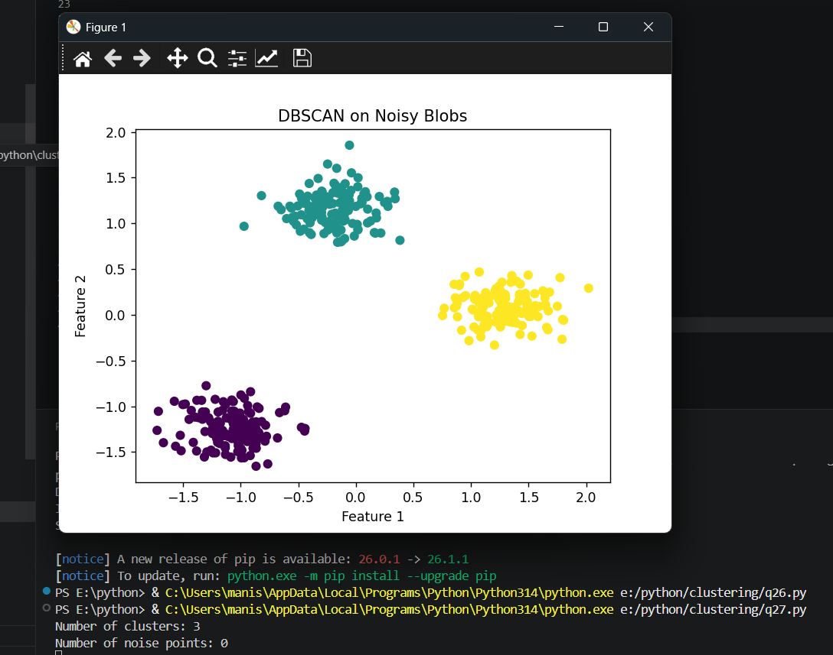

48. import matplotlib.pyplot as plt
from sklearn.datasets import load_digits
from sklearn.preprocessing import StandardScaler
from sklearn.manifold import TSNE
from sklearn.cluster import AgglomerativeClustering

# Load Digits dataset
digits = load_digits()
X = digits.data

# Scale data
X_scaled = StandardScaler().fit_transform(X)

# Reduce dimensions using t-SNE
tsne = TSNE(n_components=2, random_state=42, perplexity=30)
X_tsne = tsne.fit_transform(X_scaled)

# Apply Agglomerative Clustering
agg = AgglomerativeClustering(n_clusters=10)
labels = agg.fit_predict(X_tsne)

# Visualize clusters
plt.scatter(X_tsne[:, 0], X_tsne[:, 1], c=labels)
plt.title("Agglomerative Clustering on Digits Dataset using t-SNE")
plt.xlabel("t-SNE Component 1")
plt.ylabel("t-SNE Component 2")
plt.show()

