1. What is Simple Linear Regression?
Simple Linear Regression is a statistical method used to model the relationship between one independent variable (X) and one dependent variable (Y). It fits a straight line to the data using the equation Y = mX + c. The goal is to predict Y based on X. It assumes a linear relationship between the variables.
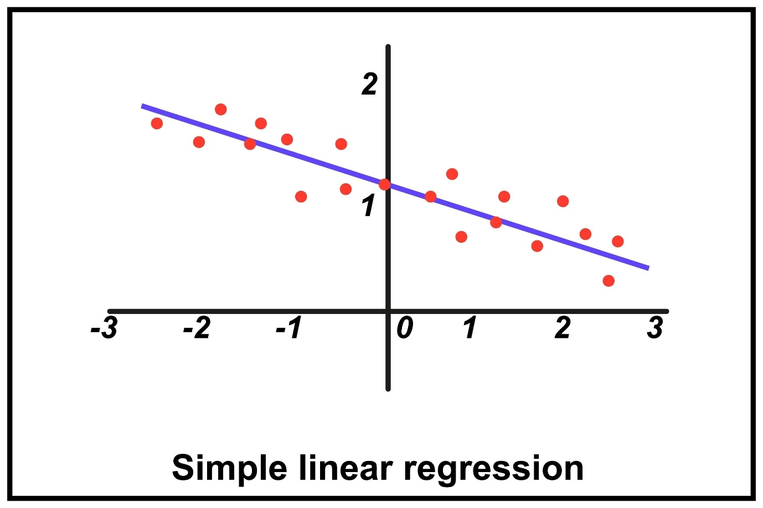

2. What are the key assumptions of Simple Linear Regression?
The main assumptions are linearity, independence of errors, homoscedasticity (constant variance of errors), and normally distributed residuals. It also assumes there is little or no measurement error in the independent variable. Violating these assumptions can reduce model accuracy.

3. What does the coefficient m represent in the equation Y = mX + c?
The coefficient m represents the slope of the regression line. It indicates how much the dependent variable (Y) changes when the independent variable (X) increases by one unit. A positive value means Y increases with X, while a negative value means Y decreases.

4. What does the intercept c represent in the equation Y = mX + c?
The intercept c represents the value of Y when X equals zero. It is the point where the regression line crosses the Y-axis. It provides a baseline value of the dependent variable when there is no influence from X.

5. How do we calculate the slope m in Simple Linear Regression?
The slope is calculated using the formula
m = Σ[(Xi − X̄)(Yi − Ȳ)] / Σ[(Xi − X̄)²].
It measures the covariance of X and Y divided by the variance of X. This gives the best-fit line for predicting Y from X.

6. What is the purpose of the least squares method in Simple Linear Regression?
The least squares method finds the regression line that minimizes the sum of squared differences between observed and predicted values. These differences are called residuals. By minimizing these errors, the method provides the most accurate linear fit to the data.

7. How is the coefficient of determination (R²) interpreted in Simple Linear Regression?
R² measures how well the regression model explains the variation in the dependent variable. Its value ranges from 0 to 1. For example, an R² of 0.8 means 80% of the variation in Y is explained by X. Higher values indicate a better model fit.

8. What is Multiple Linear Regression?
Multiple Linear Regression models the relationship between one dependent variable and two or more independent variables. It predicts the outcome using several predictors simultaneously. The general equation is Y = b0 + b1X1 + b2X2 + ... + bnXn.

9. What is the main difference between Simple and Multiple Linear Regression?
Simple Linear Regression uses one independent variable to predict the dependent variable. Multiple Linear Regression uses two or more independent variables. Multiple regression allows more complex relationships and better prediction accuracy.

10. What are the key assumptions of Multiple Linear Regression?
Assumptions include linearity, independence of errors, homoscedasticity, normal distribution of residuals, and no multicollinearity among predictors. These conditions ensure reliable and unbiased coefficient estimates.

11. What is heteroscedasticity, and how does it affect the results of a Multiple Linear Regression model?
Heteroscedasticity occurs when the variance of the residuals is not constant across all levels of the independent variables. This violates regression assumptions. It can lead to unreliable standard errors and incorrect hypothesis testing.

12. How can you improve a Multiple Linear Regression model with high multicollinearity?
Multicollinearity can be reduced by removing highly correlated variables, combining variables, or using techniques like Principal Component Analysis (PCA). Regularization methods such as Ridge or Lasso regression can also help.

13. What are some common techniques for transforming categorical variables for use in regression models?
Categorical variables are commonly transformed using one-hot encoding, dummy variables, or label encoding. These methods convert categories into numerical values. This allows regression models to process categorical data.

14. What is the role of interaction terms in Multiple Linear Regression?
Interaction terms capture situations where the effect of one independent variable depends on another variable. They are created by multiplying two variables together. This helps model more complex relationships between predictors.

15. How can the interpretation of intercept differ between Simple and Multiple Linear Regression?
In simple regression, the intercept represents Y when X = 0. In multiple regression, it represents the predicted value of Y when all independent variables equal zero. Sometimes this value may not have practical meaning.

16. What is the significance of the slope in regression analysis, and how does it affect predictions?
The slope indicates the direction and strength of the relationship between variables. It shows how much the dependent variable changes when the predictor changes by one unit. It directly influences the predicted values.

17. How does the intercept in a regression model provide context for the relationship between variables?
The intercept sets the baseline level of the dependent variable when predictors are zero. It helps position the regression line on the graph. This baseline provides context for interpreting the slope and predictions.

18. What are the limitations of using R² as a sole measure of model performance?
R² does not indicate whether the model is appropriate or whether predictors are significant. It always increases when more variables are added, even if they are irrelevant. Therefore, it should be used with other metrics like Adjusted R² or RMSE.

19. How would you interpret a large standard error for a regression coefficient?
A large standard error indicates high uncertainty in the coefficient estimate. It suggests the variable may not be a reliable predictor. This may occur due to multicollinearity, small sample size, or noisy data.

20. How can heteroscedasticity be identified in residual plots, and why is it important to address it?
Heteroscedasticity appears as a funnel or pattern in residual vs predicted plots instead of random scatter. It shows that error variance changes with predictions. Addressing it improves the reliability of statistical tests.

21. What does it mean if a Multiple Linear Regression model has a high R² but low adjusted R²?
This suggests that some predictors do not meaningfully contribute to the model. While R² increases with more variables, adjusted R² penalizes unnecessary predictors. It indicates possible overfitting.

22. Why is it important to scale variables in Multiple Linear Regression?
Scaling ensures that variables with large values do not dominate the model. It helps algorithms converge faster and improves interpretability. Techniques include standardization and normalization.

23. What is polynomial regression?
Polynomial regression is a form of regression that models a non-linear relationship between variables using polynomial terms. It extends linear regression by adding powers of the predictor variable. For example, X² or X³.

24. How does polynomial regression differ from linear regression?
Linear regression models relationships using a straight line. Polynomial regression uses curved relationships by adding higher-degree terms. This allows it to capture more complex patterns in the data.

25. When is polynomial regression used?
Polynomial regression is used when the relationship between variables is non-linear but still continuous. It helps capture curved patterns in data. It is common in growth trends, physics data, and time-based patterns.

26. What is the general equation for polynomial regression?
The general equation is:
Y = b0 + b1X + b2X² + b3X³ + ... + bnXⁿ.
Here, n represents the degree of the polynomial. Higher degrees allow more complex curves.

27. Can polynomial regression be applied to multiple variables?
Yes, polynomial regression can be extended to multiple variables. Each variable can have polynomial terms and interaction terms. However, the model can become complex and prone to overfitting.

28. What are the limitations of polynomial regression?
Polynomial regression can easily overfit the data if the degree is too high. It may also behave poorly outside the training range. Additionally, higher-degree models can become difficult to interpret.

29. What methods can be used to evaluate model fit when selecting the degree of a polynomial?
Methods include cross-validation, adjusted R², AIC, BIC, and mean squared error (MSE). These metrics help determine the best polynomial degree. The goal is to balance accuracy and model simplicity.

30. Why is visualization important in polynomial regression?
Visualization helps understand whether the polynomial curve fits the data well. Plotting the regression curve against data points reveals underfitting or overfitting. It also helps in choosing the correct polynomial degree.

31. How is polynomial regression implemented in Python?
In Python, it is typically implemented using the scikit-learn library. You do not use a separate algorithm; instead, you transform your input data using Polynomial Features to create new squared/cubed columns, and then you fit a standard Linear Regression model to that transformed data.

