Statistics – 10 Questions and Answers
1What is a random variable in probability theory?
A random variable is a function that assigns a numerical value to each outcome of a random experiment.
It translates outcomes from a sample space into numbers.
2. What are the types of Random Variables?
There are two main types:
- Discrete random variable – Takes countable values (e.g., 0, 1, 2, 3).
- Continuous random variable – Takes any value within a given interval.
3. Explain the difference between discrete and continuous distributions
Discrete distribution:
- Deals with countable values.
- Uses Probability Mass Function (PMF).
- Probabilities are found by summation.
Continuous distribution:
- Deals with uncountable values in an interval.
- Uses Probability Density Function (PDF).
- Probabilities are found by integration.
- Probability of a single exact value is zero.
4. What is a binomial distribution, and how is it used in probability?
A discrete probability distribution that models the number of successes
in a fixed number of independent trials with two outcomes (success/failure).
Defined by parameters n (trials) and p (probability of success).
5. What is the standard normal distribution, and why is it important?
A continuous distribution with mean 0 and standard deviation 1.
It is symmetric about zero and used to calculate z-scores.
6. What is the Central Limit Theorem (CLT), and why is it critical in statistics?
The sampling distribution of the sample mean approaches normal distribution
as sample size becomes large, regardless of population distribution.
7.What is the significance of confidence intervals in statistical analysis?
A range of values that likely contains the true population parameter.
A 95% confidence level means we are 95% confident the interval contains the true value.
8.What is the concept of expected value in a probability distribution?
The long-run average value of a random variable.
It is the weighted average of all possible outcomes using probabilities.
9. Write a Python program to generate 1000 random numbers from a normal distribution with mean = 50 and standard deviation = 5. Compute its mean and standard deviation using NumPy, and draw a histogram to visualize the distribution.
import numpy as np
import matplotlib.pyplot as plt
# Generate 1000 random numbers from normal distribution
mean = 50
std_dev = 5
data = np.random.normal(mean, std_dev, 1000)
sample_mean = np.mean(data)
sample_std = np.std(data)
print("Sample Mean:", sample_mean)
print("Sample Standard Deviation:", sample_std)
# Draw histogram
plt.hist(data, bins=30, edgecolor='black')
plt.title("Histogram of Normal Distribution (mean=50, std=5)")
plt.xlabel("Values")
plt.ylabel("Frequency")
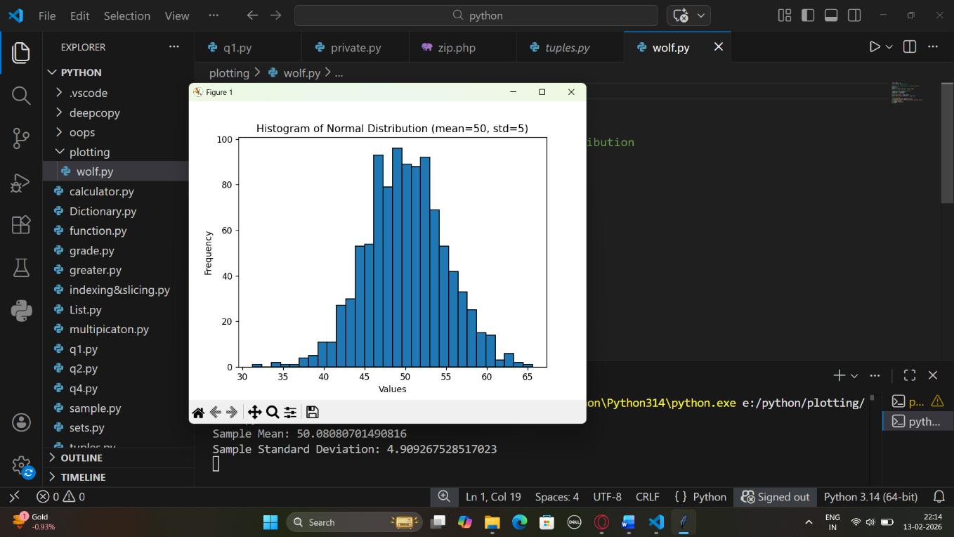plt.show()

10. You are working as a data analyst for a retail company. The company has collected daily sales data for 2 years and wants you to identify the overall sales trend. daily_sales = [220, 245, 210, 265, 230, 250, 260, 275, 240, 255, 235, 260, 245, 250, 225, 270, 265, 255, 250, 260] ● Explain how you would apply the Central Limit Theorem to estimate the average sales with a 95% confidence interval. ● Write the Python code to compute the mean sales and its confidence interval.

10. Steps to Estimate Average Sales with 95% Confidence Interval
- Calculate the sample mean
$$\overset{ˉ}{x}=\frac{1}{n}\sum_{i=1}^{n}{x_{i}}$$
- Calculate the sample standard deviation (s)
$$s=\sqrt{\frac{1}{n-1}\sum_{i=1}^{n}{(}x_{i}-\overset{ˉ}{x})^{2}}$$
- Compute Standard Error (SE)
$$SE=\frac{s}{\sqrt{n}}$$
- Use t-distribution for 95% CI (because n is small)
$$CI=\overset{ˉ}{x}±t_{α/2,n-1}⋅SE$$
Where:
  - $t_{α/2,n-1}$is the critical t-value
  - $α=0.05$
daily_sales = [220, 245, 210, 265, 230, 250, 260, 275, 240, 255,
235, 260, 245, 250, 225, 270, 265, 255, 250, 260]

Step 1: Sample mean
$$\overset{ˉ}{x}=\frac{∑x_{i}}{n}=\frac{4965}{20}=248.25$$
Step 2: Sample standard deviation
$$s=\sqrt{\frac{∑(x_{i}-\overset{ˉ}{x})^{2}}{n-1}}≈17.26$$
Step 3: Standard error
$$SE=\frac{s}{\sqrt{n}}≈\frac{17.26}{4.472}≈3.86$$
Step 4: t-critical value (95% CI, df = 19)
$$t_{0.975,19}≈2.093$$
Step 5: Margin of error
$$ME=t⋅SE≈2.093⋅3.86≈8.08$$
Step 6: 95% Confidence Interval
$$CI=\overset{ˉ}{x}±ME=248.25±8.08=(240.17,256.33)$$

✅ Final Answer:
- Mean daily sales: 248.25
- 95% Confidence Interval: (240.17, 256.33)

Python Code to Compute Mean & 95% CI
import numpy as np
import scipy.stats as stats

daily_sales = [220, 245, 210, 265, 230, 250, 260, 275, 240, 255,
235, 260, 245, 250, 225, 270, 265, 255, 250, 260]

# Sample size
n = len(daily_sales)

# Sample mean
mean_sales = np.mean(daily_sales)

# Sample standard deviation (ddof=1 for sample sd)
std_sales = np.std(daily_sales, ddof=1)

# Standard Error
se = std_sales / np.sqrt(n)

# t-critical value for 95% CI
t_crit = stats.t.ppf(0.975, df=n-1)

# Margin of Error
margin = t_crit * se

# Confidence Interval
ci_lower = mean_sales - margin
ci_upper = mean_sales + margin

mean_sales, (ci_lower, ci_upper)
