Question1:What is hypothesis testing in statistics?
Answer:
Hypothesis testing is a statistical method used to make decisions or draw conclusions about a population based on sample data. It involves formulating a claim (hypothesis) about a population parameter (such as a mean or proportion) and then using statistical evidence to determine whether there is enough support to reject that claim
Question 2: What is the null hypothesis, and how does it differ from the alternative hypothesis?
Answer:
The null hypothesis (H₀) is a statement that assumes there is no effect, no difference, or no relationship in the population. It represents the default or status quo assumption.
The alternative hypothesis (H₁ or Ha) is the statement that contradicts the null hypothesis. It suggests that there is an effect, a difference, or a relationship.
Key Differences:
- The null hypothesis assumes no change or no effect.
- The alternative hypothesis suggests that a change or effect exists.
- In hypothesis testing, we test whether there is enough evidence to reject the null hypothesis in favor of the alternative hypothesis.
Question 3: Explain the significance level in hypothesis testing and its role in deciding the outcome of a test.
Answer:
The significance level (α) is the probability of rejecting the null hypothesis when it is actually true. It represents the risk of making a Type I error.
Common significance levels are 0.05 (5%), 0.01 (1%), and 0.10 (10%).
Role in decision-making:
- Before conducting a test, the researcher chooses a significance level (α).
- After calculating the p-value:
  - If p-value ≤ α, we reject the null hypothesis.
  - If p-value > α, we fail to reject the null hypothesis.

Question 4: What are Type I and Type II errors? Give examples of each.
Answer:
In hypothesis testing, errors can occur when making decisions about the null hypothesis.
Type I Error (False Positive)
A Type I error occurs when we reject the null hypothesis (H₀) even though it is actually true.
It is denoted by α (the significance level).
Example:
Suppose a medical test is checking whether a patient has a disease.
- H₀: The patient does not have the disease.
- If the test result says the patient has the disease (reject H₀), but in reality they are healthy, this is a Type I error.

Type II Error (False Negative)
A Type II error occurs when we fail to reject the null hypothesis even though it is false.
It is denoted by β.
Example:
Using the same medical test:
- H₀: The patient does not have the disease.
- If the test result says the patient is healthy (fail to reject H₀), but they actually have the disease, this is a Type II error.
Question 5: What is the difference between a Z-test and a T-test? Explain when to use each.
Answer:
Both Z-tests and T-tests are used to test hypotheses about population means, but they differ in certain conditions.
Feature | Z-test | T-test
Population variance | Known | Unknown
Sample size | Large (n ≥ 30) | Small (n < 30)
Distribution used | Normal distribution | t-distribution
Shape | Fixed | Depends on degrees of freedom
When to use a Z-test:
- When the population standard deviation (σ) is known.
- When the sample size is large (usually n ≥ 30).
When to use a T-test:
- When the population standard deviation is unknown.
- When the sample size is small (n < 30).
- Data should be approximately normally distributed.

Question 6: Write a Python program to generate a binomial distribution with n=10 and p=0.5, then plot its histogram.
Answer:
import numpy as np
import matplotlib.pyplot as plt

# Parameters
n = 10 # number of trials
p = 0.5 # probability of success
size = 1000 # number of samples

# Generate binomial distribution data
data = np.random.binomial(n, p, size)

# Plot histogram
plt.hist(data, bins=range(n+2), edgecolor='black', align='left')
plt.title("Binomial Distribution (n=10, p=0.5)")
plt.xlabel("Number of Successes")
plt.ylabel("Frequency")
plt.xticks(range(n+1))
plt.show()

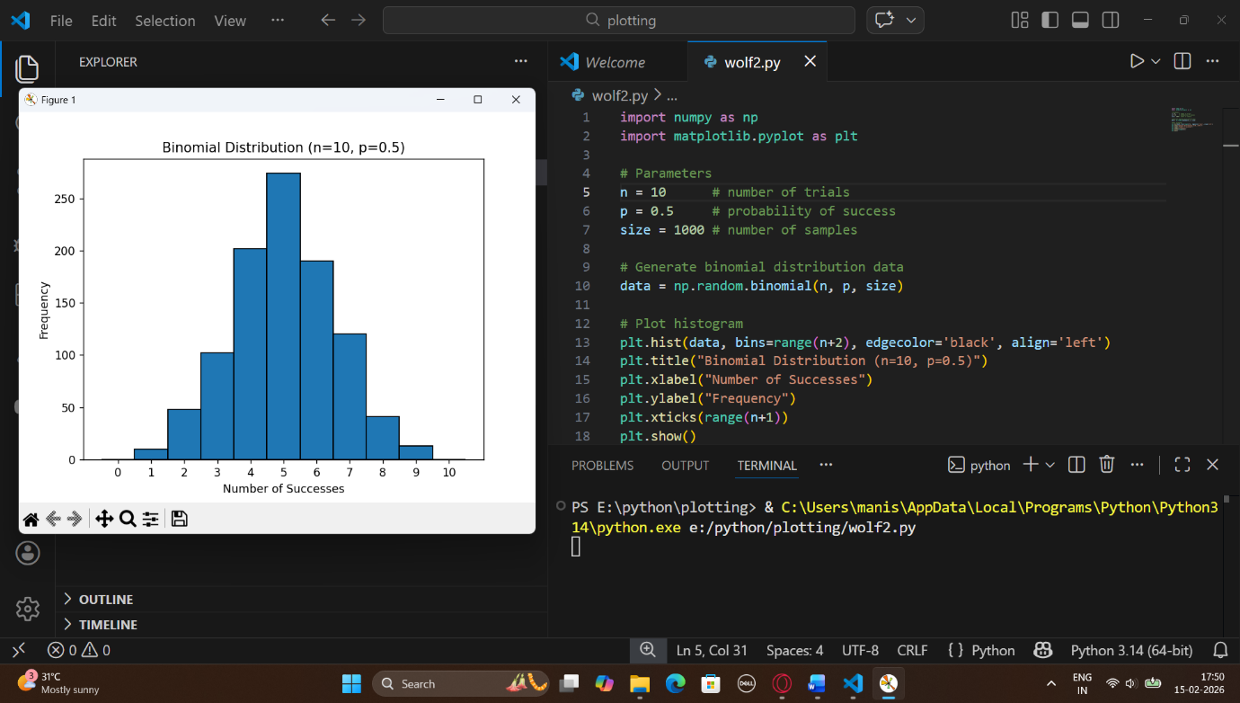

Question 7: Implement hypothesis testing using Z-statistics for a sample dataset in Python. Show the Python code and interpret the results. sample_data = [49.1, 50.2, 51.0, 48.7, 50.5, 49.8, 50.3, 50.7, 50.2, 49.6, 50.1, 49.9, 50.8, 50.4, 48.9, 50.6, 50.0, 49.7, 50.2, 49.5, 50.1, 50.3, 50.4, 50.5, 50.0, 50.7, 49.3, 49.8, 50.2, 50.9, 50.3, 50.4, 50.0, 49.7, 50.5, 49.9]
Answer:
import numpy as np
from scipy import stats

# Given sample data
sample_data = [49.1, 50.2, 51.0, 48.7, 50.5, 49.8, 50.3, 50.7, 50.2, 49.6,
50.1, 49.9, 50.8, 50.4, 48.9, 50.6, 50.0, 49.7, 50.2, 49.5,
50.1, 50.3, 50.4, 50.5, 50.0, 50.7, 49.3, 49.8, 50.2, 50.9,
50.3, 50.4, 50.0, 49.7, 50.5, 49.9]

# Convert to numpy array
data = np.array(sample_data)

# Hypothesized population mean
mu = 50

# Sample statistics
sample_mean = np.mean(data)
sample_std = np.std(data, ddof=1)
n = len(data)

# Z-statistic calculation
z_stat = (sample_mean - mu) / (sample_std / np.sqrt(n))

# Two-tailed p-value
p_value = 2 * (1 - stats.norm.cdf(abs(z_stat)))

print("Sample Mean:", sample_mean)
print("Sample Standard Deviation:", sample_std)
print("Z-statistic:", z_stat)
print("P-value:", p_value)

Output:
Sample Mean: 50.08888888888889
Sample Standard Deviation: 0.5365379910807955
Z-statistic: 0.9940271559503017
P-value: 0.3202096468890012

Question 8: Write a Python script to simulate data from a normal distribution and calculate the 95% confidence interval for its mean. Plot the data using Matplotlib.
Answer:
import numpy as np
import matplotlib.pyplot as plt
from scipy import stats

# Set random seed for reproducibility
np.random.seed(42)

# Parameters for normal distribution
mu = 50 # True mean
sigma = 10 # True standard deviation
n = 100 # Sample size

# Simulate data
data = np.random.normal(mu, sigma, n)

# Calculate sample statistics
sample_mean = np.mean(data)
sample_std = np.std(data, ddof=1)

# Calculate 95% confidence interval
confidence_level = 0.95
alpha = 1 - confidence_level
t_critical = stats.t.ppf(1 - alpha/2, df=n-1)
margin_of_error = t_critical * (sample_std / np.sqrt(n))

ci_lower = sample_mean - margin_of_error
ci_upper = sample_mean + margin_of_error

# Print results
print(f"Sample Mean: {sample_mean:.2f}")
print(f"95% Confidence Interval: ({ci_lower:.2f}, {ci_upper:.2f})")

# Plot histogram
plt.figure(figsize=(8, 5))
plt.hist(data, bins=15, density=True, alpha=0.6, color='skyblue', edgecolor='black')

# Plot sample mean and confidence interval
plt.axvline(sample_mean, color='red', linestyle='dashed', linewidth=2, label='Sample Mean')
plt.axvline(ci_lower, color='green', linestyle='dashed', linewidth=2, label='95% CI Lower')
plt.axvline(ci_upper, color='green', linestyle='dashed', linewidth=2, label='95% CI Upper')

plt.title('Histogram of Simulated Normal Data')
plt.xlabel('Value')
plt.ylabel('Density')
plt.legend()
plt.tight_layout()
plt.show()

Output:
Sample Mean: 48.96
95% Confidence Interval: (47.16, 50.76)
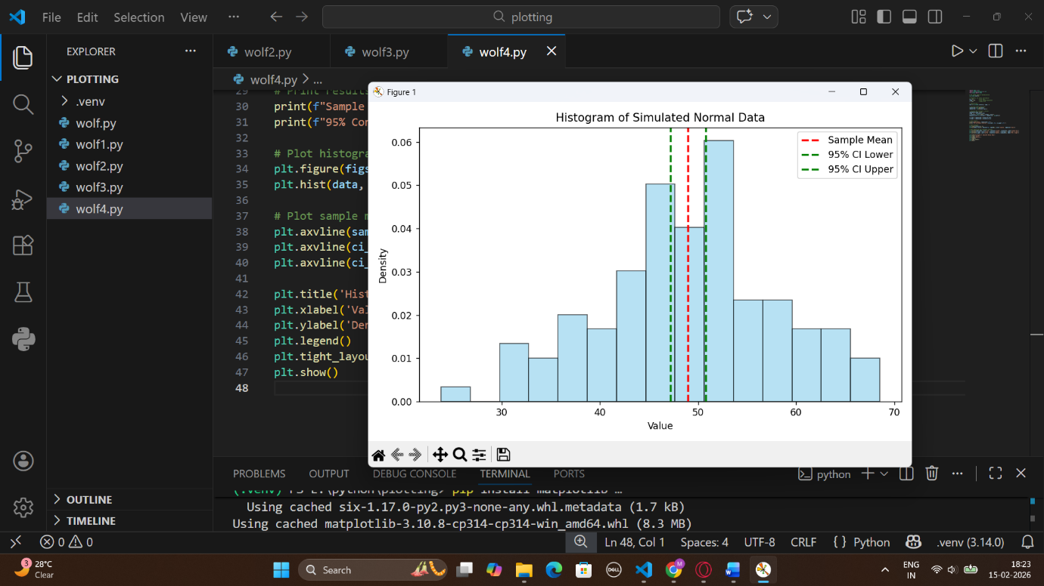

Question 9: Write a Python function to calculate the Z-scores from a dataset and visualize the standardized data using a histogram. Explain what the Z-scores represent in terms of standard deviations from the mean.
Answer:
import numpy as np
import matplotlib.pyplot as plt

def calculate_z_scores(data):
mean = np.mean(data)
std = np.std(data, ddof=1) # Sample standard deviation
z_scores = (data - mean) / std
return z_scores

# Example dataset
data = np.array([10, 12, 23, 23, 16, 23, 21, 16])

# Calculate Z-scores
z_scores = calculate_z_scores(data)

print("Original Data:", data)
print("Z-scores:", np.round(z_scores, 2))

# Plot histogram of Z-scores
plt.figure(figsize=(8,5))
plt.hist(z_scores, bins=8, alpha=0.7, color='skyblue', edgecolor='black')
plt.title("Histogram of Z-scores")
plt.xlabel("Z-score")
plt.ylabel("Frequency")
plt.axvline(0, color='red', linestyle='dashed', linewidth=2, label='Mean (Z=0)')
plt.legend()
plt.tight_layout()
plt.show()