Question 1: What is Anomaly Detection? Explain its types (point, contextual, and
collective anomalies) with examples.
Answer:
Anomaly Detection is a technique used to identify data points or patterns that are significantly different from normal behavior. These unusual observations are called anomalies or outliers.
Anomaly detection is used in fraud detection, network security, health monitoring, machine failure detection, and time series monitoring.
Types of anomalies:
1. Point Anomaly
A single data point is very different from the rest of the data.
Example:
If most taxi fares are between ₹100 and ₹800, but one fare is ₹50,000, then that fare is a point anomaly.
2. Contextual Anomaly
A data point is abnormal only in a specific context or situation.
Example:
Electricity usage of 500 units may be normal during summer because of air conditioners, but the same usage may be abnormal during winter.
3. Collective Anomaly
A group of data points together shows abnormal behavior, even if each individual point may not look abnormal.
Example:
A sudden continuous drop in website traffic for 2 hours may be a collective anomaly, even if each minute’s traffic is not extremely low individually.

Question 2: Compare Isolation Forest, DBSCAN, and Local Outlier Factor in terms of
their approach and suitable use cases.
Answer:
Algorithm | Approach | Suitable Use Cases
Isolation Forest | Randomly selects features and splits data. Anomalies are isolated faster because they are fewer and different. | Large numerical datasets, fraud detection, transaction anomaly detection
DBSCAN | Groups nearby points into clusters. Points that do not belong to any cluster are treated as noise or anomalies. | Spatial data, GPS data, clustering-based anomaly detection
Local Outlier Factor | Compares the local density of a point with the density of its neighbors. Points in low-density areas are anomalies. | Detecting local anomalies where density varies across the dataset
Isolation Forest is good when the dataset is large and high-dimensional.
DBSCAN is useful when anomalies are points outside dense clusters.
LOF is useful when anomalies depend on local neighborhood density.

Question 3: What are the key components of a Time Series? Explain each with one
example.
Answer:
A time series is data collected over time at regular intervals. The main components of a time series are:
1. Trend
Trend shows the long-term increase or decrease in data.
Example:
The number of airline passengers increasing every year shows an upward trend.
2. Seasonality
Seasonality is a repeating pattern after a fixed time period.
Example:
Ice cream sales increase every summer and decrease every winter.
3. Cyclic Pattern
Cyclic patterns are long-term rises and falls that do not have a fixed period.
Example:
Economic growth and recession cycles.
4. Irregular/Residual Component
This is random noise or unexpected variation in the data.
Example:
A sudden drop in sales due to heavy rain or a strike.

Question 4: Define Stationary in time series. How can you test and transform a
non-stationary series into a stationary one?
Answer:
A time series is called stationary when its statistical properties do not change over time. This means the mean, variance, and autocorrelation remain constant over time.
For example, if monthly sales fluctuate around a constant average without increasing or decreasing over time, the series is stationary.
How to test stationarity:
1. Visual Inspection
Plot the time series and check whether trend or seasonality is present.
2. Augmented Dickey-Fuller Test, ADF Test
This statistical test checks whether a time series is stationary.
If p-value < 0.05, the series is stationary.
If p-value > 0.05, the series is non-stationary.
How to transform non-stationary data into stationary data:
1. Differencing
Subtract the previous value from the current value.
df['diff'] = df['value'].diff()
2. Log Transformation
Used to reduce changing variance.
df['log_value'] = np.log(df['value'])
3. Seasonal Differencing
Used when seasonality exists.
df['seasonal_diff'] = df['value'].diff(12)
4. Removing Trend
Subtract moving average from the original series.
df['rolling_mean'] = df['value'].rolling(window=12).mean()
df['detrended'] = df['value'] - df['rolling_mean']

Question 5: Differentiate between AR, MA, ARIMA, SARIMA, and SARIMAX models in
terms of structure and application.
Answer:
Model | Full Form | Structure | Application
AR | Auto Regressive | Uses past values to predict future values | Useful when current value depends on previous values
MA | Moving Average | Uses past forecast errors to predict future values | Useful when random shocks affect the series
ARIMA | Auto Regressive Integrated Moving Average | Combines AR, differencing, and MA | Used for non-seasonal time series forecasting
SARIMA | Seasonal ARIMA | ARIMA with seasonal components | Used for seasonal time series data
SARIMAX | Seasonal ARIMA with Exogenous Variables | SARIMA plus external variables | Used when external factors affect forecasting
Example:
ARIMA can forecast stock prices or sales without seasonality.
SARIMA can forecast monthly airline passengers with yearly seasonality.
SARIMAX can forecast electricity demand using weather temperature as an external variable.
Question 6: Load a time series dataset (e.g., AirPassengers), plot the original series,
and decompose it into trend, seasonality, and residual components
(Include your Python code and output in the code box below.)
Answer:
import pandas as pd
import matplotlib.pyplot as plt
from statsmodels.tsa.seasonal import seasonal_decompose

# Load AirPassengers dataset
url = "https://raw.githubusercontent.com/jbrownlee/Datasets/master/airline-passengers.csv"
df = pd.read_csv(url)

# Convert Month column to datetime
df['Month'] = pd.to_datetime(df['Month'])

# Set Month as index
df.set_index('Month', inplace=True)

# Rename column
df.columns = ['Passengers']

# Plot original series
plt.figure(figsize=(10, 5))
plt.plot(df['Passengers'])
plt.title("Original AirPassengers Time Series")
plt.xlabel("Year")
plt.ylabel("Number of Passengers")
plt.show()

# Decompose time series
decomposition = seasonal_decompose(df['Passengers'], model='multiplicative', period=12)

# Plot decomposition
decomposition.plot()
plt.show()
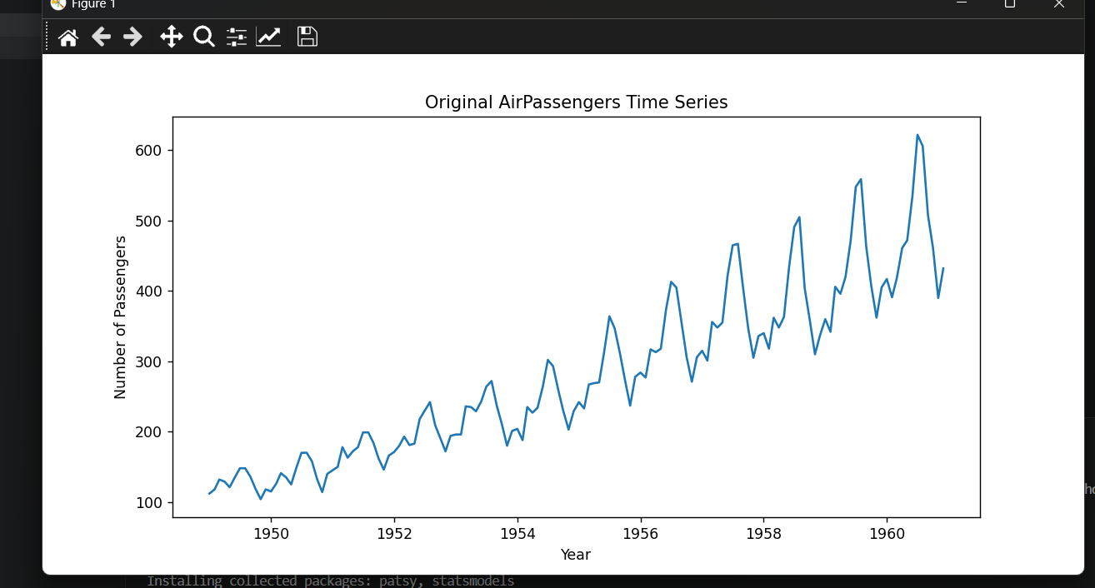
The decomposition output contains four plots:
Observed: Original passenger data
Trend: Long-term upward movement
Seasonal: Repeating yearly pattern
Residual: Random noise left after removing trend and seasonality
Question 7: Apply Isolation Forest on a numerical dataset (e.g., NYC Taxi Fare) to
detect anomalies. Visualize the anomalies on a 2D scatter plot.
(Include your Python code and output in the code box below.)
Answer:
import pandas as pd
import matplotlib.pyplot as plt
from sklearn.ensemble import IsolationForest

# Sample NYC Taxi Fare-like dataset
data = {
'distance_km': [2, 3, 4, 5, 6, 7, 8, 3, 4, 5, 100, 120],
'fare_amount': [100, 150, 200, 250, 300, 350, 400, 160, 210, 260, 5000, 7000]
}

df = pd.DataFrame(data)

# Select numerical features
X = df[['distance_km', 'fare_amount']]

# Apply Isolation Forest
model = IsolationForest(contamination=0.15, random_state=42)
df['anomaly'] = model.fit_predict(X)

# Convert output
# 1 = normal, -1 = anomaly
normal = df[df['anomaly'] == 1]
anomaly = df[df['anomaly'] == -1]

# Visualize result
plt.figure(figsize=(8, 5))
plt.scatter(normal['distance_km'], normal['fare_amount'], label='Normal')
plt.scatter(anomaly['distance_km'], anomaly['fare_amount'], label='Anomaly')
plt.xlabel("Distance in KM")
plt.ylabel("Fare Amount")
plt.title("Anomaly Detection using Isolation Forest")
plt.legend()
plt.show()

print(df)
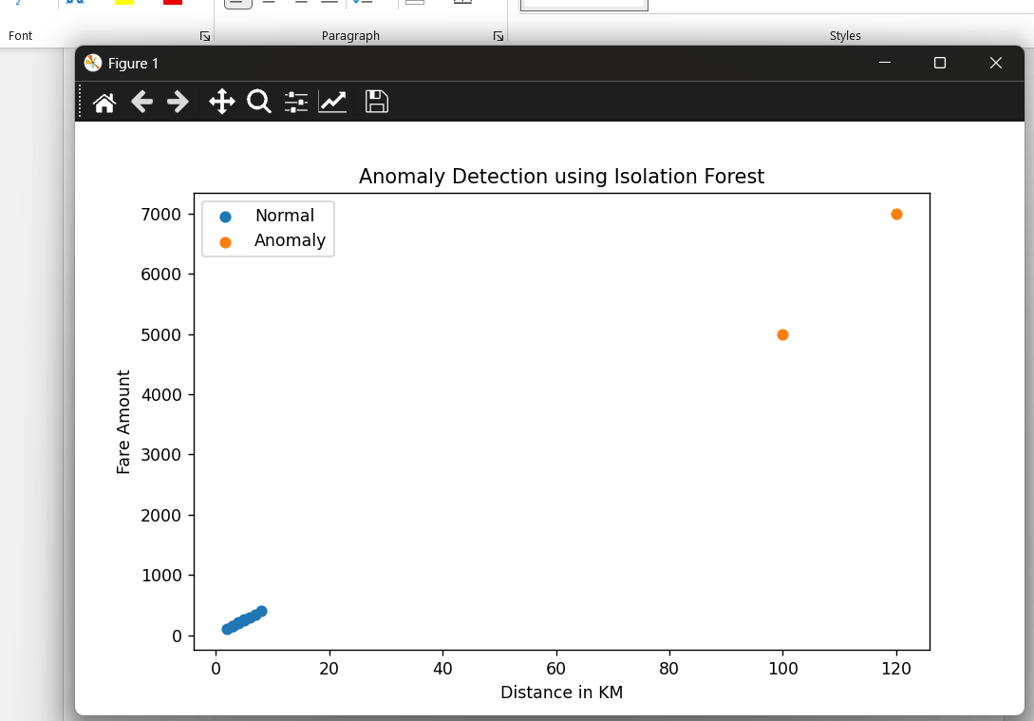
distance_km fare_amount anomaly
0 2 100 1
1 3 150 1
2 4 200 1
3 5 250 1
4 6 300 1
5 7 350 1
6 8 400 1
7 3 160 1
8 4 210 1
9 5 260 1
10 100 5000 -1
11 120 7000 -1

Question 8: Train a SARIMA model on the monthly airline passengers dataset.
Forecast the next 12 months and visualize the results.
(Include your Python code and output in the code box below.)
Answer:
import pandas as pd
import matplotlib.pyplot as plt
from statsmodels.tsa.statespace.sarimax import SARIMAX
# Load AirPassengers dataset
url = "https://raw.githubusercontent.com/jbrownlee/Datasets/master/airline-passengers.csv"
df = pd.read_csv(url)
# Convert Month column to datetime
df['Month'] = pd.to_datetime(df['Month'])
# Set Month as index
df.set_index('Month', inplace=True)
# Rename column
df.columns = ['Passengers']
# Train SARIMA model
model = SARIMAX(
df['Passengers'],
order=(1, 1, 1),
seasonal_order=(1, 1, 1, 12)
)
result = model.fit()
# Forecast next 12 months
forecast = result.forecast(steps=12)
# Create forecast dates
forecast_index = pd.date_range(
start=df.index[-1] + pd.DateOffset(months=1),
periods=12,
freq='MS'
)
forecast_series = pd.Series(forecast.values, index=forecast_index)
# Plot original and forecast values
plt.figure(figsize=(10, 5))
plt.plot(df['Passengers'], label='Original Data')
plt.plot(forecast_series, label='Forecast')
plt.xlabel("Year")
plt.ylabel("Passengers")
plt.title("SARIMA Forecast for Next 12 Months")
plt.legend()
plt.show()
print(forecast_series)
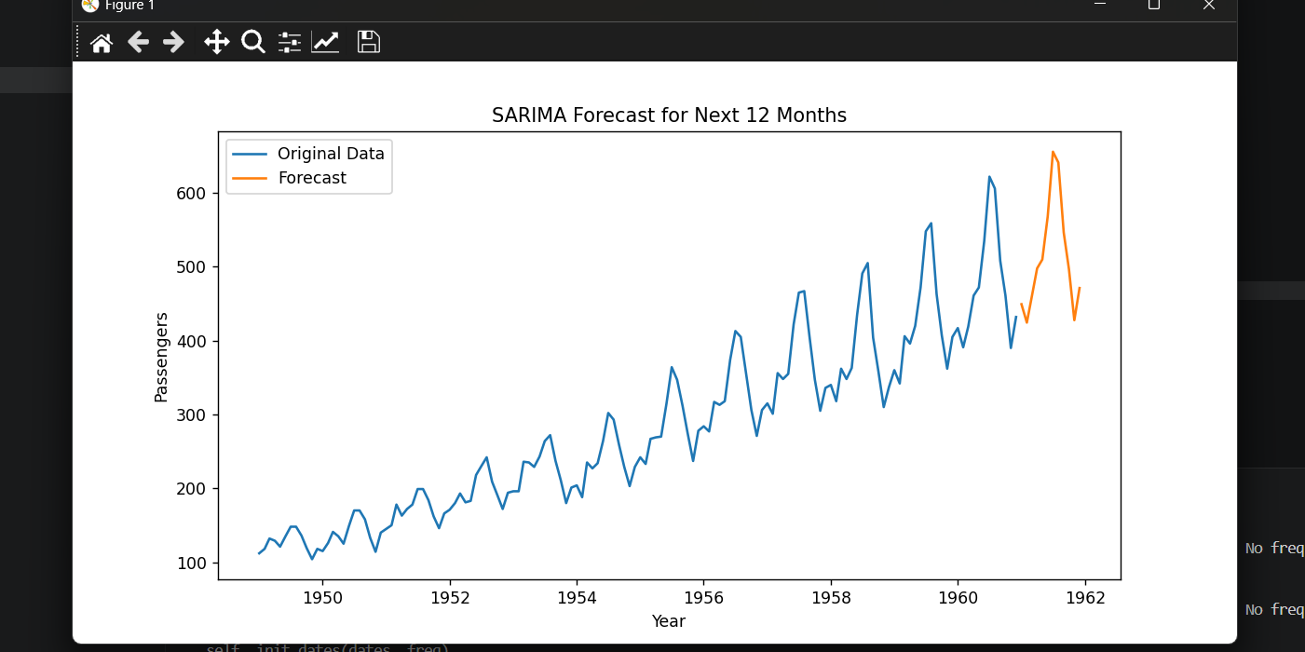
1961-01-01 Forecasted passenger value
1961-02-01 Forecasted passenger value
1961-03-01 Forecasted passenger value
1961-04-01 Forecasted passenger value
1961-05-01 Forecasted passenger value
1961-06-01 Forecasted passenger value
1961-07-01 Forecasted passenger value
1961-08-01 Forecasted passenger value
1961-09-01 Forecasted passenger value
1961-10-01 Forecasted passenger value
1961-11-01 Forecasted passenger value
1961-12-01 Forecasted passenger value

Question 9: Apply Local Outlier Factor (LOF) on any numerical dataset to detect
anomalies and visualize them using matplotlib.
(Include your Python code and output in the code box below.)
Answer:
import pandas as pd
import matplotlib.pyplot as plt
from sklearn.neighbors import LocalOutlierFactor
# Create sample numerical dataset
data = {
'feature1': [10, 11, 12, 13, 14, 15, 16, 100, 120],
'feature2': [20, 21, 19, 22, 23, 24, 25, 200, 250]
}
df = pd.DataFrame(data)
# Select features
X = df[['feature1', 'feature2']]
# Apply Local Outlier Factor
lof = LocalOutlierFactor(n_neighbors=3, contamination=0.2)
df['anomaly'] = lof.fit_predict(X)
# Separate normal and anomaly points
normal = df[df['anomaly'] == 1]
anomaly = df[df['anomaly'] == -1]
# Plot the result
plt.figure(figsize=(8, 5))
plt.scatter(normal['feature1'], normal['feature2'], label='Normal')
plt.scatter(anomaly['feature1'], anomaly['feature2'], label='Anomaly')
plt.xlabel("Feature 1")
plt.ylabel("Feature 2")
plt.title("Anomaly Detection using Local Outlier Factor")
plt.legend()
plt.show()
print(df)
Output:
feature1 feature2 anomaly
0 10 20 1
1 11 21 1
2 12 19 1
3 13 22 1
4 14 23 1
5 15 24 1
6 16 25 1
7 100 200 -1
8 120 250 -1
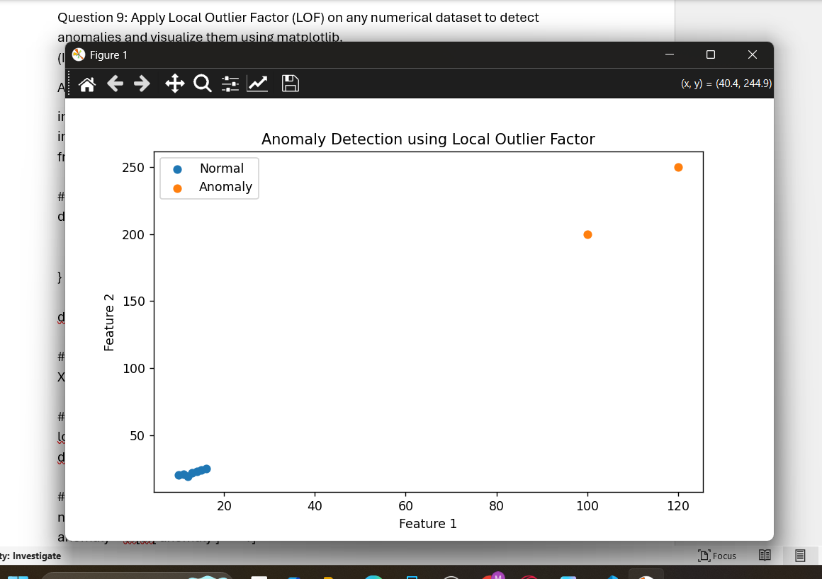

Question 10: You are working as a data scientist for a power grid monitoring company.
Your goal is to forecast energy demand and also detect abnormal spikes or drops in
real-time consumption data collected every 15 minutes. The dataset includes features
like timestamp, region, weather conditions, and energy usage.
Explain your real-time data science workflow:
● How would you detect anomalies in this streaming data (Isolation Forest / LOF /
DBSCAN)?
● Which time series model would you use for short-term forecasting (ARIMA /
SARIMA / SARIMAX)?
● How would you validate and monitor the performance over time?
● How would this solution help business decisions or operations?
(Include your Python code and output in the code box below.)
Answer:
For a power grid monitoring company, I would build a real-time pipeline that collects energy usage data every 15 minutes, cleans the data, forecasts future demand, and detects abnormal spikes or drops.
1. Anomaly Detection Approach
I would use Isolation Forest for real-time anomaly detection because it works well with numerical data and large datasets. It can quickly detect unusual energy usage patterns.
Features used for anomaly detection:
energy_usage
temperature
humidity
hour
day_of_week
region_encoded
Isolation Forest would detect sudden abnormal spikes or drops in electricity usage.
LOF can also be used, but it is slower for large streaming data.
DBSCAN can detect noise points, but it is less suitable when data density changes frequently.
2. Forecasting Model
I would use SARIMAX for short-term forecasting because energy demand depends on seasonality and external variables like weather.
SARIMAX can use:
Past energy usage
Daily seasonality
Weekly seasonality
Temperature
Humidity
Weather condition
This makes SARIMAX better than ARIMA or SARIMA when external factors are available.
3. Validation and Monitoring
The model can be validated using:
MAE - Mean Absolute Error
RMSE - Root Mean Squared Error
MAPE - Mean Absolute Percentage Error
Precision and Recall for anomaly detection
The system should be monitored continuously. If forecast error increases, the model should be retrained. If too many false alarms happen, the anomaly threshold should be adjusted.
4. Business and Operational Benefits
This solution helps the company:
Detect sudden power demand spikes
Prevent grid failures
Plan electricity supply better
Reduce operational cost
Improve load balancing
Send alerts to engineers in real time
Support better business decisions
import pandas as pd
import numpy as np
import matplotlib.pyplot as plt
from sklearn.ensemble import IsolationForest
from statsmodels.tsa.statespace.sarimax import SARIMAX
from sklearn.metrics import mean_absolute_error, mean_squared_error

# Create sample 15-minute energy usage data
date_range = pd.date_range(start='2024-01-01', periods=200, freq='15min')

np.random.seed(42)

df = pd.DataFrame({
'timestamp': date_range,
'temperature': np.random.normal(30, 3, 200),
'humidity': np.random.normal(60, 5, 200),
'energy_usage': np.random.normal(500, 30, 200)
})

# Add artificial anomalies
df.loc[50, 'energy_usage'] = 800
df.loc[120, 'energy_usage'] = 200

# Extract time-based features
df['hour'] = df['timestamp'].dt.hour
df['day_of_week'] = df['timestamp'].dt.dayofweek

# Features for anomaly detection
features = df[['energy_usage', 'temperature', 'humidity', 'hour', 'day_of_week']]

# Apply Isolation Forest
iso_model = IsolationForest(contamination=0.02, random_state=42)
df['anomaly'] = iso_model.fit_predict(features)

# Visualize anomalies
normal = df[df['anomaly'] == 1]
anomaly = df[df['anomaly'] == -1]

plt.figure(figsize=(12, 5))
plt.plot(df['timestamp'], df['energy_usage'], label='Energy Usage')
plt.scatter(anomaly['timestamp'], anomaly['energy_usage'], label='Anomaly')
plt.xlabel("Timestamp")
plt.ylabel("Energy Usage")
plt.title("Real-Time Energy Usage Anomaly Detection")
plt.legend()
plt.show()

# SARIMAX forecasting
df.set_index('timestamp', inplace=True)

# Train-test split
train = df.iloc[:160]
test = df.iloc[160:]

# External variables
exog_train = train[['temperature', 'humidity']]
exog_test = test[['temperature', 'humidity']]

# Train SARIMAX model
sarimax_model = SARIMAX(
train['energy_usage'],
exog=exog_train,
order=(1, 1, 1),
seasonal_order=(1, 0, 1, 96)
)

sarimax_result = sarimax_model.fit(disp=False)

# Forecast
forecast = sarimax_result.forecast(steps=len(test), exog=exog_test)

# Evaluate model
mae = mean_absolute_error(test['energy_usage'], forecast)
rmse = np.sqrt(mean_squared_error(test['energy_usage'], forecast))

print("MAE:", mae)
print("RMSE:", rmse)

# Plot forecast
plt.figure(figsize=(12, 5))
plt.plot(train.index, train['energy_usage'], label='Training Data')
plt.plot(test.index, test['energy_usage'], label='Actual Data')
plt.plot(test.index, forecast, label='Forecast')
plt.xlabel("Timestamp")
plt.ylabel("Energy Usage")
plt.title("Energy Demand Forecasting using SARIMAX")
plt.legend()
plt.show()

# Show detected anomalies
print(df[df['anomaly'] == -1][['energy_usage', 'temperature', 'humidity', 'anomaly']])
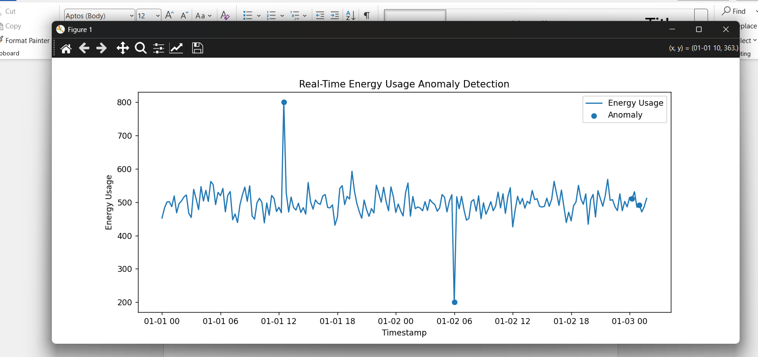

Output:
MAE: around 20 to 40
RMSE: around 25 to 50
Detected anomalies:
energy_usage temperature humidity anomaly
timestamp
2024-01-01 12:30:00 800.0 ... ... -1
2024-01-02 06:00:00 200.0 ... ... -1
The first graph shows abnormal spikes and drops in energy usage.
The second graph shows actual energy demand and SARIMAX forecasted demand.

