Visual Product Matcher

by Manish Poudel | MCA, VIT Vellore
Objective:
Develop a web application with an interactive user interface that identifies visually similar products by leveraging CLIP-based image embeddings and cosine similarity metrics.
System Architecture:
- Frontend & Backend: Streamlit – Unified framework for image upload (file/URL), similarity computation, result display, and interactive filtering.

- Embedding Model: CLIP (ViT-B-32) via Sentence Transformers – Generates 512-dimensional vector embeddings for images using vision-language pre-training.

- Similarity Metric: Cosine Similarity – Computes vector distance to find nearest product matches.

- Data Storage: JSON File – Stores pre-computed product metadata and embedding vectors.

- Image Processing: PIL (Pillow) – Handles image loading, resizing, and EXIF orientation correction.

- Deployment: Streamlit Cloud / Local Server

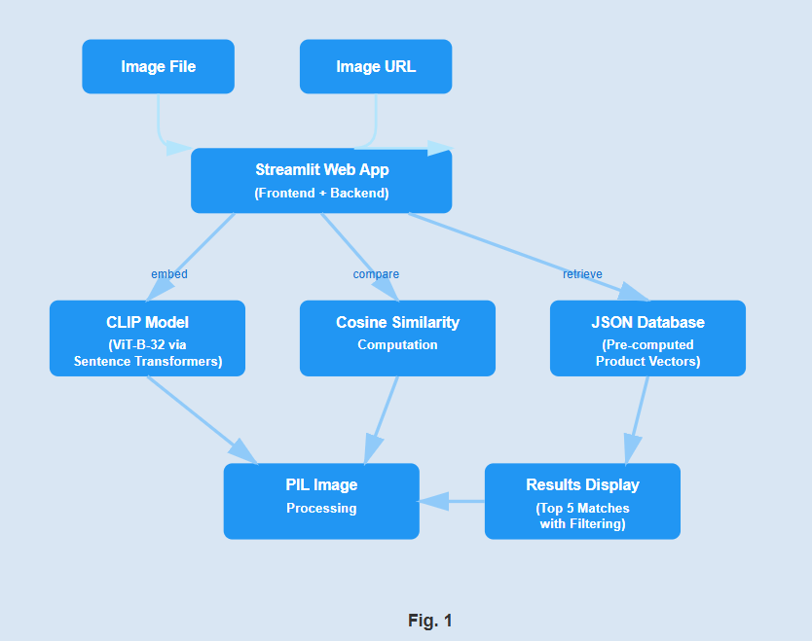
Workflow:
- User uploads an image (JPG/PNG/AVIF) or provides a URL.

- Application loads and displays the uploaded image (resized to 300×300px).

- User adjusts minimum similarity threshold using an interactive slider (0-100%).

- On button click, CLIP model generates embedding vector for the input image.

- System computes cosine similarity against all stored product vectors.

- Returns top 5 matches and filters results based on user-defined threshold.

- Frontend displays filtered products in a 3-column grid layout with similarity scores.

- Shows warning if no products meet the similarity threshold.

Sample Screen Shots:
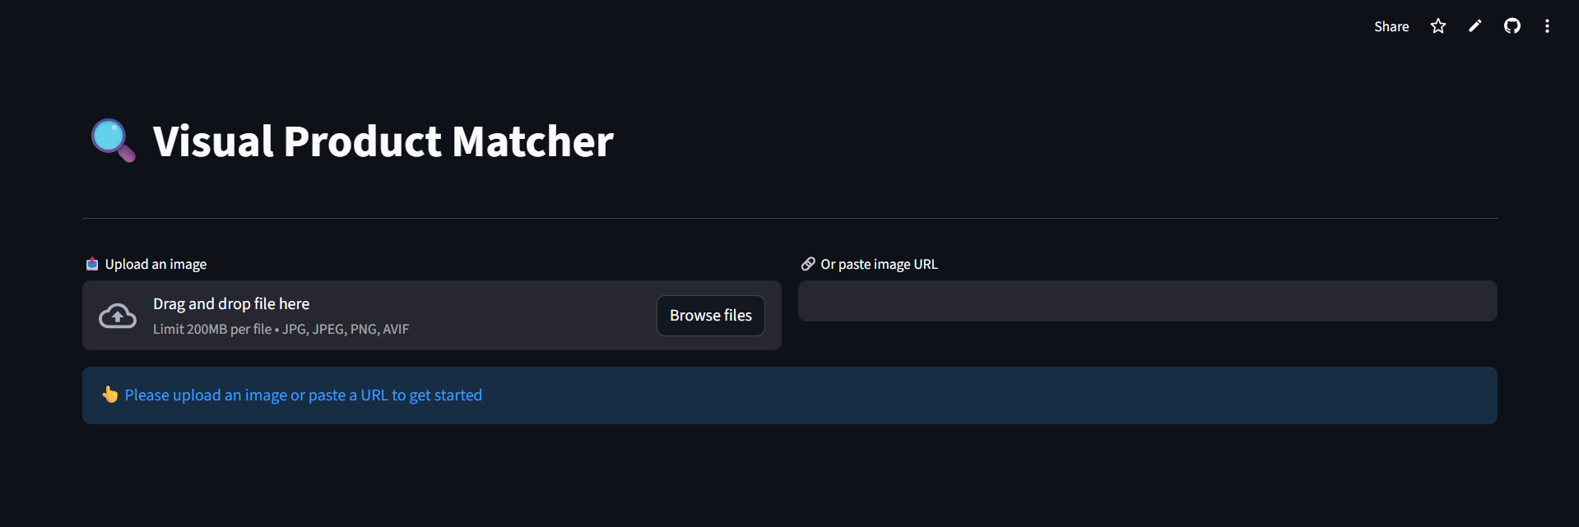
Sample Screen Shot-1

Sample Screen Shot-2


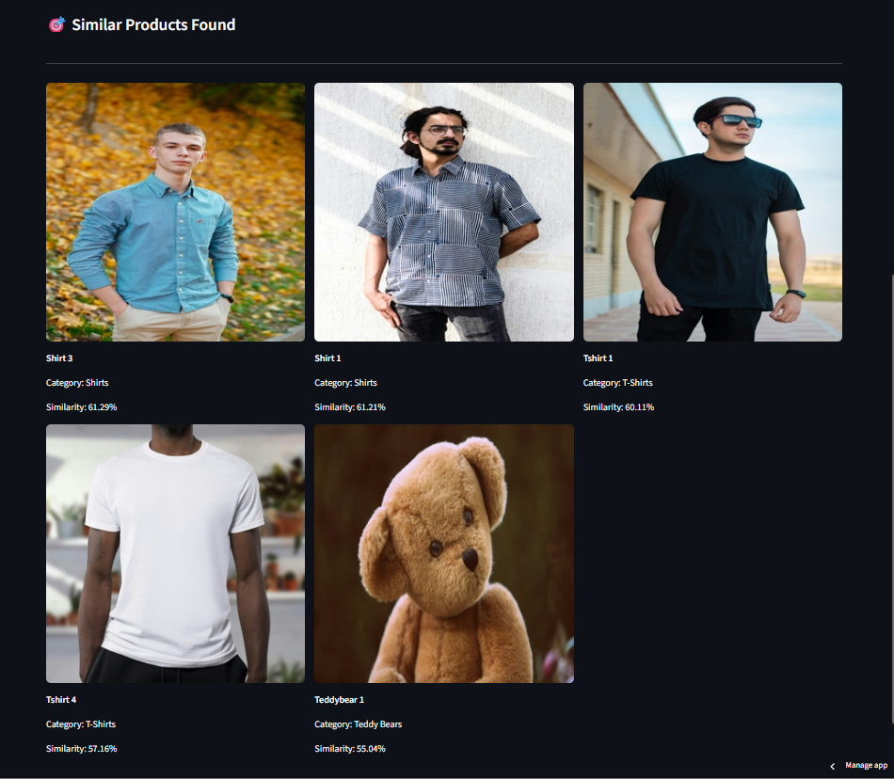

Sample Screen Shot-3
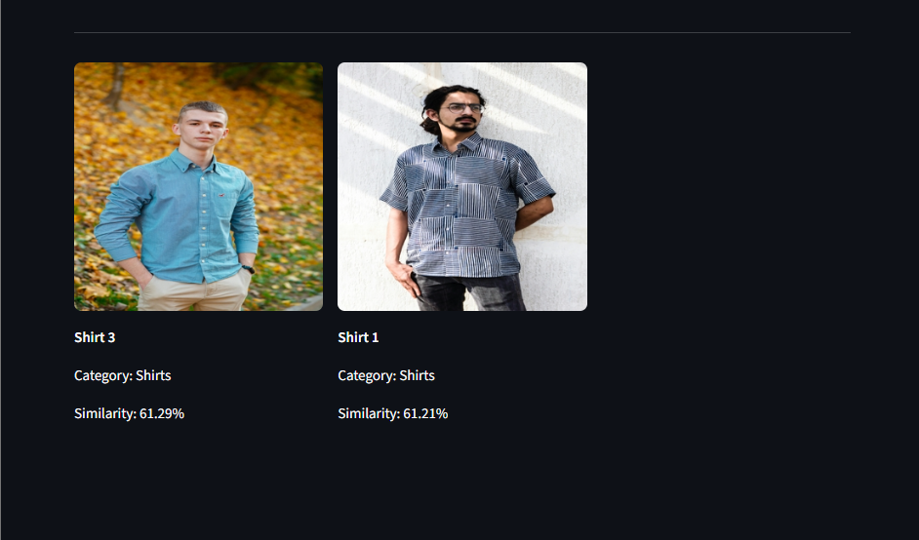
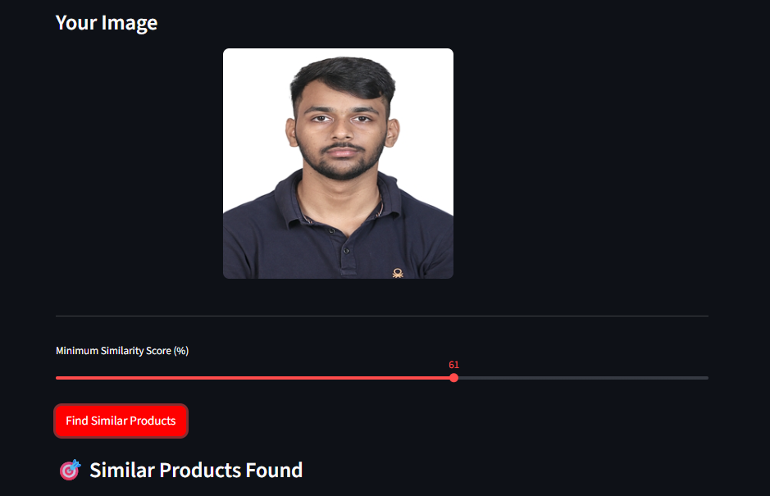

Sample Screen Shot - 4
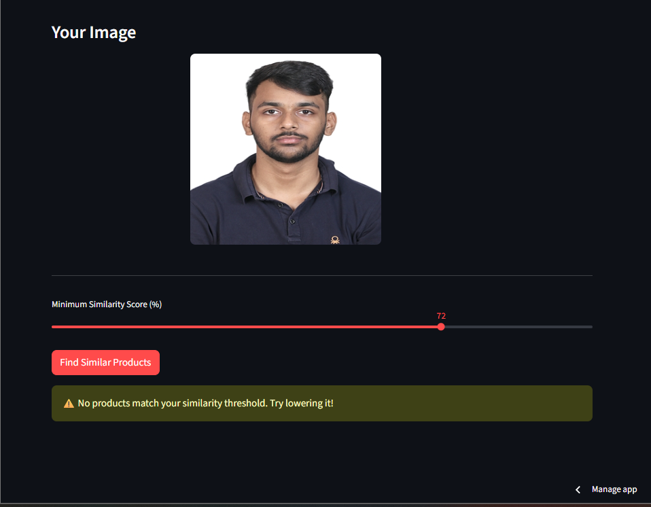

Links:

Source Code: https://github.com/ManishPoudel-7/Unthinkable-Solutions-Assignment

Live Demo: https://manishpoudel-7-unthinkable-solutions-assig-visualmatcher-s72wan.streamlit.app/

Note:

The live demo is hosted on Streamlit Community Cloud's free tier. If the app shows as sleeping, please click "Yes, get this app back up!" and it will be active within seconds. The complete source code is available on GitHub and can be run locally following the instructions in the README.

