**Restaurant Food Delivery System Free Download Bootstrap Source code**

**Landing Page**

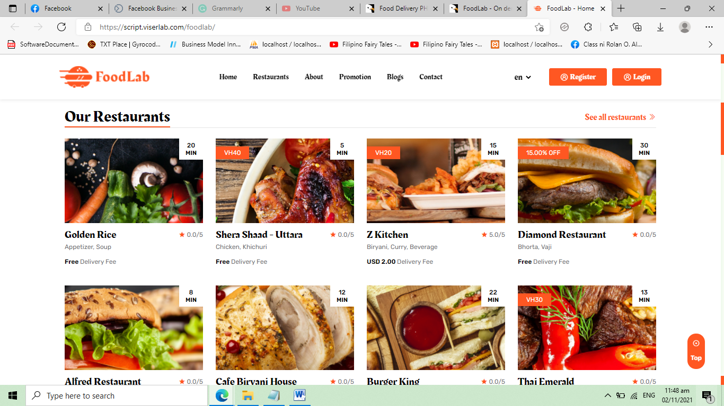

**Registration Form**

* Restaurant Name
* Complete Address
* Email Address
* Owner name
* TIN number
* Company Logo
* Upload Business permit for verification
* Latitude
* Longitude
* Username
* Password

**Login Form**

**Admin Dashboard**

* Number of restaurants
* Number of foods
* Number of delivery drivers
* Daily Transactions

**Restaurant Information Management – crud (table and form)**

* Restaurant Name
* Complete Address
* Email Address
* Owner name
* TIN number
* Company Logo
* Upload Business permit for verification
* Latitude
* Longitude
* View Map button
* Username
* Password
* Status – active, inactive

**Food List Archive – table only for viewing**

* Restaurant
* Food name
* Price per serving
* Image
* Description
* Status – available, not available

**Delivery Drivers – crud (table and form)**

* Full name
* Address
* Contact number
* Email address
* Profile picture
* Driver’s license
* Username
* Password
* Account status – active, inactive

**Feedback and Reports – table only for viewing**

* Title
* **Description**
* Date
* Submitted by
* Status – closed, open, solved
* Update status button

**System Settings – update settings**

* Max order allowed
* Commission %
* Drivers Rate

**Admin Users – crud (table and form)**

* Full name
* Email
* Complete address
* Username
* Password
* Status – active, inactive

**Sales and Commission Report**

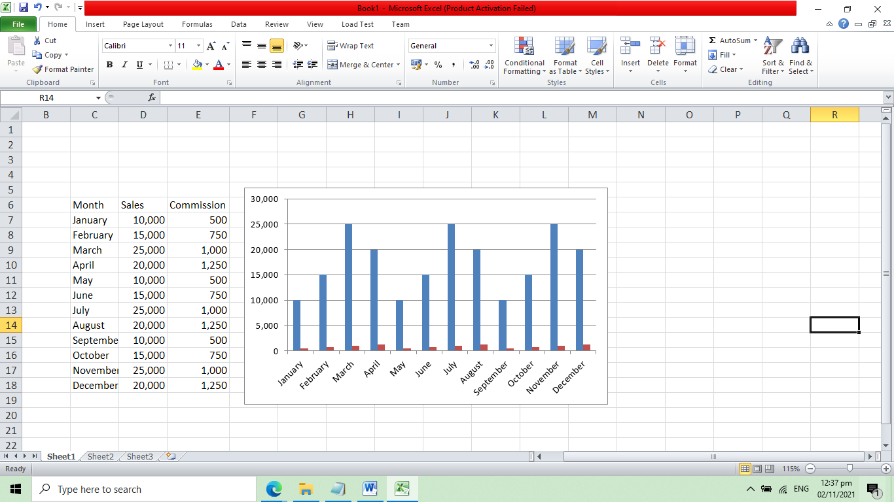

**Restaurant Account**

**Dashboard**

* Total Sales
* Total Orders
* Number of foods available
* Daily Sales
* Daily Orders

**Food List Archive – crud (table and form)**

* Food name
* Price per serving
* Image
* Description
* Status – available, not available

**Order List**

* Order code
* Customer name
* Order date
* Food
* Amount
* Delivery Charge
* Total Amount
* Delivery Driver name
* Status – pending, cancelled, delivered

**Daily Sales Report**

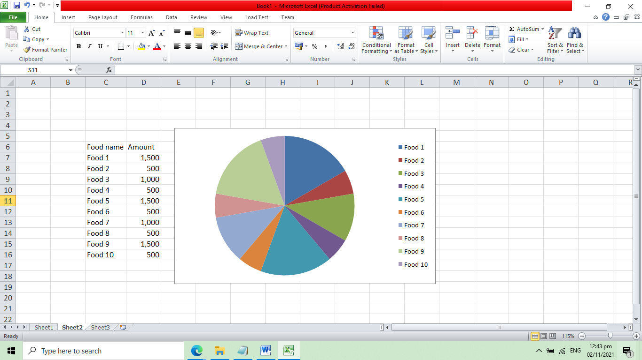

**Profile**

* Restaurant Name
* Complete Address
* Email Address
* Owner name
* TIN number
* Company Logo
* Upload Business permit for verification
* Latitude
* Longitude
* Username
* Password

**Delivery Driver Account**

**Driver Dashboard**

* Number of delivery
* Total Commission

**Order List**

* Order code
* Customer name
* Order date
* Food
* Amount
* Delivery Charge
* Total Amount
* Status – pending, cancelled, delivered

**Commission Report**

