Task 1. Creating and Renaming Files/Directories
Step 1: Created a directory named test_dir using mkdir.
Step 2: Inside test_dir, created an empty file called example.txt using touch.
Step 3: Renamed example.txt to renamed_example.txt using mv
Following is the output screenshot:
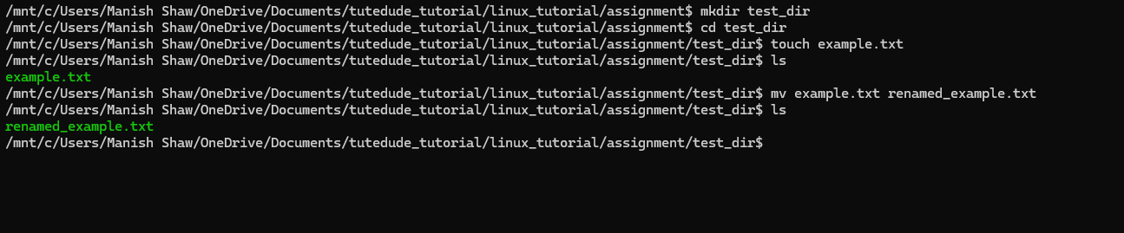
Task 2: Viewing File Contents
Step 1: Created a file name renamed_example.txt under directory /etc/passwd and used cat to display the contents of /etc/passwd/renamed_example.txt
Step 2: Displayed only the first 5 lines of /etc/passwd/renamed_example.txt using head.
Step 3: Displayed only the last 5 lines of /etc/passwd using tail.
Following is the output screenshot:
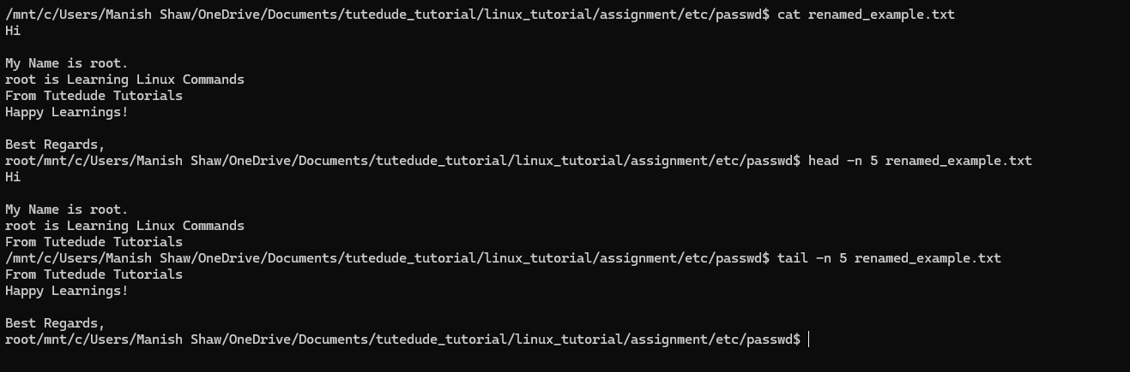
Task 3: Searching for Patterns
Step 1: Used grep to find all lines containing the word "root" in /etc/passwd.
Following is the output screenshot:

Task 4: Zipping and Unzipping
Step 1: Compressed the test_dir directory into a file named test_dir.zip using zip.
Step 2: Unzipped the test_dir.zip into a new directory named unzipped_dir using unzip.
Following is the output screenshot:
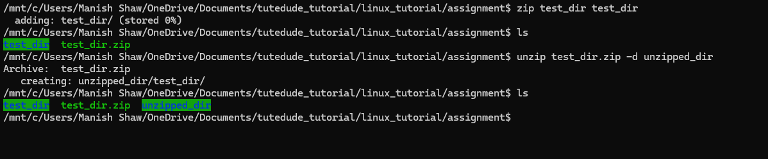
Task 5: Downloading Files
Step 1: Used wget to download a file from a URL (e.g., https://www.iana.org/help/example-domains)
Following is the output screenshot:
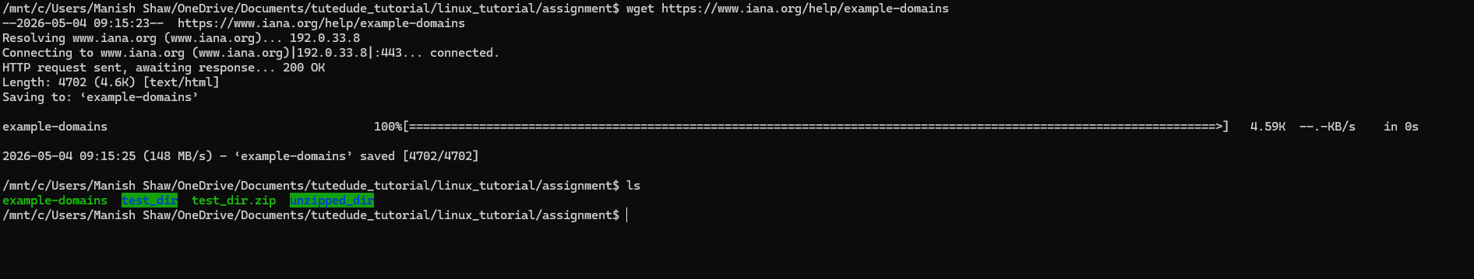
Task 6. Changing Permissions
Step 1: Created a file named secure.txt using touch
Step 2: Changed its permissions to read-only for everyone using chmod 444.
Following is the output screenshot:
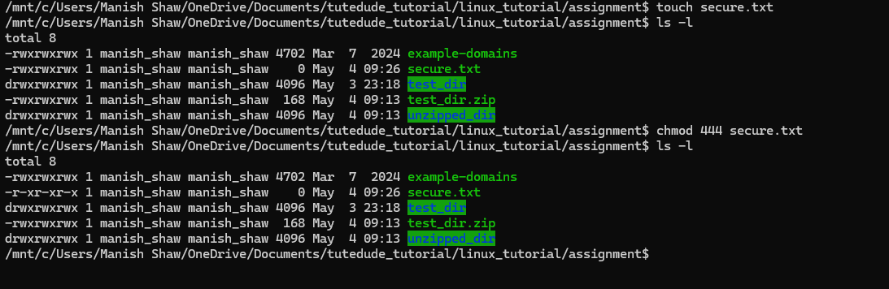

Task 7: Working with Environment Variables
Step 1: Used export to set a new environment variable called MY_VAR with the value "Hello, Linux!".
Following is the output screenshot:
