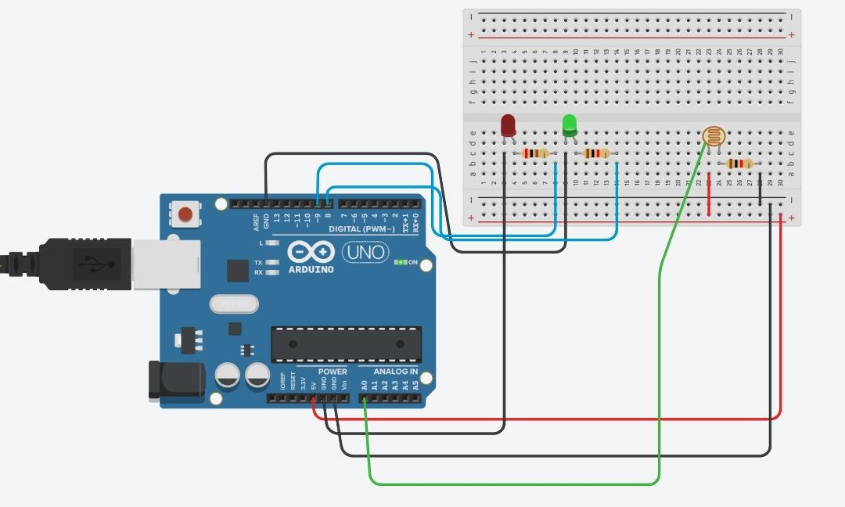 Diagram

Theory:To know the surrounding is light or dark we can use arduino uno with photo resistor connected with it with the help of jumper wire. In this,when the sensor senses the dark environment it send signal to arduino and arduino in turn makes the green light glow while when sensor senses light ardiuno makes the red light glow.

Trouble faced: In writing code and learning the function and operation of tindercad.

Precaution:

* Connection should be neat and tight,jumper wire should be used.
* Resistance should be accurate,otherwise led may burn.
* Correct and right use of coding and compilation.

Learning outcome: We can make our life comfortable with these electronic devices. We can invent many other useful devices.