On page load you can see all your notes.

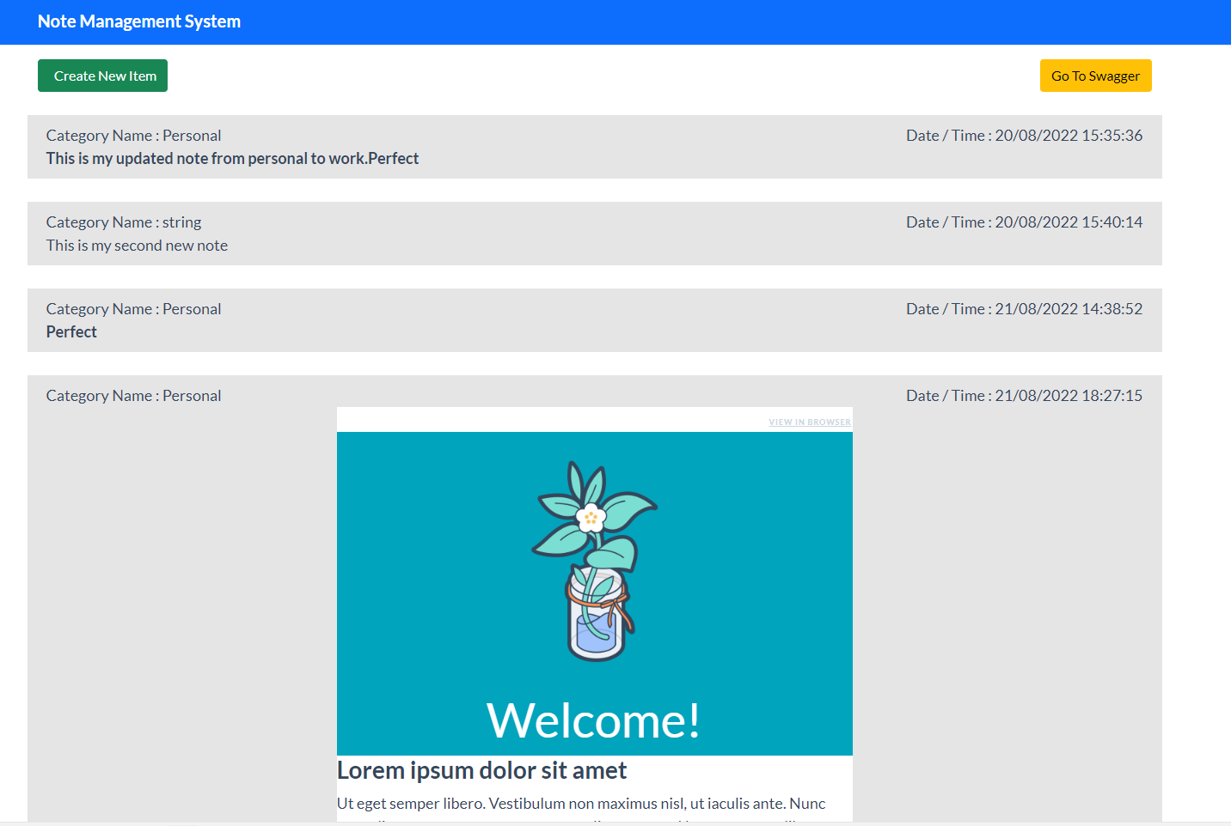

Please click on Create New Item Button to add new note.

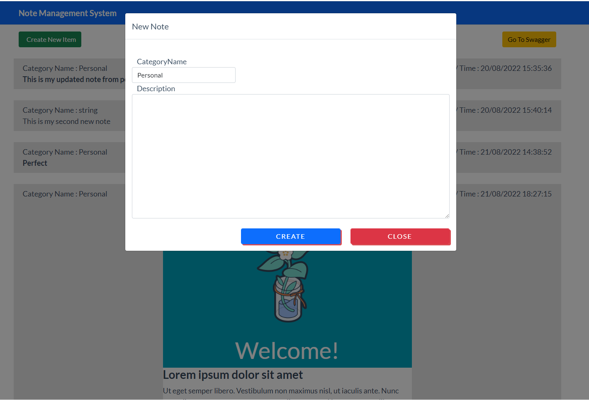

1. Select category
2. Add text or HTML code in text area
3. Click on Create button.

**It will add in your home page without reloading the whole page**



Click on Go to Swagger button. You will be redirect to API

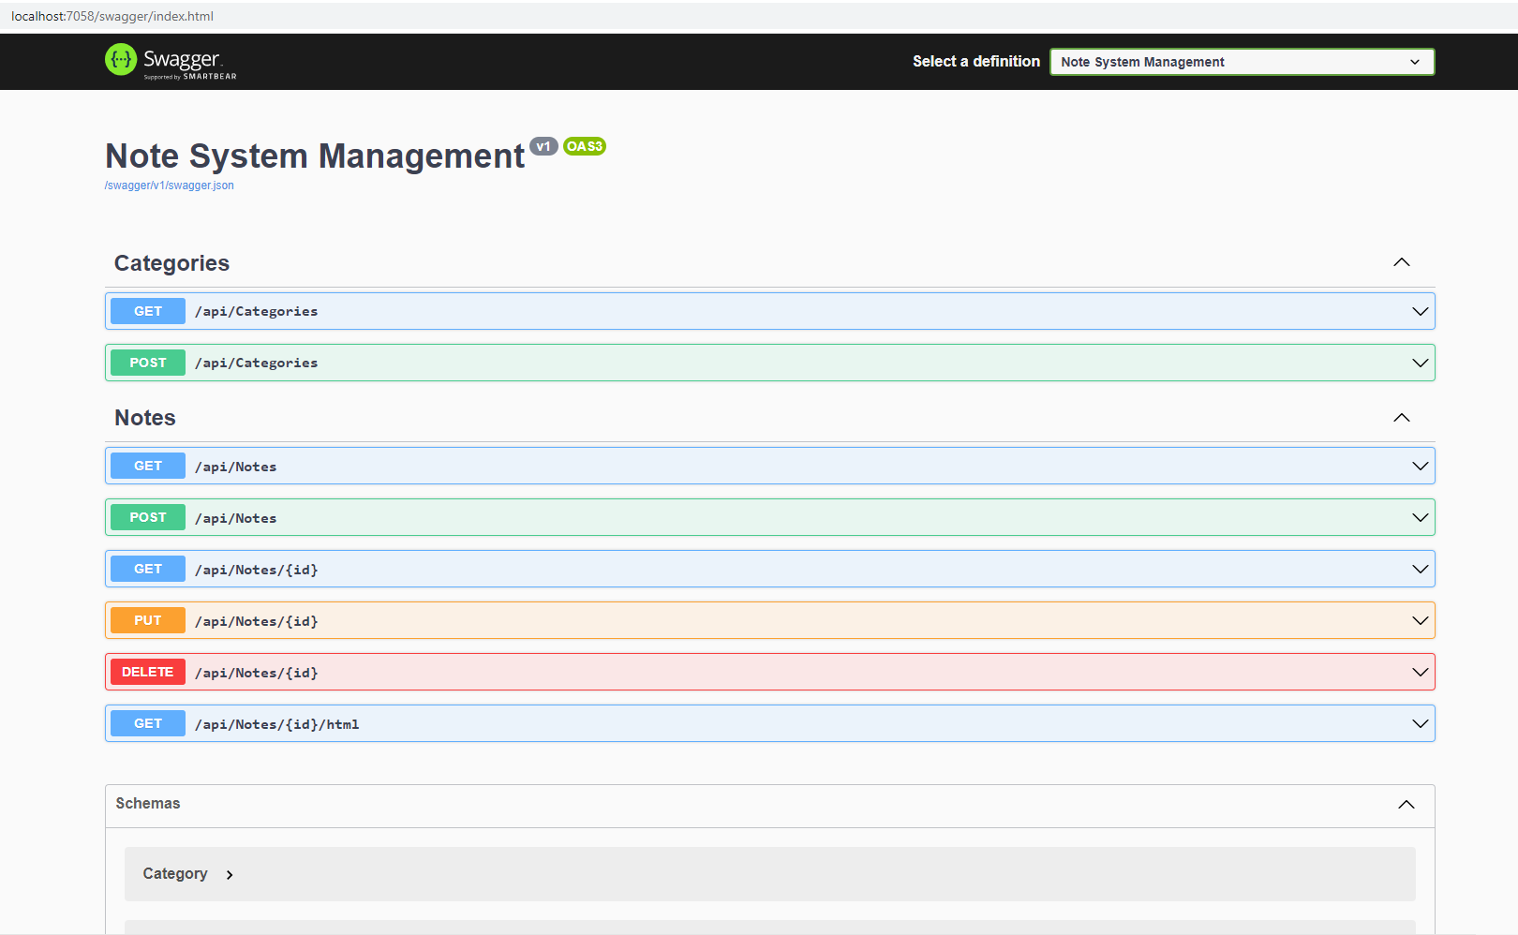

Also created simple unit test for CategoriesController fo GetAllCategories()

